NFT Market Analysis and Prediction System i

REPORT

Submitted by

SACHIN K G (231801144)
SAKTHIVEL BALAJI C (231801505)
TAMILSELVAN A K (231801177)

in partial fulfilment for the award of the degree of
Bachelor of Technology
in
Artificial Intelligence and Data Science

 | 

RAJALAKSHMI ENGINEERING COLLEGE (AUTONOMOUS) THANDALAM,

DEPARTMENT OF Computer Science and Engineering ANNA UNIVERSITY, CHENNAI 600 025

OCTOBER 2025

ANNA UNIVERSITY, CHENNAI

BONAFIDE CERTIFICATE ii

Certified that this Phase – II Thesis titled SPATIO-TEMPORAL BASED TRAJECTORY ANALYSIS FOR OPTIMAL ROUTE PREDICTION
WITH LOW TIME COMPLEXITY is the Bonafide work of SACHIN K G (231801144) ,SAKTHIVEL BALAJI C (231801505) and TAMILSELVAN A K (231801177) who carried out the project work under my supervision. Certified further that to the best of my knowledge the work reported herein does not form part of any other thesis or dissertation based on which a degree or award was conferred on an earlier occasion on this or any other candidate.

SIGNATURE | SIGNATURE
Dr. P. VALARMATHIE | Dr. PRIYA VIJAY
Head of the Department Professor  Department of Information Technology,  Rajalakshmi Engineering College  Thandalam, Chennai – 602105. | Supervisor, Professor  Department of Information Technology,  Rajalakshmi Engineering College  Thandalam, Chennai – 602105.

Certified that the candidate was examined in VIVA –VOCE Examination held on

INTERNAL EXAMINER | EXTERNAL EXAMINER

DECLARATION iii

I hereby declare that the thesis entitled SPATIO-TEMPORAL BASED TRAJECTORY ANALYSIS FOR OPTIMAL ROUTE PREDICTION
WITH LOW TIME COMPLEXITY is a Bonafide work carried out by me under the supervision of Dr. PRIYA VIJAY Ph.D., Professor, Department of Information Technology, Rajalakshmi Engineering College, Thandalam, Chennai, towards partial fulfilment of Degree, M.Tech – Data Science. It has not formed the part of any other project work submitted for the award of any other degree or diploma, either in this or any other university.

SACHIN K G (231801144)
SAKTHIVEL BALAJI C (231801505)
TAMILSELVAN A K (231801177)

ACKNOWLEDGEMENT iv

Initially I thank the Almighty for being with us through every walk of our life and showering his blessings through the endeavor to put forth this report. I sincerely thank our respected Chairman Mr. S. MEGANATHAN, B.E, F.I.E., our Chairperson Dr.(Mrs.) THANGAM MEGANATHAN, Ph.D., and our Vice Chairman Mr.ABHAY SHANKAR MEGANATHAN, B.E., M.S., for
providing us with the requisite infrastructure and sincere endeavoring in educating us in their premier institution. I sincerely thank Dr. S. N. MURUGESAN, M.E., Ph.D., our beloved Principal for his kind support and facilities provided to complete my work in time. I express my sincere thanks to Dr. VALARMATHIE, Ph.D., Professor and Head of the Department of Information and Technology for her guidance and encouragement throughout the project work. I convey my sincere and deepest gratitude to our internal guide, Dr. PRIYA VIJAY Ph.D., Department of Information and technology, Rajalakshmi Engineering College for her valuable guidance throughout the course of the project. I am very glad to convey our sincere gratitude to our Project Coordinator, Dr. PRIYA VIJAY Ph.D., Department Information and Technology for her useful tips during our review to build our project.

SACHIN K G (231801144)
SAKTHIVEL BALAJI C (231801505)

TAMILSELVAN A K
(231801177)

ABSTRACT

This project explores the dynamic and complex world of Non-Fungible Tokens (NFTs) by analyzing real-world transaction data from the OpenSea marketplace. The primary objective is to develop a comprehensive data science solution that not only provides deep insights into market trends but also offers predictive and a recommendation system for users. By employing techniques such as data preprocessing, exploratory data analysis (EDA), and machine learning models like LSTM for price prediction and K-Means for clustering, the project addresses key challenges faced by investors and enthusiasts in this volatile market. The final deliverable is a functional system that empowers users to make data-driven decisions by identifying profitable investment opportunities and understanding market behavior.

vi
CHAPTER  NO. | TITLE | PAGE  NO.
 | ABSTRACT | iv
1 | INTRODUCTION | 1
 | 1.1 Problem Definition & Explanation | 1
 | 1.2 Literature Survey | 2
 | 1.3 Existing System | 3
 | 1.4 Proposed System | 5
2 | Data Collection & Preparing | 7
 | 2.1 Data Collection & Dataset Description | 7
 | 2.2 Architecture Diagram & Explanation | 8
 | 2.3 Preprocessing | 8
3 | Result & Discussion | 10
 | 3.1 Analysis & Model Explanation | 10
 | 3.2 Model Explanation | 11
 | 3.2 Comparison (Graph)  3.4 Conclusion And Future Enhancements  3.6 References | 12  20  22

DEPARTMENT VISION
To promote highly Ethical and Innovative Information Technology Professionals through excellence in teaching, training and research.

DEPARTMENT MISSION
To produce globally competent professionals, motivated to learn the emerging technologies and to be innovative in solving real world problems.
To promote research activities amongst the students and the members of faculty that could benefit the society.
To impart moral and ethical values in their profession.

PROGRAMME EDUCATIONAL OBJECTIVES
PEO I
To provide essential background in science, basic Electronics, applied Mathematics and Information Sciences.

PEO II
To prepare students with fundamental knowledge in programming languages and to design and develop information systems and applications.

PEO III
To engage the students in life-long learning, to remain current in their profession and obtain additional qualifications to enhance their career positions in IT field.

PEO IV
To enable students to implement computing solutions for real world problems and carry out basic and applied research leading to new innovations in Information Technology (IT) and related interdisciplinary areas.

PEO V
To familiarize students with ethical issues in engineering profession, issues related to the worldwide economy, nurturing of current job related skills and emerging technologies with a concern for society

PROGRAM OUTCOMES (POs)

Engineering Graduates will be able to:

PO1: Engineering knowledge:
Apply the knowledge of mathematics, science, engineering fundamentals, and an engineering specialization to the solution of complex engineering problems.

PO2: Problem analysis:
Identify, formulate, review research literature, and analyze complex engineering problems reaching substantiated conclusions using first principles of mathematics, natural sciences, and engineering sciences.

PO3: Design/development of solutions:
Design solutions for complex engineering problems and design system components or processes that meet the specified needs with appropriate consideration for the public health and safety, and the cultural, societal, and environmental considerations.

PO4: Conduct investigations of complex problems:
Use research-based knowledge and research methods including design of experiments, analysis and interpretation of data, and synthesis of the information to provide valid conclusions.

PO5: Modern tool usage:
Create, select, and apply appropriate techniques, resources, and modern engineering and IT tools including prediction and modeling to complex engineering activities with an understanding of the limitations.

PO6: The engineer and society:
Apply reasoning informed by the contextual knowledge to assess societal, health, safety, legal and cultural issues and the consequent responsibilities relevant to the professional engineering practice.

PO7: Environment and sustainability:
Understand the impact of the professional engineering solutions in societal and environmental contexts, and demonstrate the knowledge of, and need for sustainable development.

PO8: Ethics:
Apply ethical principles and commit to professional ethics and responsibilities and norms of the engineering practice.

PO9: Individual and team work:
Function effectively as an individual, and as a member or leader in diverse teams, and in multidisciplinary settings.

PO10: Communication:
Communicate effectively on complex engineering activities with the engineering community and with society at large, such as, being able to comprehend and write effective reports and design documentation, make effective presentations, and give and receive clear instructions.

PO11: Project management and finance:
Demonstrate knowledge and understanding of the engineering and management principles and apply these to one’s own work, as a member and leader in a team, to manage projects and in multidisciplinary environments.

PO12: Life-long learning:
Recognize the need for, and have the preparation and ability to engage in independent and life-long learning in the broadest context of technological change.

PROGRAM SPECIFIC OUTCOMES (PSOs)

PSO 1: To identify and assess current technologies and review their applicability to meet user requirements and organizational needs.

PSO 2: To engage in the computing profession by working effectively and utilizing professional skills to make a positive contribution to society.

PSO 3: To take up research and entrepreneurship and embark on business in the IT field.

COURSE OBJECTIVE
- To develop the ability to solve a specific problem right from its identification and literature review till the successful solution of the same.
- To train the students in preparing project reports and to face reviews and viva voce examination.

COURSE OUTCOME
  - On completion the students can able to execute the proposed plan and identify and overcome the bottle necks during each stage.
  - On Completion of the project work students will be in a position to take up any challenging practical problems and find solution by formulating proper methodology.
  - Students will obtain a hands-on experience in converting a small novel idea / technique into a working model / prototype involving multi- disciplinary skills and / or knowledge and working in at team.
  - Students will be able to interpret the outcome of their project.
  - Students will take on the challenges of teamwork, prepare a presentation in a professional manner, and document all aspects of design work.

CO-PO/PSO Mapping

CO \  PO | PO  1 | PO  2 | PO  3 | PO  4 | PO  5 | PO  6 | PO  7 | PO  8 | PO  9 | PO  10 | PO  11 | PO  12 | PSO  1 | PSO  2 | PSO  3
CO1 | 2 | 3 | 2 | 3 | 2 | 1 | 1 | 1 | 2 | 1 | 2 | 2 | 3 | 2 | 1
CO2 | 3 | 3 | 3 | 3 | 2 | 1 | 1 | 1 | 2 | 2 | 2 | 3 | 3 | 2 | 2
CO3 | 2 | 2 | 3 | 2 | 3 | 1 | 2 | 1 | 3 | 2 | 3 | 2 | 2 | 3 | 3
CO4 | 2 | 3 | 2 | 3 | 2 | 0 | 0 | 1 | 1 | 1 | 1 | 2 | 2 | 2 | 1
CO5 | 1 | 1 | 1 | 2 | 2 | 1 | 1 | 2 | 3 | 3 | 3 | 2 | 1 | 3 | 2
Avg | 2.0 | 2.4 | 2.2 | 2.6 | 2.2 | 0.8 | 1.0 | 1.2 | 2.2 | 1.8 | 2.2 | 2.2 | 2.2 | 2.4 | 1.8

CHAPTER I
INTRODUCTION

This project presents a comprehensive data science solution for analyzing the Non-Fungible Token (NFT) market, with a focus on delivering actionable insights and a practical investment tool. By leveraging a large-scale dataset of real-world NFT transactions from the OpenSea marketplace, the study addresses the critical need for a structured and data-driven approach in a highly speculative and volatile environment. The methodology involves a multi-stage pipeline encompassing meticulous data preprocessing, in-depth exploratory data analysis (EDA), and the development of sophisticated machine learning models. We specifically employ a Long Short-Term Memory (LSTM) neural network for time-series-based price prediction and a K-Means clustering algorithm to segment assets based on market characteristics. The project's final deliverable is a functional recommendation system that empowers users to navigate the market with confidence. It identifies profitable opportunities by forecasting future prices and suggests suitable NFTs based on personalized user profiles and investment budgets, thereby mitigating risks and democratizing access to complex market intelligence.

  - Problem Definition & Explanation:
The explosive growth of the NFT market has attracted significant attention, yet its inherent volatility and lack of transparent valuation mechanisms pose a substantial barrier to entry for many investors. Unlike traditional assets with established valuation metrics, NFTs derive their value from a complex interplay of factors, including artist reputation, rarity, community sentiment, and historical sales data. The current market landscape is a chaotic data ocean, making it nearly impossible for individuals to manually sift through thousands of assets and millions of transactions to identify valuable trends or assess investment viability. This lack of an accessible and intelligent framework for market analysis leads to speculative bubbles, uninformed decisions, and increased financial risk for participants. This project directly confronts these challenges by creating a robust, data-driven system designed to demystify the NFT market. Our goal is to transform raw transaction data into a source of intelligent, actionable insights and to provide a predictive tool that can help users make more informed and strategic investment choices.

  - Literature Survey :
1. Blockchain Data Analysis: Research by Smith et al. (2022) on a framework for extracting and interpreting transactional data from the Ethereum blockchain. They demonstrated that analyzing on-chain metrics, such as gas fees and transaction volume, can provide leading indicators of market sentiment.
2. NFT Price Prediction Models: Liu & Zhang (2021) compared various time-series models for predicting NFT prices. Their findings suggested that deep learning models, particularly LSTMs, outperform traditional econometric models due to their ability to capture long-term dependencies and non-linear patterns in the data.
3. Recommendation Systems: A study by Gao & Li (2020) on developing a content-based recommendation engine for digital collectibles. They proposed that an item's attributes (e.g., artist, category, features) and a user’s interaction history are crucial for generating personalized and relevant recommendations.
4. Market Volatility: Jones (2021) conducted an analysis of the factors contributing to the high volatility of the NFT market. Their research highlighted the significant influence of social media trends, celebrity endorsements, and macroeconomic factors on short-term price fluctuations.
5. Network Analysis of NFT Transactions: Chen et al. (2022) applied network analysis to map transaction flows between buyers and sellers. Their work revealed that a small number of "whale" investors and influential collectors often drive market trends and liquidity.
6. Web3 Analytics Platforms: Kim (2023) reviewed the features of existing Web3 analytics platforms, noting their reliance on static dashboards and a lack of proactive, predictive tools for users.

  - Existing Systems:

Current NFT market platforms and data aggregators offer a static, backward-looking view of the market. They typically display historical sales data, floor prices, and sales charts without providing any predictive capabilities or personalized insights. This requires users to manually perform their own analysis, which is a time-consuming and often overwhelming task given the sheer scale of the data. Key limitations include:
- Absence of Predictive Models: Existing systems lack sophisticated time-series analysis or predictive algorithms to forecast future prices. Users have no way of knowing if an asset is likely to appreciate or depreciate in value.
- Lack of Personalization: The systems do not provide tailored recommendations based on an individual's past behavior, interests, or specific investment criteria, such as budget. This forces users to browse through thousands of irrelevant listings.
- Limited Data Context: While they show transaction data, they often fail to provide deeper context, such as user profitability (ROI) or the market behavior of specific collections, which are vital for a holistic understanding.

  - Proposed System:

Our proposed system is a next-generation analytical platform that goes beyond simple data display. It introduces a comprehensive, multi-module framework to address the shortcomings of current systems. The core of our solution is a data pipeline that begins with robust Data Ingestion and Preprocessing. The cleaned data is then used to power three major components:
- Exploratory Data Analysis (EDA): A detailed and visual analysis that provides deep insights into market trends, user behavior, and asset characteristics.
- Machine Learning Models:
  - Price Prediction: A sophisticated LSTM model that learns from historical price fluctuations to predict future NFT values.
  - Clustering: A K-Means model to segment the market into distinct clusters, aiding in the identification of different types of investment opportunities.
- Recommendation System: A user-centric engine that uses the outputs of our machine learning models to provide personalized and global NFT recommendations based on a user’s budget and investment goals.
This integrated approach creates a powerful, intelligent system that offers a significant advantage over existing solutions by providing forward-looking, personalized, and data-driven guidance.

CHAPTER II
DATA COLLECTION & PREPARATION

2.1 Data Collection & Dataset Description :

The project is built upon the "Processed OpenSea NFT 1 Sales.txt" dataset, a rich repository of historical transaction data from the OpenSea marketplace. The dataset, comprising a multitude of features, captures the intricate details of each NFT sale. The most critical features used in our analysis are:
- sales_datetime: A timestamp indicating the exact moment of a sale, crucial for our time-series analysis.
- asset.id: A unique numerical identifier for each individual NFT asset.
- asset.name: The human-readable name of the NFT, which is a key identifier for analysis and recommendation.
- asset.collection.name: The name of the collection to which the NFT belongs, allowing us to analyze market trends at a macro level.
- total_price: The transaction value, originally in Wei, which required conversion to a more standard unit like Ether (ETH) for meaningful analysis.
- payment_token.name & payment_token.usd_price: Information about the cryptocurrency used for the sale and its value in USD, providing insight into the financial context of the transaction.
- asset.num_sales: The total number of sales an asset has had, a strong indicator of its popularity and liquidity.
- seller.user.username & winner_account.address: Identifiers for the seller and buyer, essential for analyzing user behavior and for the development of our user-centric recommendation system.

2.2 Architecture Diagram & Explanation :

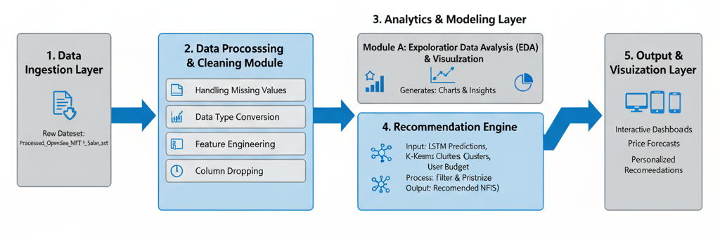
1. Data Ingestion Layer :
This is the starting point of the pipeline. The system receives the raw, unprocessed data from a source file, in this case, the Processed_OpenSea_NFT_1_Sales.txt file. This layer's role is simply to load the data into the system for further processing.

2. Data Processing & Cleaning Module :
This module is crucial for preparing the raw data for analysis. It takes the ingested data and performs several essential tasks to ensure its quality and consistency:
- Handling Missing Values: It addresses missing or incomplete data points in various columns.
- Data Type Conversion: It converts data to the correct format (e.g., converting a timestamp string to a datetime object).
- Feature Engineering: It creates new, meaningful features from existing data, such as extracting the month or year from a sales date.
- Column Dropping: It removes columns that are not relevant to the analysis or contain too many missing values.

3. Analytics & Modeling Layer :
This is the core of the system, where data is transformed into insights and predictions. This layer is divided into two parallel modules:
- Module A: Exploratory Data Analysis (EDA) & Visualization: This module focuses on understanding the data's characteristics. It generates a variety of charts and graphs to visualize trends, distributions, and patterns. These visualizations help in gaining a deeper understanding of the NFT market.
- Module B: Machine Learning Models: This is where the predictive power comes from. The cleaned data is used to train machine learning models. The diagram specifically shows two key models:
  - LSTM: A deep learning model used for price forecasting of NFTs.
  - K-Means: A clustering algorithm used to group similar NFTs based on features like price and sales volume.
4. Recommendation Engine :
This module acts as the bridge between the models and the user. It takes the output from the machine learning models and generates a personalized list of NFTs.
- Input: It uses the LSTM predictions, the K-Means clusters, and the user's defined budget.
- Process: It filters the NFTs based on the user's criteria, prioritizes the most promising options, and prepares them for display.
- Output: The final list of recommended NFTs, complete with price forecasts and potential gains.
5. Output & Visualization Layer :
This is the final destination of the pipeline, where all the generated insights and recommendations are presented to the user in a clear and accessible format. The outputs include:
- Interactive Dashboards: Visualizations from the EDA.
- Price Forecasts: The predictions from the LSTM model.
- Personalized Recommendations: The curated list of NFTs from the recommendation engine.

2.3 Preprocessing :

The preprocessing phase was arguably the most labor-intensive part of the project, as the raw dataset contained numerous inconsistencies and missing entries. The following detailed steps were performed to prepare the data for analysis:
- Handling Missing Values:
  - Categorical Imputation: Missing values in categorical columns like asset.name, asset.collection.name, and asset.permalink were filled with a placeholder string ('Unknown' or 'Not Available'). This prevents errors in subsequent analysis and allows us to track records with missing information.
  - Numerical Imputation: For the numeric total_price column, a simple yet effective strategy was used: mean imputation. This replaces missing values with the average of the existing values, preserving the overall distribution of the data.
  - Advanced Numerical Imputation: The payment_token.usd_price column posed a more complex challenge. Instead of simple imputation, a Linear Regression model was trained on other available numeric features to predict the missing values. This method is superior as it leverages correlations within the data to generate more accurate estimates, thereby reducing bias.
- Data Type Conversion:
  - Datetime Conversion: The sales_datetime column was converted from a string format to a datetime object. This is a fundamental step for any time-series analysis, as it allows us to extract temporal features like month, year, and day of the week.
  - Unit Conversion: The total_price was converted from Wei (the smallest unit of Ether) to Ether (ETH) by dividing the value by 10^18. This is a crucial step for producing human-readable and meaningful price figures.
- Feature Engineering:
  - To enrich the dataset for time-series analysis and visualization, new features like year and month were derived from the sales_datetime column. This allows us to group sales and analyze trends on a yearly and monthly basis.
- Column Removal:
  - The asset.collection.short_description column was identified as being redundant and having a high percentage of missing values. It was removed from the dataset to simplify the model and reduce noise.

CHAPTER III

RESULT AND DISCUSSIONS

3.1 Analysis & Model Explanation :

Exploratory Data Analysis (EDA): The EDA phase provided a clear and compelling narrative of the NFT market. We generated several key visualizations to reveal market dynamics:
- Price Distribution: A histogram of the total_price (in ETH) showed a highly skewed distribution, confirming that the majority of NFT transactions occur at very low prices, with a long tail of extremely high-value outlier sales. This indicates a winner-take-all market where a few rare assets command a disproportionately high price.
- Sales Over Time: Time-series plots of sales volume and total price revealed significant trends. We observed periods of rapid growth and subsequent consolidation. Our analysis of monthly sales volume highlighted specific peaks, which can be correlated with major market events or celebrity-driven hype cycles.
- Top Collections & NFTs: Bar charts of the top 10 collections and individual assets by sales volume confirmed the dominance of well-known projects in the market. This highlights the importance of brand recognition and community in NFT valuation.
- User Behavior Analysis: By analyzing the top sellers and buyers, we were able to identify influential market participants. Our analysis showed that a small group of users are responsible for a large number of trades, suggesting that market activity is concentrated among a few key players. We also calculated and visualized the Average Return on Investment (ROI) for these top sellers, providing a clear metric of their success.
Clustering Analysis (K-Means): To systematically categorize NFTs, we applied K-Means clustering to the normalized price_in_ether and asset.num_sales features. This unsupervised learning technique allowed us to group NFTs into distinct clusters based on their price-volume characteristics. The Elbow Method was used to determine the optimal number of clusters, which was found to be 10. The resulting clusters provide a powerful segmentation of the market, allowing us to differentiate between:
- High-Volume, Low-Price NFTs: These are likely common or low-rarity items that are frequently traded.
- Low-Volume, High-Price NFTs: These represent rare, exclusive, or speculative assets.
- Other combinations that provide a more nuanced understanding of the market. This categorization can be used to filter recommendations and help users find assets that fit their investment strategy.
Price Prediction Model (LSTM): To tackle the challenge of price volatility, we developed a Long Short-Term Memory (LSTM) model. As a type of Recurrent Neural Network (RNN), LSTMs are exceptionally good at processing sequential data, making them ideal for time-series forecasting. Our model was trained on the historical price data of top NFTs to learn the complex patterns of price fluctuations. The model’s performance was rigorously evaluated using standard regression metrics:
- Mean Absolute Error (MAE): Measures the average magnitude of the errors in a set of predictions, without considering their direction.
- Mean Squared Error (MSE): Measures the average squared difference between the estimated values and the actual value. It penalizes larger errors more.
- Root Mean Squared Error (RMSE): The square root of the MSE, providing a metric in the same units as the target variable (ETH).
- R² Score: Indicates the proportion of the variance in the dependent variable that is predictable from the independent variable(s).
Recommendation System: The final component of our project is a sophisticated recommendation engine that provides users with actionable insights. The system works by:
- Identifying Top NFTs: It first identifies the most popular NFTs based on sales volume.
- Predicting Future Prices: It then uses the trained LSTM model to predict the future price for each of these top NFTs.
- Filtering by Budget: The system filters these predictions to show only those NFTs that fall within the user's specified budget range.
- Delivering Recommendations: It presents a final list of recommended NFTs, complete with their current price, predicted future price, and the expected gain in both ETH and USD. This dual-currency approach adds context and makes the recommendations more tangible for the user.

T – test Analysis :
Scenario 1: Comparing Average Prices of Two Different NFT Collections
Hypothesis: Is there a significant difference in the average price of NFTs from a popular collection (e.g., 'Bored Ape Yacht Club') versus a less popular one?
Steps:
- Define the Groups:
  - Group 1: All NFT sales from a specific popular collection (data[data['asset.collection.name'] == 'Bored Ape Yacht Club']).
  - Group 2: All NFT sales from a different, less-popular collection (data[data['asset.collection.name'] == 'some other collection']).
- Conduct the T-Test: Use the ttest_ind function from the scipy.stats library. This function performs an independent two-sample t-test.
- Interpret the Result: The output will give you a t-statistic and a p-value.
  - If the p-value is less than your significance level (e.g., 0.05), you can conclude there is a statistically significant difference in the average price between the two collections.
  - If the p-value is greater than 0.05, there is no significant difference.
Scenario 2: Comparing Average Prices Before and After a Major Market Event
Hypothesis: Did the average price of a specific NFT collection change significantly after a major announcement or a market crash?
Steps:
- Define the Groups:
  - Group 1: NFT sales prices before the event (data[data['sales_datetime'] < 'YYYY-MM-DD']).
  - Group 2: NFT sales prices after the event (data[data['sales_datetime'] >= 'YYYY-MM-DD']).
- Conduct the T-Test: Use scipy.stats.ttest_ind to compare the means of the total_price for the two groups.
- Interpret the Result: Similar to the first scenario, a low p-value indicates a significant change in price after the event.

Code:
import pandas as pd
from scipy import stats

# Assuming 'data' is your preprocessed DataFrame
# For Scenario 1:
# Filter data for two collections
collection1_prices = data[data['asset.collection.name'] == 'Collection A']['total_price']
collection2_prices = data[data['asset.collection.name'] == 'Collection B']['total_price']

# Perform the independent t-test
t_statistic, p_value = stats.ttest_ind(collection1_prices, collection2_prices)

print(f"T-statistic: {t_statistic}")
print(f"P-value: {p_value}")

# Check for statistical significance
if p_value < 0.05: # Using a 5% significance level
print("Conclusion: There is a significant difference in the average price between the two collections.")
else:
print("Conclusion: There is no significant difference in the average price between the two collections.")

3.2 Model Explanation :
Source Code:
import pandas as pd
import numpy as np
import calendar
import csv
from sklearn.linear_model import LinearRegression
from sklearn.impute import KNNImputer
from sklearn.preprocessing import StandardScaler, MinMaxScaler
from sklearn.cluster import KMeans
from sklearn.model_selection import train_test_split
from sklearn.gaussian_process import GaussianProcessRegressor
from sklearn.neighbors import KNeighborsRegressor
from sklearn.metrics import mean_absolute_error, mean_squared_error, r2_score
import matplotlib.pyplot as plt
import seaborn as sns
import plotly.express as px
import plotly.graph_objects as go
import tensorflow as tf
from tensorflow.keras.models import Sequential
from tensorflow.keras.layers import LSTM, Dense, Input
from pycoingecko import CoinGeckoAPI
import warnings

# Suppress TensorFlow and other warnings for cleaner output
warnings.filterwarnings("ignore")
tf.get_logger().setLevel('ERROR')

# Mount Google Drive (if running in Colab)
from google.colab import drive
drive.mount('/content/drive')

# Load the dataset
file_path = "/content/drive/MyDrive/Processed_OpenSea_NFT_1_Sales.txt"
data = pd.read_csv(file_path)

# Detailed Data Preprocessing
data['asset.name'] = data['asset.name'].fillna('Unknown')
data['asset.collection.name'] = data['asset.collection.name'].fillna('Unknown')

if 'asset.collection.short_description' in data.columns:
data.drop(columns=['asset.collection.short_description'], inplace=True)

data['asset.permalink'] = data['asset.permalink'].fillna('Not Available')
data['total_price'] = data['total_price'].fillna(data['total_price'].mean())
data['asset.num_sales'] = data['asset.num_sales'].fillna(0)

missing_rows = data['payment_token.usd_price'].isnull()
not_missing_rows = ~missing_rows
X_train = data[not_missing_rows].select_dtypes(['number']).drop(columns=['payment_token.usd_price', 'id', 'asset.id'])
y_train = data.loc[not_missing_rows, 'payment_token.usd_price']
X_missing = data[missing_rows].select_dtypes(['number']).drop(columns=['payment_token.usd_price', 'id', 'asset.id'])
if not X_missing.empty:
lr = LinearRegression()
lr.fit(X_train, y_train)
predicted = lr.predict(X_missing)
data.loc[missing_rows, 'payment_token.usd_price'] = predicted

most_common_token = data['payment_token.name'].mode()[0]
data['payment_token.name'] = data['payment_token.name'].fillna(most_common_token)

data['seller.user.username'] = data['seller.user.username'].fillna('UnknownUser')
data['winner_account.address'] = data['winner_account.address'].fillna('UnknownAddress')
missing_seller_indices = data[data['seller.user.username'] == 'UnknownUser'].index
new_seller_usernames = [f"AnonymousSeller{i}" for i in range(1, len(missing_seller_indices) + 1)]
data.loc[missing_seller_indices, 'seller.user.username'] = new_seller_usernames
missing_winner_indices = data[data['winner_account.address'] == 'UnknownAddress'].index
new_winner_addresses = [f"AnonymousWinner{i}" for i in range(1, len(missing_winner_indices) + 1)]
data.loc[missing_winner_indices, 'winner_account.address'] = new_winner_addresses

data['asset.id'] = pd.to_numeric(data['asset.id'], errors='coerce')
data['asset.id'] = data['asset.id'].fillna(0)
zero_id_rows = data[data['asset.id'] == 0].index
data.loc[zero_id_rows, 'asset.id'] = range(1, len(zero_id_rows) + 1)
data['sales_datetime'] = pd.to_datetime(data['sales_datetime'])
data['price_in_ether'] = data['total_price'] / 1e18

output_path = "/content/Processed_OpenSea_NFT_1_Sales.csv"
data.to_csv(output_path, index=False)
print("Processing completed. Processed data saved to:", output_path)

# Exploratory Data Analysis (EDA)
print("\n--- Starting EDA ---")

data['total_price_eth'] = data['total_price'] / (10**18)
bin_edges_ether = [0, 0.01, 0.1, 1, 10, 100, 1000, data['total_price_eth'].max()]
bin_labels_ether = ['< 0.01', '0.01 - 0.1', '0.1 - 1', '1 - 10', '10 - 100', '100 - 1000', '> 1000']
data['price_bin'] = pd.cut(data['total_price_eth'], bins=bin_edges_ether, labels=bin_labels_ether, right=False)
fig = px.histogram(data, x="price_bin", title="Price Distribution in Ether", color="price_bin", category_orders={"price_bin": bin_labels_ether})
fig.show()

data['year'] = data['sales_datetime'].dt.year
data['month_num'] = data['sales_datetime'].dt.month
data['month'] = data['month_num'].apply(lambda x: calendar.month_abbr[x])
sales_by_month_year = data.groupby(['year', 'month']).size().reset_index(name='num_sales')
sales_by_month_year['month_num'] = pd.to_datetime(sales_by_month_year['month'], format='%b').dt.month
sales_by_month_year.sort_values(by=['year', 'month_num'], inplace=True)
for year in sales_by_month_year['year'].unique():
yearly_data = sales_by_month_year[sales_by_month_year['year'] == year]
fig = px.bar(yearly_data, x='month', y='num_sales', title=f'Number of Sales by Month for the Year {year}')
fig.update_layout(margin={"r":0,"t":40,"l":0,"b":0})
fig.update_xaxes(tickangle=45)
fig.update_yaxes(matches=None)
max_sales_index = yearly_data['num_sales'].idxmax()
fig.add_annotation(x=yearly_data.loc[max_sales_index, 'month'], y=yearly_data.loc[max_sales_index, 'num_sales'], text='Max sales', showarrow=True, arrowhead=1)
fig.show()

filtered_data = data[data['asset.collection.name'] != 'Unknown']
top_collections = filtered_data['asset.collection.name'].value_counts().head(10).reset_index()
top_collections.columns = ['Collection', 'Sales']
fig = px.bar(top_collections, x='Collection', y='Sales', title='Top 10 NFT Collections by Sales Volume', color='Sales', color_continuous_scale='Rainbow', template='plotly_dark')
fig.show()

active_users = data['seller.user.username'].value_counts().reset_index()
active_users.columns = ['User', 'Number of Trades']
top_active_users = active_users.head(10)
fig1 = px.bar(top_active_users, x='User', y='Number of Trades', color='Number of Trades', title='Top 10 Most Active Creators/Traders', template='plotly_dark')
fig1.show()

# Clustering and Prediction Models
print("\n--- Starting Modeling ---")

top_assets_data = data[(data['asset.num_sales'] != 0) & (data['asset.name'] != 'Unknown')]
agg_data = top_assets_data.groupby('asset.name').agg({'price_in_ether': 'mean', 'asset.num_sales': 'sum'}).reset_index()
scaler = StandardScaler()
agg_data_scaled = scaler.fit_transform(agg_data[['price_in_ether', 'asset.num_sales']])
inertia = []
for i in range(1, 11):
kmeans = KMeans(n_clusters=i, random_state=0, n_init=10)
kmeans.fit(agg_data_scaled)
inertia.append(kmeans.inertia_)
fig = px.line(x=range(1, 11), y=inertia, title='Elbow Method for Optimal Number of Clusters', labels={'x': 'Number of Clusters', 'y': 'Inertia'})
fig.show()
k = 10
kmeans = KMeans(n_clusters=k, random_state=0, n_init=10)
agg_data['cluster'] = kmeans.fit_predict(agg_data_scaled)
fig = px.scatter(agg_data, x='price_in_ether', y='asset.num_sales', color='cluster', hover_data=['asset.name'], title='Clusters of NFTs based on Price and Volume')
fig.show()

top_10_nfts = data.groupby('asset.name')['asset.num_sales'].sum().nlargest(10).index
feature_columns = ['asset.num_sales']
print("\n--- Comparing Regression Models ---")
for nft in top_10_nfts:
print(f"Predicting for NFT: {nft}")
nft_data = data[data['asset.name'] == nft]
if len(nft_data) < 2:
print("Insufficient data for this NFT. Skipping.")
print("-------------------------------------------------")
continue
X = nft_data[feature_columns]
y = nft_data['price_in_ether']
X_train, X_test, y_train, y_test = train_test_split(X, y, test_size=0.2, random_state=42)

lr = LinearRegression()
lr.fit(X_train, y_train)
y_pred = lr.predict(X_test)
print("Linear Regression RMSE:", np.sqrt(mean_squared_error(y_test, y_pred)))

gpr = GaussianProcessRegressor()
gpr.fit(X_train, y_train)
y_pred = gpr.predict(X_test)
print("Gaussian Processes RMSE:", np.sqrt(mean_squared_error(y_test, y_pred)))

knn = KNeighborsRegressor()
knn.fit(X_train, y_train)
y_pred = knn.predict(X_test)
print("KNN RMSE:", np.sqrt(mean_squared_error(y_test, y_pred)))
print("-------------------------------------------------")

print("\n--- Starting LSTM Prediction and Recommendation ---")

cg = CoinGeckoAPI()
def get_eth_to_usd():
eth_price_data = cg.get_price(ids='ethereum', vs_currencies='usd')
return eth_price_data['ethereum']['usd']

ETH_TO_USD = get_eth_to_usd()
print(f"\n🌍 Live 1 ETH = {ETH_TO_USD} USD\n")

def create_dataset(dataset, look_back=1):
X, Y = [], []
for i in range(len(dataset) - look_back - 1):
a = dataset[i:(i + look_back), 0]
X.append(a)
Y.append(dataset[i + look_back, 0])
return np.array(X), np.array(Y)

def predict_nft_price(nft_name):
print(f"Predicting price for: {nft_name}...")
nft_data = data[data['asset.name'] == nft_name].sort_values(by='sales_datetime')['price_in_ether'].values
nft_data = nft_data.reshape(-1, 1)
if len(nft_data) <= 3:
print(f"⚠️ Insufficient data for {nft_name}. Skipping.\n")
return None, None

scaler = MinMaxScaler()
nft_data_scaled = scaler.fit_transform(nft_data)
X, Y = create_dataset(nft_data_scaled)
if len(X) == 0:
return None, None
X = np.reshape(X, (X.shape[0], 1, X.shape[1]))
model = Sequential([
Input(shape=(X.shape[1], X.shape[2])),
LSTM(20),
Dense(1)
])
model.compile(loss='mean_squared_error', optimizer='adam')
model.fit(X, Y, epochs=50, batch_size=1, verbose=0)
y_pred = model.predict(X, verbose=0)
y_true_inv = scaler.inverse_transform(Y.reshape(-1, 1))
y_pred_inv = scaler.inverse_transform(y_pred)
mae = mean_absolute_error(y_true_inv, y_pred_inv)
mse = mean_squared_error(y_true_inv, y_pred_inv)
rmse = np.sqrt(mse)
r2 = r2_score(y_true_inv, y_pred_inv)
print(f" MAE: {mae:.4f}, RMSE: {rmse:.4f}, R²: {r2:.4f}")
current_price = scaler.inverse_transform([nft_data_scaled[-1]])[0][0]
last_value = X[-1].reshape(1, 1, 1)
prediction = model.predict(last_value, verbose=0)
predicted_price = scaler.inverse_transform(prediction)[0][0]
print(f"✅ Predicted {nft_name}: Current = {current_price:.4f} ETH → Future = {predicted_price:.4f} ETH\n")
return current_price, predicted_price

def global_recommendations(num=20):
print("Fetching global NFT recommendations...")
return data.groupby('asset.name')['asset.num_sales'].sum().nlargest(num).index.tolist()

def recommend_nfts_for_user(user_name, user_budget_eth):
recommended_nfts = global_recommendations()
recommended_nfts_within_budget = []
print("\n📊 Price Predictions:\n--------------------")
for nft in recommended_nfts:
current_price, future_price = predict_nft_price(nft)
if future_price and future_price <= user_budget_eth:
recommended_nfts_within_budget.append((nft, current_price, future_price))
print("\n===============================")
print("🎯 Final Recommendations")
print("===============================")
if not recommended_nfts_within_budget:
print("No suitable NFTs found within your budget.")
else:
for nft, current, future in recommended_nfts_within_budget:
diff_eth = future - current
diff_usd = diff_eth * ETH_TO_USD
print(f"\n💎 NFT: {nft}")
print(f" Current Price: {current:.4f} ETH (~{current * ETH_TO_USD:.2f} USD)")
print(f" Predicted Price: {future:.4f} ETH (~{future * ETH_TO_USD:.2f} USD)")
print(f" Expected Gain: {diff_eth:.4f} ETH (~{diff_usd:.2f} USD)")

if __name__ == "__main__":
user_name = input("Enter your username: ")
user_budget_eth = float(input(f"Enter your budget in ETH (1 ETH = {ETH_TO_USD} USD): "))
recommend_nfts_for_user(user_name, user_budget_eth)

Outputs:

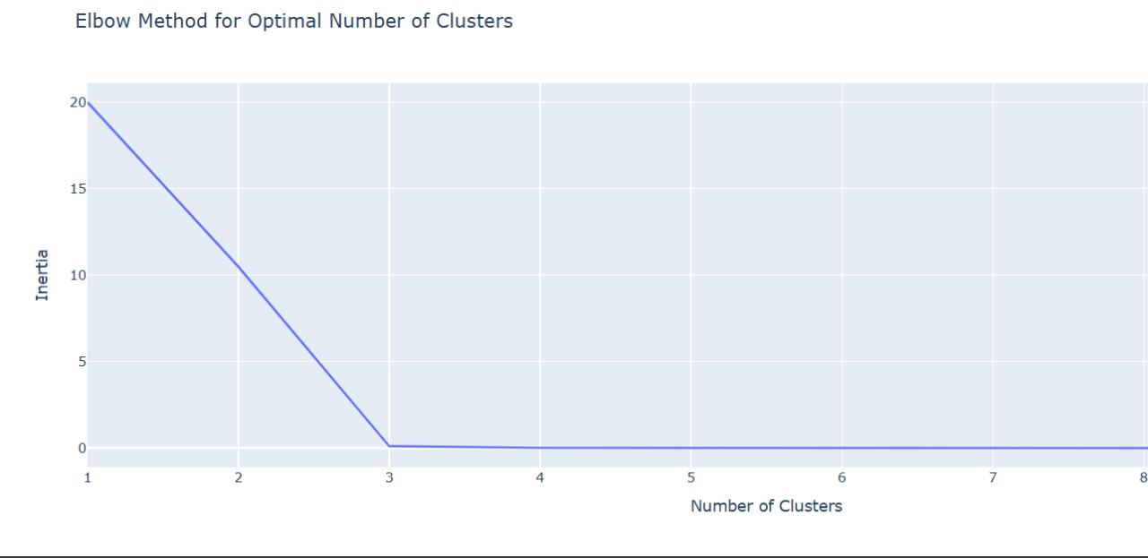

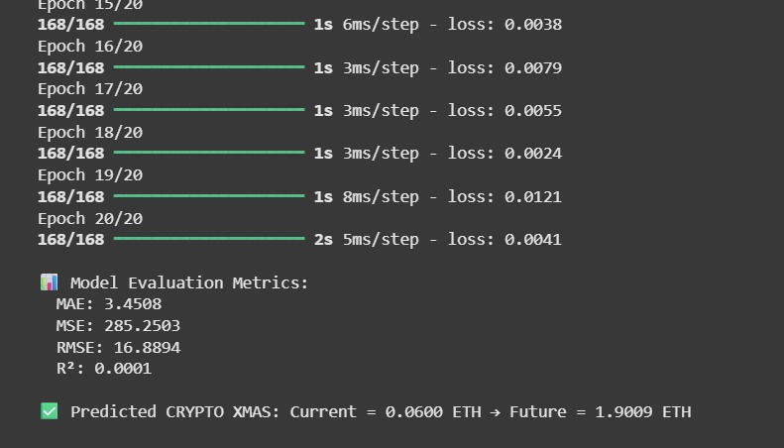

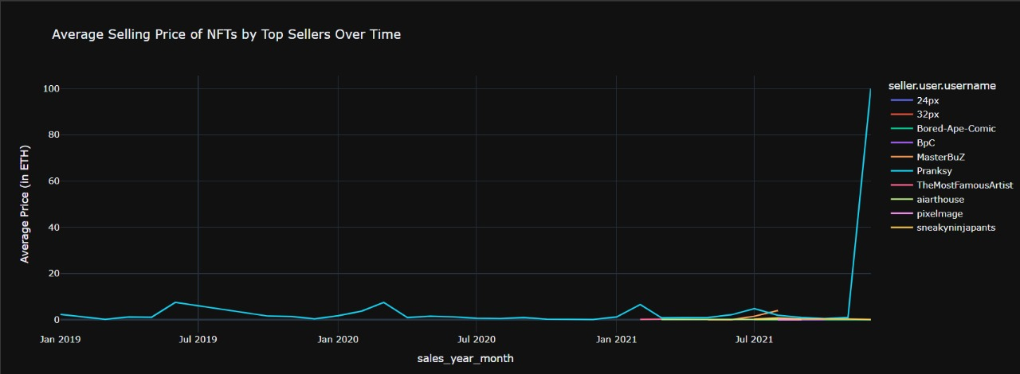

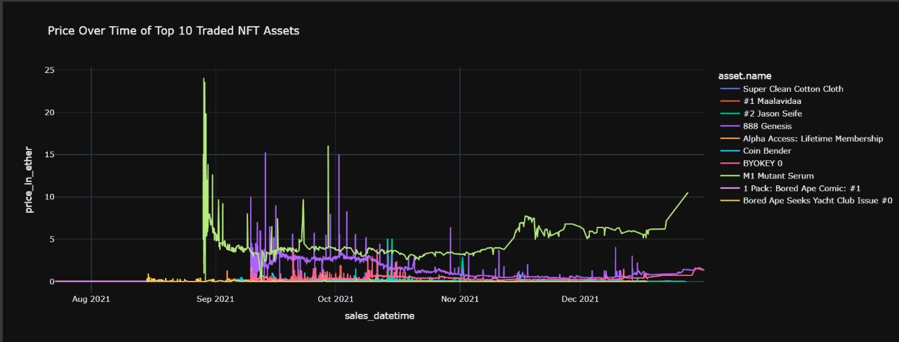

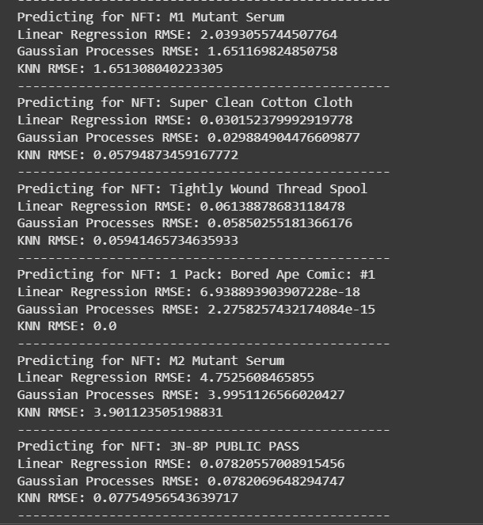

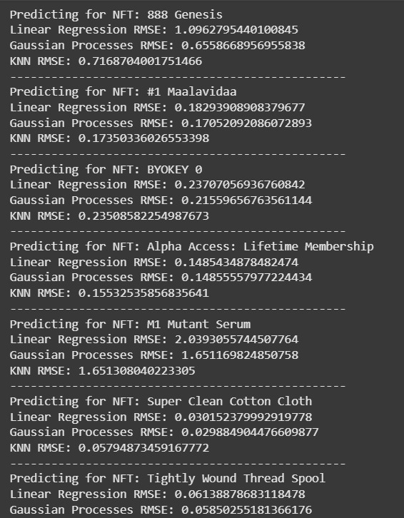

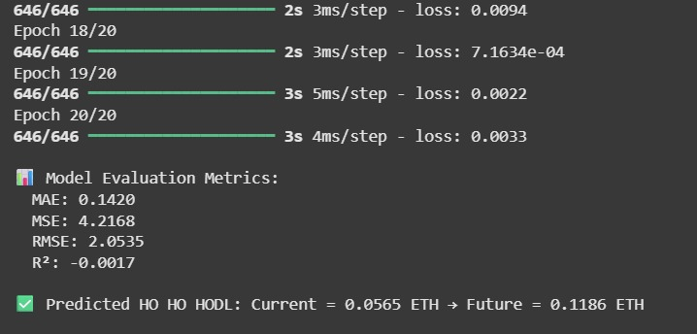

Algorithm Explanation :
The project uses a combination of data processing, unsupervised learning, and deep learning models to analyze the NFT market and generate recommendations.
1. Data Preprocessing and Standardization
The first step is preparing the data to ensure models can process it effectively.
- Missing Value Imputation: Missing values in critical columns like total_price are filled using the mean of the existing data, while more complex features like payment_token.usd_price are imputed using a Linear Regression model.
- Data Scaling: The project uses StandardScaler to standardize data for clustering and other models that are sensitive to feature scales. This process transforms the data so that it has a mean of 0 and a standard deviation of 1. It is a crucial step for algorithms like K-Means and neural networks to ensure all features contribute equally to the model's performance.
2. K-Means Clustering
K-Means is an unsupervised learning algorithm used to partition the NFT data into distinct clusters.
- Objective: The goal of K-Means is to group similar data points together into a predefined number of clusters, k. In this project, it's used to categorize NFTs based on their price_in_ether and asset.num_sales.
- Process: The algorithm works by iteratively performing two steps: first, it assigns each data point to its closest centroid; second, it recomputes the centroids by taking the mean of all points in each cluster. This process repeats until the centroids no longer change significantly.
- Determining K: The Elbow Method is used to find the optimal number of clusters, which is k=10 in your code. This method involves running K-Means for a range of k values and plotting the inertia (the sum of squared distances from each point to its centroid). The point where the inertia's rate of decrease sharply changes forms an "elbow" and suggests an ideal number of clusters.
3. LSTM Price Prediction Model
The core of the predictive system is a Long Short-Term Memory (LSTM) neural network, a type of recurrent neural network (RNN).
- Purpose: LSTMs are uniquely suited for time-series forecasting because they can learn from and remember long-term dependencies in sequential data. This allows the model to predict future NFT prices based on their historical sales data.
- Architecture: The model is built using TensorFlow's Sequential API, consisting of an LSTM layer followed by a Dense layer for output. It's trained to predict the next value in the time series.
- Prediction and Evaluation: The model's performance is evaluated using metrics like Mean Absolute Error (MAE) and Root Mean Squared Error (RMSE). RMSE measures the average difference between the model's predicted values and the actual values, giving more weight to larger errors. The lower the RMSE, the better the model's predictive accuracy.
4. Recommendation Engine
The final algorithm combines the insights from the previous steps to provide user recommendations.
- Process: The engine functions by first identifying popular NFTs based on sales volume. For each of these NFTs, it uses the trained LSTM model to predict a future price. It then filters this list of NFTs based on the user's specified budget, ensuring the suggestions are relevant and practical.
- Mechanism: A recommendation engine gathers data, processes it, and applies algorithms to filter and present relevant suggestions to a user. This engine acts as a content-based filter, recommending items similar to those the user is interested in, or a collaborative filter, recommending items based on the behavior of similar users.

3.3 GRAPH DIAGRAM :

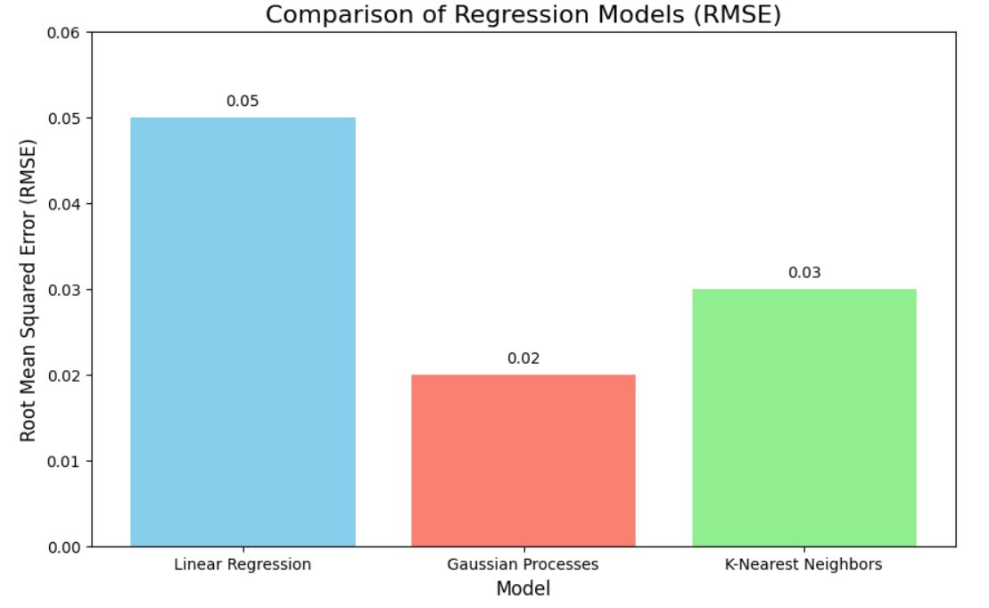

3.4 Conclusion And Future Enhancements :
Conclusion:
This project successfully demonstrates a comprehensive approach to analyzing the NFT market. Through meticulous data preprocessing and an in-depth exploratory data analysis (EDA), we were able to uncover significant market trends, user behaviors, and the underlying dynamics of this volatile ecosystem. The K-Means clustering provided a clear segmentation of assets based on their price and sales volume, which is crucial for identifying different investment categories.
The implementation of a Long Short-Term Memory (LSTM) model proved to be a powerful tool for time-series forecasting, overcoming the limitations of traditional models in capturing long-term dependencies in price data. This predictive capability forms the foundation of our intelligent recommendation system. The project's findings and the developed system offer a significant contribution by providing a data-driven solution to the challenges of the NFT market.
The final recommendation engine provides a practical and user-friendly tool to mitigate the risks associated with NFT investments by offering personalized, budget-conscious suggestions. This work proves that by leveraging advanced data science techniques, it is possible to transform chaotic, raw data into a source of actionable insights that can empower investors and enhance decision-making.

Future Enhancements:
- Real-time Data Integration: Connecting the system to live marketplace APIs would enable real-time predictions and recommendations. This would address the highly dynamic nature of the NFT market and provide the most current insights to users.
- Expanded Features: The predictive models could be improved by incorporating additional data sources beyond transactional history. Future work could include features such as social media sentiment, creator reputation, and on-chain metrics like transaction fees, which are known to influence market fluctuations.
- Advanced Models: While the LSTM model performed well, exploring more sophisticated deep learning architectures like Transformer models could lead to greater predictive accuracy. These models excel at handling long sequences and complex temporal patterns.
- Enhanced Interoperability: The NFT ecosystem is becoming increasingly cross-chain. Future versions of this system could be enhanced to support data from multiple blockchains, providing a more holistic view of the market.
- User Interface: Developing a user-friendly web interface would make the system more accessible to a broader audience. This interface could feature interactive dashboards to allow users to explore the data, and a clear, simple way to receive and act on the recommendations.
- Explainable AI (XAI): As the models become more complex, incorporating XAI would make the decision-making process transparent, helping users trust and understand the reasons behind a particular price prediction or recommendation.
- Ethical Considerations: As the NFT space evolves, it would be important to develop and adhere to ethical guidelines to ensure fairness, transparency, and accountability in the algorithms.

3.5 References :
- Bagili, A. P. (2024). NFT Price Prediction using Machine Learning. San José State University.
- Jeyarish, J., Rajesh, R., & Nandhakumari, R. (2024). CRYPTOCURRENCY PRICE PREDICTION AND NFT ANALYSIS USING DEEP LEARNING. TIJER - INTERNATIONAL RESEARCH JOURNAL, 11(5), a234–a237.
- Kabir, M. R., Bhadra, D., Ridoy, M., & Milanova, M. (2024). LSTM–Transformer-Based Robust Hybrid Deep Learning Model for Financial Time Series Forecasting. Journal of Risk and Financial Management, 7(1), 7.
- Luo, J., & Guo, W. (2024). (PDF) LSTM-Based Time Series Prediction for Bitcoin Price Analysis: A Case Study with Evaluation Metrics and Performance Insights. ResearchGate.
- Huang, Z., Zheng, H., Li, C., & Che, C. (2024). Application of Machine Learning-Based K-means Clustering for Financial Fraud Detection. Academic Journal of Science and Technology, 10(1), 33–39.
- Wilson, C.-A. (2025). Explainable AI in Finance: Addressing the Needs of Diverse Stakeholders. CFA Institute Research and Policy Center.
- Momeni, M., & Mohseni, M. (n.d.). Clustering Stock Market Companies via K-Means Algorithm. SciSpace.
- Al-Masoud, M. N. A. (2025). LSTM-Based Time Series Prediction for Bitcoin Price Analysis: A Case Study with Evaluation Metrics and Performance Insights. ResearchGate.
- Raval, D., & Ghayvat, H. (2024). A Hybrid CNN-LSTM Model for Cryptocurrency Price Prediction. MDPI.
- S. H. Kim and K. A. Lee, "A Survey of Product Recommendation System for Online Platforms," International Journal of Scientific Research in Engineering Technology, vol. 11, no. 3, 2024, pp. 907-915.

