|  |  |
| --- | --- |
| **Exp No: 3**  **Date: 23.2.25** | **HELLO WORLD IN SERVLET** |

**AIM:**

To write a servlet program that prints “Hello World !” when accessed through a browser.

**PROGRAM:**

<%@ page language="java" contentType="text/html; charset=ISO-8859-1"  
    pageEncoding="ISO-8859-1"%>  
<!DOCTYPE html>  
<html>  
<head>  
<meta charset="ISO-8859-1">  
<title>hai</title>  
</head>  
<body>  
<p>Hello World</p>  
</body>  
</html>

**HelloWorld.Java:**

package dom.sachin.servlet;  
  
import java.io.IOException;  
import javax.servlet.ServletException;  
import javax.servlet.annotation.WebServlet;  
import javax.servlet.http.HttpServlet;  
import javax.servlet.http.HttpServletRequest;  
import javax.servlet.http.HttpServletResponse;  
  
/**  
 * Servlet implementation class HelloWorld  
 */  
@WebServlet("/HelloWorld")  
public class HelloWorld extends HttpServlet {  
private static final long serialVersionUID = 1L;  
         
    /**  
     * @see HttpServlet#HttpServlet()  
     */  
    public HelloWorld() {  
        super();  
        // TODO Auto-generated constructor stub  
    }  
  
/**  
* @see HttpServlet#doGet(HttpServletRequest request, HttpServletResponse response)  
*/  
protected void doGet(HttpServletRequest request, HttpServletResponse response) throws ServletException, IOException {  
// TODO Auto-generated method stub  
//response.getWriter().append("Served at: ").append(request.getContextPath());  
PrintWriter p=response.getWriter();  
p.println("HelloWorld");  
}  
  
/**  
* @see HttpServlet#doPost(HttpServletRequest request, HttpServletResponse response)  
*/  
protected void doPost(HttpServletRequest request, HttpServletResponse response) throws ServletException, IOException {  
// TODO Auto-generated method stub  
doGet(request, response);  
}  
  
}

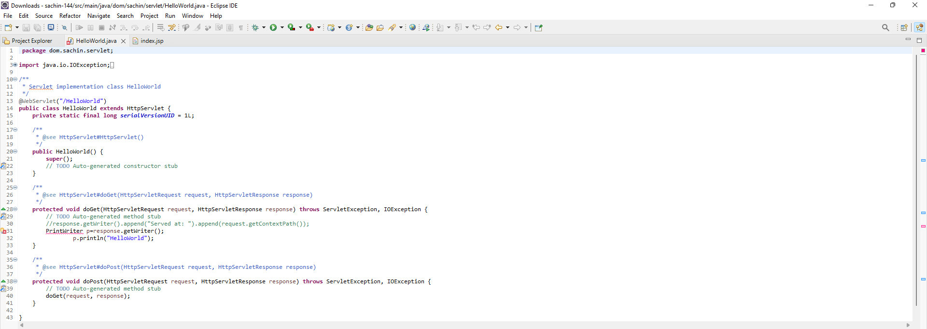

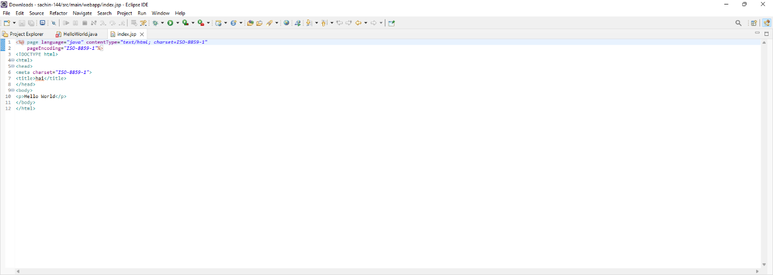

**OUTPUT:**

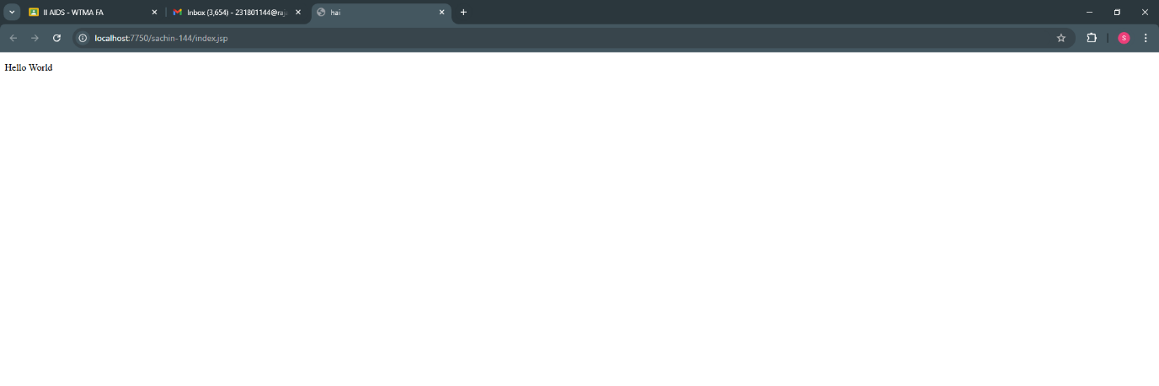

**RESULT :**Thus the experiment to print “Hello world “ using servlet when accessed through a browser has been implemented and verified successfully