PROJECT PROPOSAL
QuickBuy- (Smart Local Shopping & Delivery Application)

EXECUTIVE SUMMARY
In today’s fast-paced lifestyle, consumers need quick access to essential goods from nearby local shops. However, traditional shopping requires visiting multiple stores to check availability, price, and quality, leading to time wastage and inconvenience. At the same time, local shop owners struggle to digitally reach nearby customers and compete with large e-commerce platforms. To overcome these challenges, QuickBuy – Smart Local Shopping & Delivery Application is proposed as a region-based digital solution.
QuickBuy is a full-stack mobile and web application that connects customers with nearby grocery stores and local shops in real time. Users can submit product requests through the app, which are instantly sent to registered shops within the selected region. Shop owners respond with product availability, price, and quality details, enabling users to compare offers based on price, ratings, distance, and quality before placing an order.
The application supports both delivery and self-pickup options, along with real-time notifications for smooth communication. A built-in rating and review system ensures transparency and trust. Technically, QuickBuy follows a modular client-server architecture, divided into four frontend and four backend modules to ensure scalability, security, and maintainability.
Overall, QuickBuy enhances local shopping by reducing time, improving price transparency, and supporting local businesses. The system provides a practical and scalable solution suitable for modern smart-city and local commerce environments.

BACKGROUND AND PROBLEM STATEMENT
2.1 Problem Definition
The current local shopping system is inefficient and time-consuming for both customers and shop owners. Customers must physically visit multiple nearby shops to check product availability, compare prices, and assess quality, which leads to unnecessary travel, increased time consumption, and inconvenience. There is no reliable way for customers to know in advance whether a required product is available at a nearby shop or at what price.
At the same time, local shop owners lack a digital platform to instantly connect with nearby customers. They are unable to respond to real-time customer demands, promote their available stock, or compete effectively with large e-commerce platforms that offer greater visibility and convenience. This gap results in missed sales opportunities for shop owners and reduced customer satisfaction.
Therefore, there is a need for a smart, region-based digital solution that enables real-time communication between customers and local shops, provides price and quality comparison, and supports fast delivery or pickup options. Such a system should reduce shopping time, improve transparency, and strengthen local commerce.

2.2 Proposed Solution
To address the challenges of inefficient local shopping and limited digital reach of local shop owners, QuickBuy – Smart Local Shopping & Delivery Application is proposed as a region-based digital platform. The system enables real-time communication between customers and nearby local shops through a notification-driven model.
In QuickBuy, users can submit a request for required products through the mobile or web application and select the region in which they want to shop. This request is instantly broadcast to all registered shop owners within the selected area. Shop owners who have the requested items can respond with details such as product availability, price, and quality information. The user can then compare multiple offers based on price, ratings, distance, and overall shop reputation before placing an order.
The platform also supports both delivery and self-pickup options, allowing users to choose the most convenient method. Real-time notifications ensure smooth and timely communication, while an integrated rating and review system promotes transparency and trust. By digitizing interactions between customers and local shops, QuickBuy reduces shopping time, improves price transparency, enhances customer satisfaction, and empowers local businesses with greater visibility and competitiveness.

PROJECT OBJECTIVES
3.1 Primary Objectives
Objective 1: Develop Real-Time Local Shopping Communication System
• Design a notification-based system to connect users with nearby local shops
• Broadcast user product requests to shops within the selected region
• Enable shop owners to respond in real time with availability and offers
• Ensure low-latency and reliable communication
Objective 2: Implement Price and Quality Comparison Mechanism
• Allow shop owners to submit price and product details
• Compare multiple shop offers based on price, ratings, and distance
• Display quality indicators using user reviews and ratings
• Support informed decision-making for users
Objective 3: Integrate Order Processing and Delivery Management
• Enable users to place orders directly through the application
• Provide options for home delivery or self-pickup
• Track order status from confirmation to completion
• Manage delivery assignment and status updates
Objective 4: Develop Secure User, Shop Owner, and Admin Management
• Implement secure JWT-based authentication
• Manage user roles (customer, shop owner, admin)
• Store user profiles, shop details, and region data securely
• Ensure data privacy, session management, and access control
Objective 5: Build Rating, Feedback, and Trust System
• Allow users to rate shops and products after purchase
• Calculate overall shop ratings and trust scores
• Display reviews to assist future customers
• Prevent misuse through moderation and validation
3.2 Secondary Objectives
Objective 6: Enhance User Experience and Interface Design
• Design an intuitive and user-friendly interface
• Ensure responsive design for mobile and web platforms
• Provide easy navigation and clear visual feedback
• Improve overall user engagement and accessibility
Objective 7: Implement Region-Based Shop Discovery
• Enable users to select and change shopping regions
• Automatically identify nearby shops using location data
• Filter shops based on distance and availability
• Improve accuracy of local shop reachability
Objective 8: Enable Real-Time Notifications and Alerts
• Send instant notifications for new requests and responses
• Notify users about order status updates
• Alert shop owners of new customer requests
• Ensure reliable and timely message delivery
Objective 9: Develop Analytics and Monitoring System
• Track user activity and order trends
• Analyze shop performance and response rates
• Generate system usage reports
• Support admin decision-making and optimization
Objective 10: Ensure System Scalability and Future Expansion
• Design a modular and scalable system architecture
• Support addition of new regions and shops
• Enable integration with digital payments and wallets
• Prepare system for future feature enhancements

SCOPE OF WORK
4.1 In-Scope Features
User Authentication & Management
✓ User registration and login
✓ JWT-based secure session management
✓ User, shop owner, and admin role management
✓ User profile creation and region selection
✓ Password reset and account security
Shop Owner & Inventory Management
✓ Shop registration and verification
✓ Shop profile and location management
✓ Product availability and pricing management
✓ Order acceptance and status updates
✓ Shop performance tracking
Product Request & Notification System
✓ User product request submission
✓ Region-based request broadcasting
✓ Real-time notifications to shop owners
✓ Instant response handling from shops
✓ Request expiry and management
Price & Quality Comparison
✓ Comparison of multiple shop offers
✓ Price comparison across nearby shops
✓ Display of shop ratings and reviews
✓ Quality evaluation based on user feedback
✓ Distance-based shop sorting
Order Processing & Delivery Management
✓ Order placement through the application
✓ Home delivery and self-pickup options
✓ Real-time order status tracking
✓ Delivery partner assignment
✓ Order completion and confirmation
Rating & Review System
✓ User ratings for shops and products
✓ Review submission after order completion
✓ Overall shop rating calculation
✓ Feedback visibility for other users
✓ Abuse and spam prevention mechanisms
Admin Panel & System Control
✓ Admin dashboard for system monitoring
✓ User and shop management
✓ Complaint and dispute handling
✓ Analytics and usage reports
✓ System configuration and moderation
User Interface
✓ Responsive design (mobile and web)
✓ Simple and intuitive navigation
✓ Real-time feedback and notifications
✓ Clean dashboards and status views
✓ Error handling and loading indicators

PROJECT STRUCTURE AND MODULES
The project is organized into 8 modules across frontend and backend:
5.1 Frontend Modules (4 Modules)
Module 1: User Authentication & Profile Management
• Duration: 1 week
• Components:
• Login and signup pages
• User profile dashboard
• Region selection interface
• Profile edit forms
• Secure session management

Module 2: Product Request & Offer Comparison UI
• Duration: 1.5 weeks
• Components:
• Product request submission form
• Category and item selection interface
• Real-time offer display from shops
• Price, rating, and distance comparison UI
• Offer selection interface

Module 3: Order Placement & Delivery Tracking
• Duration: 1.5 weeks
• Components:
• Order confirmation screen
• Delivery or self-pickup selection
• Real-time order status view
• Delivery tracking interface
• Order history view

Module 4: Rating, Review & Notification Interface
• Duration: 1 week
• Components:
• Push notification UI
• In-app alerts and messages
• Shop and product rating forms
• Review submission interface
• Feedback history view

5.2 Backend Modules (4 Modules)
Module 5: Authentication & User Management Service
• Duration: 1 week
• Components:
• JWT-based authentication
• User, shop owner, and admin role management
• Secure profile and region data storage
• Password reset and account security
• Session validation

Module 6: Shop, Product & Offer Management Service
• Duration: 1.5 weeks
• Components:
• Shop registration and verification
• Product availability and pricing management
• Offer response handling
• Shop inventory control
• Database indexing and optimization

Module 7: Notification, Order & Delivery Processing
• Duration: 1.5 weeks
• Components:
• Real-time request broadcasting
• Notification service integration
• Order lifecycle management
• Delivery partner assignment
• Order status updates

Module 8: Analytics, Ratings & Admin Control
• Duration: 1 week
• Components:
• Rating and review calculations
• Shop performance analytics
• User activity monitoring
• Admin dashboard and controls
• Report generation

TECHNICAL ARCHITECTURE
6.1 Technology Stack
Frontend:
• React.js (UI framework)
• React Router (client-side routing)
• Axios (HTTP client)
• Redux / Context API (state management)
• TailwindCSS (utility-first CSS framework)
• Firebase Cloud Messaging (real-time notifications)
• Responsive UI components
Backend:
• Spring Boot 2.x (application framework)
• Spring Security (authentication and authorization)
• Spring Data MongoDB (database abstraction)
• JWT (JSON Web Tokens)
• Maven (build automation tool)
• Lombok (boilerplate code reduction)
• Validation Framework (input validation)
Database:
• MongoDB (NoSQL document-oriented database)
• Spring Data MongoDB (ORM/ODM layer)
Development & Testing:
• VS Code / IntelliJ IDEA (IDE)
• Postman (API testing)
• Git & GitHub (version control)

6.2 System Architecture
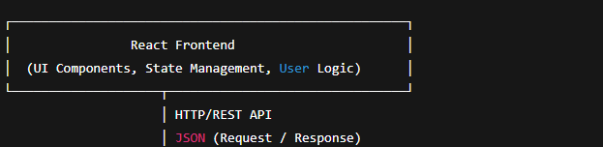
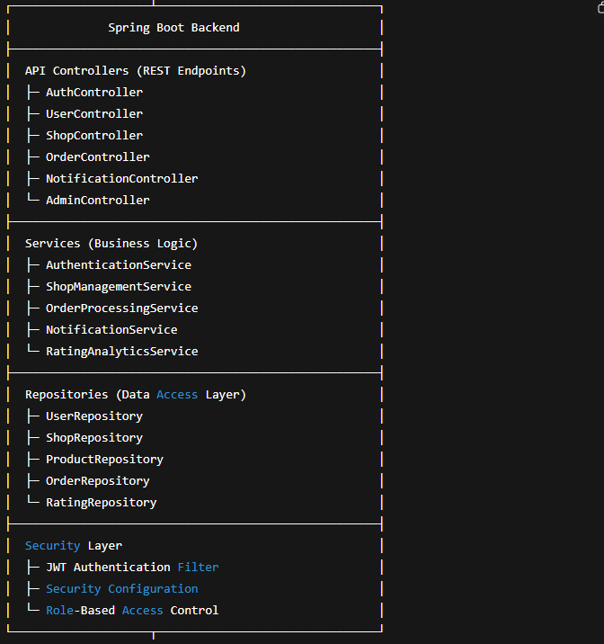
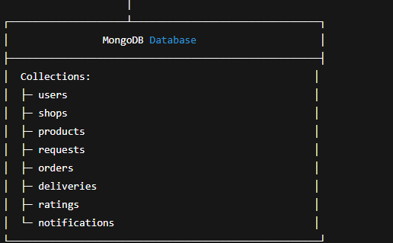
6.3 Key Design Patterns
MVC Pattern:
• Model: MongoDB entities (User, Shop, Product, Order)
• View: React UI components
• Controller: Spring Boot REST controllers
Service Layer Pattern:
• Separation of business logic from controllers
• Reusable and testable services
• Improved maintainability
Repository Pattern:
• Abstraction of database operations
• Consistent data access interface
• Easy scalability and database flexibility
JWT-Based Authentication:
• Stateless authentication mechanism
• Secure role-based access control
• Scalable across distributed systems
REST API Design:
• Resource-oriented endpoints
• Standard HTTP methods (GET, POST, PUT, DELETE)
• JSON-based communication
• Consistent error handling
Component-Based Frontend Architecture:
• Reusable React components
• Unidirectional data flow
• Better testing and UI maintainability

SUCCESS CRITERIA
1. Functional Effectiveness
• All core features such as product requests, shop responses, price comparison, and order placement work correctly
• Real-time notifications are delivered without delay
• Delivery and self-pickup options function as expected
2. User Experience & Usability
• The application provides an intuitive and user-friendly interface
• Navigation is simple and responsive across devices
• Users can complete shopping tasks with minimal steps
3. System Performance & Reliability
• The system handles multiple user and shop requests efficiently
• Response time remains low during peak usage
• Application remains stable without crashes or data loss
4. Security & Data Protection
• User and shop data are securely stored and protected
• JWT-based authentication prevents unauthorized access
• Sensitive information is not exposed or misused
5. Scalability & Maintainability
• The system supports the addition of new users, shops, and regions
• Modular architecture allows easy feature enhancement
• Codebase follows standard development practices
6. Transparency & Trust
• Price and rating information is accurate and clearly displayed
• Review system reflects genuine user feedback
• Trust scores help users make informed decisions
7. Local Business Impact
• Local shops experience improved digital visibility
• Increased customer engagement and order conversions
• Fair competition with large e-commerce platforms
8. Overall System Acceptance
• Positive feedback from users and shop owners
• High adoption rate in selected regions
• The system meets all stated project objectives

CONCLUSION
QuickBuy is a smart, region-based local shopping and delivery application designed to simplify and modernize the traditional local shopping experience. By enabling real-time communication between customers and nearby shops, the system reduces shopping time, improves price transparency, and enhances customer convenience. The integration of delivery and self-pickup options further increases flexibility and user satisfaction.
The project follows a modular and secure technical architecture with clearly defined frontend and backend components, ensuring scalability, maintainability, and data security. Features such as price comparison, real-time notifications, and a rating and review system promote transparency and trust while empowering local shop owners with greater digital visibility.
Overall, QuickBuy provides a practical and scalable solution that supports local businesses, improves user experience, and aligns with modern smart-city and digital commerce requirements. The successful implementation of this system demonstrates its potential to positively impact local commerce ecosystems and serves as a strong foundation for future enhancements and wider adoption.

