|  |
| --- |
| CG System Study – wcm2  2018 |
|  |
| March 8  RF  Authored by: Sachin Shetty |

# Components

# /apps/capital-group/components/content

|  |  |  |  |
| --- | --- | --- | --- |
| Component | Custom | Direct Extension | Custom Extension |
| 1. adchoices | Y |  |  |
| 1. articlelist |  |  | Y |
| 1. breadcrumb |  | Y |  |
| 1. briefcase | Y |  |  |
| 1. card | Y |  |  |
| 1. carousel |  |  | Y |
| 1. carousellist |  |  | Y |
| 1. contact-us | Y |  |  |
| 1. contentfragment |  |  | Y |
| 1. contentfragmentlist | Y |  |  |
| 1. disclosure | Y |  |  |
| 1. dropdown-link | Y |  |  |
| 1. heroimage |  |  | Y |
| 1. highcharts | Y |  |  |
| 1. Iframe | Y |  |  |
| 1. Image |  |  | Y |
| 1. List |  | Y |  |
| 1. rpearticle |  |  | Y |
| 1. rpetable |  |  | Y |
| 1. rpetext |  |  | Y |
| 1. search | Y |  |  |
| 1. sectiontext |  |  | Y |
| 1. sharing |  | Y |  |
| 1. socialshare | Y |  |  |
| 1. table | Y |  |  |
| 1. tabs |  |  | Y |
| 1. teaser |  | Y |  |
| 1. text |  |  | Y |
| 1. title |  | Y |  |

/apps/capital-group/components/form

|  |  |  |  |
| --- | --- | --- | --- |
| Component | Custom | Direct Extension | Custom Extension |
| 30.button |  |  | Y |
| 31.container |  | Y |  |
| 32. FormContainer |  |  | Y |
| 33. hidden |  | Y |  |
| 34.options |  |  | Y |
| 35.text |  | Y |  |

* 1. Dialog
  2. Style options
  3. Desktop view
  4. Mobile view

1. Adchoices
2. Articlelist
   1. Dialog

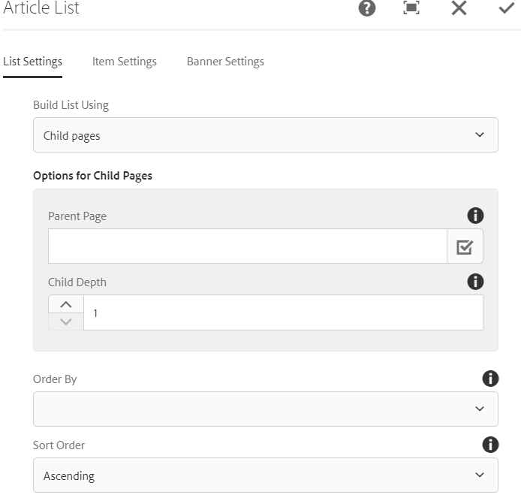 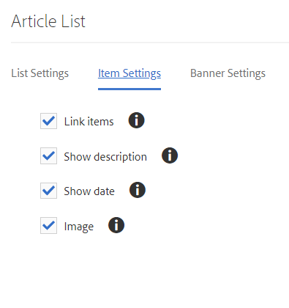

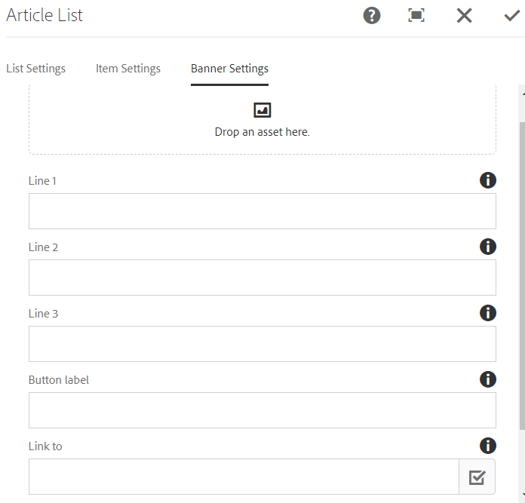

* 1. Style options

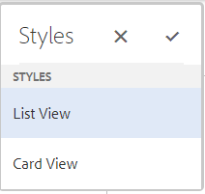

* 1. Desktop view



Displays image (/root/image), title, description and date

* 1. Mobile view



1. Breadcrumb
2. Briefcase
3. Card
   1. Dialog

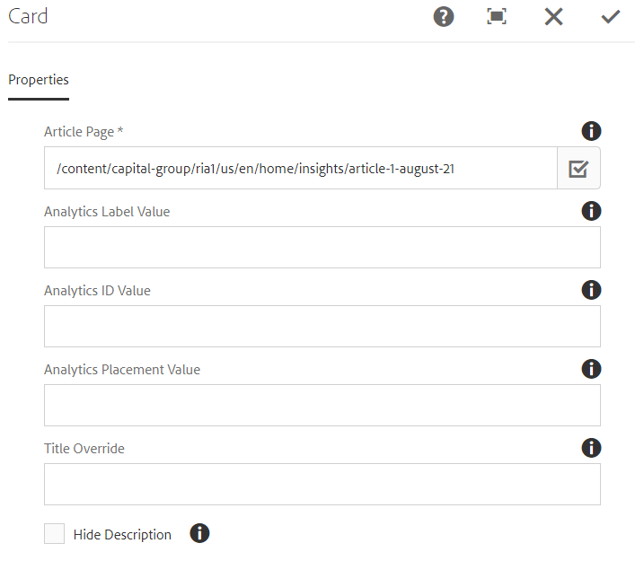

* 1. Style options

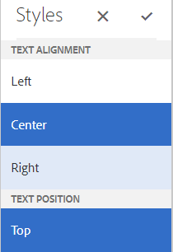 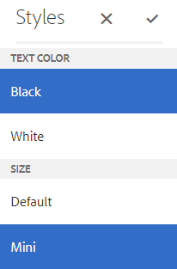

* 1. Desktop view



* 1. Mobile view



Card component displays title, description and image as background from article page path that is authored. In mobile view description is hidden.

1. Carousel
   1. Dialog

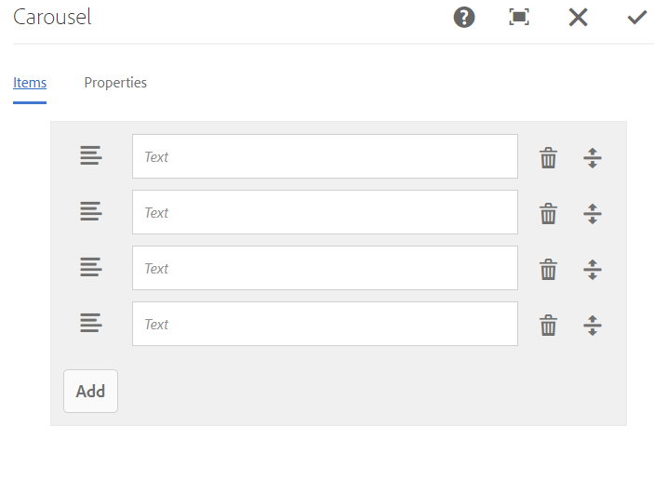 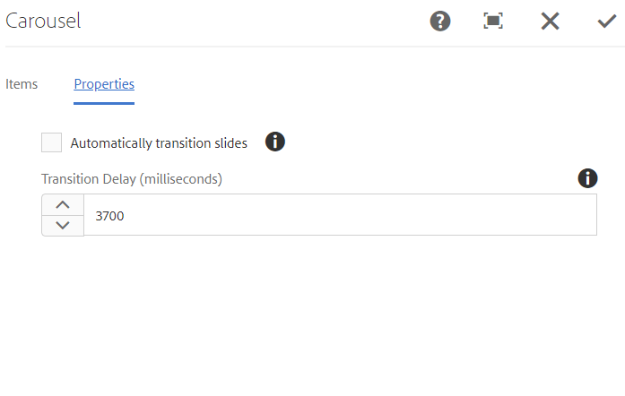

* 1. Style options

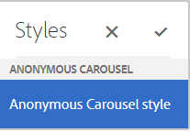

* 1. Desktop view

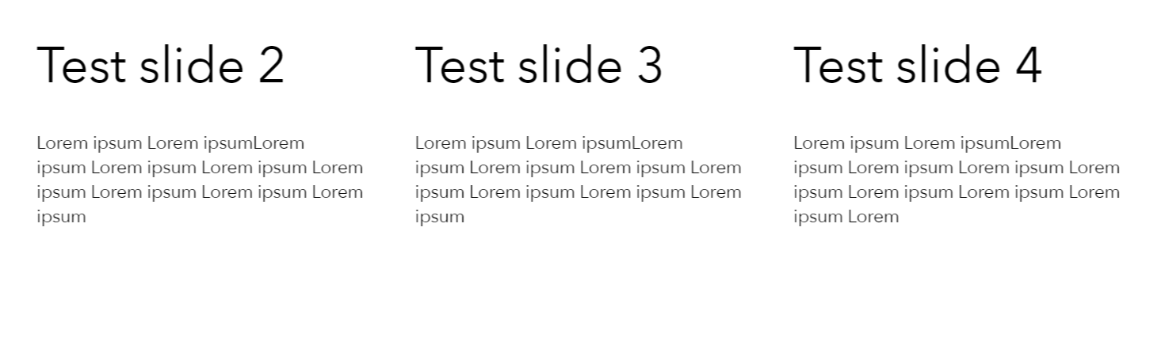

Even in desktop slider is of touch nature.

* 1. Mobile view

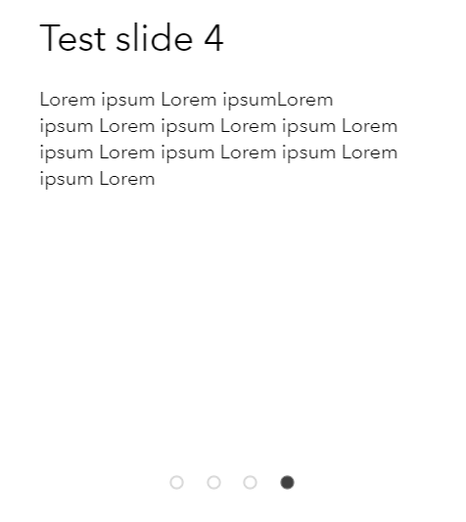

1. Carousellist
   1. Dialog

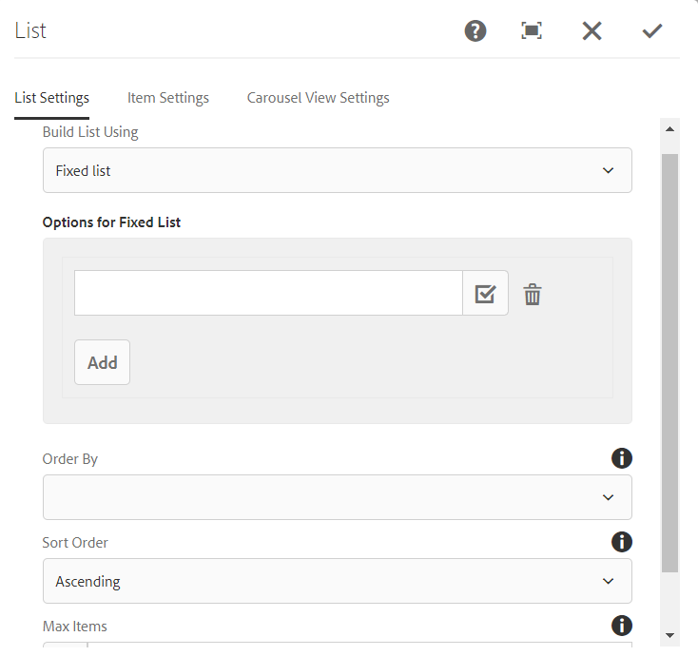 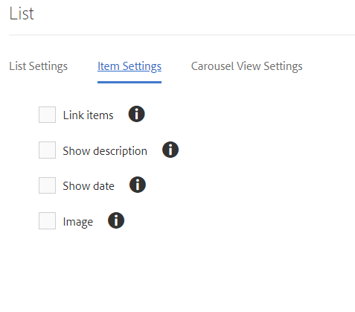

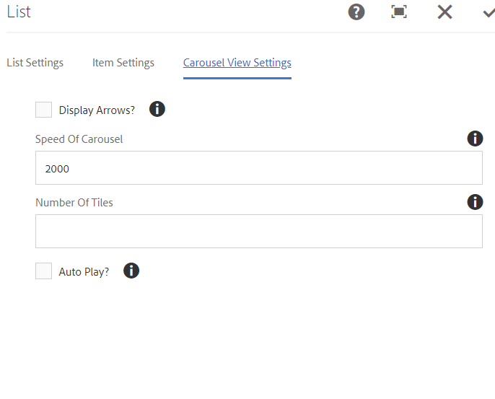

* 1. Style options

Couldn’t find any

* 1. Desktop view



* 1. Mobile view



1. Contactus
2. Contentfragment
3. Contentfragmentlist
4. Disclosure
5. Dropdownlink
6. Heroimage
   1. Dialog

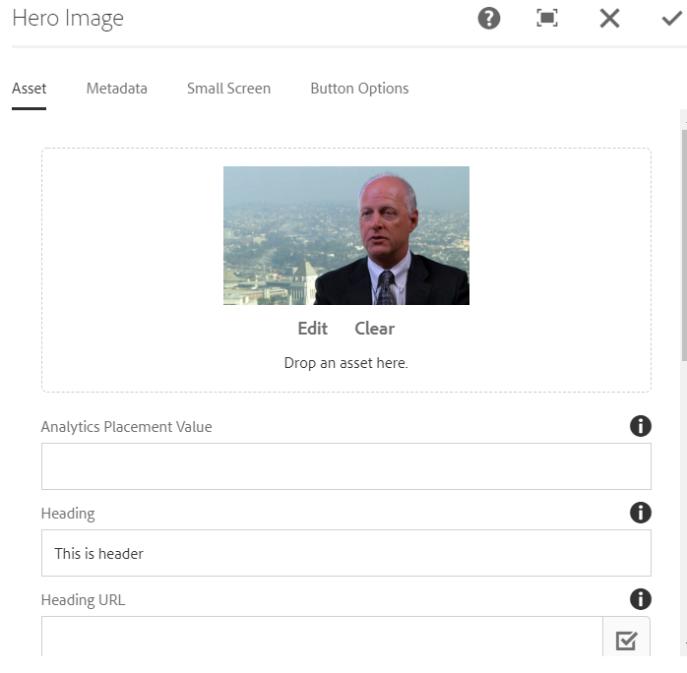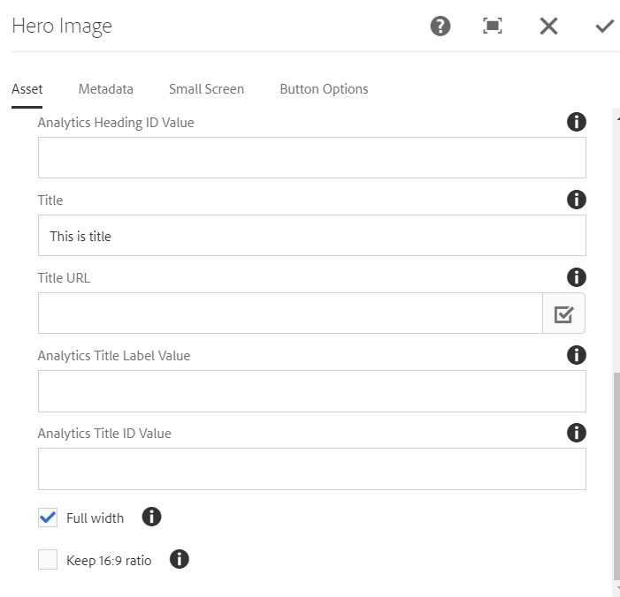

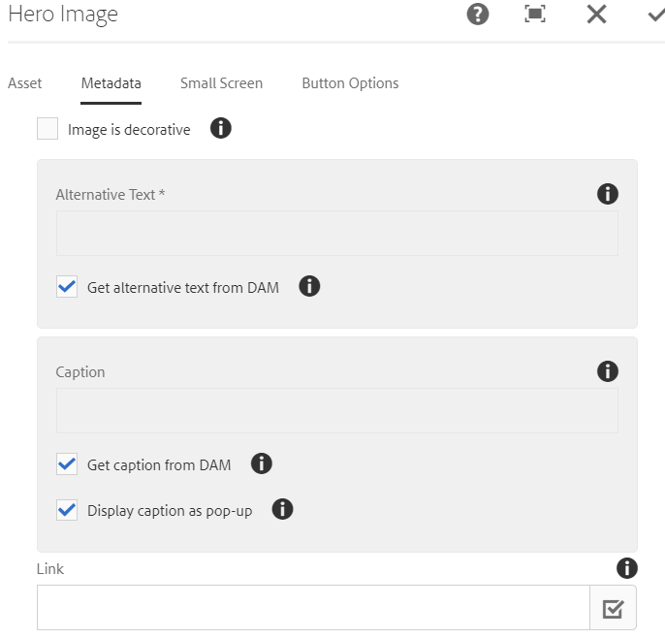 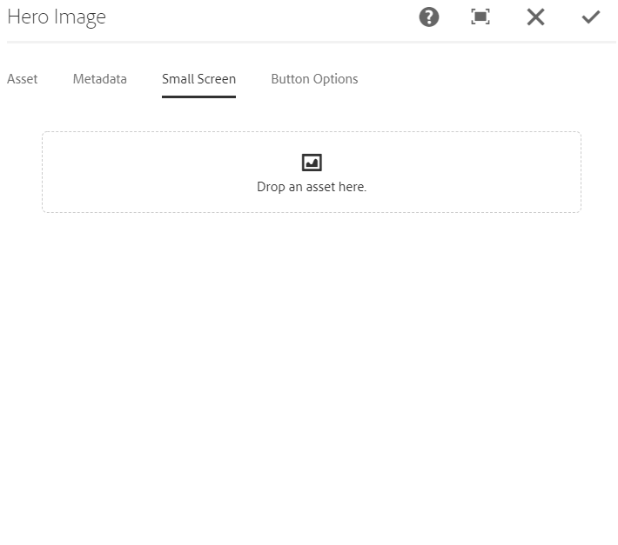

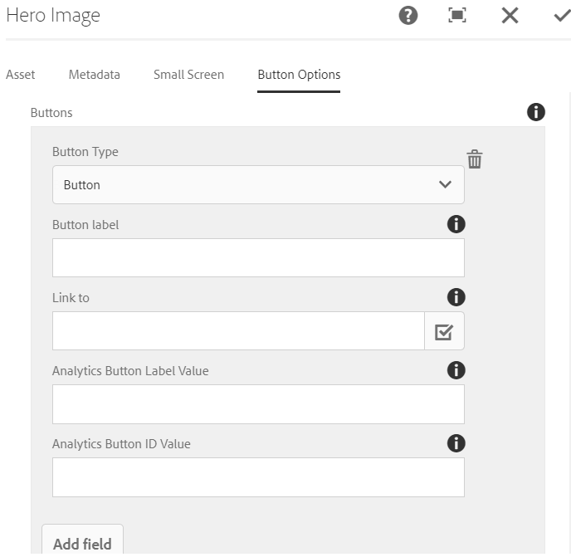

* 1. Desktop view



* 1. Different style options

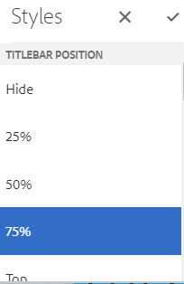 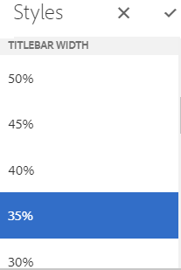 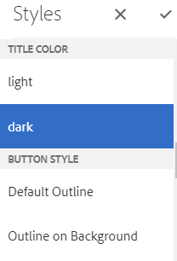

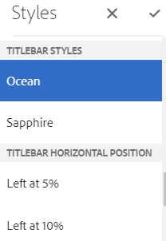 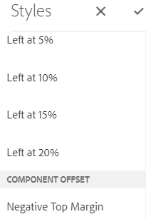

* 1. Mobile view

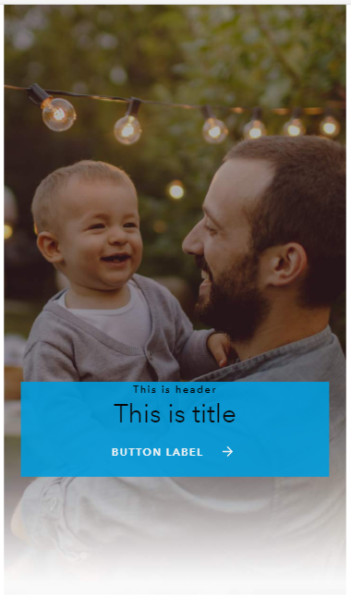

Small screen image would be displayed if authored separately in small screen field.

If width of the image matches the screen width then image is swapped in JS.

1. Iframe
2. Image
3. List
4. Rpearticle
5. Rpetable
6. rpetext
7. search
8. Sectiontext
9. Sharing
10. Socialshare
11. Table

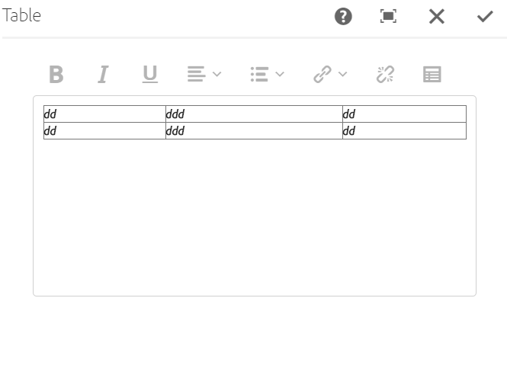

1. Tabs
   1. Dialog

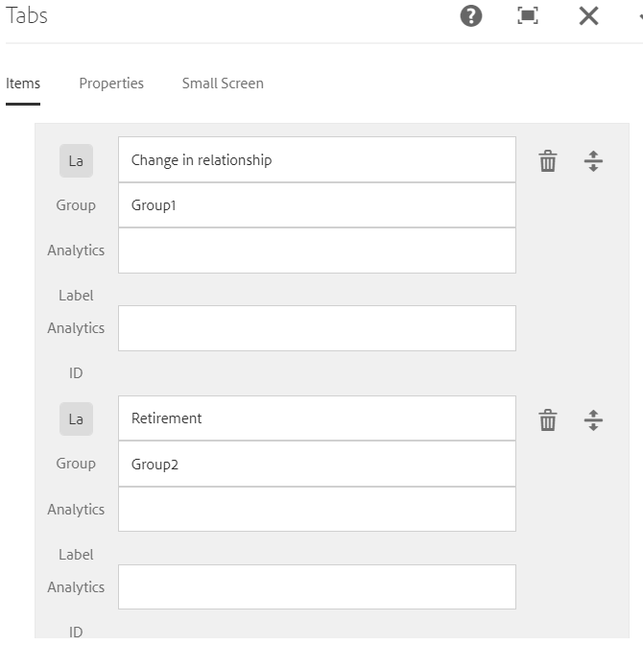 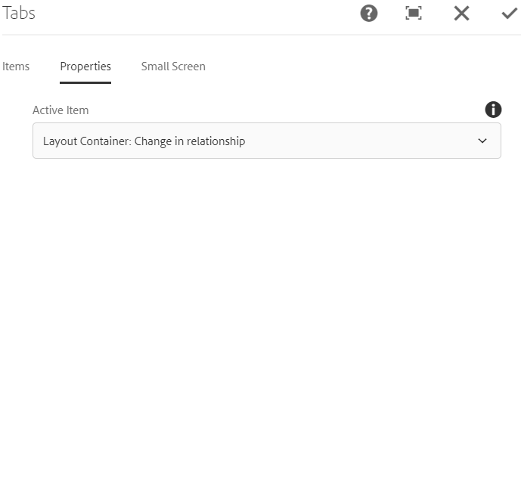

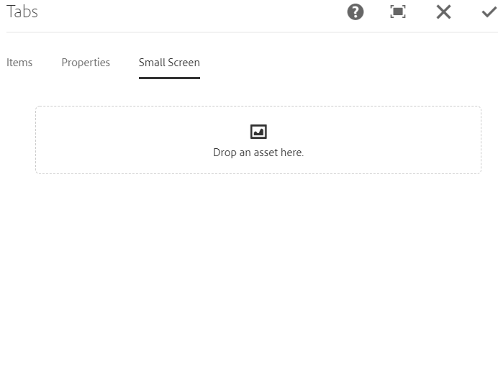

* 1. Style options

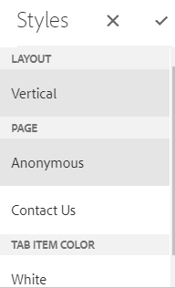

* 1. Desktop view

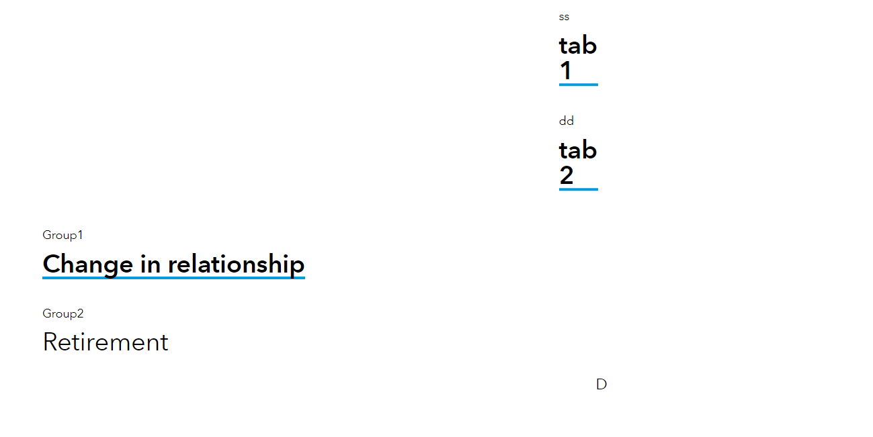

* 1. Mobile view

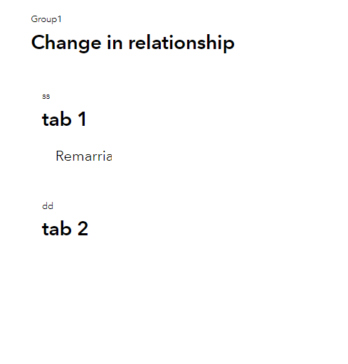

1. Teaser
   1. Dialog

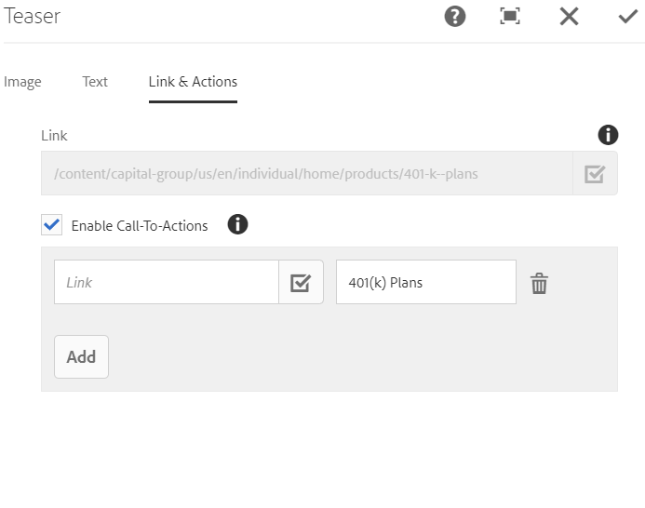 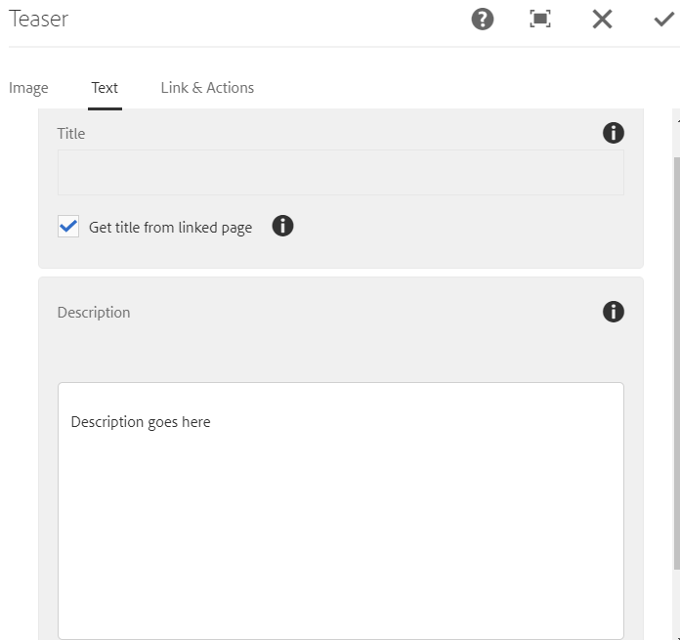

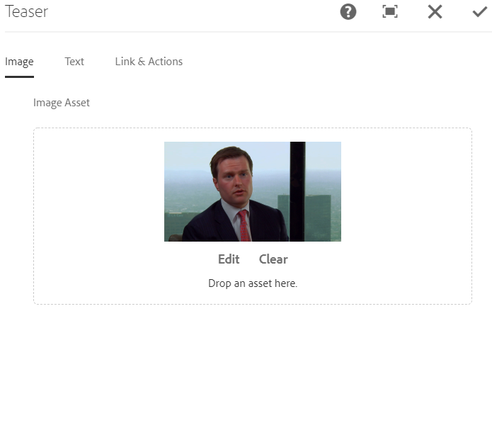

* 1. Style options

No policy or style found

* 1. Desktop view



* 1. Mobile view



1. text
2. title