**REACT JS**

**WEEK 7**

## **Objectives**

* Explain React events
* Explain about event handlers
* Define Synthetic event
* Identify React event naming convention

In this hands-on lab, you will learn how to:

* Implement Event handling concept in React applications
* Use this keyword
* Use synthetic event

## **Prerequisites**

The following is required to complete this hands-on lab:

* Node.js
* NPM
* Visual Studio Code

## **Notes**

Estimated time to complete this lab: **90 minutes.**

Create a React Application “eventexamplesapp” to handle various events of the form elements in HTML.

1. Create “Increment” button to increase the value of the counter and “Decrement” button to decrease the value of the counter. The “Increase” button should invoke multiple methods.
   1. To increment the value
   2. Say Hello followed by a static message.

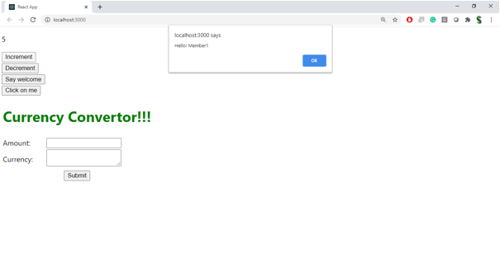

1. Create a button “Say Welcome” which invokes the function which takes “welcome” as an argument.

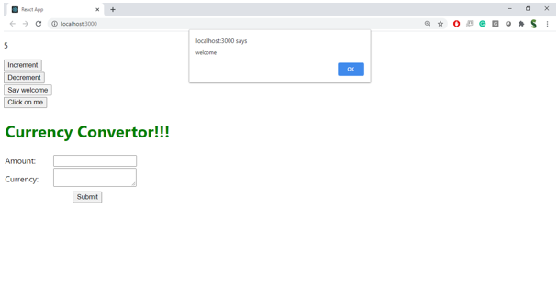

1. Create a button which invokes synthetic event “OnPress” which display “I was clicked”

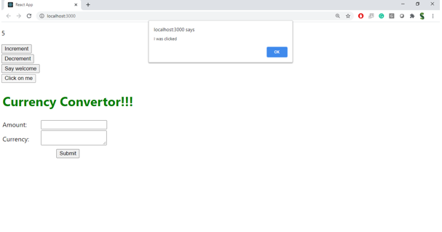

Create a “CurrencyConvertor” component which will convert the Indian Rupees to Euro when the Convert button is clicked.

Handle the Click event of the button to invoke the handleSubmit event and handle the conversion of the euro to rupees.

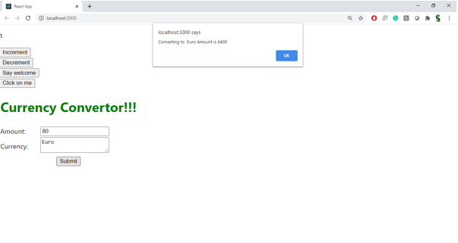

Index.js:

import React from 'react';import ReactDOM from 'react-dom/client';import './index.css';import App from './App';import reportWebVitals from './reportWebVitals';const root = ReactDOM.createRoot(document.getElementById('root'));root.render( <React.StrictMode> <App /> </React.StrictMode>);// If you want to start measuring performance in your app, pass a function// to log results (for example: reportWebVitals(console.log))// or send to an analytics endpoint. Learn more: https://bit.ly/CRA-vitalsreportWebVitals();

Index.css:

body { margin: 0; font-family: -apple-system, BlinkMacSystemFont, 'Segoe UI', 'Roboto', 'Oxygen', 'Ubuntu', 'Cantarell', 'Fira Sans', 'Droid Sans', 'Helvetica Neue', sans-serif; -webkit-font-smoothing: antialiased; -moz-osx-font-smoothing: grayscale;}code { font-family: source-code-pro, Menlo, Monaco, Consolas, 'Courier New', monospace;}App.js

import React from 'react';import './App.css';import Counter from './components/Counter';import Welcome from './components/Welcome';import SyntheticEventButton from './components/SyntheticEventButton';import CurrencyConverter from './components/CurrencyConverter';function App() { return ( <div className="App"> <section> <Counter /> <Welcome /> <SyntheticEventButton /> </section> <section> <CurrencyConverter /> </section> </div> );}export default App;

Report Web Vitals:

const reportWebVitals = onPerfEntry => { if (onPerfEntry && onPerfEntry instanceof Function) { import('web-vitals').then(({ getCLS, getFID, getFCP, getLCP, getTTFB }) => { getCLS(onPerfEntry); getFID(onPerfEntry); getFCP(onPerfEntry); getLCP(onPerfEntry); getTTFB(onPerfEntry); }); }};export default reportWebVitals;

Package.json:

{ "name": "eventexamplesapp", "version": "0.1.0", "private": true, "dependencies": { "@testing-library/dom": "^10.4.0", "@testing-library/jest-dom": "^6.6.3", "@testing-library/react": "^16.3.0", "@testing-library/user-event": "^13.5.0", "react": "^19.1.0", "react-dom": "^19.1.0", "react-scripts": "5.0.1", "web-vitals": "^2.1.4" }, "scripts": { "start": "react-scripts start", "build": "react-scripts build", "test": "react-scripts test", "eject": "react-scripts eject" }, "eslintConfig": { "extends": [ "react-app", "react-app/jest" ] }, "browserslist": { "production": [ ">0.2%", "not dead", "not op_mini all" ], "development": [ "last 1 chrome version", "last 1 firefox version", "last 1 safari version" ] }}

Output:

