REACT JS

WEEK 7

## **Objectives**

* Explain various ways of conditional rendering
* Explain how to render multiple components
* Define list component
* Explain about keys in React applications
* Explain how to extract components with keys
* Explain React Map, map() function

In this hands-on lab, you will learn how to:

* Implement conditional rendering in React applications

## **Prerequisites**

The following is required to complete this hands-on lab:

* Node.js
* NPM
* Visual Studio Code

## **Notes**

Estimated time to complete this lab: **60 minutes.**

Create a React App named “bloggerapp” in with 3 components.

1. Book Details
2. Blog Details
3. Course Details

Implement this with as many ways possible of Conditional Rendering.

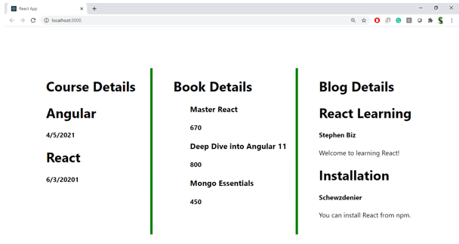

**Hint:**

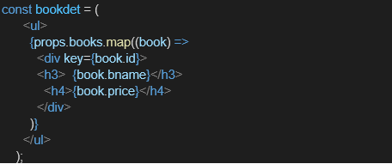

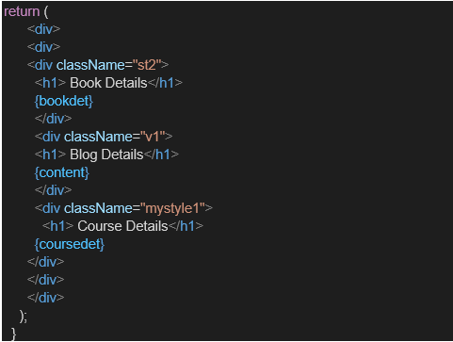

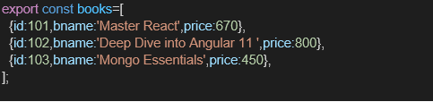

Index.js:

import React from 'react';import ReactDOM from 'react-dom/client';import './index.css';import App from './App';import reportWebVitals from './reportWebVitals';const root = ReactDOM.createRoot(document.getElementById('root'));root.render( <React.StrictMode> <App /> </React.StrictMode>);// If you want to start measuring performance in your app, pass a function// to log results (for example: reportWebVitals(console.log))// or send to an analytics endpoint. Learn more: https://bit.ly/CRA-vitalsreportWebVitals();

Index.css:

body { margin: 0; font-family: -apple-system, BlinkMacSystemFont, 'Segoe UI', 'Roboto', 'Oxygen', 'Ubuntu', 'Cantarell', 'Fira Sans', 'Droid Sans', 'Helvetica Neue', sans-serif; -webkit-font-smoothing: antialiased; -moz-osx-font-smoothing: grayscale;}code { font-family: source-code-pro, Menlo, Monaco, Consolas, 'Courier New', monospace;}App.js

import React from 'react';import './App.css';import BookDetails from './components/BookDetails';import BlogDetails from './components/BlogDetails';import CourseDetails from './components/CourseDetails';const books = [ { id: 101, bname: 'Master React', price: 1000 }, { id: 102, bname: 'Deep Dive into Angular 11', price: 1500 }, { id: 103, bname: 'Mongo Essentials', price: 2000 },];function App() { const showBooks = true; const showCourses = true; const showBlogs = true; return ( <div className="App" style={{ display: 'flex', justifyContent: 'space-around' }}> {showCourses && <CourseDetails />} {showBooks && <BookDetails books={books} />} {showBlogs ? <BlogDetails /> : <p>No Blog Content</p>} </div> );}export default App;

Report Web Vitals:

const reportWebVitals = onPerfEntry => { if (onPerfEntry && onPerfEntry instanceof Function) { import('web-vitals').then(({ getCLS, getFID, getFCP, getLCP, getTTFB }) => { getCLS(onPerfEntry); getFID(onPerfEntry); getFCP(onPerfEntry); getLCP(onPerfEntry); getTTFB(onPerfEntry); }); }};export default reportWebVitals;

Package.json:

{ "name": "bloggerapp", "version": "0.1.0", "private": true, "dependencies": { "@testing-library/dom": "^10.4.0", "@testing-library/jest-dom": "^6.6.3", "@testing-library/react": "^16.3.0", "@testing-library/user-event": "^13.5.0", "react": "^19.1.0", "react-dom": "^19.1.0", "react-scripts": "5.0.1", "web-vitals": "^2.1.4" }, "scripts": { "start": "react-scripts start", "build": "react-scripts build", "test": "react-scripts test", "eject": "react-scripts eject" }, "eslintConfig": { "extends": [ "react-app", "react-app/jest" ] }, "browserslist": { "production": [ ">0.2%", "not dead", "not op_mini all" ], "development": [ "last 1 chrome version", "last 1 firefox version", "last 1 safari version" ] }}

Output:

