**VISVESVARAYA TECHNOLOGICAL UNIVERSITY**

**Belgaum -590018, Karnataka**

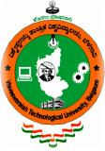

**A MINI PROJECT REPORT**

**ON**

**DATABASE MANAGEMENT SYSTEM**

**“ONLINE TRAIN TICKET RESERVATION SYSTEM”**

**Submitted in partial fulfillment of the requirement for the award of the degree of**

Submitted by:

**AKHILA ML (4MG19CS001)**

**MONIKA RANI (4MG19CS022)**

Under the guidance of:

**Mr. PRADEEP BM**

Assistant. Prof., Dept. of CSE

**GMIT, Bharathinagara**

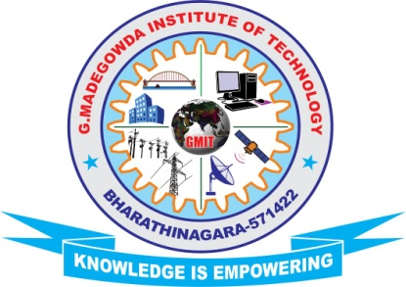

DEPARTMENT OF COMPUTER SCIENCE & ENGINEERING

G. MADEGOWDA INSTITUTE OF TECHNOLOGY

Bharathinagara, Maddur Taluk, Mandya Dist- 571422