**G. MADEGOWDA INSTITUTE OF TECHNOLOGY,**

Bharathinagara, Maddur Taluk, Mandya Dist-571422

**DEPARTMENT OF COMPUTER SCIENCE & ENGINEERING**

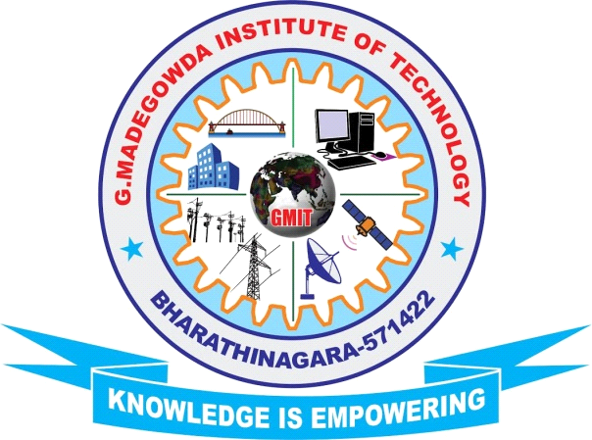

**CERTIFICATE**

Certified that the mini project work entitled **“ONLINE TRAIN TICKET RESERVATION SYSTEM”** is bonified work carried out by **AKHILA ML (USN: 4MG19CS001) and MONIKA RANI (USN: 4MG19CS022)** during the year 2021-22 as per the University requirement for the V semester academic curriculum. The mini project report has been approved as it satisfies the requirements with respect to the project work prescribed for Bachelor of Engineering degree.

**Signature of Guide Signature of HOD**

**Prof. PRADEEP BM**   **Mr. VIJAYKUMAR M S**

Asst. Prof., Dept. of CSE Assoc. Prof., & Head, Dept. of CSE

GMIT, Bharathinagara GMIT, Bharathinagara

**Examiners**

**Internal External**

Name:

Signature: