**Proposal of protocol based vehicle tracking system using ESP32**

**Methodology:**

Proposed Layer Based Design approach:

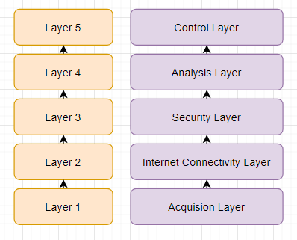

Figure 1.0

Figure 1.0 represents the proposed layer based design approach for the IOT based

Implementation of GPS tracking system. The proposed layer based design consists of acquisition layer, internet connectivity layer, security layer, parameter analysis layer and control layer. Each proposed layer performs the layer specific modularized operation that is explained as below.

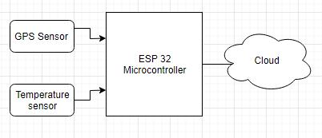

**Acquision Layer :**

The data acquision layer performs real-time GPS data collection using GPS module, temperature monitoring. The ESP32 controller which measures the sensor input and displays the data using the LCD display and sends the data to the cloud. The controller sends the data to the cloud. The controller is powered on using power supply.

**Internet connectivity Layer:**

In the internet connectivity layer, the GPS data collected from the ESP32 controller is sent to the cloud using Wifi connection. The Wifi credentials are configured in the device in order to establish the connection to the internet. The data collected from the internet is sent to cloud for further analysis.

**Security Layer:**

The security layer provides the security mechanisms that need to be implemented in order to establish the secure connection to the cloud.

**Analysis Layer and control Layer:**

The **analysis layer** and **control layer** analyses the data received from the device and decides the changes that need to be applied in order to achieve the results.

The software implementation flow is as mentioned in the above approach.

The hardware required for the implementation:

* ESP32 microcontroller
* GPS tracking sensor
* LCD display/PC