**Que- What is Devops ?**

Ans – DevOps culture is a way of working that involves collaboration, communication, and a shared responsibility for products between development and operations teams

- Devops is culture / Development is doing by one team and Operations are doing by another team. There should be collaboration between Development Team and Operations team to Deliver Project to client quickly with Quality that’s where DevOps culture came into market.

* If there is no communication between Development and Operations teams then project delivery will become slow and client will loose his business.

**Que – why we use Devops ?**

**Ans –**

* The main aim of devops is used to simplify and automate and speed up project build + deployment + delivery process to client with high quality.
* By following DevOps culture we can deliver application to client quickly with quality.

**Development Team (Programmers)**

1. Collect Requirements
2. Analyze Requirements
3. Planning (Designing)
4. Implementation (Coding)
5. Testing
6. Code Integration

**Operations Team (Devops Engineer)**

1. Setup machines
2. Setup Network
3. Setup Servers
4. Setup Database
5. Prepare Infrastructure for Project execution
6. Take project code from Repository (GitHub)
7. Perform Project Build (Compile)
8. Package Project (jar or war)
9. Deploy Project to Server.

**Infrastructure**

* Infrastructure is nothing but the setup of the machine

**Infrastructure Setup**

* To run a project we need to prepare environment
* **Environment means the platform which is used to run our project**
* Computers
* Network
* Power
* Air Conditioner
* Web Servers
* Database Servers
* Storage
* Security
* Some companies will purchase and setup infrastructure that is called on On-Premises Infrastructure.
* If we setup on-prem infrastructure then we have to purchase, setup & manage everything required for project.
* It requires lot of money and time.
* Instead of setting up on-prem infrastructure we can go for Cloud-Infrastructure.
* If we go for Cloud Infrastructure we can take all the software's for Rent then Cloud Provider will manage

**Note: AWS is one of the leading Cloud Provider available in the market.**

**Linux**

* Linux is free and opensource operating system
* **In realtime, We will use Linux OS to setup Infrastructure**
* **We will use Shell Scripting to automate our regular work**
* (server restart, data backup, logs backup, temp files delete etc...)
* After Learning Linux & AWS we can setup infrastructure in AWS Cloud

===========================================================

**Build & Deployment**

===========================================================

* Developers will develop project using one programming language
* Ex: Java, Python, C#, PHP etc....
* Developers will keep code in Repository Ex: SVN, GitHub, Bitbucket etc...
* DevOps engineer should take that code from Repository
* DevOps engineer should perform Project Build and Deployment
* Project Build means converting the project code into executable format
* Project Deployment means keeping project executable file into server
* After Deployment then Deliver project to client

***** Code ====> Git Hub ====> Build ====> Deploy ===> Deliver *****

To automate Build & Deployments we will use Several Tools

**DevOps Tool Chain**

==============

DevOps Tools

==============

1) Terraform: To create infrastructure in cloud platform (HCL)

2) Chef / Puppet / Ansible : Configuration management (YML)

3) Git Hub / BitBucket : Source Code Repository Server

4) Maven / Gradle : Build Tool

5) SonarQube : Code Review (To identify developers mistakes ,check code quality )

6) Nexus / JFrog : Artifactory Server

7) Tomcat : Webserver

8) Docker : Containerization s/w ( Package our application as a container)

9) Kubernetes/OpenShift : Orchestration s/w (YML) ( Our application run on realtime)

10) Jenkins / Argo CD / Github Actions : CI CD server

11) Promethues & Grafana : Monitoring (Servers Monitoring)

12) ELK / Splunk : Application Log Monitoring

13) JIRA : Project Management + Bug Reporting

**Date : 23-Sep-2024**

**Topic : Linux OS**

===========================================================

**Que - Where we will use linux os in real-time ?**

Jenkins Server

Docker Server

K8S Cluster

SonarQube Server

Nexus Server

Ansible Server => To setup all above servers/tools we will use Linux machines only.

**Que - What is OS ?**

Ans - It is a software which acts as mediator between user and computer.

* Users will communicate with computers using OS.
* Without OS we can't use any computer.
* OS provides platform to run our applications in computer.
* Ex: notepad, paint, calculator, browser, tomcat....
* We have several operating systems in market Ex: Windows, Linux, Mac,Android,IOS....

===========================================================

**Windows OS**

* Developed by Microsoft company (Bill Gates).
* Windows os is licensed (commercial) Windows is single user based os.
* Windows is GUI based (graphical user interface) - Security features are less in windows os (anti virus s/w required) – Beacause of .exe files chances of getting virus( Data, Files Corrupted) for that Anti-Virus is required.
* Windows is recommended for personal use Ex: watch movies, play games, online classes....

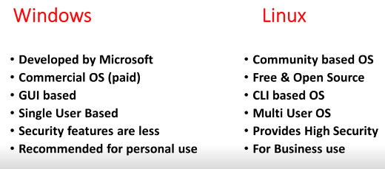

**Linux OS**

* Linux is community based os (not specific to any company) => Linux is free and open source os.
* Linux is Multi User based OS. Multiple users connect at a time.
* Linux is highly secured (anti virus is not required)
* Linux is both GUI & CLI based os (command line interface)
* Linux is highly recommended for business use (servers management) Ex: Webservers, DB Servers, Jenkins, Docker, K8S, Ansible....

===========================================================

**Linux History**

===========================================================

* Linux OS developed by "Linus Torvalds" -> Linus Torvalds identified some challenges/issues in "Unix OS".
* Linus Torvalds identified one OS which is matching with his ideas.
* i.e Minux os
* Linus Torvalds used Minux OS code and made some changes and released into market as new OS i.e Linux OS.
* (Li) nus + Mi (nux) = Linux

=========================================================== **Linux Distributions**

===========================================================

* Linus Torvalds provided Linux OS source code for free of cost.
* So many companies downloaded Linux OS source code and modified according to their requirement and released into market with their brand names. Those are called as Linux Distributions.

Ex: Amazon Linux, Ubuntu, Red Hat, Cent OS, Kali, SUSE, Fedora....

**Note: We have 200+ Linux Distributions in the market.**

===========================================================

How to setup Linux Machine ?

Approach-1 : Take machine & install Linux OS.

Approach-2 : Install linux os as guest os using Virtual Box.

Approach-3 : Setup Linux VM in cloud and connect with that.

========================================================

👉 AWS Account Setup : https://youtu.be/xi-JDeceLeI?si=4MgBX_H4_NPuzdT8

👉 Connect Linux VM with MobaXterm : https://youtu.be/uI2iDk8iTps?si=ZuZs0lQTxoRpbRMk

👉 Connect Linux VM with putty : https://youtu.be/GXc_bxmP0AA?si=HgSydrP89mPxv23s

👉 Connect Linux VM with GitBash : https://www.youtube.com/watch?v=JMlQaTXvw5o

===========================================================

**Date : 24-Sep-2024**

**Topic : Linux OS**

===========================================================

**Linux Architecture Components**

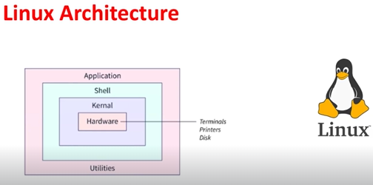

1. **Applications / Commands**

1. **Shell** ( is going to read the command from the user)
2. **Kernel**
3. **Hardware Components**

**What is shell ?**

Ans – Shell is Like a container.

* Shell acts as mediator( interface) between user and kernel.
* Shell is responsible to process user given commands.
* is going to read the command from the user
* shell is verify command syntax are valid or not
* Shell is responsible for process our commands in linux.
* Shell translate commands into kernel understandable format

**Note:** when we execute a command, shell verify command syntax. If commad is valid then shell will convert that command into kernel understable format.

# check default shell of our linux vm - **echo $SHELL**

===========================================================

**What is Kernel in linux ?**

* Kernel is heart of Linux Operating System
* Kernel is a mediator between SHELL and Hardware components.
* Kernel will get instructions (Command) from shell then kernel will convert those instructions into hardware understandable format.

**What Kernel does ?**

Ans-

* memory management
* Process management
* Device drivers
* System calls and security

# print kernel version

Command - $ uname –r

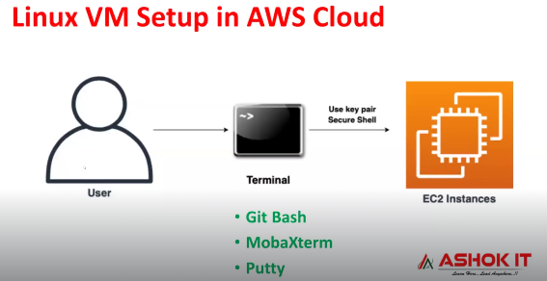

**Linux File System Hierarchy**

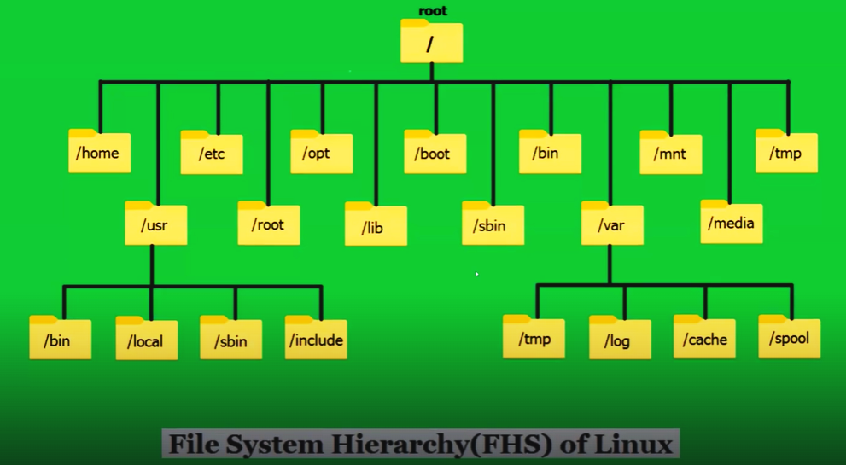

===========================================================

Linux Commands

===========================================================

* Whoami – Logged in username
* pwd – Present working directiory
* Date – Todays date
* cal - Calender
* cal 2025
* cal 5 2025
* cd / - root directory
* cd /home/ec2-user
* ls –l - List root directory

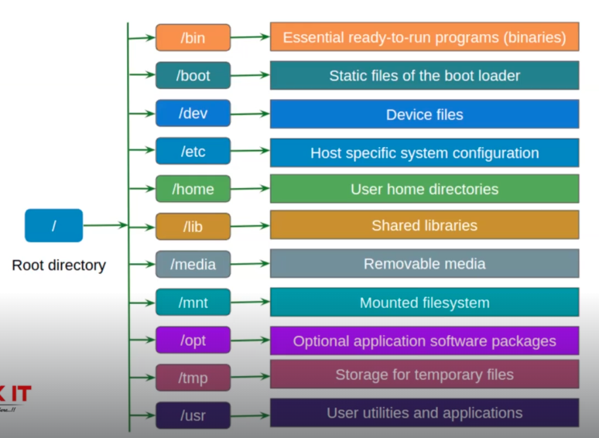

===========================================================

**Date : 25-Sep-2024**

**Topic : Linux Commands**

===========================================================

**Working with directories and files in Linux**

=============================================

* **mkdir : make directory**
* mkdir abc aws devops
* **rmdir : remove Only empty directory**
* rmdir abc

**Note: To delete non-empty directories we will use below command**

* rm -rf <dir-name>
* rm = remove rf= recursive forcefully
* we can delete directory using rm –rf command as well as txt file.
* It will delete Empty as well as non Empty directories and files.

**touch : to create empty files**

* touch f1.txt f2.txt f3.txt
* we can create file without an extension.
* **ls : display present working directory content**
* **ls -l : long list the files in alphabetical order**
* **ls -lr : display files in reverse of alphabetical order**
* **ls -lt : display latest files on top**
* **ls -ltr : display old files on top**
* **ls -la : display hidden files**

**cd : to change directory**

* cd <dirname>

**cd .. - to come-out from current directory**

**ls -l <dir-name>** - to change a particular directory.

**rm** : to delete file

* rm can delete empty as well as non-empty file.
* rm f1.txt

**Command** - rm -rf <dir-name>

Command – rm *.txt ( delete all txt file at a time)

mv : For rename & move

**Command** - mv existing-name new-name

**Command** - mv presention-location new-location

To move multiple files from one directory to another directory use

**Command -** Mv file1 file 2 /home/ec2-user/destination-directory

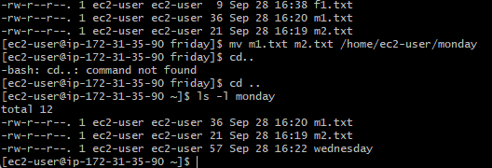

cat : create new file with data + append data to file + print file data

# create new file with data

cat > f1.txt and press ctrl + c to save the file.

* we can create file without an extension
* Cat > f1.txt – is data is already present then it will override new data

# append data to existing file

Cat will append data only at last line.

cat >> f1.txt

# print file data

* cat f1.txt

# print file data along with line numbers

* cat -n f1.txt

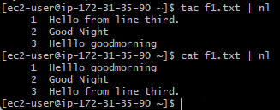

tac : To print file data from bottom to top

**cp : copy file data from one file to another file**

**Command -** cp f1.txt f2.txt

Note: If we want to copy data from multiple files then we should use cat command

cat f1.txt f2.txt > f3.txt

this command can also create a destination file is it is not exists.

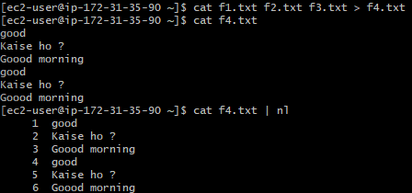

Copy 2 files data in non-empty file without overriding existing data

Command – cat t11.txt t22.txt >> t33.txt

=========================

Date : 26-Sep-2024

Topic : Linux Commands

=========================

**head :** print first 10 lines of the file

head f1.txt

head -n 20 f1.txt

head -n 50 f1.txt

**tail :** print last 10 lines of the file

tail f1.txt

tail -n 25 f1.txt

**Grep : gloabl regular expression print**

Using grep command we can search for content in the file

# print lines which contains admin keyword

grep 'admin' data.txt

# print lines which contains nexus keyword

grep 'nexus' data.txt

# ignore case

**grep -i 'nexus' data.txt**

# print lines which contains nexus keyword with line numbers

grep -n 'nexus' data.txt

# search in all files of pwd

grep -n -i 'Nexus' *

grep –ni ‘Nexus’

# print lines which doesn't contains teen keyword –v for ignoring keyword

Command -**grep -v 'teen' f1.txt**

# check for 'tw' keyword in last 10 lines of file

tail f1.txt | grep 'tw'

**Text Editors in Linux**

=======================

vi (visual editor) it is default editor in linux machines.

Using 'vi' we can create new files and we can modify existing file data.

$ vi aws.txt

vi command is having 3 modes

1) command mode (just to open the file)

Ex: vi filename

2) insert mode (to edit the file ) --- press 'i' in keyboard

3) esc mode (to come-out from insert mode) -- press 'esc' in keyboard

## Save changes &amp; close the file :wq

## Without saving changes close the file :q!

Note: vi command will open the file if it is avilable otherwise it will create new file and it will open that file.

=======================

**file creation commands**

=======================

touch : to create empty file

cat : create file with data

cp : copy one file data into another file (cp f1.txt f2.txt)

vi : create and open file for editing (vi f3.txt)

====================

reading file data

====================

cat : print file data from top to bottom

tac : print file data from bottom to top

head : print first 10 lines of file data

tail : print last 10 lines of file data

vi : open the file

grep : filter the data (search the data)

=============

**SED Command**

=============

**SED stands for stream editor**

SED is used to process the data (substitute, delete, print, insert)

Using SED command we can perform operations on the file without opening the file.

Sed is working at line level.

SED is very powerful command in linux

* replace first occurance of linux keyword with unix
* sed 's/linux/unix/' data.txt
* replace second occurance of linux keyword with unix
* sed 's/linux/unix/2' data.txt
* replace 3rd occurance of linux keyword with unix
* sed 's/linux/unix/3' data.txt
* replace all occurances of linux keyword with unix
* sed 's/linux/unix/g' data.txt
* **substitute and save changes in original file**

**Command** - sed -i 's/linux/unix/g' data.txt

# delete first line of the file

sed -i '1d' data.txt

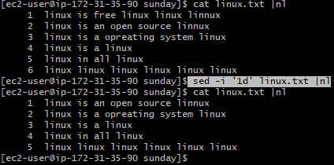

# delete fourth line of the file

sed -i '4d' data.txt

To delete Last line –

Sed -i ‘$d’ linux.txt

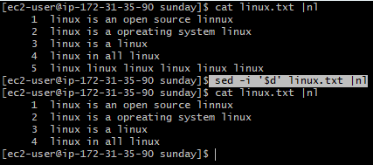

To delete 2nd line to last line -

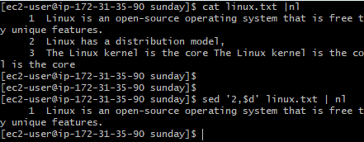

To delete 3rd line to 6th line

Command sed –i ‘3,6d’ llinux.txt |nl

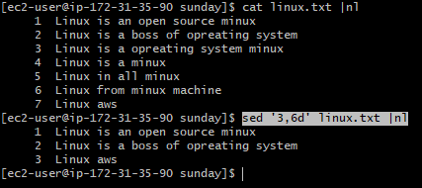

# delete data from nth line to last line

sed -i 'n,$d' data.txt

Note: n is a number

# delete data from 5th line to 15th line

sed -i '5, 15d' data.txt

**# insert data at 2nd line**

**Command -** sed '2i\i love india' data.txt

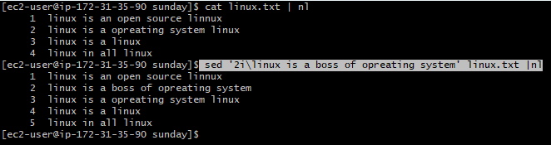

# Insert data into the firest line

**Command -** sed '1i\i love india' data.txt

For Insert and save

**Command -** sed – i '1i\i love india' data.txt

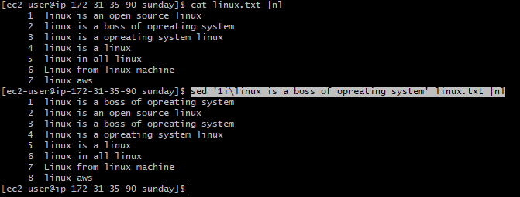

# insert data at last line

Command - sed '$a\i am from ashokit' data.txt

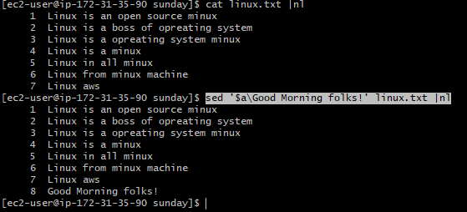

=========================

***Date : 27-Sep-2024***

***Topic : User Management***

* Linux is a multi-user based OS.
* Multiple users can access single Linux machine and can perform multi-tasking at a time.

Note: "ec2-user" is a default user in amazon linux vm.

Note: ec2-user having sudo priviliges (administrator).

Within one linux machine we can create multiple user accounts.

when we create user account, for user one home directory will be created.

ec2-user /home/ec2-user

john /home/john

smith /home/smith

# create user

sudo useradd uname

# set password for user &amp; update pwd for user

sudo passwd uname

# display all users created

cat /etc/passwd

# swith user account

su uname

**# navigate to logged in user home directory**

**cd** ~

# Delete user

$ sudo userdel uname

# Delete user along with user home directory

$ sudo userdel uname --remove

# how to change username

$ sudo usermod -l new-name old-name

/etc/passwd: This file Contains general user information.

/etc/shadow: This file Contains hashed passwords and other security-related information.

**Working with user groups in linux**

===================================

When we create user in linux, for every user one user group also will be created with the given username.

# Display all groups in linux

$ cat /etc/group

# Create group in linux

$ sudo groupadd group-name

# Adding user to group

$ sudo usermod -aG group-name username

# Remove user from the group

$ sudo gpasswd -d username group-name

# display users belongs to a group

**Command -** sudo lid -g group-name

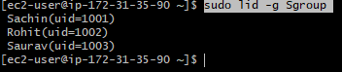

# display user belongs to which groups

Command- id username

# delete group

$ sudo groupdel group-name

# changing group name

$ sudo groupmod -n new-name old-name

=================================

What is sudoers file in Linux

=================================

* It is very important configuration file in linux machine.
* By Using this file we can control which user can run linux command as a super user.

# print sudoersfile content

sudo cat /etc/sudoers

# check root user priviliges

sudo grep 'root' /etc/sudoers

Note: We should be very careful while working with sudoers file. If we do any mistakes in sudoers file then we can't use that user account.

########## Giving sudo previliges for user #######

# open sudoers file

Command - sudo visudo

Note: goto root user details, add one our user just below root user like below

# add user like below

ashok ALL=(ALL) ALL

After making above changes, to close sudoers file ( CTRL + X + Y + Enter )

===========================================================

How to enable password based authentication for users in linux vm?

===========================================================

In linux vm, by default password authentication is no

Que – Why we password authentication is required ?

Ans –

* If we want to connect with linux vm using username and password then we need to set that value as yes.
* To enable password authentication we need to modify "sshd_config" file in linux.

# Display sshd_configurration file data

$ sudo cat /etc/ssh/sshd_config

# Open file

$ sudo vi /etc/ssh/sshd_config

Note: Go to insert mode and enable pwd based authentication as yes

# restart sshd service

# sudo systemctl restart sshd

Note : Now we can connect with linux vm using username and pwd

# use below command in gitbash to connect

ssh username@public-ip

**=====================================================**

**Date : 30-Sep-2024**

**Topic : chmod + chown + zip + networking commands**

**=====================================================**

**Using file permissions we can secure our files and we can protect our file data.**

We have 3 types of permissions in linux

* r read
* w write
* x execute
* file/directory permissions will be represented like below

rwxrwxrwx f1.txt

* file permissions contains 9 characters are divided into 3 parts

First 3 characters - user/owner permissions

Middle 3 characters - group permissions

Last 3 characters other - users permissions

If first character is **d** that means it’s a directory

If first character is **-** then it is an normal file.

-rw-r--r--. 1 ec2-user ec2-user 209 Oct 1 05:22 w1.txt

drwxr-xr-x. 2 ec2-user ec2-user 6 Oct 1 08:47 wed

After first character the rest of is permissions

**drwxr-xr-x. 2 ec2-user ec2-user 6 Oct 1 08:47 wed**

Lets under file permissions with diff scenarios

* first 3 character is Represent **owner** permission.

**Owner**

-rw-r--r--. 1 ec2-user ec2-user 209 Oct 1 05:22 w1.txt

* Middle 3 characters represent **group** permission.

**Group**

-rw-r--r--. 1 ec2-user ec2-user 209 Oct 1 05:22 w1.txt

* Last 3 characters represent **other-users** permission.

**Other-User**

-rw-r--r--. 1 ec2-user ec2-user 209 Oct 1 05:22 w1.txt

Scenario-1 :: rw-r--r-- f1.txt

user : read + write

group : read

others : read

Scenario-2 :: rwxr-xr-x f1.txt

user : read + write + execute

group : read + execute

others : read + execute

Scenario-3 : rwx--xr-x f1.txt

user : read + write + execute

group : execute

others : read + execute

To change file/directory permissions we will use 'chmod' command

* + - * **+ to add permission**
* **- to remove permission**

Giving execute permission for user

$ chmod u+x f1.txt

-rw-r--r--. 1 ec2-user ec2-user 209 Oct 1 05:22 w1.txt

**Command for Permisson**

[ec2-user@ip-172-31-35-90 wednesday]$ chmod u+x w1.txt |nl

[ec2-user@ip-172-31-35-90 wednesday]$ ls –l

**Execute Permission added**

-rwxr--r--. 1 ec2-user ec2-user 209 Oct 1 05:22 w1.txt

# giving write permission for group

$ chmod g+w f1.txt

# Remove execute permission for others

$ chmod o-x f1.txt

# give all permissions for group

$ chmod g+rwx f1.txt

# Remove all permissions for others

$ chmod o-rwx f1.txt

====================================

**File Permissions in Numeric Format**

====================================

0 - No permission

1. Execute
2. Write
3. (2 + 1) Write + Execute
4. Read
5. (4 + 1) Read + Execute
6. (4 + 2) Read + Write
7. (6 + 1) Read + Write + Execute

# ugo+x

chmod 111 f1.txt

# ugo+w

chmod 222 f1.txt

# u+rwx g+rw o+rx

chmod 765 f1.txt

# u+r g+rx o+rw

chmod 456 f1.txt

# ugo+rwx

chmod 777 f1.txt

# u-rwx g-rwx o+rwx

chmod 007 f1.xt

===============

chown command

===============

It is used to change file/directory ownership

# change owner

sudo chown new-owner file/directory

# change owner-group

sudo chown :new-group file/directory

# change owner &amp; group of file/directory

sudo chown new-owner:new-group file/directory

============================================

Q) What is the diff between chmod &amp; chown ?

============================================

chmod To change file/directory permissions

chown To change owner/group

=================================

Working with Zip files in linux

=================================

Zip is used for files archieve (compress)

## syntax to create zip file

zip zip-file-name content

# create some empty files

touch f1.txt f2.txt f3.txt

# create zip file with content

zip ashokit_data *.txt

# unzip the zip file

unzip ashokit_data.zip

======================

Networking commands

======================

ping : To check connectivity of other servers

ping www.google.com

ping www.facebook.com

ping 192.168.2.009

wget : It is used to download files from internet based on given url

wget https://dlcdn.apache.org/maven/maven-3/3.9.9/binaries/apache-maven-3.9.9-bin.zip

curl : It is used to send HTTP Request to server

curl https://dummyjson.com/quotes/random

ifconfig: To get ip address of our machine

file permission chmod command = cat s2.txt

=====================================================

Date : 01-Oct-2024

Topic : Linux Commands

=====================================================

find : it is used to search files &amp; directories in linux machine

# search for the files which are having name as f1.txt

sudo find /home -name f1.txt

# search for empty files inside /home

sudo find /home -type f -empty

# search for empty directories inside /home

sudo find /home -type d -empty

uptime : from when our linux vm is running

free : to display memory details

top : display running processes

=====================

process management

=====================

# display running process

ps aux

Note: Every process will process id (PID)

# kill the process

kill -9 PID

=============================================

How to change hostname in vm (temporarly) ?

=============================================

# set hostname

$ sudo hostname new-name

# re-start session

$ exit

Note: connect back to vm then we can see configured hostname

===================================

How to set hostname permanentley

===================================

# update hostname in below file

$ sudo vi /etc/hostname

# restart the vm

Note: After restart hostname configured in file will be reflected in terminal.

==========================

Package Managers in Linux

==========================

Package means a software

Ex: git, maven, java, python etc.....

Package managers are used to "install/upgrade/remove" software packages in linux machines.

Package managers are specific to linux distribution.

Amazon Linux / Red Hat Linux / cent os : yum

Ubuntu / Debian Linux : apt

# check git client installed or not

git --version

# install git client s/w

sudo yum install git

# check git installation path

whereis git

# check java installed or not

java -version

# install java s/w

sudo yum install java

# check java installation path

whereis java

======================================================

Assignment : Remove git and java from linux machine

sudo yum list installed | grep java

copy file name and paste

======================================================

=============================

Webserver Setup in Linux VM

============================

Webserver is a software which is used to run websites.

Website means collection of web pages

Ex: login page, registration page, forgot pwd page, dashboard page...

Websites are divided into 2 types

1) Static website

2) Dynamic website

The website which gives same response for every user is called as static website.

The website which gives response based on logged in user is called as dynamic website.

Ex: gmail, facebook, instagram....

To run static websites we can use 'httpd' as webserver.

To run dynamic websites we can use "tomcat, iis" as webserver

================================

Static website hosting in linux

================================

# install webserver

$ sudo yum install httpd -y

# start webserver

$ sudo service httpd start

Note: httpd webserver runs on HTTP protocol with 80 as port number.

* To access our webserver we need to enable 80 port number in security group inbound rules.
* We can access our webserver using ec2-vm public ip.

# Navigate to website content directory

$ cd /var/www/html

# create index.html file and write a msg in that file

$ sudo vi index.html

Note: After saving index.html access EC2 VM public ip in browser.

================================

**What is systemctl in linux ?**

* systemctl is used to manage services in linux machines. It is called as Service Manager.

using systemctl we can perform below operations

a) start a service

b) stop a service

c) restart a service

# check status of httpd

sudo systemctl status httpd

# stop httpd server

sudo systemctl stop httpd

# start httpd server

sudo systemctl start httpd

# reload service

sudo systemctl reload http

=========

Summary

=========

1) What is OS

2) Windows Vs Linux

3) Linux History + Distributions

4) Linux VM setup in AWS cloud

5) Connect with Linux VM using SSH Clients

- MobaXterm

- Putty

- GitBash

6) Working with Directories &amp; Files

7) Text Editors (vi &amp; sed)

8) Text Filters (head, tail, grep)

9) User Management &amp; Groups

10) How to enable pwd based authentication

11) File Permissions (chmod)

12) File Ownership (chown)

13) Archieves (zip + unzip)

14) Network Commands

15) Package Managers

16) Static Website Hosting in Linux (httpd)

17) Service Management (systemctl)

18) Process Management

19) Changing Hostname

20) sudoers file + sshd_config file

21) Linux Architecture

22) Linux File System