Build Tools :-

=> Build tools are used to automate project build process.

=> Build process means convert project source code into executable format.

===========================================================================

**Java Project Execution Flow**

=> Developers will develop source code for the project

Ex: .java files

=> We need to convert source code into byte code using java compiler

=> When we compile source code it will be converted into byte code

Ex: .class files

=> We need to package .class files as jar or war file.

JAR : Java Archieve

WAR : Web Archieve

=> Standalone apps will be packaged as jar file

=> Web Apps will be packaged as war file.

===========================================================================

**Java Build Tools**

=> We have below build tools to automate java projects build process.

1) Ant (Outdated)

2) Maven

3) Gradle

**Maven**

===========================================================================

=> It is a build tool

=> It is free and open source s/w developed by Apache Org.

=> Maven s/w developed by using Java language.

=> Maven is used as java projects build automation tool.

=================================

What we can do by using maven ?

=================================

1) We can create java project folder structure.

2) We can download required libraries

Ex: hibernate, springboot, junit, log4j, jackson...

3) We can compile source code of the project

.java file -------> .class file

4) We Execute Unit test cases of the

5) We can package our application as jar or war file

.class files ------> jar or war

Note: The main aim of maven is to automate and simplify java projects build process.

Note : for python build tool is not required because python is considered as an scripting

language.

**Maven Setup in Windows**

===========================================================================

@@@ Reference Video : https://www.youtube.com/watch?v=hV1OWzYpzxo

1) Download and Install Java

2) Set JAVA_HOME and Java Path

3) Verify Java Installation

4) Download Maven Software

5) Set MAVEN_HOME and Maven Path

6) Verify Maven Setup

===========================================================================

**Maven Setup in Linux**

===========================================================================

# check maven software availability

$ mvn -version

# install maven s/w

$ sudo yum install maven

# check maven software availability

$ mvn -version

===========================================================================

**Maven Terminology**

===========================================================================

mvn **archetype:**generate -**DgroupId**=com.mycompany.app -**DartifactId**=my-app -DarchetypeArtifactId=maven-archetype-quickstart -DarchetypeVersion=1.5 -DinteractiveMode=false

1) **archetype** : Represents type of project we want to create

quick-start : stand-alone app (jar)

web-app : web application (war)

2) **groupId** : Represents company domain name

ex : in.ashokit

com.ibm

com.tcs

3) **artifactId** : Represents project name

ex: sbi_net_banking_app

ashokit_ecomm

4) **version** : Represents project version

ex:

1.0-SNAPSHOT (under development)

1.0-RELEASE (delivered to production)

5**) packaging** : represents project executable format

ex: jar or war

6) **dependencies** : Libraries requied for project development

ex: third party libraries -hibernate, springboot, junit, log4j....

7) **maven goals** : To perform build process

ex:

compile

test

package

install

deploy

8) **maven repositories** : Location where maven dependencies will be stored.

1) **central repository** (public, managed by apache)

2) **remote repository** (private, company specific - nexus/jfrog)

3) **local repository** (will be created in local system) (.m2)

**02-DevOps - 08-OCT-24**

===========================================================================

**Creating Maven Stand-alone application**

===========================================================================

=> Execute below command in cmd to create maven stand-alone application

mvn archetype:generate -DgroupId=in.ashokit -DartifactId=sbi-app -DarchetypeArtifactId=maven-archetype-quickstart -DarchetypeVersion=1.4 -DinteractiveMode=false

=> Execute below command to create maven web application

mvn archetype:generate -DgroupId=in.ashokit -DartifactId=my-web-app -DarchetypeArtifactId=maven-archetype-webapp -DarchetypeVersion=1.4 -DinteractiveMode=false

=> Navigate into project directory and execute maven goals

$ mvn package

===========================================================================

**Maven Goals**

===========================================================================

=> Maven Goals are used to perform Project Build Process

Syntax : mvn <goal-name>

Note: We need to execute maven goals from project root directory

(where pom.xml is available)

=> We have several maven goals like below

# clean : To delete target directory

# compile : Compile source code of the project

Note: It will convert .java files to .class files

Note: It will generate target directory to store .class files

# test : To execute project unit test code (junits)

test = compile + test

# package : To package our project as a jar / war file

package = compile + test + package

Note: application package will be stored into target directory.

Ex: **mvn clean package**

**Clean +compile+test**

# install : To publich our project artifact (jar/war) into maven repository.

install = compile + test + package + install

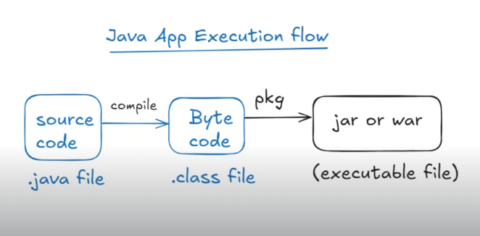

===================

**Maven Dependencies**

===================

=> Maven dependencies means libraries required for the project development.

Ex: spring-core, junit, hibernate etc..

Note: Developers will add required dependencies in project pom.xml file.

=> We can find maven dependencies in www.mvnrepository.com

<dependency>

<groupId>org.springframework</groupId>

<artifactId>spring-core</artifactId>

<version>6.1.13</version>

</dependency>

=> Add above dependency in project pom.xml file under <dependencies/> section and execute maven goals.

mvn clean package

===================

**Maven Repositories**

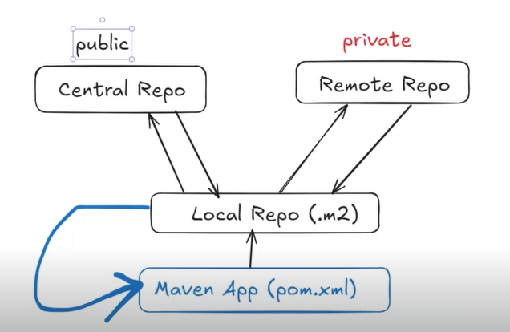

Repositoriy : It is a place where maven dependencies will be stored.

=> We have 3 types of repositories in maven

1) Local Repository

2) Central Repository

3) Remote Repository

=> Local Repository will be created in our machine (.m2 folder)

=> Central Repository will be maintained by apache organization (public)

=> Remote Repository will be maintained by our company to store shared libraries.

Note: To setup remote repositories we will use Nexus / JFrog softwares.

Note: Only First time maven will download dependencies from central / remote repository to local repository.

=> Maven project will take dependencies from local repository (.m2).

==================

Maven - Summary

==================

1) What is build tool & why

2) What is java application build process

3) Maven Introduction

4) Maven Setup in windows

5) What we can do using maven

6) Maven Terminology

7) Maven Project creation

8) Maven Dependencies

9) Maven Goals

10) Maven Repositories