**Introduction:**

**Table 1.** Comparison between Cloud computing and Fog computing.

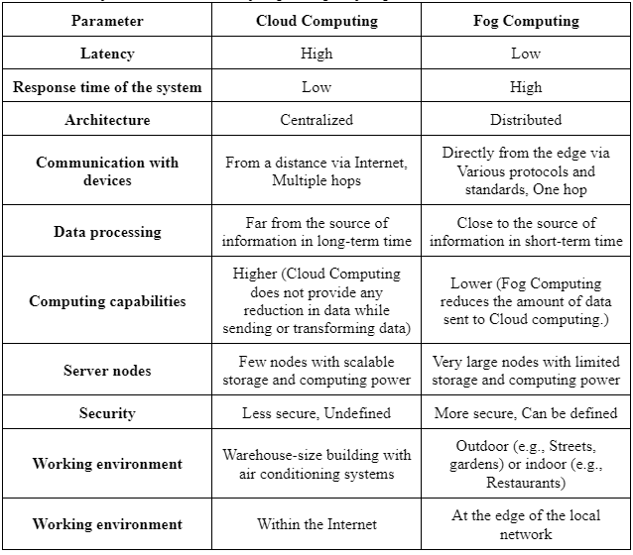

**Table 2. Properties of the nodes.**

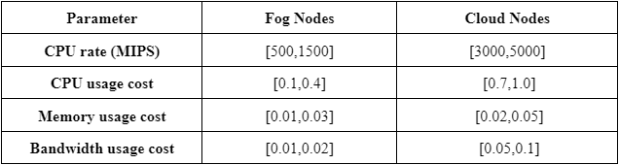

**Table 3. Properties of the tasks to be assigned.**

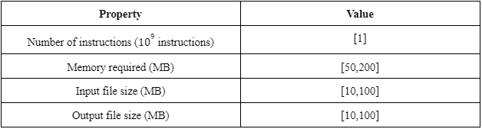

**Task Allocation**

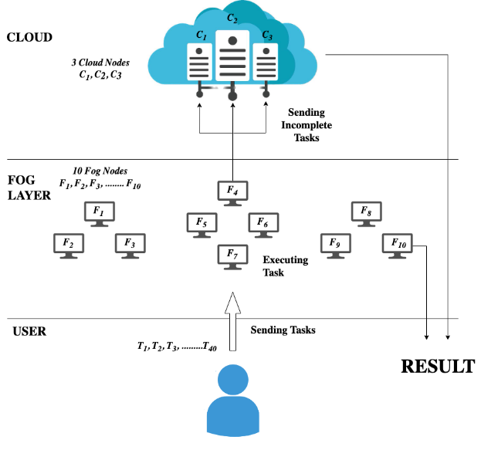

Fig 1. Proposed Vehicular Fog Computing Architecture

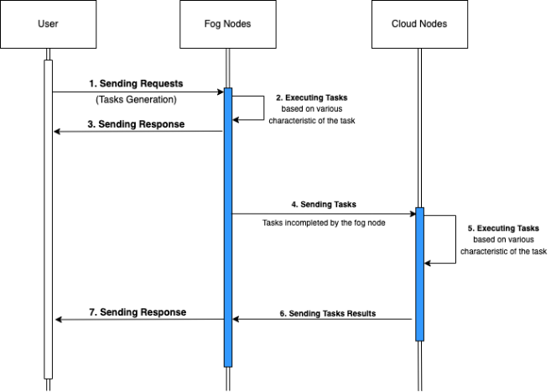

Fig 2. Implemented Task Allocation in Vehicular Fog Computing

**Implementation**

1. **Genetic Algorithm**

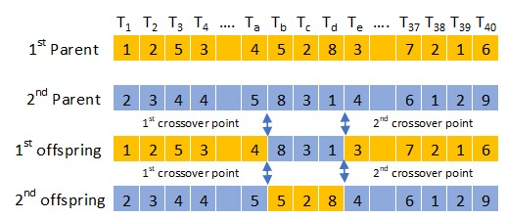

Fig 3. Genetic Crossover Operator

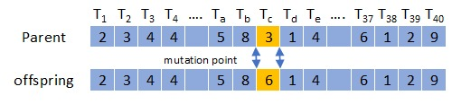

Fig 4. Mutation Operator

1. **PSO**

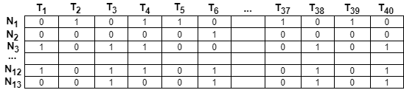

Fig 5. Velocity Matrix

**Result**

1. **GA**

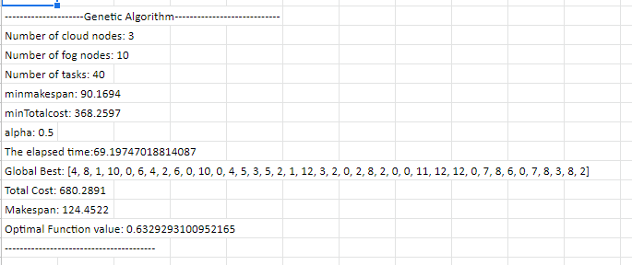

Fig 6. Implementation Output for Genetic Algorithm

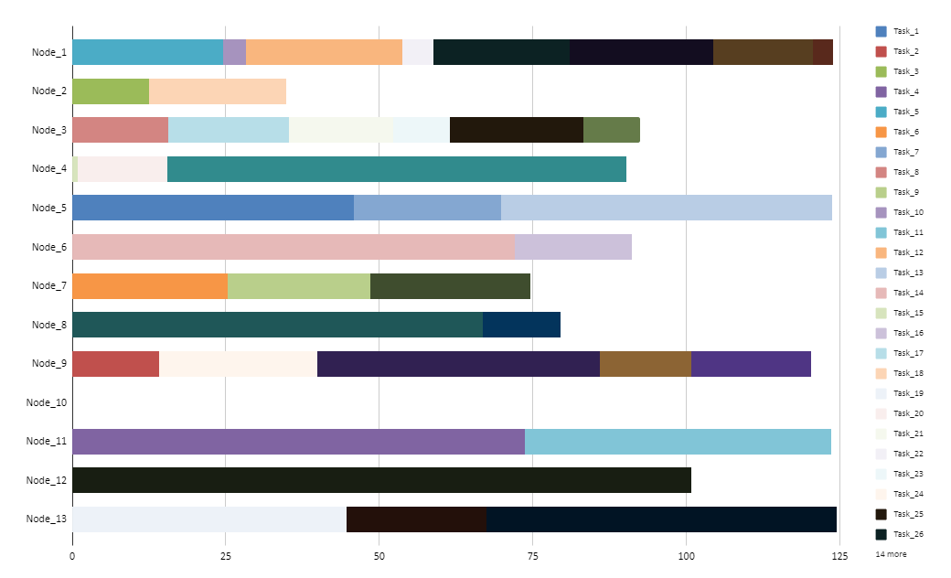

Fig 7. Gantt Chart for Genetic Algorithm

1. **PSO**

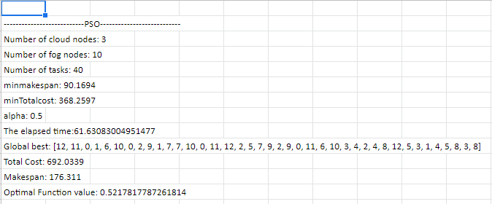

Fig 8. Implementation Output for Modified Particle Swarm Optimization

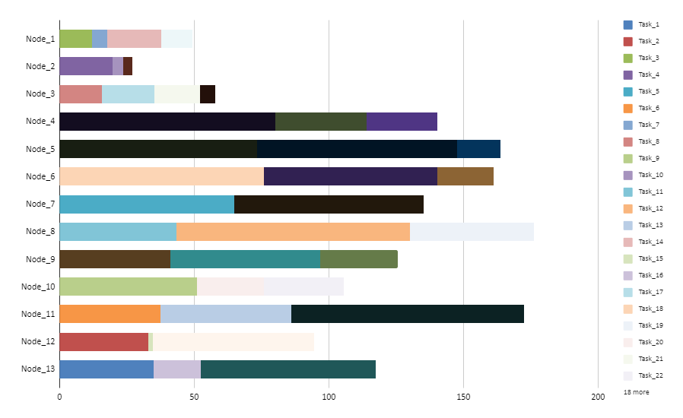

Fig 9. Gantt Chart for Modified Particle Swarm Optimization

**Analysis**

1. **Comparative Analysis**

**Table 4. Comparative Analysis Between GA and MPSO.**

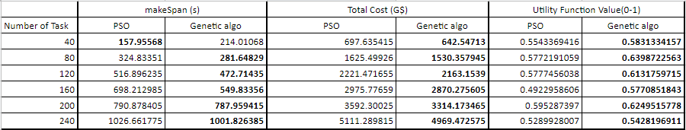

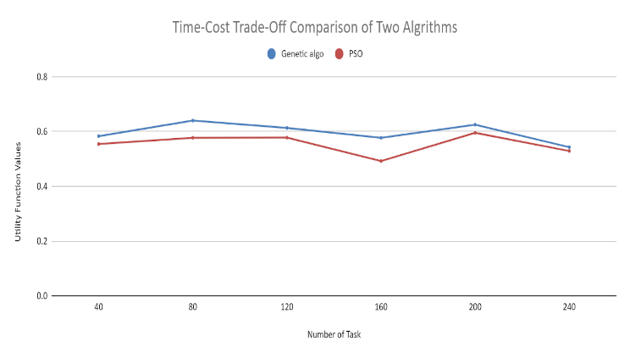

Fig 10. Graphical Representation for Comparative Analysis

1. **Alpha Comparison for Genetic Algorithm**

**Table 5. Alpha Value Comparison for Genetic Algorithm.**

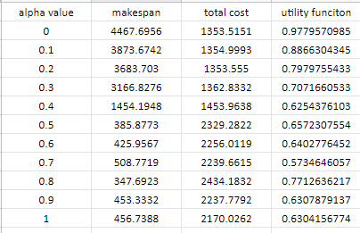

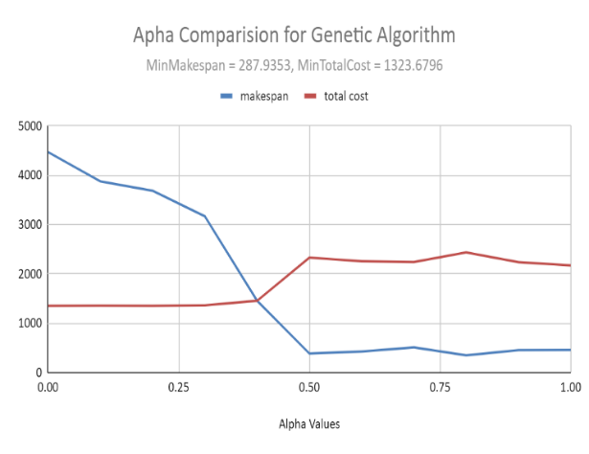

Fig 11. Graphical Representation for Alpha Comparison of GA

1. **Alpha Comparison for Modified Particle Swarm Optimization**

**Table 6. Alpha Value Comparison for Modified Particle Swarm Optimization**

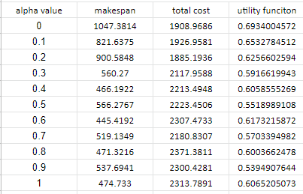

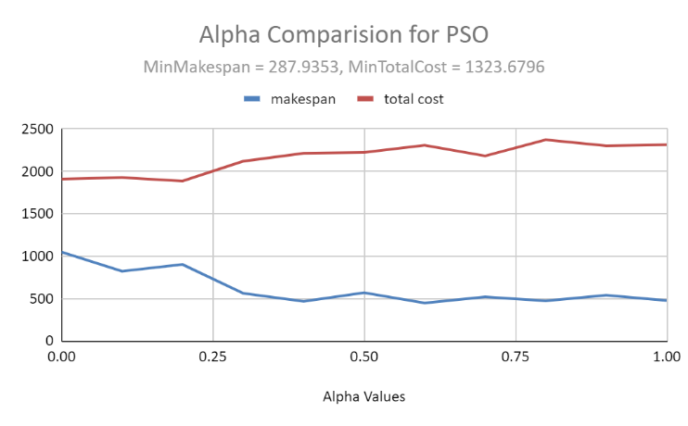

Fig 12. Graphical Representation for Alpha Comparison of MPSO