1) Pick out the odd rhyming word.

 [पुढीलपैकी यमक न जुळणारी शब्द जोडी निवडा.

1)dance-glance

2)heir-when

3)to-do

4)there-where

2) Which of the given words does not rhyme with the other.

(कोणत्या शब्दाचे इतर शब्दांशी यमक जुळत नाही.

1)ring

2)sing

3)big

4)thing

3) Choose the correct rhyming word ' well '

(Well या शब्दाशी यमक जुळणारा शब्द निवडा.)

1)girl

2)bell

3)apple

­­­­4)ball

4) Find the word that does not rhyme with the other words.

(इतर शब्दांशी यमक न जुळणारा शब्द शोधून काढा )

1)fit-hit

2)pink-sink

3)read-rich

4)bake-make

5) Select the rhyming word to fill in the empty part.

[रिकामी जागा भरण्या साठी  योग्य यमक जुळणारे शब्द निवडा.}

 ten, pen  , men  ,  ..........

1)man

2)done

3)gun

4)hen

6) Which off the following words not rhyme with the rest ?

(पुढील पैकी कोणता शब्द इतर शब्दांशी यमक जुळणारा नाही ? )

1)chalk

2)block

3)talk

4)took

7) Which of the given words begins with the capital letter?

1)mango

2)Mohan

3)man

4)monkey

8) Select the latter with " f " sound from the given option ?

1)p

2)h

3)f

4)b

9) which of the given words does not begin with the sound " ज " ?

1)giraffe

2)ginger

3)gate

4)gentle

10) Choose the word that does not sound as " ग " in the end ?

1)ring

2)sing

3)pink

4)king

11) which of the given words has different sound of the letter "u “?

1) but

2) put

3) push

4)full

12) Choose the word that begins with different sound?

1)bag

2)bat

3)pad

4)bad

13) Which of the given words is not a body part?

1)Nail

2)Mind

3)Tounge

4)Brain

14) Which word is not a part of leg?

1)Knee

2)Arm

3)Ankle

4)Heel

15) Which word is not a part of hand?

1)Arm

2)Elbow

3)Plam

4)Toes

16) Choose the proper related word for the following words...

**Stand, run, kick, ....**

1)Knee

2)Legs

3)Ankle

4)Toes

17 ) If eye : watch then nose : ?

1)Look

2)Breathe

3)Listen

4)Watch

18) If breathe : nose, then voice: ?

1)Throat

2)Neck

3)Chin

4)Ear

 19) If arm : elbow then leg : ?

1)Foot

2)Ankle

3)Toes

4)Knee

20) On which part of our body do we wear a watch ?

1)Palm

2)Wrist

3)Elbow

4)Knee

21) Find odd man out :

1)crow

2)peacock

3)sparrow

4)cow

22) Choose the correct alternative related with 'circus'.

1)potter

2)doctor

3)joker

4)painter

23) Select the name of a grain from the given option:

1)wheat

2)wheel

3)whole

4)what

24) complete the name of the clothes we wear while

going to the school: **uni_** **_ _ _**

1)firm

2)ferm

3)form

4)furm

25) Rearrange the given letters in correct order and select the name of animal : **phelenta**

1)elephant

2)entaphel

3)lentaphe

4)elentaph

26) Rearrange the given letters in correct order and select the name of colour : **lelwoy**

1)elloyw

2)yelloy

3)welloy

4)lewloy

27) Choose the pair of words that do not come together :

1)Shoes and socks

2)Read and write

3)Lock and key

4)Day and morning

28) Find the wrong pair of words :

1)Bat - ball

2)Question - answer

3)Up - come

4)Cup - saucer

29) Select the sport having wrong items to play with:

1)Badminton ( racket, cock)

2)Football ( ball, stick)

3)Hockey (ball, stick)

4)Cricket ( bat, ball )

30) Choose the correct word to add to the given list :

**school, student, teacher, blackboard, books, library, play-ground**

1)Saucer

2)Uniform

3)Boat

4)Train

31) As yellow as ................

1)rain

2)dawn

3)honey

4)turmeric

32)As sweet as ...........

1)bitter gourd

2)suger

3)lemon

4)chilli

33)As green as ..........

1)steam

2)orange

3)leaf

4)Hair

34) as cold as -------------

i) liquid

ii) ice

iii) moon

iv)air

35) as ------------ as silk.

i) rough

ii) clean

iii) soft

iv) hard

36) as bright as ----------

i)moon

ii)sun

iii) metal

iv) gold

37) as slow as -------------

i)butterfly

ii) ice

iii) bee

iv)snail

38) as strong as ---------------

i) deer

ii) cock

iii) mouse

iv) elephant

39) as light as ----------------

i) leaf

ii) feather

iii) balloon

iv) pot

40) as white as ---------------

i) hair

ii) balloon

iii) hare

iv) snow

41) as ------------- as tea

i) hot

ii) cold

iii) spicy

iv) sour

42)select the correct pair of opposite word :

1)clean × dirty

2)good × clever

3)tall × big

4)bad × wrong

43)choose the wrong pair of opposite words:

1)up × down

2)tall × straight

3)soft × hard

4)man × women

44)choose the correct opposite word for 'success'

1)profit

2)merit

3)failure

4)win

45)begining × ……................

1)starting

2)ending

3)opening

4)making

46)smooth × .........................

1)rough

2)hard

3)dirty

4)plane

47) Select correct alternatives related with flower.

1] potato

2] swing

3] star

4] hibiscus

48) Fill in the blanks.

**Ca_ef_lly**

1] u,s

2] r,u

3] a,e

4] o,r

49) See the picture and choose correct related word.

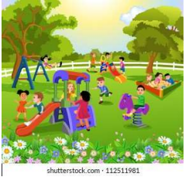

1]garden

2]school

3]hospital

4]temple

50) Select the word related with given picture.



1] happy

2] sad

3] funny

4 ] afraid

51) Choose the option related with vegetables.

1] pen,book,pencil

2] moon,star,sky

3]spinach,brianjal,tomato

4]rose,lotus,champa

52) Choose the category for the given word.

**Diwali**

1] festival

2] fruit

3] special day

4] language

**A) Fill in the blanks with the correct HOMOPHONE.**

53) Teacher said come..........

1) Hair 2) Here 3) Hare 4) Hire

54) My mother is always...............

1) Right 2) Rite 3) Write 4) Riot

55) We are going to school .........bus.

1) buy 2) bye 3) by 4) boy

56) Viren likes to ............ mango.

1) it 2) ate 3) eat 4) eight

57) The.......... is a very beautiful animal .

1) dear 2) deer 3) dare 4) dire .

58) ........... have got money .

1) Eye 2) I 3) Aie 4)Aai

59) I want to ............her at the park.

1) Meet 2) Meat 3) Mit 4) Mint

60) My brother............. the first prize.

1) won 2) one 3) own 4) on .

61) Identify the following Fruit.

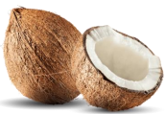

1) Papaya

2) Lemon

3) Taman

4) Coconut.

62) which fruit is Sour in taste from the following.

1) Chikoo

2) Banana

3) Papaya

4) Orange

63) which fruit has Purple Colour from the following.

1) Guava

2) mango

3 Jamun

4) Apple.

64) which fruit has smaller size from the following options?

1) Watermelon

2) Jamun

3) Musk melon

4) Coconut.

65) Find odd man out.

1) Banana

2) Peas

3) Papaya

4) Grapes

66) Find related word with fruit.

1) Sweet

2) Stone

3) Water

4) high.

67) Complete the spelling of following fruits.

**Gra__es**

1) m

2) x

3) t

4) P

68) Select the action word related to the given picture.

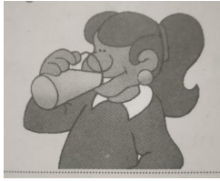

a) eating

b) jumping

c) drinking

d) washing

69) Identify the incorrect describing word related to the given picture.

a) Black

b) Tall

c) Thin

d) Fat

70) Choose the proper describing word for the given picture.

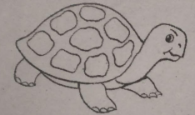

a) fast

b) sour

c) slow

d) sad

71) What is the boy doing in the picture?

a) cutting

b) grating

c) shelling

d) washing

72) Choose the correct describing word for the following picture.

a) angry

b) afraid

c) mad

d) cry

73) Rearrange the letters to get a meaningful word from -- esh ?

1. esh
2. seh
3. hse
4. she

74) Find the similar word for the word 'Rabbit?

(1) Hare

(2) Here

(3) Rat

(4) pet

75) Find the describing hidden Word in the word 'microsoft ' ?

(1) So

(2) cost

(3) soft

(4) of

76) How many two lettered words can be formed by using the letters of the word 'phone ' ?

(1) Three

(2) four

(3) one

(4) two

77) Which pronoun is hidden in the following word .choose the correct option 'hour'?

(1) or (2) oh (3) our (4) ro

78) Choose the correct related word for the word ' sweet' ?

(1) milk

(2) jilebi

(3) roti

(4) grevy

78) Choose the correct letters to make meaningful words ?

**___old ___old ___old**

1. s g h
2. (2) s t o
3. s n t
4. s b n

79) Look at the picture and say wherethe ball is:

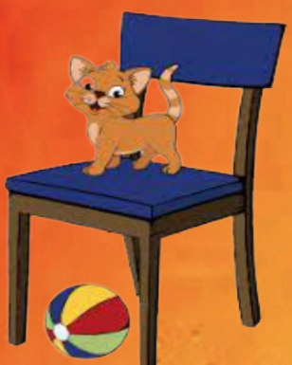1) in the chair

2) on the chair

3) under the chair

4) near the chair

80) The fruits are.....the table.

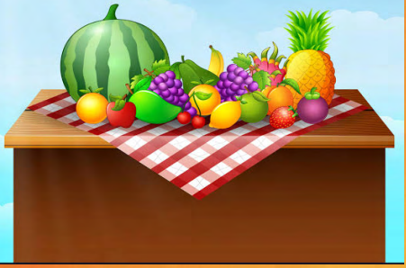

1) under

2)on

3) in

4) onto

81) The boy is throwing the ball ....... the net.

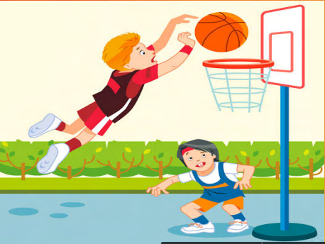

1) in

2) on

3) into

4) over

82) The man is walking ....... the bank.

1) towards

2) to

3) near

4) over

83) The ball is rolling ......the box.

1) onto

2) below

3) towards

4) near

84) The girl is standing.......the tree.

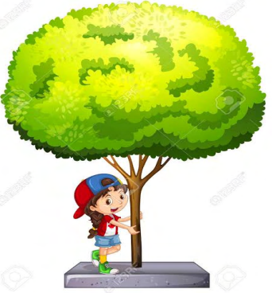

1) under

2) over

3) on

4) below

85) My mobile's battery is...........average.

1) below

2) under

3) onto

4) on