**Instruction to execute the code**

Code is at : <https://github.com/sachin2smart/RandomImageAPI>

Import & Run the Spring boot project.

First hit the request: <http://localhost:8080/>

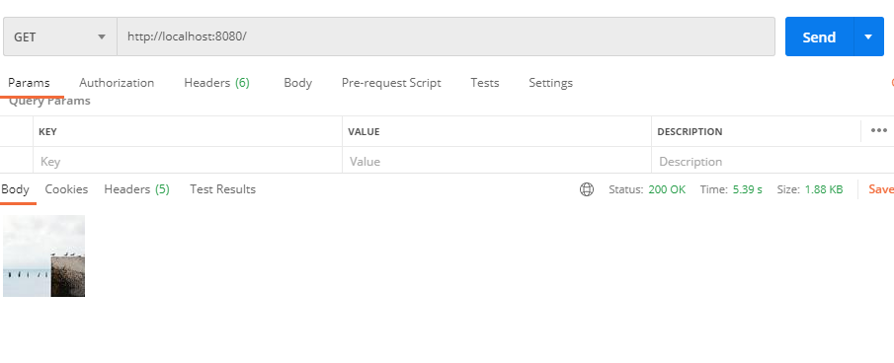

Log will give the id of the random image (as shown below : console shows - 83)

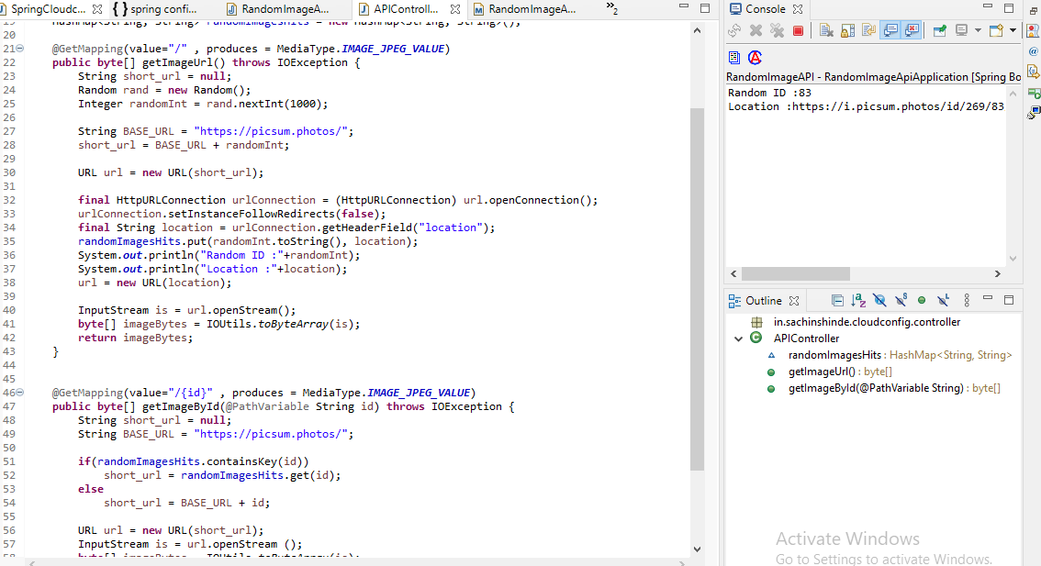

Now, hit the url: <http://localhost:8080/83> - It will give the same response, as retrieved from the random request

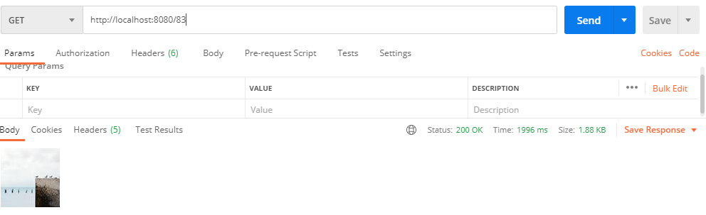

Any other can be triggered:

