**Parmar Sachin Jagdish Bhai**

Assignment-1(Front end Assignment)

MODULE: 1(HTML)

**1.Are the HTML tags and elements the same thing?**

**ANS =** NO, The HTML tags and elements are not same things.

E.X = <h1>Hello World</h1>

This example is called elements.

E.X = <h1></h1>

This example is called tags.

**2.What are tags and attributes in HTML?**

**ANS =** Tags are used to start of an HTML element and they are usually enclosed in angle brackets. An example of a tag is: <h1>.

<h1 class=” section”></h1>

IN the above example “class” is called attributes.

**3.What are void elements in HTML?**

**ANS =** The void elements are those elements who has a starting tag but not contain the ending tag.

E.X = <br>,<hr>,<img>,<input>,<source>,<link>

**4.What are HTML Entities?**

**ANS =** In a HTML we can use < > as a &lt; &gt; and non breaking space we can use &nbsp; called HTML Entities.

**5.What are different types of lists in HTML?**

**ANS =** There are “THREE” types of lists in HTML.

1.Ordered List [ <ol> -- </ol>

2.Unordered List [ <ul>--<?ul>

3.Description List [ <dl>__<dt>--</dt><dd>--</dd>__</dl>]

**6.What is the class attribute in HTML?**

**ANS =** The class attributes are given the class name HTML element. WE use .in a CSS to specify a class.

**7.What is the difference between the ‘id’ attribute and the ‘class’ attribute of HTML elements?**

**ANS =** we can use “.”to specify a **CLASS** attribute and use “#” to specify **ID** attribute. We can use same class but cannot use same id attribute.

**8.What are the various formatting tags in HTML?**

**ANS =** There are the various formatting tags in HTML.

<b> - Bold text.

<i> - Italic text.

<mark> - Marked text.

<del> - Deleted text.

<strong> - Important text.

<ins> - Insert text.

<sub> - Subscript text.

<sup> - Superscript text.

**9. How is cell padding different from cell spacing?**

**ANS =** Cell padding defines the space between a table cell’s border and cell spacing defines the space between individual cells.

**10.How can we club two or more rows or columns into a single rows and column in an HTML table?**

**ANS =** We can merge two or more table cells in a **column** using the **colspan attribute** in a **<td> HTML tag.**

To merge two or more **row cells,** use the **row span attribute.**

**11.What is the difference between a block-level element and inline elements?**

**ANS =** Block Elements occupy the full width.

Inline elements don’t start in a new line. Block elements always start in a line.

**EXAMPLE:**

Block level elements:

<section> <header> <footer> <div> <table> <aside> <article> <h1-h6>

Inline elements:

<i> <b> <img> <small> <sub> <sup> <em>

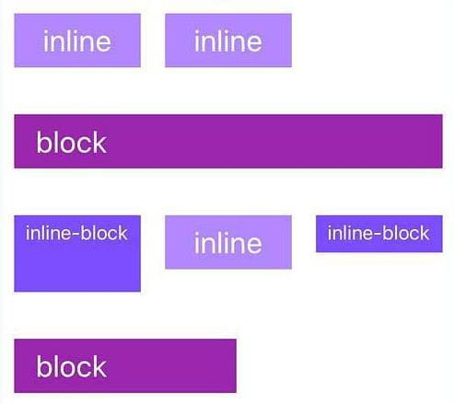

**11.How to create a Hyperlink in HTML?**

**ANS =** The Element <a> tag defines a hyperlink.

Example,

<a href =[www.facebook.com](http://www.facebook.com)”>Facebook</a>

**12.What is the use of an iframe tag?**

**ANS =** An frame is used to display another document in the current HTML document.

**13.What is the use of a span tag? Explain with example?**

**ANS =** The <span> tag is an inline container used to mark up a part of a text, or a part of a document

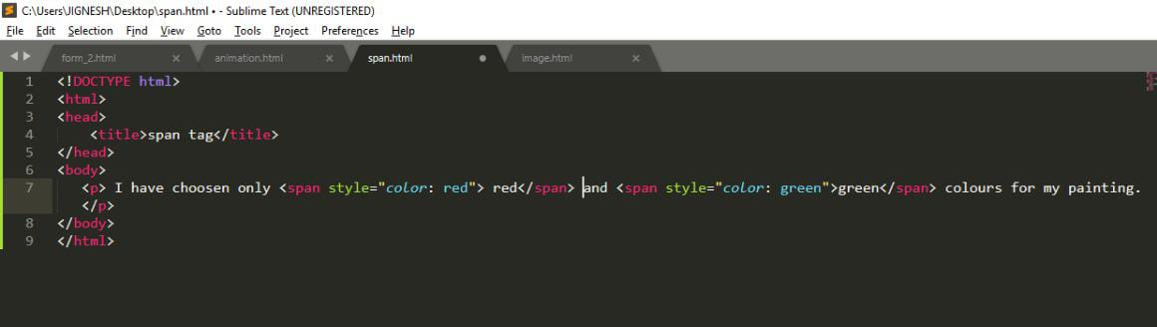

The <span> tag is easily styled by CSS or manipulated with JavaScript using the class or id attribute.

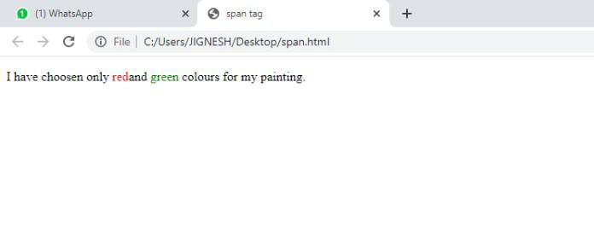

**14.** **How to insert a picture into a background image of a web page?**

**ANS =** For inserting a picture into a background image of a web page we have to use CSS, basically <style> tag and ‘background-image’ property.

**15.How are active links different from normal links?**

**ANS =** There are three types of links.

(1) Active link.

(2) Unvisited link / Normal link.

(3) Visited link.

**(1) Active link:** Active link is when we open a link once in the browser it is set to be open and remains open then the colour of the link name is changed into **Red** and remains like that.

**(2) Normal link:** When we put a link via <a> tag in HTML and run it in the browser it appears in **blue** colour with **underline.** This is called a normal link.

**16. What are the different tags to separate sections of text?**

**ANS =** There are few tags used for separation of sections of text.

1. **<hr>** ‘hr’ is a tag for horizontal lines.
2. **<br>** ‘br’ is a usually used as a breaking tag.
3. **<p>** ‘p’ is paragraph tag for the addition of a new paragraph in text.

**17. What is SVG?**

**ANS =** 1) SVG stands for ‘Scalable Vector Graphics’.

2) SVG work only HTML5.

3) SVG defines the graphics in web.

4) Every element and every attribute in SVG files can be animated

**18.What is the difference between HTML and XHTML?**

**ANS =** HTML is Hypertext Markup Language while XHTML is Extensible Hypertext Markup Language.

* HTML works on SGML (Standard Generalised Markup Language) application where XHTML works on XML (Extensible Markup Language) application.
* HTML is less expressive than XHTML.
* XHTML has much more value for the rules than HTML.
* HTML is not case sensitive but XHTML is Case sensitive.
* Compatibility of XHTML to browsers are more than HTML.

**19. What are logical and physical tags in HTML?**

**ANS = PHYSICAL TAGS:**

* Physical tags are used to decide the appearance of the text and do not provide any information about the text.
* Physical text are used to style the content only. For instance, **<i>** is used to display the text in italic format.
* It is a extremely straightforward.

**LOGICAL TAGS:**

* Logical tags describe the behaviour, nature of content for the text enclosed inside the tag. They represent the function of text on the page.
* Logical text are used to provide information by giving special importance to the text. For instance, **‘<em>’** tag is used to emphasise the text by representing it in italic format.
* It carries certain obligations.

**20. What is the ‘class’ attribute in HTML?**

**ANS =** The HTML class attributes is used to specify a class for an HTML element.

Multiple HTML element can share the same class.