**Step 1:** Start Eclipse, click on file > New > Project

**Step 2:** In the popped new wizard, scroll down and select Maven > Maven Project, click Next.

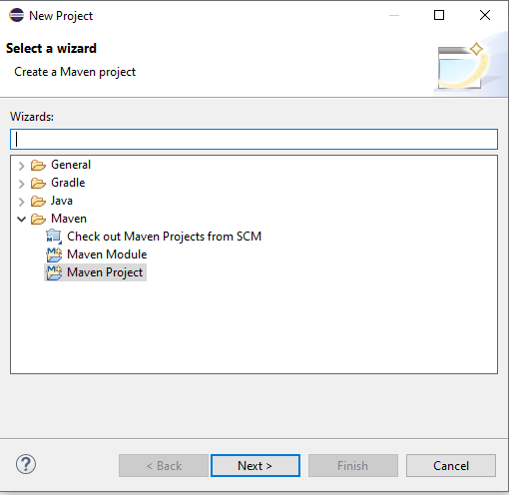

**Step 3:** Then leave the ‘Use default workspace location’ selected to create this project in the current workspace and select ‘Create a simple project. Click Next.

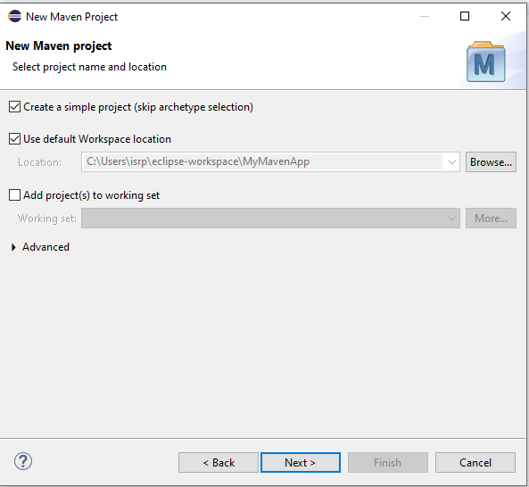

**Step 4:** Click Next. Provide Group Id, Artifact Id & version. These parameters gives your project deliverable (jar/war/ear …) a unique identity in repository. Click Finish. Refresh your project.

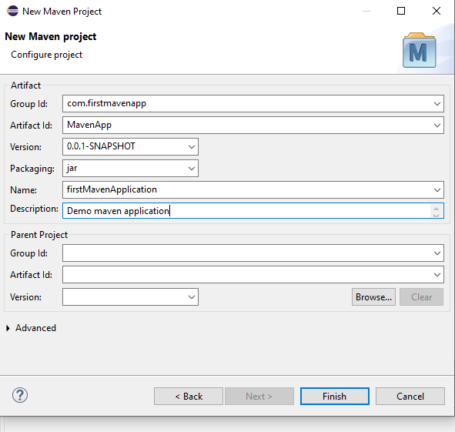

**Step 5:** Your project structure should like below one.

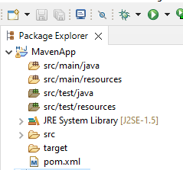

**Step 6:** In MavenApp click on src/main/java right click new>Class and create a new java class

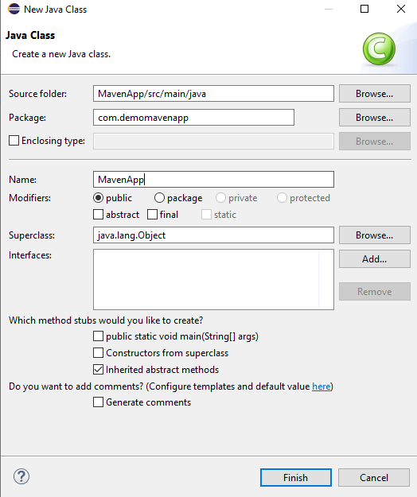

**Step 7:**

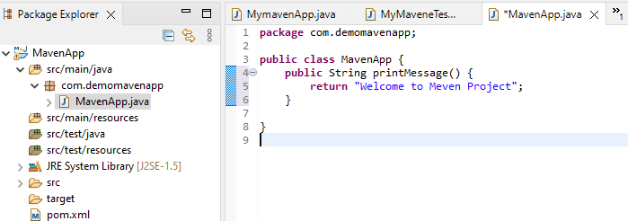

Step 8:src/test/java>new>junit test case

