SQL Internship Project Report

Name: [SACHIN KUMAR SAHU]

Date: June 27, 2025

**.Use SELECT, WHERE, ORDER BY, GROUP BY**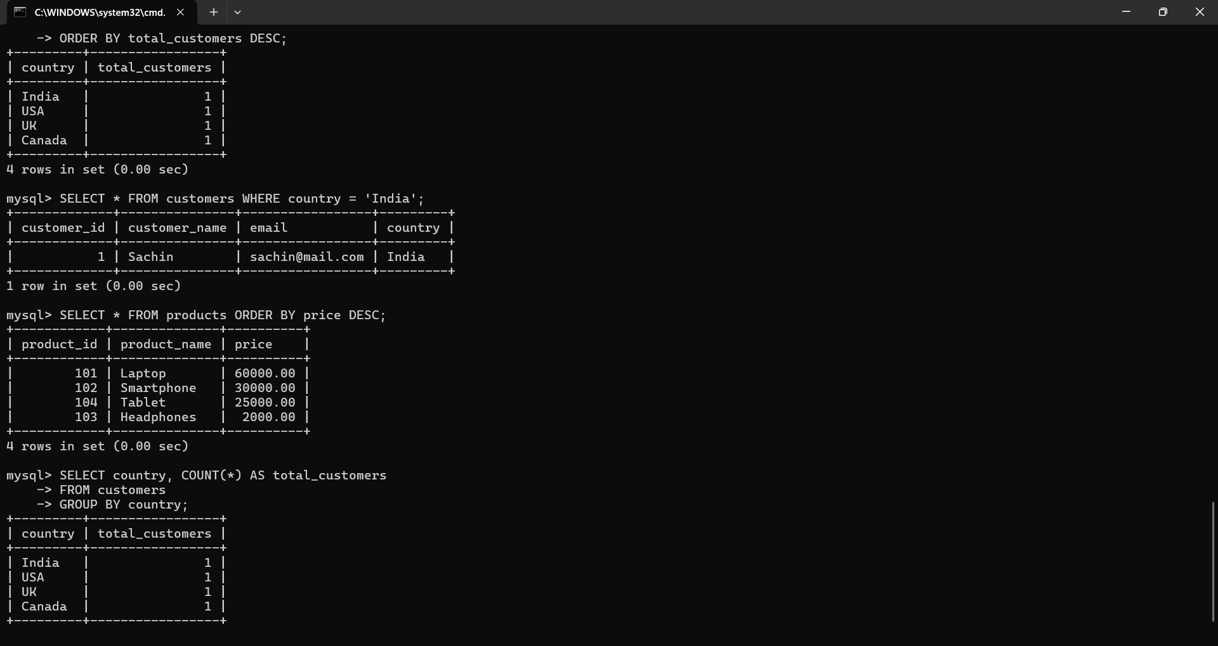

# .Use JOINS (INNER, LEFT, RIGHT)1. Introduction

This report summarizes the SQL internship project, where a simple retail database system was created with customers, products, orders, and order items. The project involved creating tables, inserting sample data, and running SQL queries including joins, aggregate functions, subqueries, views, and indexing.

# 2. Table Creation

SQL statements used to create tables:

• customers  
• products  
• orders  
• order_items

Paste Screenshot of table creation:

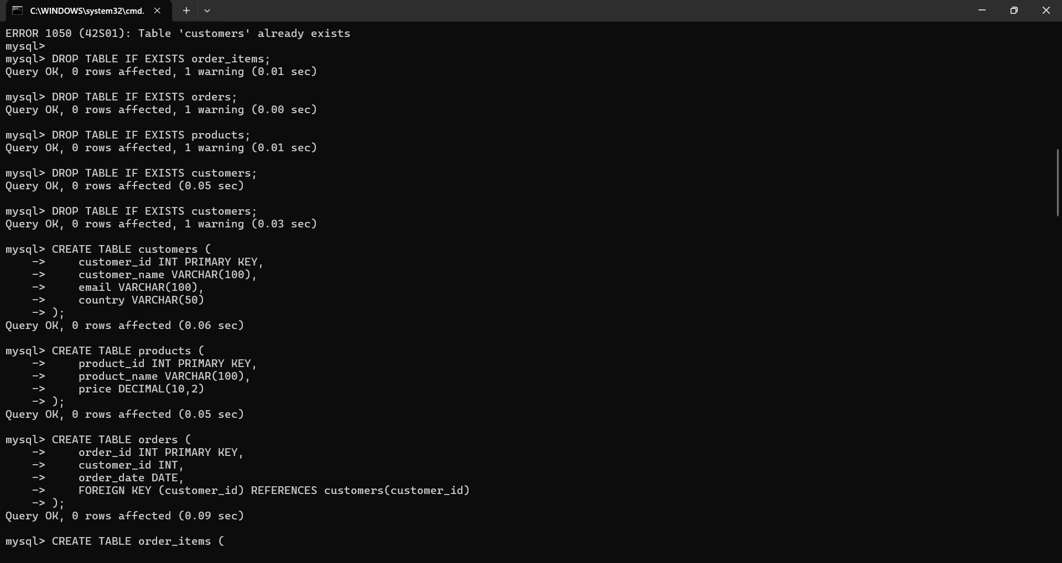

# 3. Data Insertion

Sample data was inserted into all tables.

Paste Screenshot of successful inserts or SELECT * queries:

[Insert Screenshot Here]

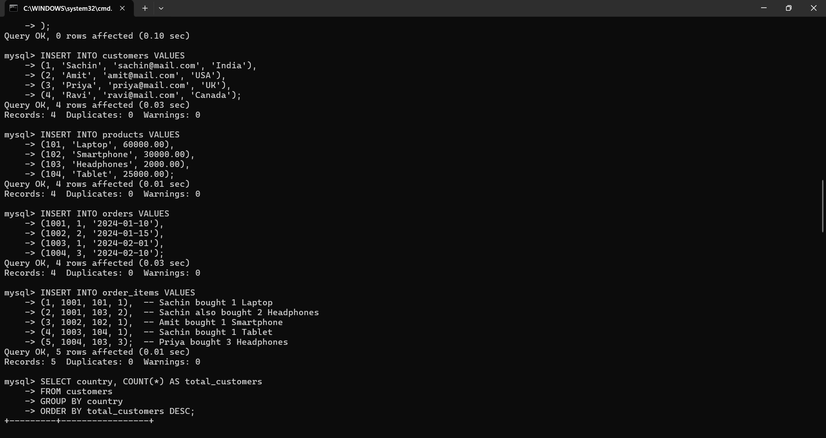

# 4. Basic Queries

Example: SELECT, WHERE, ORDER BY, GROUP BY

Paste Screenshot of output:

[Insert Screenshot Here]



# 5. Join Queries

INNER JOIN and LEFT JOIN used to combine related data across tables.

Paste Screenshot of JOIN output:

[Insert Screenshot Here]

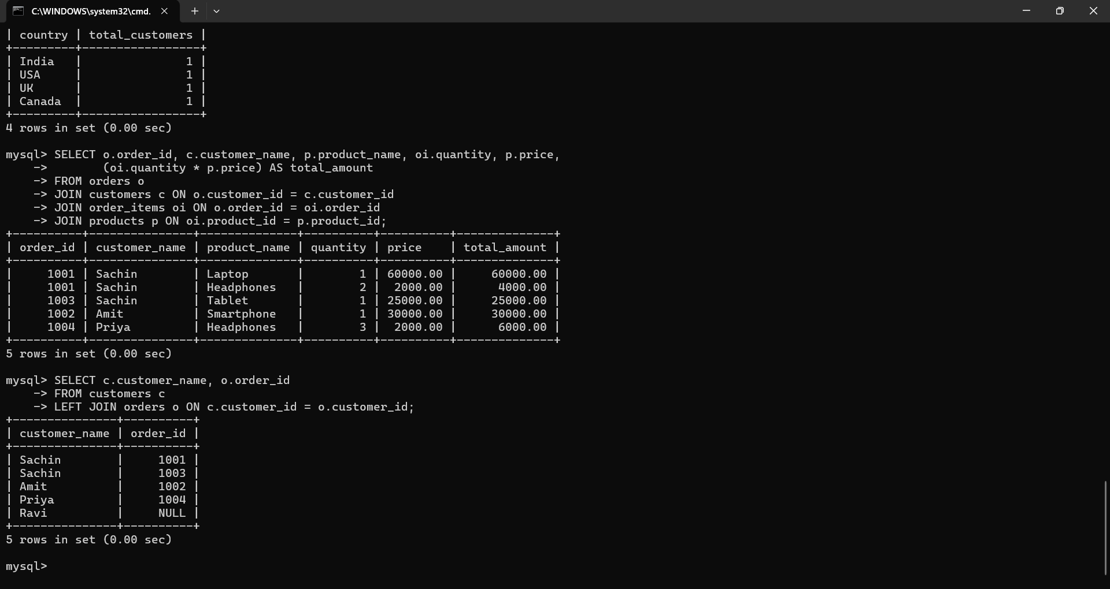

# 6. Aggregate Functions

SUM and AVG functions used to calculate revenue and averages.

Paste Screenshot of results:

[Insert Screenshot Here]

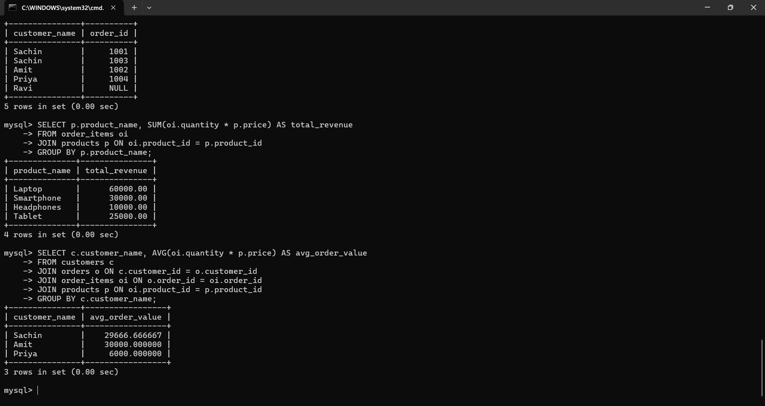

# 7. Subqueries

Used to filter based on grouped or calculated values (e.g., customers with >1 order).

Paste Screenshot of result:

[Insert Screenshot Here]

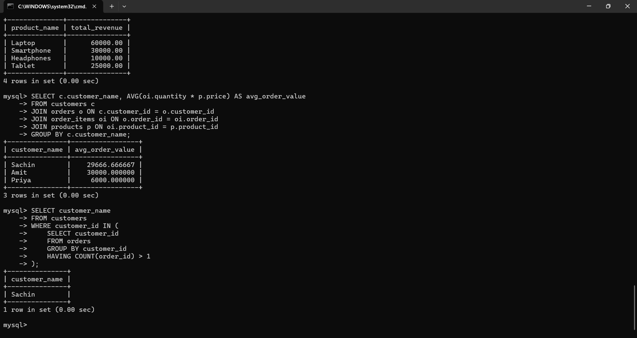

# 8. Views

Created view: customer_order_summary

Paste Screenshot of SELECT * from view:

[Insert Screenshot Here] 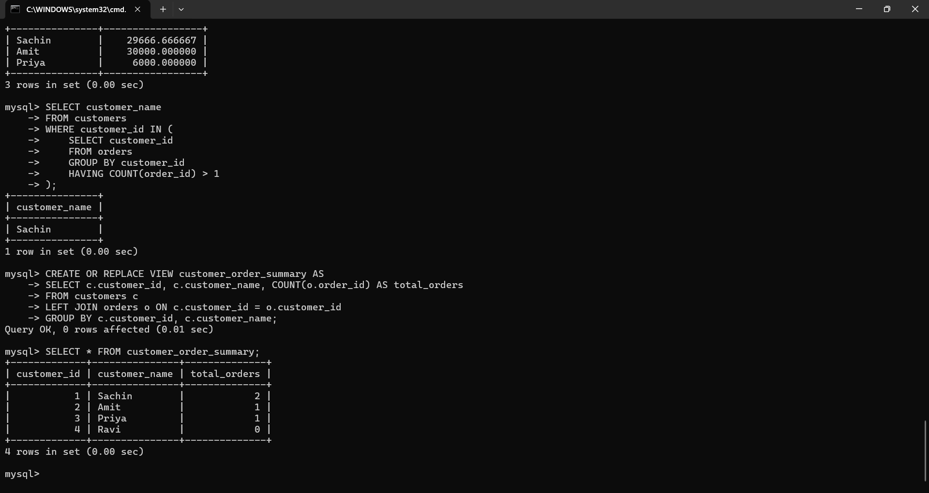

# 9. Indexing

Indexes created to improve performance on customer_id and product_id.

Paste Screenshot if tested with EXPLAIN or performance improvement:

[Insert Screenshot Here]

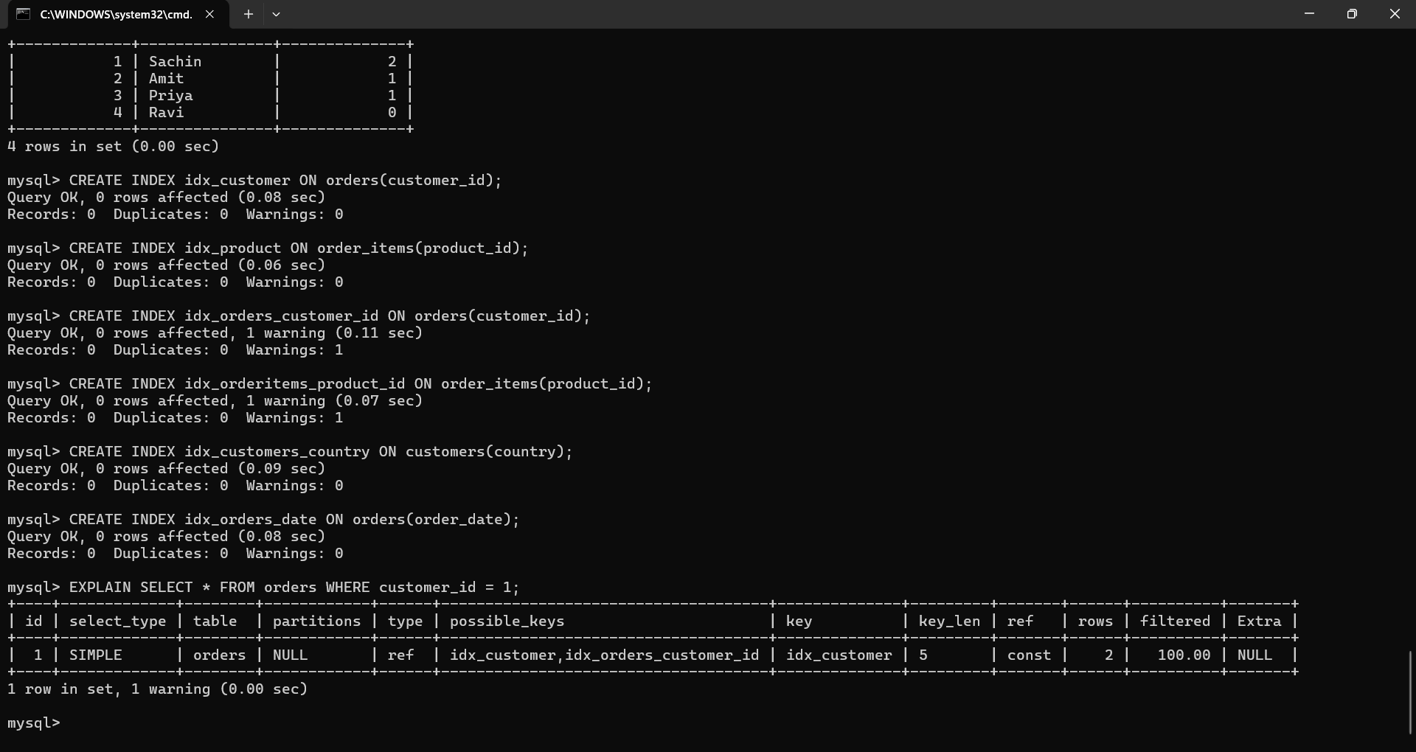

# 10. Conclusion

This SQL project helped in understanding database creation, relationships, and complex query building using different SQL techniques. The entire workflow was tested and validated through MySQL command line interface.