**Aug 19, 2023**

**Project 1:**

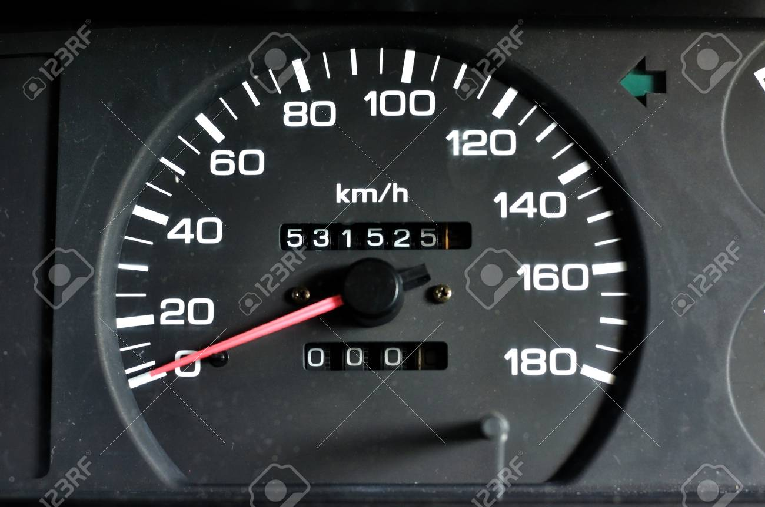

**250 Km**

**531525+250=**

**Price Petrol=95 Rs/Lt.**

**Total Lt: 10 lt.**

**Efficiency: 13 Km/Lt.**

**Find the average of your vehicle's mileage (fuel efficiency) using Python, you can follow these steps:**

**1. **Gather Data:** Collect data on the distances traveled and the corresponding fuel consumption for your vehicle. You'll need a list of distances in kilometers (or miles) and a list of corresponding fuel consumption values in liters (or gallons).**

**2. **Calculate Mileage:** For each data point, divide the distance traveled by the amount of fuel consumed to calculate the mileage (distance per unit of fuel).**

**3. **Calculate Average:** Calculate the average mileage by summing up all the calculated mileages and dividing by the total number of data points.**

**Project 2:**

**Analyzing data and making calculations using Python:**

**\*\*Expense Tracker and Analyzer:\*\***

**Create a program that allows you to track your expenses and analyze your spending habits. This project will involve data input, data manipulation, and generating basic statistics.**

**\*\*Steps:\*\***

**1. **Data Input:** Build a system where you can input your expenses along with the corresponding categories (e.g., groceries, entertainment, utilities, etc.). You can do this by taking user input in the form of expense amount and category.**

**2. **Data Storage:** Store the entered expenses in a data structure like a list of dictionaries or a Pandas DataFrame.**

**3. **Expense Analyzer:** Implement functionality to calculate various statistics, such as total expenses, average expenses per category, highest and lowest expenses, etc.**

**4. **Category-wise Analysis:** Provide the user with the ability to see how much they've spent in each category and visualize this data using graphs or charts.**

**5. **Time-based Analysis:** Extend the program to allow for time-based analysis, like monthly or yearly summaries, and calculate trends in spending.**

**6. **Budget Comparison:** If you have a budget set, compare your actual expenses to your budget and display whether you're over or under budget.**