

Exposys

Data

Labs



Certificate

o

f

Internship

TO WHOM IT MAY CONCERN

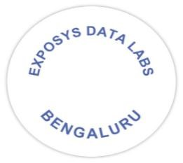

This

is

to

certify

that

Mr

.

SACHIN

MEENA

has

completed

internship

programme

on

“

Full-Stack

Developer

”

from

1.12

.2021

to

10.01.2022

.

He

took

keen

interest

in

the

work

assigned

and

successfully

completed

it.

During

the

period

of

internship

we

found

him

to

be

punctual,

hardworking

and

inquisitive.

We

wish

him

luck

and

success

in

all

his

future

endeavours.



Y

Vishnuvardhan

Chief

Director



hr@exposysdata.com

www.exposysdata.com