* **Narrow and wide transformation:** Diagram

  Description automatically generated

* **Narrow Transformation:**

1. **Map:**

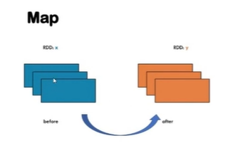

1. **flatMap:**

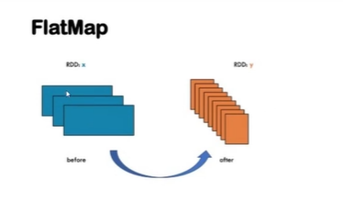

1. **Filter:**

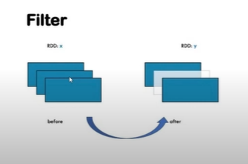

1. **Union:**

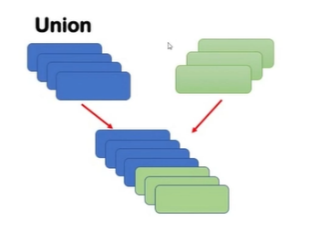

* **Wide Transformation:**

1. **GroupBy:**

1. **Intersection:**

1. **Substract:** Removes the common value from the RDDs.

1. **Distinct:** It will give the unique values from a RDD.
2. **mapValues:** it is same as map.
3. **ReduceByKey:**

1. **GroupByKey:**

* **RDDs vs Dataset vs Dataframe:**

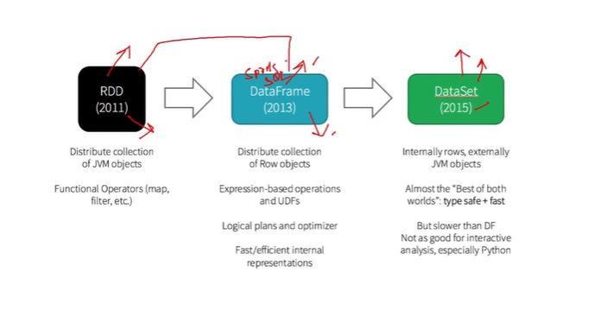

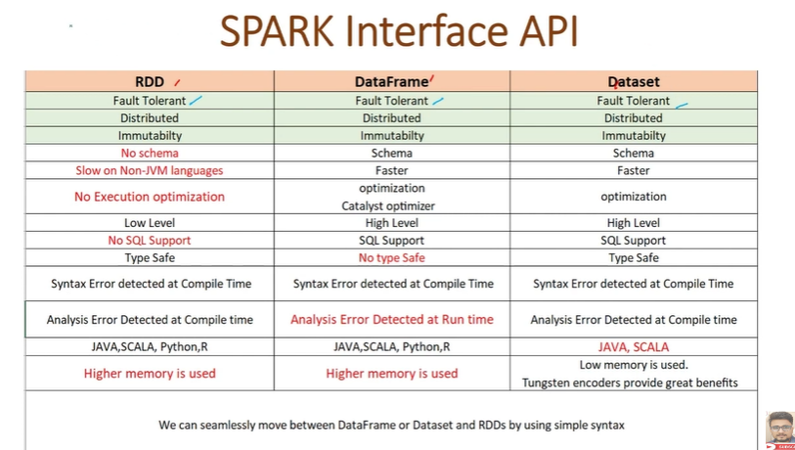

* **Spark SQL Dataframe:**

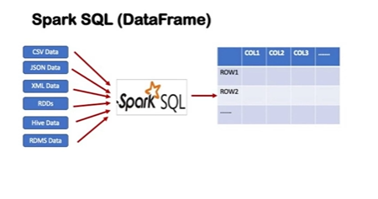

import pyspark

spark = pyspark.sql.SparkSession.builder.master("local").appName('Tutorial').getOrCreate()