LAB2 AGILE BACKLOG CREATION &SPRINT SIMULATION IN JIRA
NAME : SACHIN B R SRN : PES1UG25CS839
List of epics created
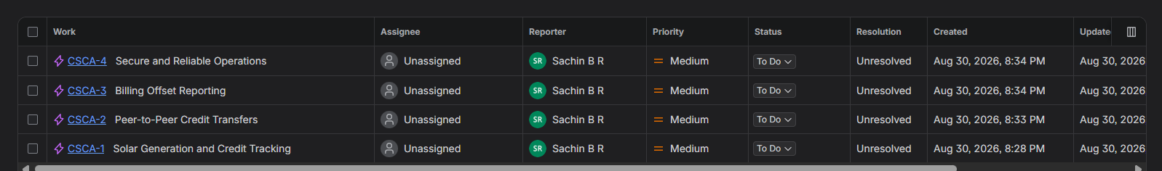
Backlogs
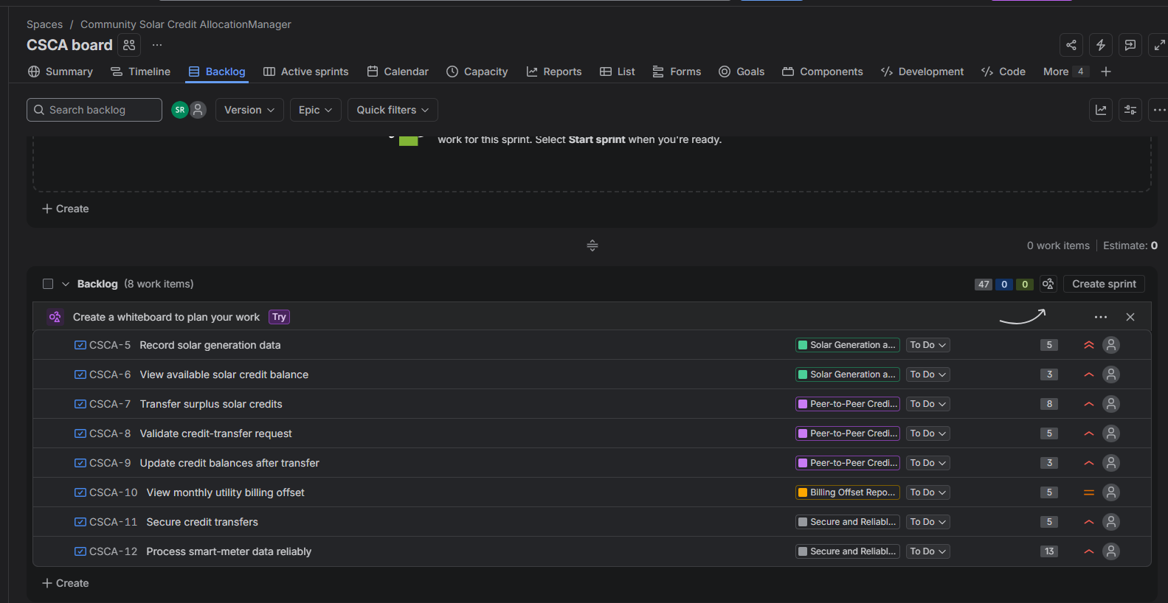
First epic and its userstories
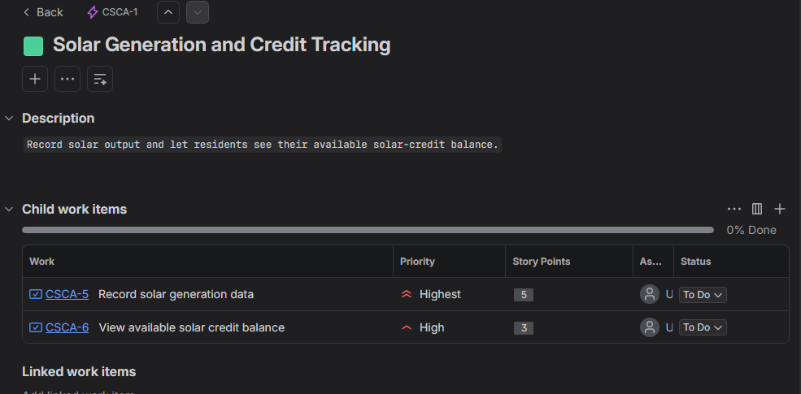
Second epic and its userstories

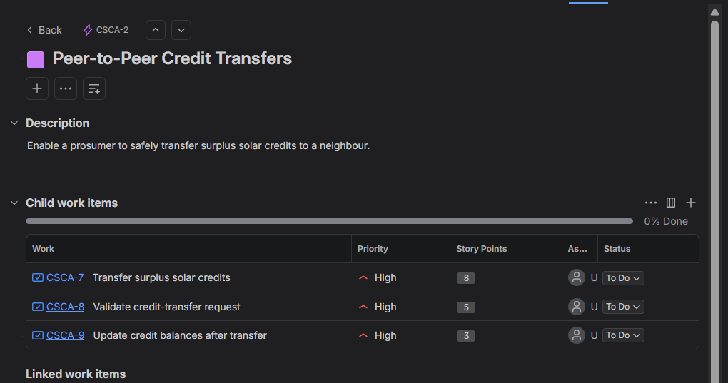
Third epic and its userstories

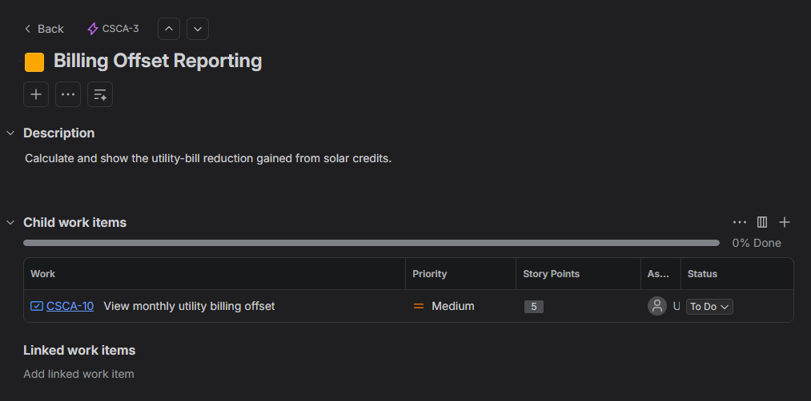
Fourth epic and its userstories

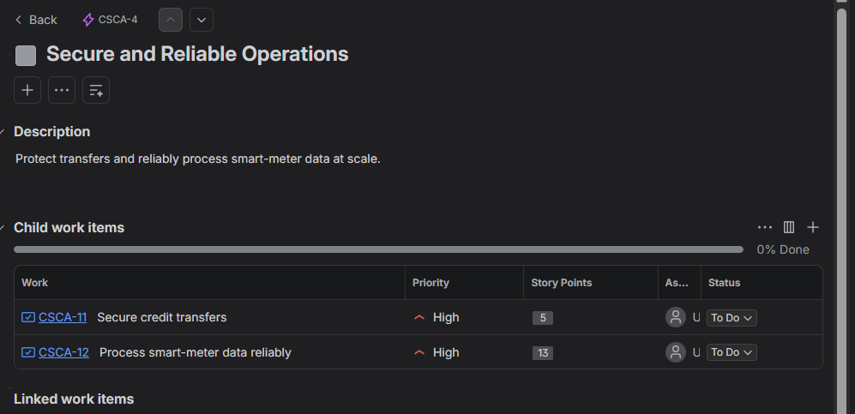
Sprint one completion
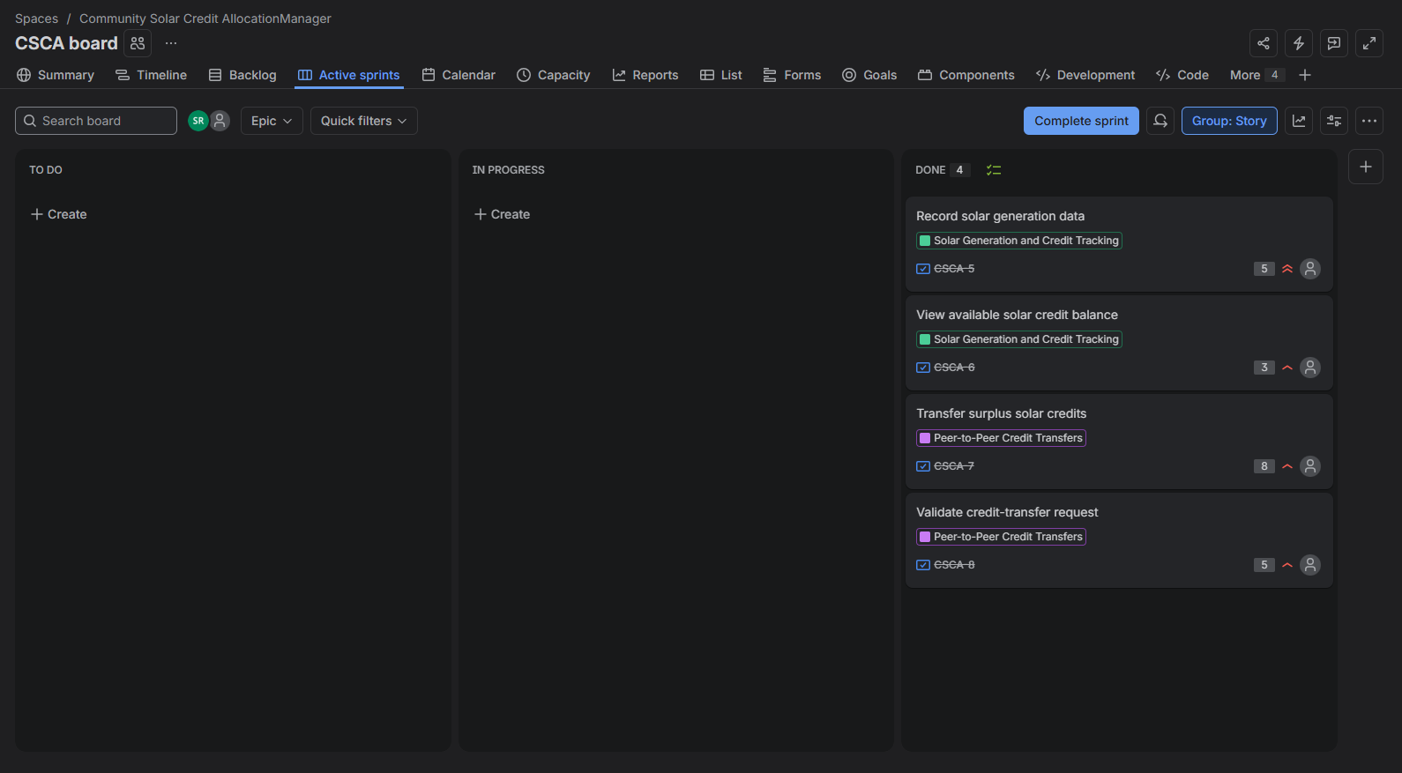
Sprint two completion
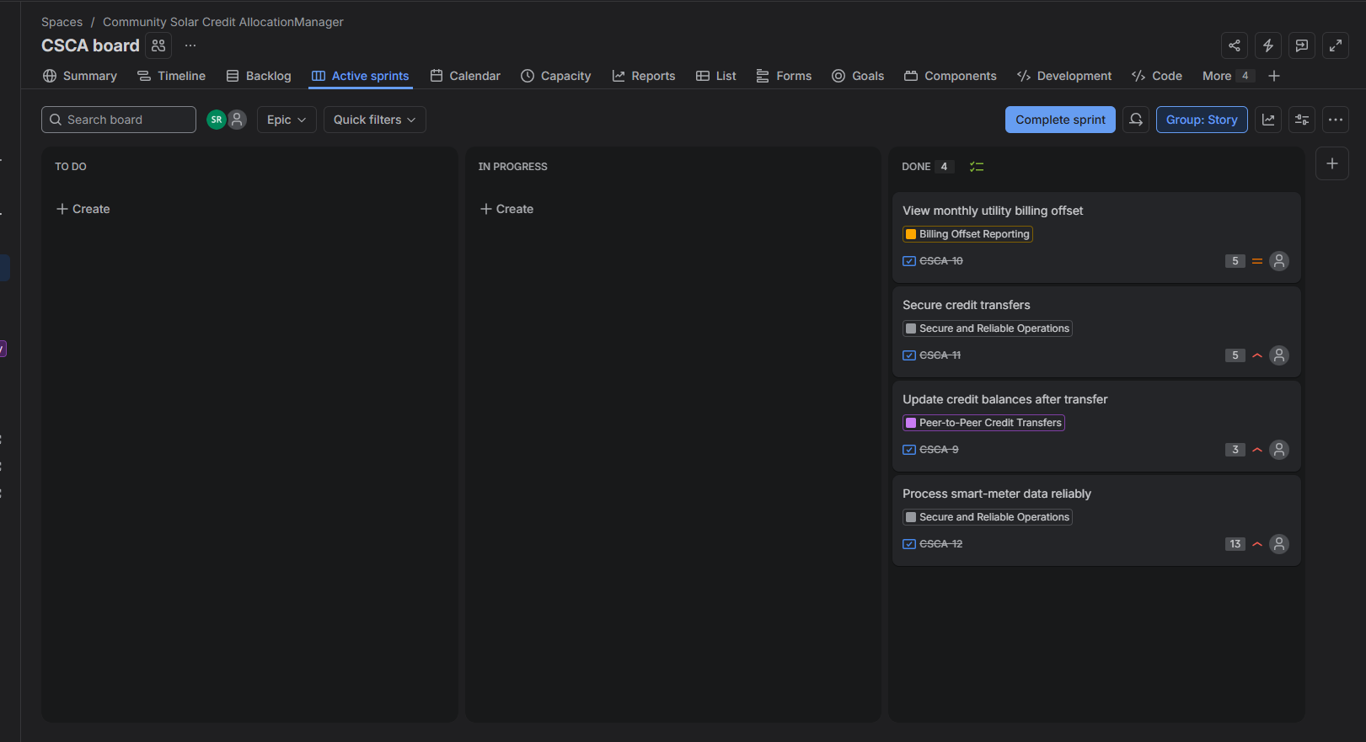
Burndown chart of first sprint
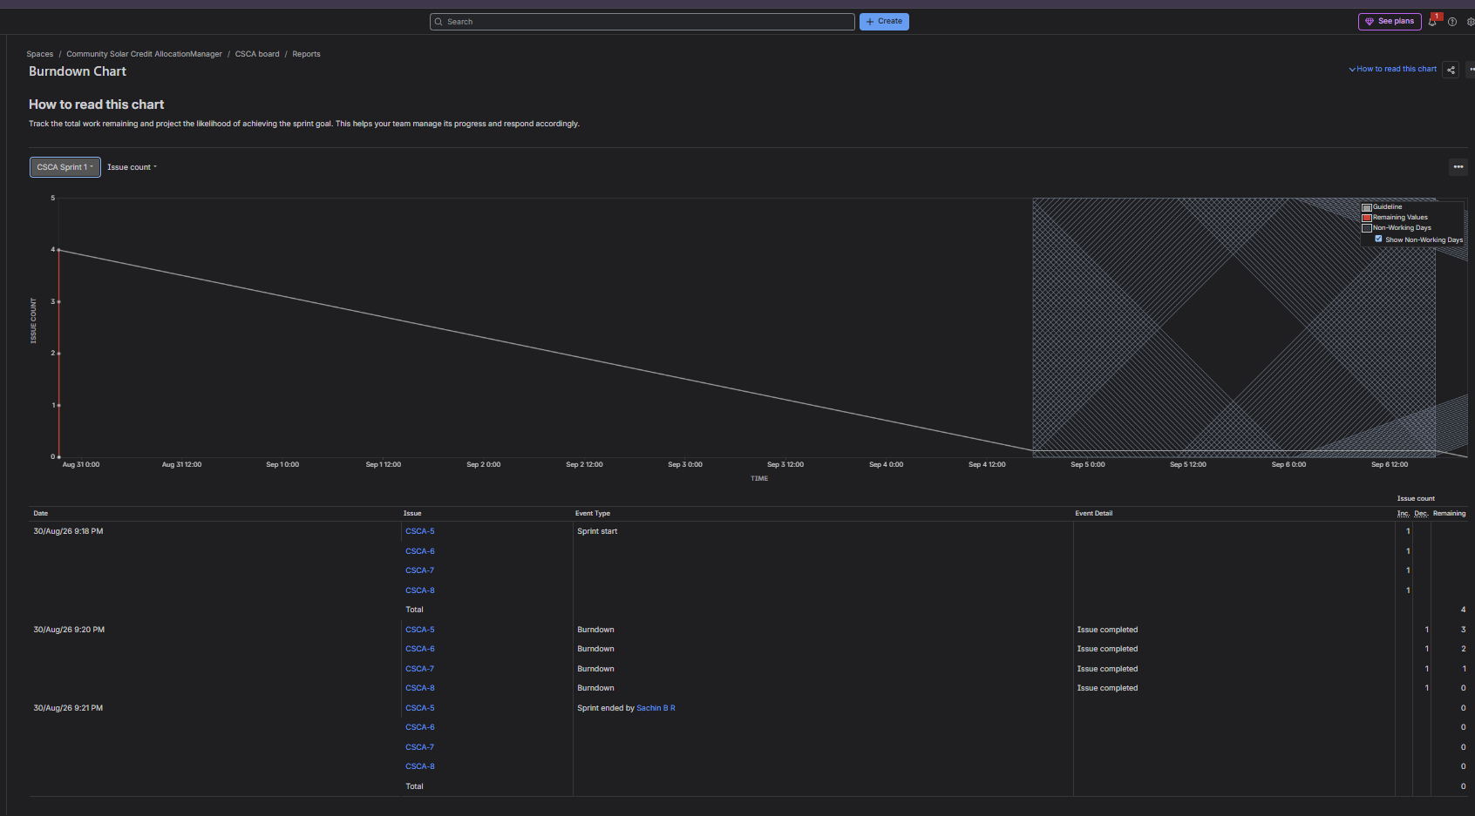
Burndown chart of second sprint
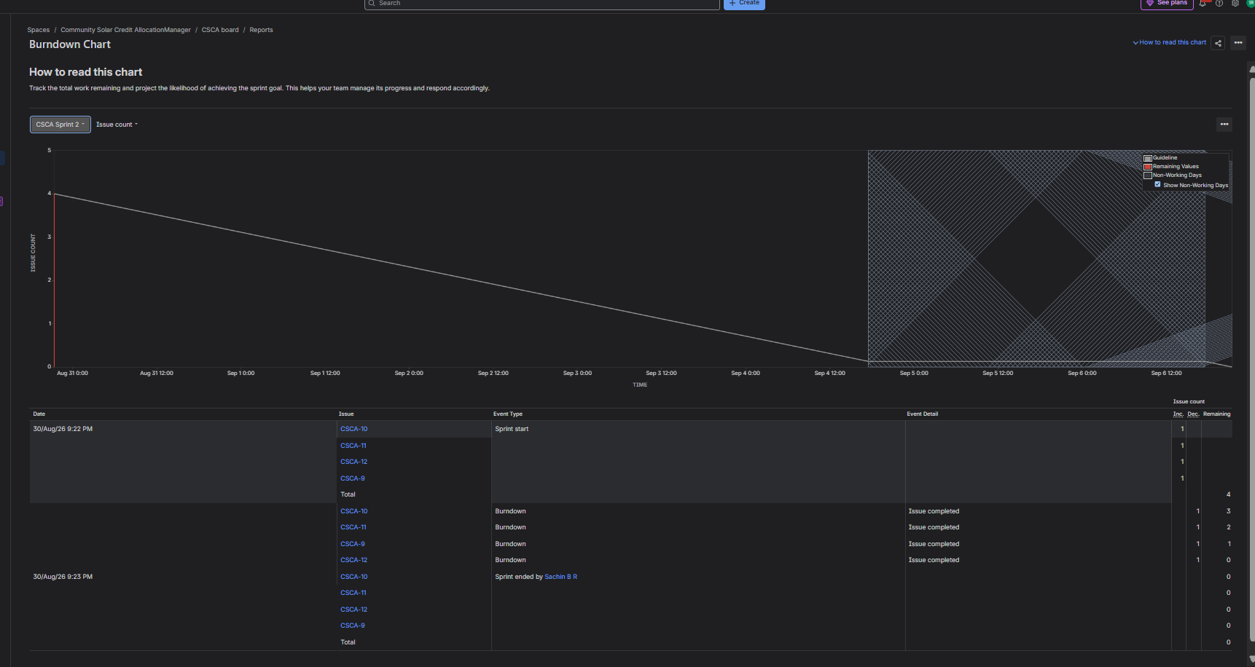
Q&A
1. Did your estimations reflect the actual effort?
The estimates represented the relative complexity and uncertainty of each user story. Simple features, such as viewing a balance, had fewer story points. More complex features, such as credit transfers and reliable smart-meter processing, had higher story points because they require validation, security, and accurate processing.
2. Was your backlog well-prioritized?
Yes. The most important stories were prioritized first: recording solar generation, viewing credit balances, transferring credits, and validating transfers. These are the core features of the application. Billing reports were medium priority because they are useful after the main credit-transfer process works.
3. How did your simulated sprint align with your plan?
Sprint 1 focused on the core solar-credit workflow. Sprint 2 completed the transfer process and added security, billing, and reliability-related work. This sequence allowed the most valuable functions to be handled first.
4. What insights did the burndown chart give about your team’s capacity?
The burndown chart showed the remaining story points during the sprint. As stories were moved to Done, the remaining work reduced. It demonstrated that larger stories require more capacity and that story-point estimates help a team plan a realistic amount of work for each sprint.

