IMPLEMENTATION NOTES

INTRO
The project currently has three completed stages:
1. Construct point-in-time SEC filing signals.
2. Evaluate the candidate signals using cross-sectional diagnostics.
3. Freeze the selected signal before developing the expected-return estimator and optimizer.

The selected signal combines:
1. Semantic similarity between a company’s most recently available SEC filing summary and the AI-infrastructure theme.
2. An LLM derived measure of the economic materiality of that exposure.

The remaining pipeline is:
standardized SEC signal → historical cross-sectional return slopes → empirical Bayes calibration → expected active return vector → constrained portfolio optimizer → portfolio evaluation

The next part is to convert the standardized signal into a point-in-time expected active return vector. The strongest framing for the paper is a methodology and measurement paper. The methodology demonstrates how an LLM derived thematic exposure can be constructed point in time, audited, converted into expected returns, and passed into a portfolio optimizer. The available 2023–2026 sample is not long enough and doesn’t cover enough market regimes to establish that the signal represents a permanent return premium. For this paper, this is reasonable and we can discuss extending it in the future.

NOTATION
The 21-day and 63-day models are estimated separately.

Treat the return horizon 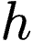 as fixed. The same procedure is run once for 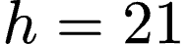 and once for 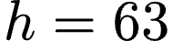.

Notation
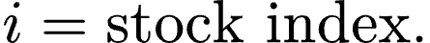
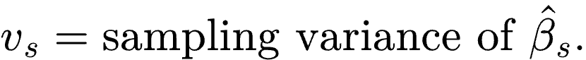

POINT-IN-TIME SIGNAL

Stocks and rebalance dates
Let 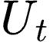 denote the set of stocks included in the universe at date . The signal is evaluated approximately monthly. The return horizons are:

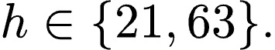

The 21-day and 63-day specifications are estimated separately. Their coefficients and empirical Bayes parameters are not pooled together.

Filing availability
For stock , let 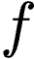 index its historical SEC filings. Let 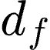 be the filing date. Let  denote the conservative filing-availability lag. The filing becomes available on:

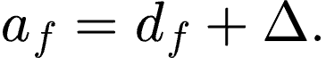

At rebalance date , the selected filing is:

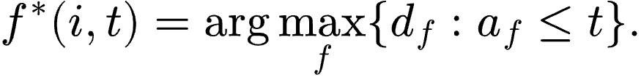

This selects the most recent filing considered available by date . No filing released after date may affect the signal at date .

Semantic similarity
Let 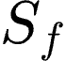 denote the structured summary of filing . Let  denote the AI-infrastructure theme description. Let 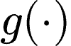 the embedding function. The filing to theme semantic similarity is:

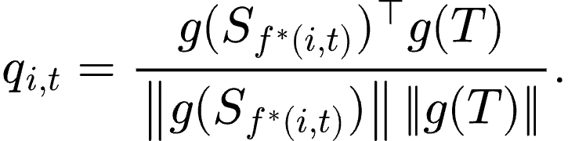

Exposure materiality
Let 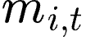 denote the exposure-materiality score extracted from the point-in-time filing. The exposure score is:
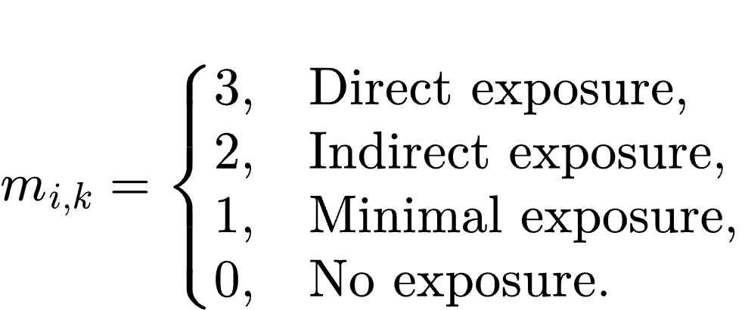

Raw interaction signal
The raw interaction is:

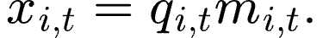

The economic motivation is that generic AI-related language receives limited weight unless the filing also describes material economic exposure. The interaction was engineered before subsequent returns were observed. The selection of this feature was made from a larger set of features and was determined by diagnostics. This process will be disclosed in the paper.

Cross-sectional standardization
At each date , calculate the cross-sectional mean:

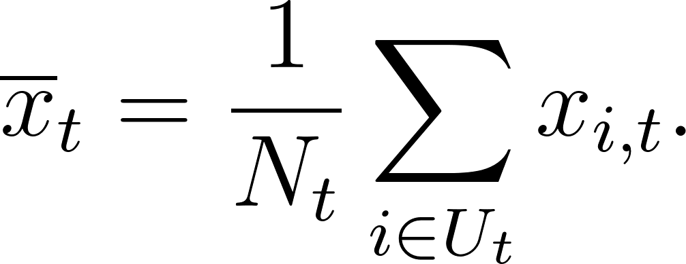

The cross sectional standard deviation is:

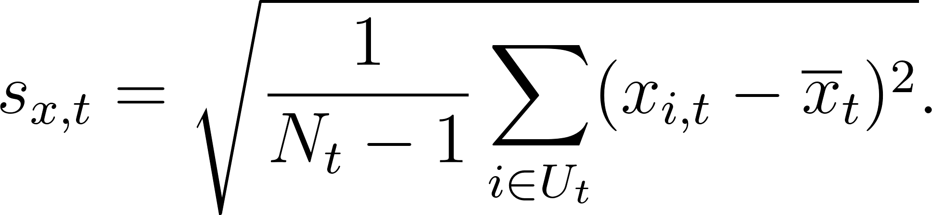

The standardized signal is:

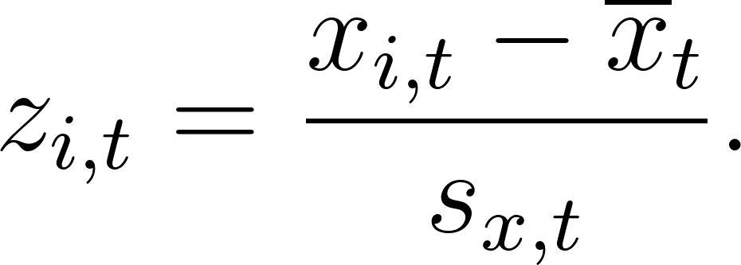

By construction:

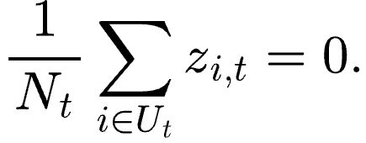

Here 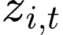 is a standardized cross-sectional score. It’s not the expected return forecast. For example, 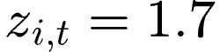 means that stock is 1.7 cross-sectional standard deviations above the universe mean on the selected SEC signal. It does not mean that the stock has an expected return of 1.7%.

SIGNAL AUDITS

Interaction vs. exposure audit
Embedding similarities are in a limited numerical range while the exposure materiality scores might vary more. The product might be dominated by the exposure score. For each date, we calculate:

Pearson and Spearman correlations are reported for:
1. Similarity alone.
2. Exposure alone.
3. Similarity multiplied by exposure.

If the interaction is nearly identical to exposure alone and does not improve the predictive diagnostics, the interpretation should be changed.

10-K versus 10-Q audit
The mean, standard deviation, and distribution of the following variables are calculated separately for 10-K and 10-Q filings:
1. Semantic similarity.
2. Exposure materiality.
3. Raw interaction.
4. Standardized interaction.

This shows whether the filing type changes the signal level.

Filing age audit
Define filing age at rebalance as:

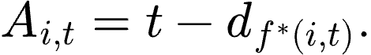

We report:
1. Median filing age.
2. Interquartile range.
3. 90th percentile.
4. Percentage older than six months.
5. Percentage older than nine months.

Run a robustness analysis excluding observations satisfying:

FORWARD-RETURN TARGET

Trading day endpoint
Let 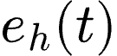 denote the -th trading date after rebalance date .

Raw forward return
Let 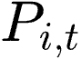 denote the adjusted price of stock at date . The forward return is:

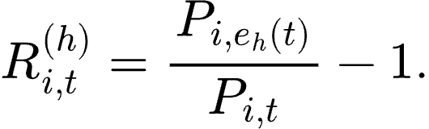

Equal-weight universe return
For the valid stock sample at date , define:

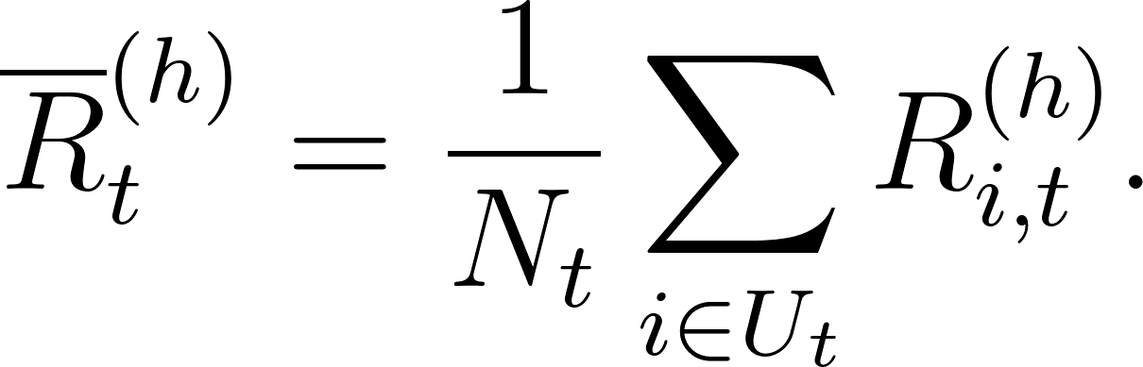

Forward active return
The response variable is:

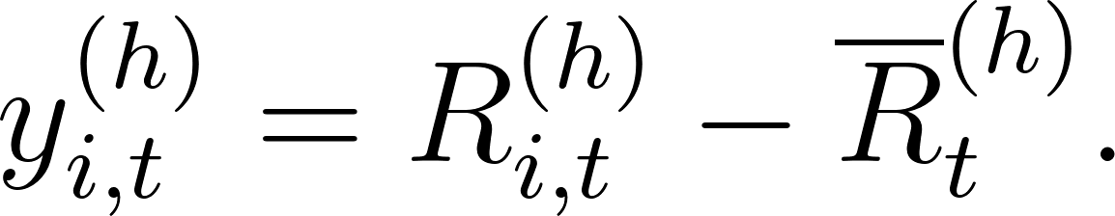

By construction:

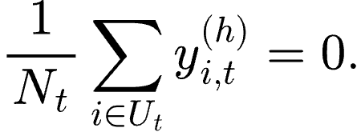

This target measures return relative to the equal weight research universe. It removes the cross-section average return but it does not remove sector effects. Sector adjusted returns will be included for robustness. The signal and active return must be recentered after removing stocks with missing signal or outcome observations.

Within the exact regression sample:

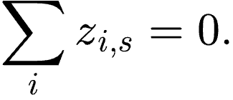

Also:

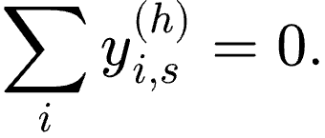

COMPLETED HISTORICAL OUTCOMES
At forecast date , only historical dates whose complete forward return endpoint occurred before date are eligible. The completed-date set is:

An expanding estimation window is used. For 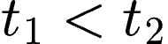:

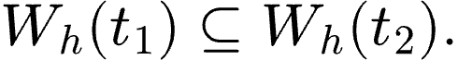

A minimum warm-up threshold is imposed:

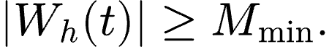

We are currently using:

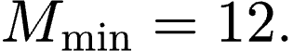

Before the threshold is reached, the forecast remains missing. Later information is not used to fill early forecast dates. The 12-period rule has been chosen as a practical warm-up.

HISTORICAL CROSS-SECTIONAL REGRESSION
For each completed historical date , estimate:

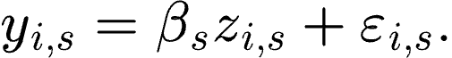

This is one regression across stocks at one historical rebalance date and not a regression on one monthly return time series. Because both 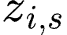 and 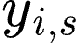 are centered in the exact regression sample, the baseline model uses no intercept.

The direct slope estimate is:

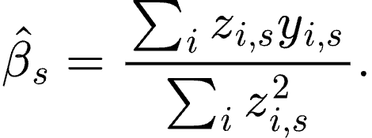

Because has approximately unit cross-sectional standard deviation, the slope measures the active return associated with a one-standard-deviation increase in the SEC signal.

For example, if 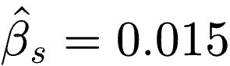, then for this completed historical cross-section, a one standard-deviation increase in the SEC signal was associated with approximately 1.5% higher active return over the selected horizon.

Sampling variance
Each historical slope estimate is noisy. Define:

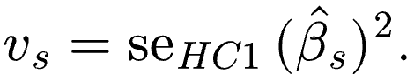

The HC1 standard error addresses cross-sectional heteroskedasticity within historical date . It does not address serial dependence across different rebalance dates.

Robust historical slope estimates
HC1 changes the estimated standard error, but it does not prevent extreme stock returns from changing the slope point estimate. The implementation produces:

1. Baseline OLS.
2. OLS after 1% and 99% winsorization of the active-return target.
3. Huber regression tests. (TBD)

These are robustness tests. The SEC signal itself remains unchanged.

EMPIRICAL-BAYES CALIBRATION

Observation model
For every completed historical date:

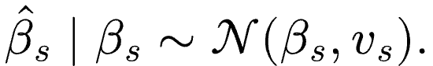

The quantity 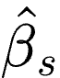 is the observed historical slope. The quantity 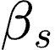 is the true but unobserved slope for that date. The sampling variance 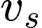 measures uncertainty in the direct slope estimate.

Population model
Assume that the true historical slopes come from a common population:

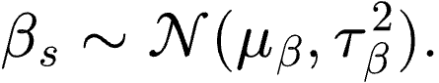

Here, 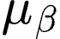 is the typical underlying signal-return slope. The quantity 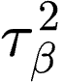 measures variation in the true slope across historical rebalance dates. The sampling variance and the between date variance are different quantities. The sampling variance measures uncertainty about one historical slope estimate. The between date variance measures variation in how strongly the signal is related to subsequent returns at a particular rebalance date.

Between date variance estimation
At current forecast date , use only completed historical dates in 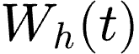. The baseline method of moments estimator is:

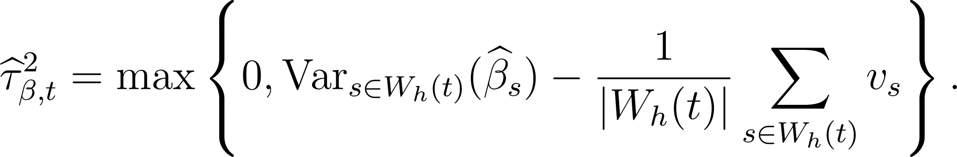

Can be interpreted as:
Observed variation across estimated slopes = genuine between-date variation + average slope estimation noise.

The zero lower bound is imposed because a variance cannot be negative. The implementation records whether this lower bound is active.

Precision weights
Define:

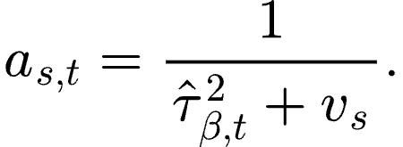

A historical slope with a smaller sampling variance receives more weight. A noisier historical slope receives less weight.

Estimated population mean
The empirical-Bayes estimate of the average slope is:

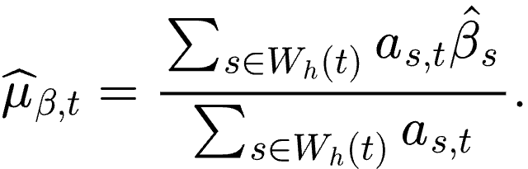

This is the predicted slope for the new period beginning at date .

Shrunk historical slopes
Define the historical shrinkage weight:

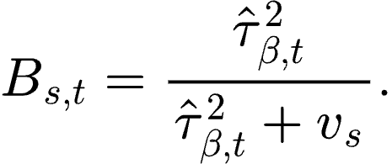

The shrunk estimate of the latent historical slope belonging to historical date , estimated using the information set available through date :

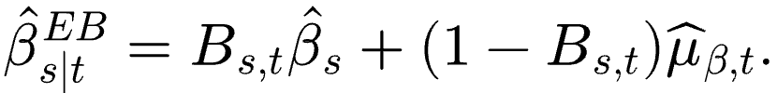

The shrunk historical slopes are empirical Bayes estimates of the latent signal payoff for completed historical periods. They show how much each noisy direct estimate is pooled toward the population mean. However, they are retrospective estimates rather than point-in-time forecasts available at the beginning of those periods.

Current period forecast:
At the current forecast date , the forward return beginning at date has not yet been observed. Therefore, the direct cross-sectional slope 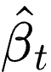 is unavailable. Using only the completed historical dates in , the empirical-Bayes estimate of the population mean slope is:

Under the empirical Bayes model, 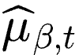 is also the predicted slope for the new return period beginning at date . The corresponding stock level expected active return is:

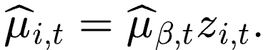

Here, is the standardized SEC signal for stock at date . The quantity converts one unit of the standardized signal into expected return units. For example, 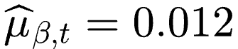, then a stock with 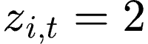 has an estimated forward active return of:

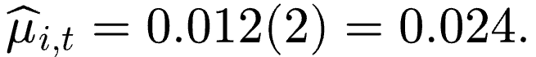

This corresponds to an expected active return of approximately 2.4% over the selected horizon.

Sign constrained forecast
As an additional economic restriction, define the forecast slope as:

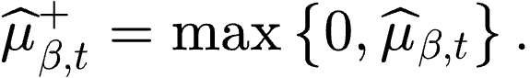

The corresponding sign-constrained stock level forecast is:

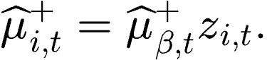

If 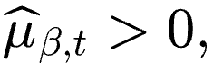 then 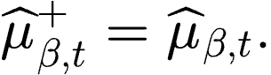 If 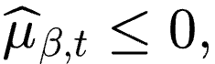 then 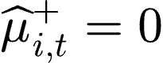 for every stock. The zero floor is an additional portfolio rule that turns the signal off when the estimated average signal payoff is nonpositive.

Relationship to shrunk historical slopes
For each completed historical date , the empirical-Bayes estimate of the latent historical slope is:

This combines the noisy direct historical slope with the estimated population mean . The quantity 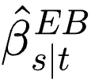 estimates the true slope that applied to the completed historical period beginning at date . For the new period beginning at date , the direct slope is not yet available. Therefore, there is no date-specific observed slope to shrink. The predicted slope for the new period is simply:

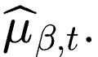

The distinction is therefore:

The stock-level expected-return forecast is then:

STOCK LEVEL EXPECTED ACTIVE RETURNS
The current standardized signal is .The expected active return is:

The expected-return vector is:

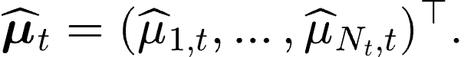

Because the signal is centered:

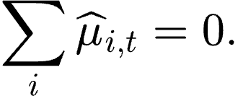

These quantities are expected returns relative to the equal-weight research universe. They are not total return forecasts. The calibration corresponds to:

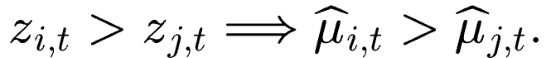

The empirical Bayes model does not change the stock ranking. It changes the units and scale of the signal. The empirical Bayes layer stabilizes the estimated return payoff assigned to one unit of the SEC signal.

OVERLAPPING RETURN ROBUSTNESS
The baseline empirical Bayes model treats the date specific historical slopes as approximately independent. That assumption is weak for monthly observations with 63-day forward returns.
We include a few robustness tests:

1. All-date baseline estimator. Estimate the point-in-time empirical Bayes model using every completed historical date. This is the primary estimator because it uses all available information.
2. Non-overlapping 63-day sequences. Divide the monthly dates into three staggered sequences:
Sequence A: 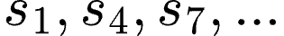
Sequence B: 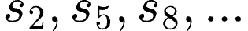
Sequence C: 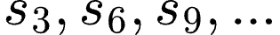

Verify using the actual trading date endpoints that the forward-return windows within each sequence do not overlap. Estimate the empirical Bayes model for each sequence.

Compare for 1 and 2:
- Estimated population mean.
- Estimated between-date variance.
- Current forecast coefficient.
- Variance-floor frequency.
- Zero-floor frequency.

3. Moving-block bootstrap, Resample historical dates using blocks of three to four monthly observations. For every bootstrap sample, recompute:

1. Historical slopes.
2. Between-date variance.
3. Empirical-Bayes population mean.
4. Forecast coefficient.

Use the bootstrap distribution to form confidence intervals.This addresses uncertainty caused by the short and dependent historical time series.

Q5-PREMIUM EMPIRICAL BAYES
The regression estimator assumes a linear signal return relationship. The existing diagnostics suggest that much of the return separation may occur in the highest signal quintile. The Q5-premium estimator is therefore a nonlinear alternative.

Q5 indicator
At historical date , define:

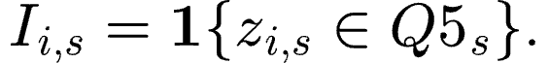

Let the share of stocks in Q5 be:

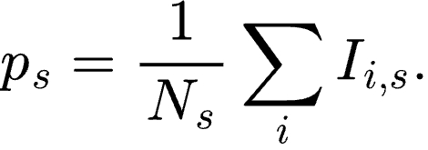

Historical Q5 premium
Define:

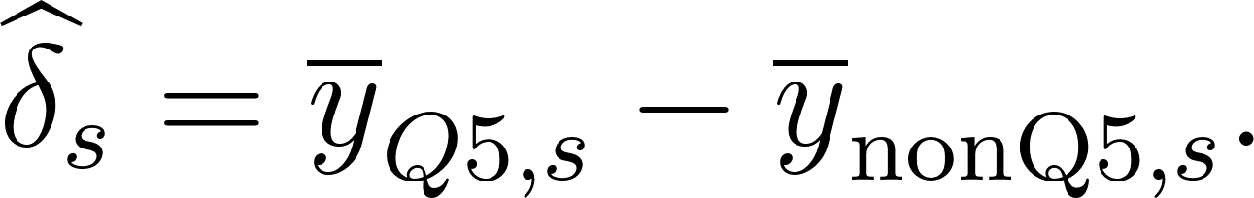

This measures how much Q5 outperformed the remainder of the universe during that completed historical period.

Sampling variance
Let 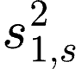 denote the sample variance of active returns in Q5. Let 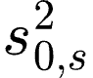 denote the sample variance outside Q5. Then:

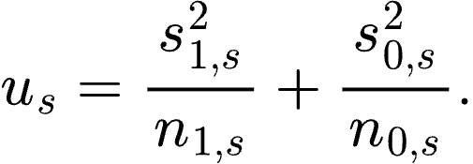

Empirical Bayes model

Use:

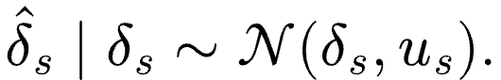

Assume:

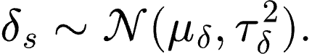

Estimate the population parameters using only completed historical dates.

Current Q5 forecast
Let 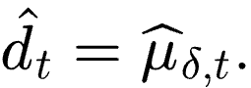 The centered stock-level Q5 forecast is:

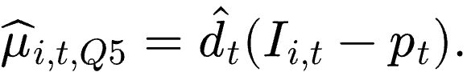

This guarantees:

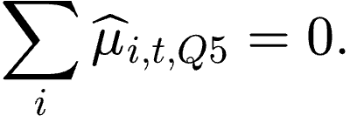

Unlike the linear estimator, the Q5 estimator changes the effective cross-sectional structure.
It collapses all Q5 stocks to one forecast level and all non-Q5 stocks to another forecast level.
It should therefore be treated as a distinct nonlinear estimator rather than as another scaling method.

DEPENDENCE AWARE SIGNAL INFERENCE
For every candidate factor and horizon, we will report:

1. Mean rank IC.
2. IC standard deviation.
3. IC information ratio.
4. Percentage of dates with positive IC.
5. Newey–West t-statistic.
6. Moving-block-bootstrap confidence interval.
7. Mean Q5-minus-Q1 spread.
8. Sector-neutral spread.
9. Dependence-aware confidence intervals for both spreads.

This includes spread estimates with confidence intervals.

CALIBRATION VALIDATION
The estimator must be evaluated using genuine out-of-sample forecasts. At each forecast date :

1. Estimate the model using only .
2. Save the predicted slope 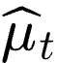.
3. Wait until the endpoint is complete.
4. Estimate the subsequently realized direct slope .
5. Compare the forecast with the realized slope.

Date-level calibration regression
Estimate:

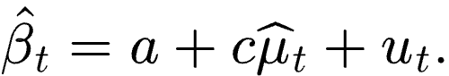

Ideal calibration corresponds approximately to:

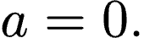

And:

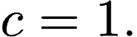

Because the number of forecast dates is small and the outcomes overlap, use moving-block-bootstrap or HAC uncertainty.

Calibration statistics
1. Mean forecast slope.
2. Mean realized slope.
3. Mean forecast error.
4. Mean absolute error.
5. Root mean squared error.
6. Correlation between predicted and realized slopes.
7. Calibration intercept.
8. Calibration coefficient.
9. Error relative to a zero-forecast benchmark.
10. Percentage of dates with the correct slope sign.

Stock-level calibration plot
Pool only genuine out-of-sample stock-level forecasts. At each date, assign stocks to forecast deciles. For every decile, calculate:

1. Mean predicted active return.
2. Mean realized active return.
3. Confidence intervals based on resampling or clustering by date.

Plot realized return against predicted return with a 45-degree reference line.

Realized-to-predicted spread ratio
Calculate:

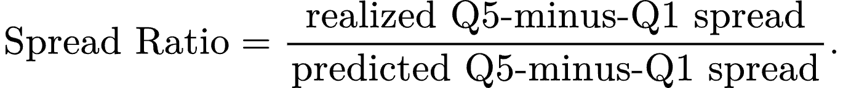

A ratio below one suggests that forecast magnitudes are too large. A ratio above one suggests that the estimator may be too conservative.

Rolling estimator figure
Plot through time:
1. .
2. 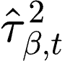.
3. Number of completed historical dates.
4. Whether the variance floor binds.
5. Whether the zero slope floor binds.

Estimator comparison
Compare:
1. Raw standardized signal.
2. Simple expanding-window average slope.
3. Precision-weighted average slope.
4. Empirical-Bayes regression slope.
5. Q5-premium empirical Bayes.

The empirical-Bayes estimator should be retained only if it improves calibration or stability relative to the simpler alternatives.

PORTFOLIO OPTIMIZER
The optimizer receives the expected active-return vector 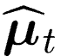. A general constrained objective is:

Here:

A market-neutral constraint is:

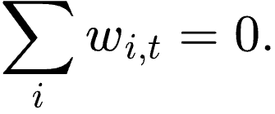

A gross-exposure constraint is:

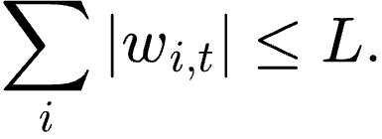

Position limits are:

Optimizer comparisons
1. Simple Q5-minus-Q1 portfolio.
2. Raw standardized signal through the optimizer.
3. Simple regression-calibrated signal.
4. Empirical-Bayes-calibrated signal.
5. Q5-premium empirical-Bayes signal.

Portfolio evaluation
1. Gross return.
2. Net return.
3. Annualized volatility.
4. Maximum drawdown.
5. Gross exposure.
6. Net exposure.
7. Turnover.
8. Assumed transaction costs.
9. Sector exposure.
10. Weight concentration.
11. Weight correlation across estimator versions.

We will determine whether calibration and optimization add value beyond the raw signal and a simple Q5-minus-Q1 portfolio.

PART 1: DISTINGUISH THE DIFFERENT SOURCES OF BIAS AND DEPENDENCE
1. Return-label leakage

Return-label leakage occurs if a forecast made at date uses historical observations whose forward returns were not yet complete at date .

Let denote a historical rebalance date.

Let denote the current forecast date.

Let 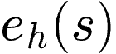 denote the trading date at which the forward return beginning at historical date ends for horizon .

For example:

At current forecast date , define the eligible historical dates as:

Only historical dates in may be used to estimate the forecast at date .

The condition 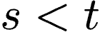 is not sufficient. The entire forward-return outcome must be complete before date .

This completed-outcome rule addresses return-label leakage in the return-estimation layer.

2. Overlapping-return dependence

Overlapping returns are not the same as future leakage.

The signal is evaluated approximately monthly, while the primary forward-return horizon is 63 trading days. Adjacent historical return windows therefore overlap.

As a result:

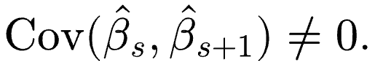

This may create serial dependence in:

1. Monthly rank IC values.
2. Q5-minus-Q1 spreads.
3. Historical cross-sectional slope estimates.
4. The slope estimates supplied to the empirical-Bayes model.

The completed-outcome rule prevents the use of unfinished future outcomes, but it does not make completed historical outcomes independent of one another.

This dependence will be addressed using:

1. Newey–West inference for time-series summary statistics.
2. Moving-block-bootstrap confidence intervals.
3. Non-overlapping-date robustness tests for the 63-day estimator.

3. LLM pretraining look-ahead risk

A contemporary LLM may possess general knowledge about a company that became available after the filing date.

For example, a model processing a 2023 filing may already know that the company later became a major AI-infrastructure beneficiary.

Separating historical dates from current forecast dates does not eliminate this possibility because the possible future information may be contained inside the feature-generation model rather than the return-estimation dataset.

The full OpenAI extraction pipeline will not be rerun before the paper deadline.

Instead, the paper will:

1. Report the exact OpenAI model identifier.
2. Report the API execution dates.
3. Archive the prompt, structured-output schema, temperature, and saved JSON responses.
4. Disclose that pretraining contamination cannot be ruled out completely.
5. Perform a small blinded human evidence audit using saved filing evidence.
6. Compare the LLM-derived signal with a simple non-LLM textual baseline using existing filing text.

The purpose of the human audit is not to prove that the model has no external knowledge. It is to test whether the assigned materiality labels are supported by the filing evidence itself.

4. Universe look-ahead and survivorship

The historical stock universe must be audited.

If the universe consists of current S&P 500 constituents backfilled into earlier dates, the application is not a historically point-in-time S&P 500 backtest.

The paper must either:

1. Use point-in-time constituent membership.
2. Describe the universe honestly as a static large-cap research universe defined as of a specified date.

If the universe is static, survivorship must be disclosed as a limitation.

The paper should not describe a static-universe historical application as a fully investable point-in-time S&P 500 strategy.

5. Factor-selection bias

The selected signal was chosen from seven SEC-derived factors and two static baselines.

Freezing the signal now prevents additional searching, but it does not erase the original factor-selection step.

The paper should therefore:

1. Report all nine originally evaluated factors.
2. State the date on which the primary factor was frozen.
3. Disclose that the primary signal was selected from nine explicit candidates.
4. Avoid introducing additional candidate alpha features.
5. Report dependence-aware confidence intervals for the complete candidate set.
6. Optionally report a moving-block-bootstrap maximum-statistic adjustment across the nine candidates.

PART 17: WHAT SHOULD NOT BE IMPLEMENTED BEFORE THE DEADLINE

Do not:

1. Rerun the complete OpenAI pipeline with anonymized filings.
2. Reproduce the full pipeline using a new open-weight model.
3. Search for new SEC-derived alpha factors.
4. Evaluate a large new grid of return horizons.
5. Build an AR or MA hierarchical Bayesian model.
6. Introduce LightGBM or neural-network estimators.
7. Replace the frozen interaction after observing the new audits.
8. Mechanically substitute a Newey–West variance into the between-date variance formula.
9. Spend a week constructing an unreliable historical index-membership dataset from questionable sources.

These are possible future extensions.

They should not prevent completion of the current paper.

PART 18: IMPLEMENTATION ORDER

Phase 1: Data and signal audit

Deliverables:

1. Immutable analysis manifest.
2. Universe-construction report.
3. Interaction-versus-exposure diagnostics.
4. 10-K-versus-10-Q diagnostics.
5. Filing-age diagnostics.
6. Full nine-factor results table.

Estimated effort: 1 to 2 days.

Phase 2: Dependence-aware inference

Implement:

1. Newey–West statistics.
2. Moving-block-bootstrap intervals.
3. Full nine-factor comparison.
4. Sector-neutral confidence intervals.

Suggested files:

src/robust_signal_inference.py

tests/test_robust_signal_inference.py

Estimated effort: 1 to 2 days.

Phase 3: Empirical Bayes

Implement:

1. Historical cross-sectional slopes.
2. HC1 sampling variances.
3. Robust slope alternatives.
4. Completed-date filtering.
5. Method-of-moments between-date variance.
6. Precision-weighted population mean.
7. Unrestricted and zero-floored forecast coefficients.
8. Stock-level expected-return panel.
9. Estimator metadata and diagnostics.

Suggested files:

src/empirical_bayes.py

tests/test_empirical_bayes.py

Estimated effort: 2 to 3 days.

Phase 4: Overlap robustness

Implement:

1. Three staggered non-overlapping 63-day sequences.
2. Moving-block-bootstrap estimator uncertainty.
3. Comparison with the all-date estimator.

Estimated effort: 1 day.

Phase 5: Calibration validation

Implement:

1. Forecast-versus-realized slope table.
2. Calibration regression.
3. Forecast-error metrics.
4. Stock-level decile calibration plot.
5. Realized-to-predicted spread ratio.
6. Rolling coefficient and variance plots.
7. Zero-floor and variance-floor frequencies.

Estimated effort: 1 to 2 days.

Phase 6: Optimizer comparison

Implement:

1. Q5-minus-Q1 benchmark.
2. Raw-signal optimizer.
3. Direct calibrated optimizer.
4. Empirical-Bayes-calibrated optimizer.
5. Q5-premium empirical-Bayes optimizer.
6. Constrained-versus-unconstrained comparison.
7. Transaction-cost and turnover analysis.

Estimated effort: 1 to 2 days.

Total expected implementation time: approximately 8 to 12 focused working days.

PART 19: PAPER POSITIONING

Primary contribution

The paper develops a point-in-time pipeline that:

1. Extracts evidence-backed thematic exposure from SEC filings.
2. Combines semantic relevance with economic materiality.
3. Audits the signal for timing, sector, filing-form, staleness, and specification risks.
4. Converts a standardized cross-sectional score into expected active returns.
5. Models uncertainty in historical signal-return slopes using empirical Bayes.
6. Connects the calibrated forecasts to a constrained portfolio optimizer.

Empirical claim

The paper should not claim that the short sample proves the existence of a permanent AI-infrastructure alpha.

The defensible claim is:

In the available 2023–2026 large-cap sample, the selected SEC-derived signal is positively associated with subsequent active returns. The evidence is limited by the short sample, overlapping return horizons, concentration in one AI-investment regime, factor selection, sector exposure, possible universe survivorship, and potential LLM pretraining contamination.

Contribution statement

We formalize and audit the full transition from point-in-time filing text to portfolio weights. The methodology separates thematic measurement, return calibration, estimation uncertainty, and portfolio construction rather than treating an NLP score as an expected-return forecast.

Strongest framing

The paper should not be framed as:

“We discovered a new AI alpha factor.”

A stronger framing is:

“We developed a leakage-audited and uncertainty-aware methodology for converting LLM-derived filing measurements into expected active returns and constrained portfolio weights, and we demonstrate the approach using AI-infrastructure exposure in US large-cap equities.”

PART 20: LIMITATIONS

The paper should explicitly acknowledge:

1. Approximately 36 monthly signal dates.
2. Overlapping 63-day return horizons.
3. A sample concentrated in one AI-investment regime.
4. Selection from nine explicit candidate factors.
5. Partial dependence of the raw spread on sector exposure.
6. Possible survivorship if the universe is static.
7. Possible LLM knowledge acquired after the filing dates.
8. Limited precision in estimating between-date slope variance.
9. Sensitivity of portfolio results to optimizer constraints.
10. The fact that the linear empirical-Bayes layer changes scale rather than ranking.

These limitations do not invalidate the methodology.

They limit the strength of the empirical return claim.

EXECUTIVE SUMMARY FOR A COLLABORATOR

We have frozen the SEC-derived signal and will not rerun the OpenAI extraction or search for new factors. The next step is to audit the existing signal for universe construction, filing form, filing age, and whether the interaction adds information beyond exposure alone. We will then implement a point-in-time empirical-Bayes estimator that converts the standardized signal into expected active returns using only completed historical outcomes. Because the 63-day returns overlap, we will use dependence-aware inference, block-bootstrap uncertainty, and non-overlapping-date robustness. After validating calibration, we will compare the raw signal, calibrated signal, empirical-Bayes signal, and Q5-premium model inside the actual constrained optimizer. The paper will be framed as a methodology and measurement contribution with an honest empirical illustration rather than definitive evidence of a permanent new factor.

