Hello khan, I’m writing this document to show Some issues that I find and to get clarifications on them. I’m going to mark the order as rivision until the issues are fixed. I’ll point out the details below

1)

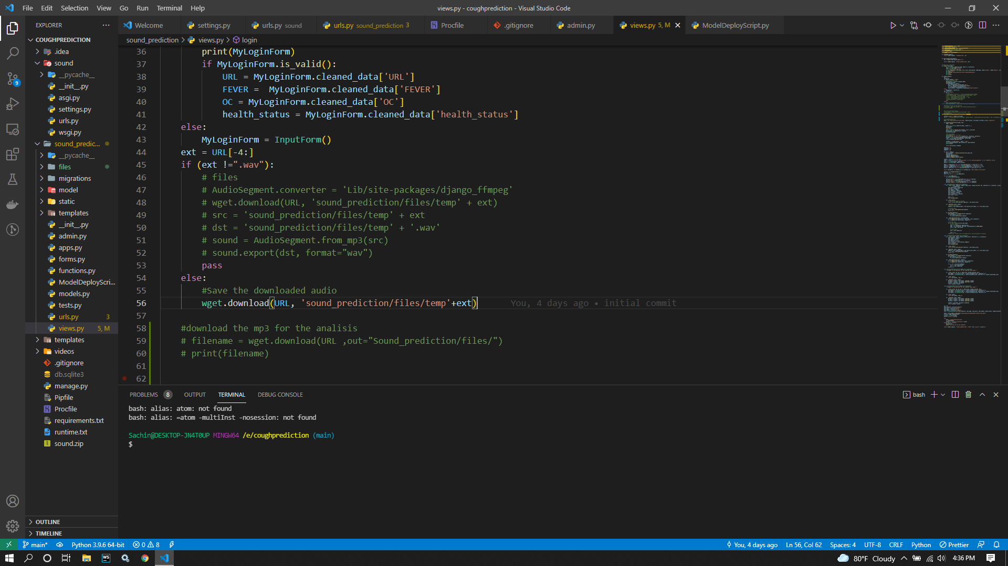

I can see you have written code section to download the audio from the provided URL, check the end of the URL string and based on its format ends with “.wav” it’ll download and placed in the position “sound-prediction/files/temp.wav” (.wav comes from declared string “ext”).

So I want to change this approach as I mentioned down below in the comented section. I’m sending a direct audio link that does not have file type at the end, like “.mp3” or “.wav” extension in the URL.but It’s a audio file and I need that downloaded as the temp audio here.

2)

Based on the changes that I’ve mentioned , change the declaration of variables “file_name” and “data_”. I’ve commented out the code sample for tha as well.

Refer the attached image for more information

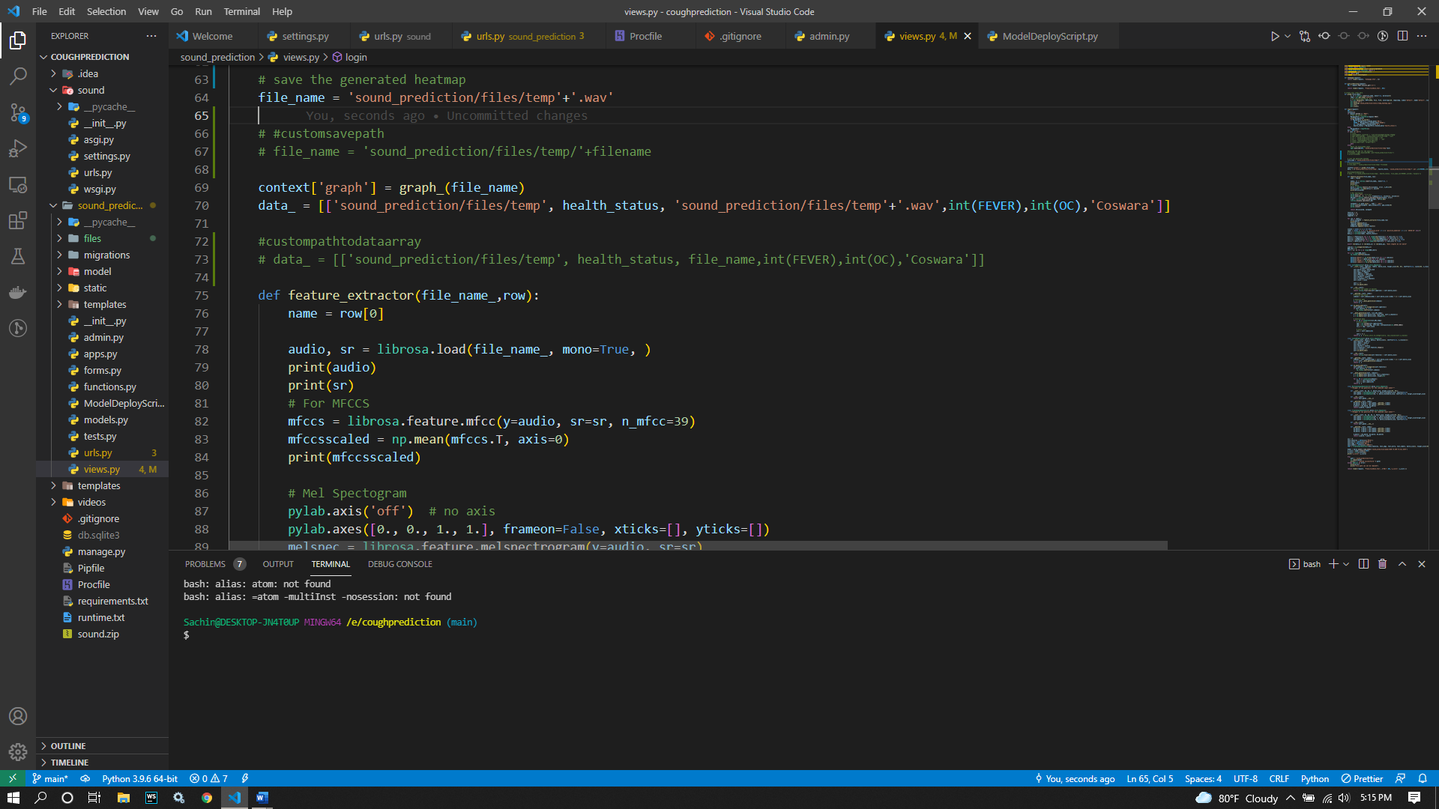

3)

Based on the code that you provided, I created a virtual environment and install all the libraries available in the document and run the manage.py script to launch the development server.

Here all the sample data are still available in the “files” folder

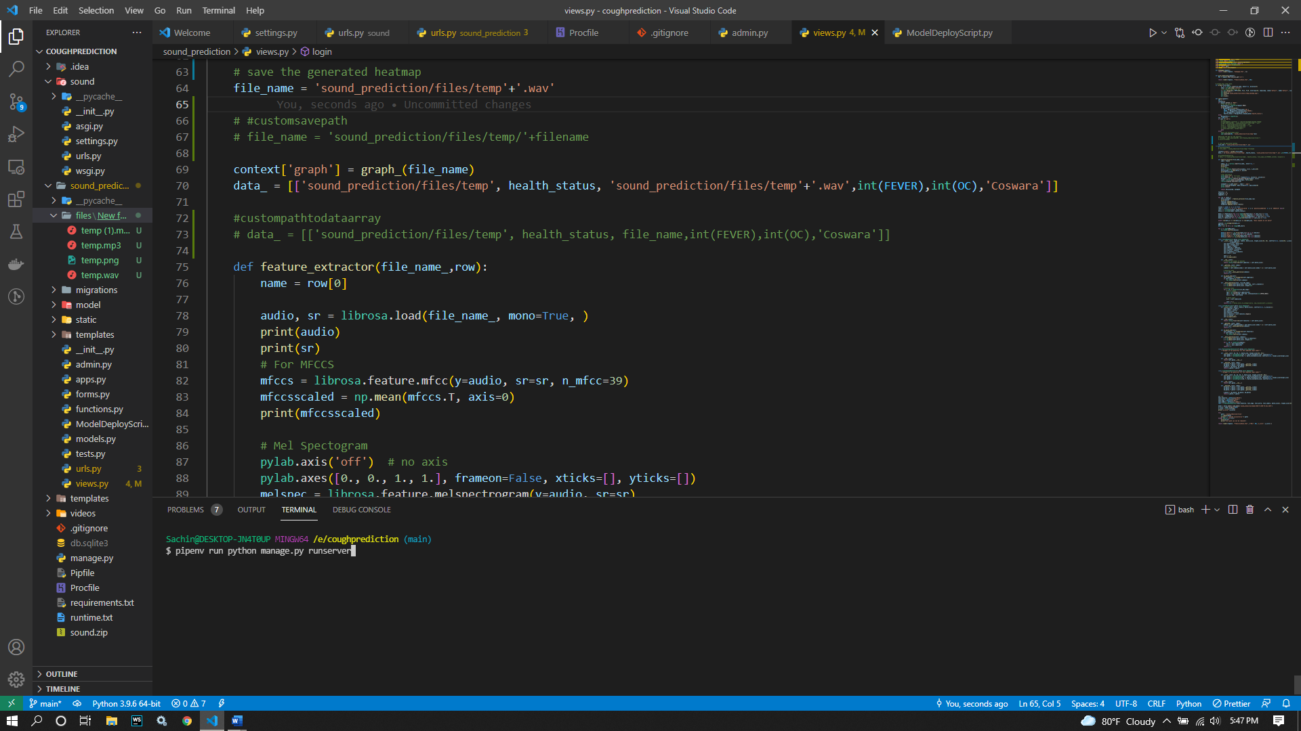

4)It launches the development server as below

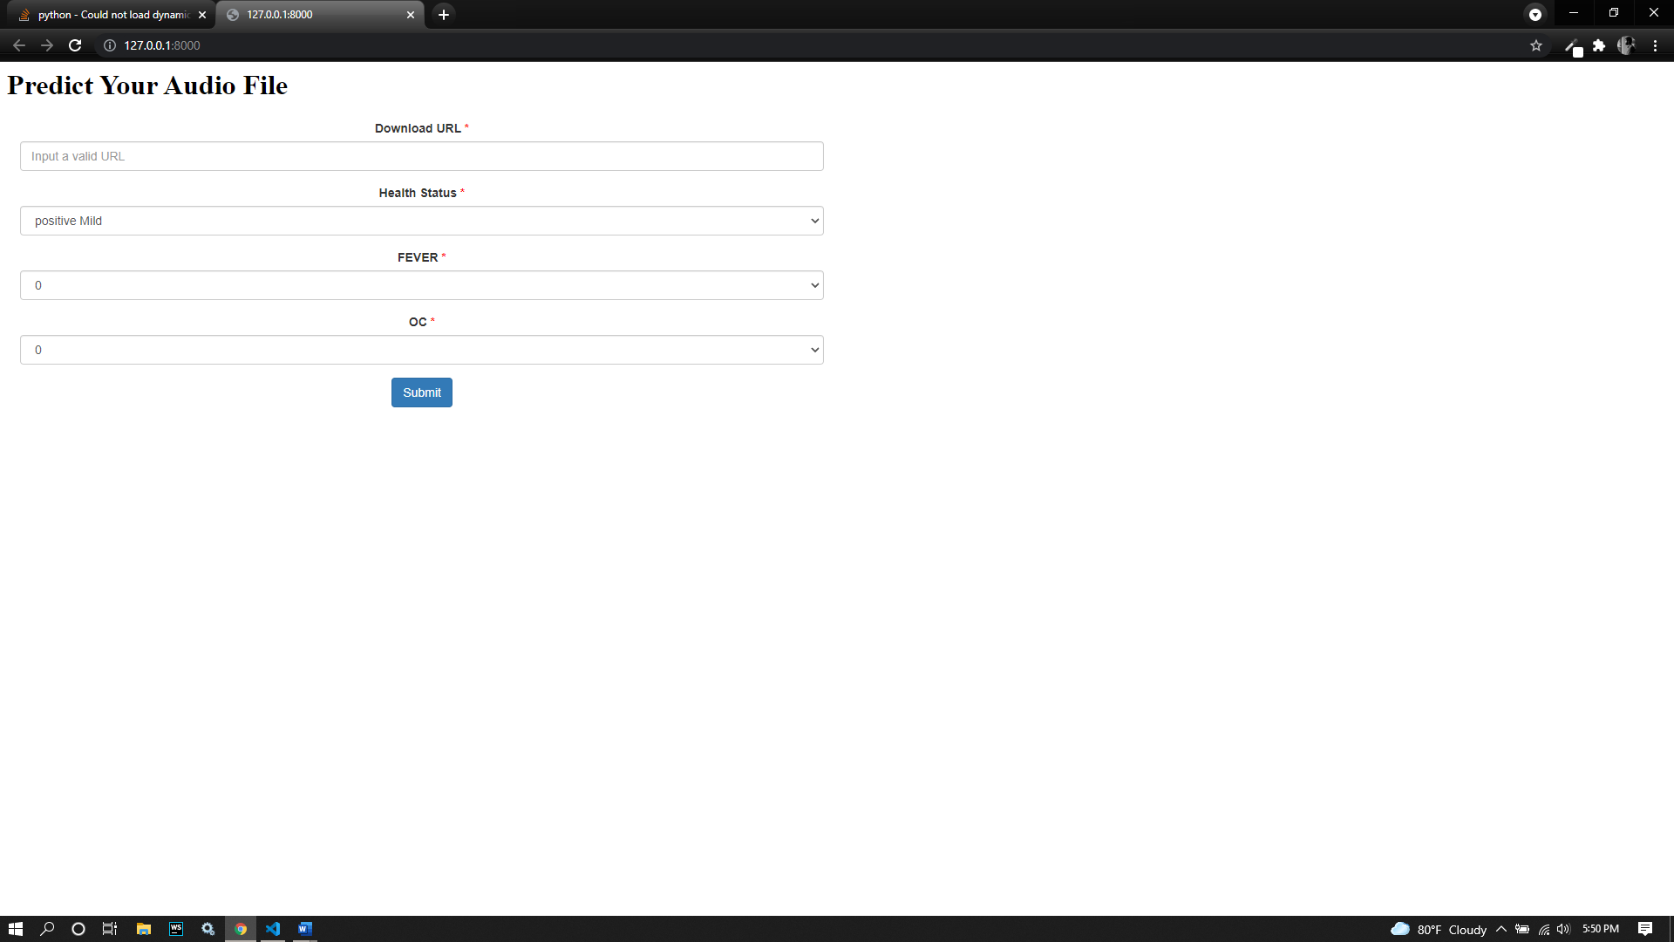

For testing purposes I’m going to insert a audio with .wav ending in the URL section

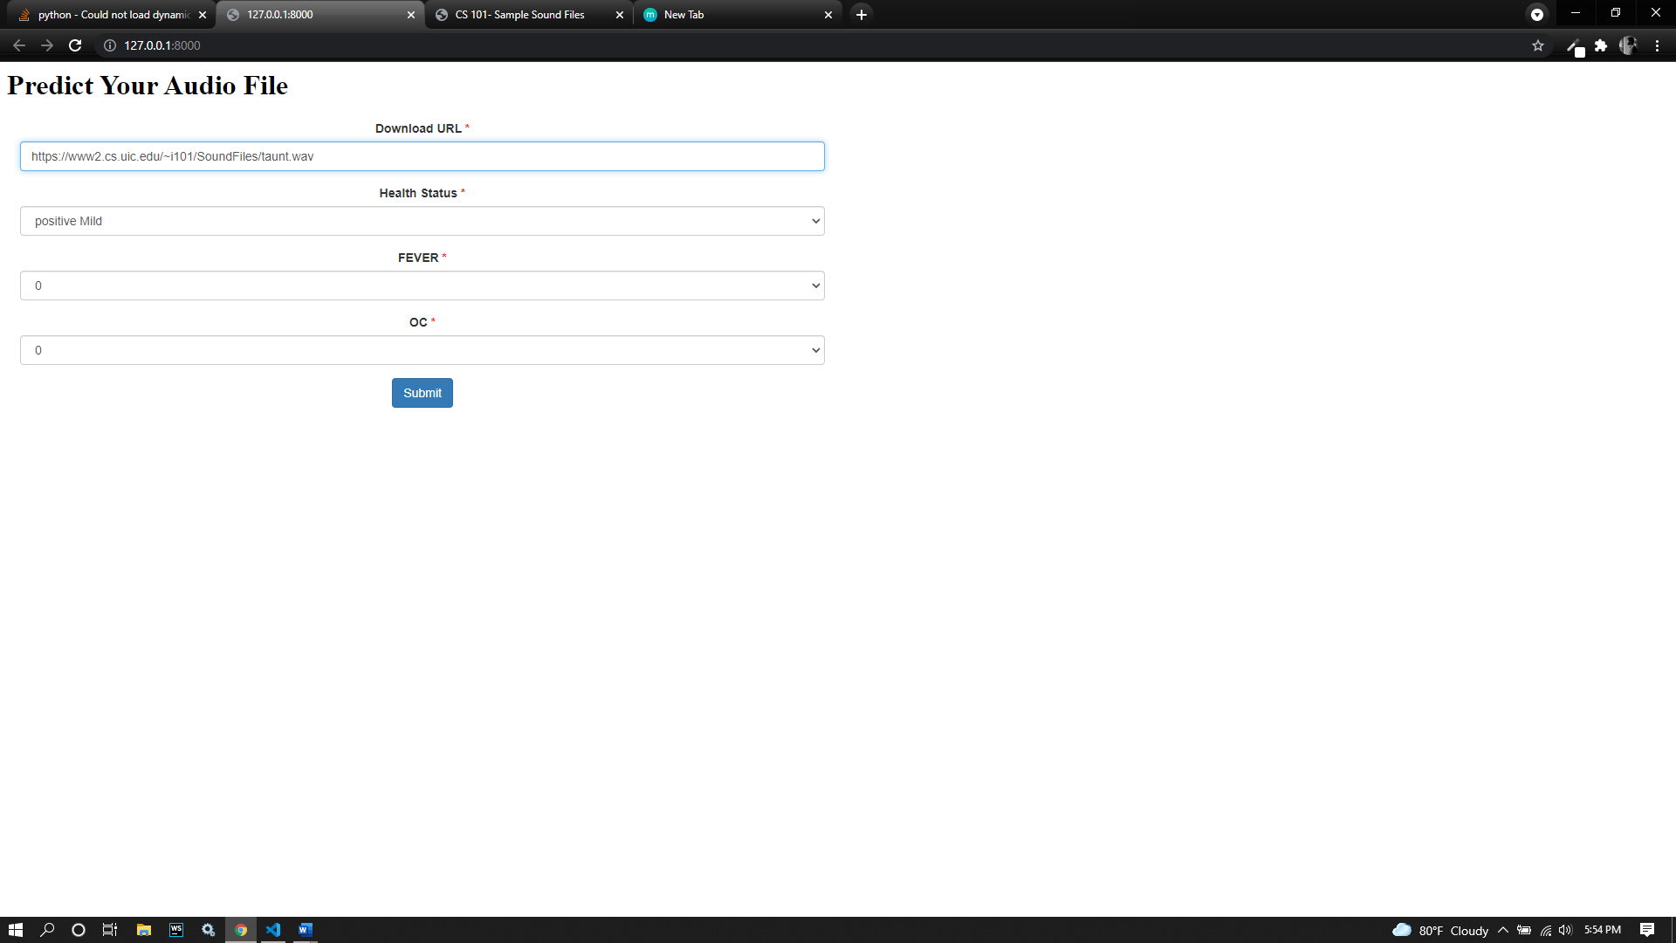

So based on the data It provide me this result, which is newly obtained

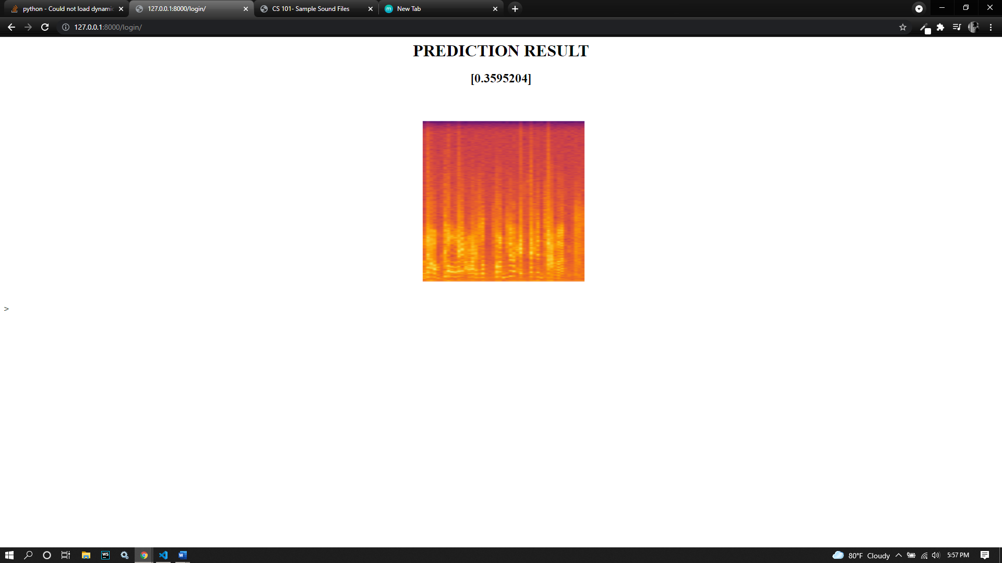

Now I’m going to try with a URL that doesn’t end with “.wav”, It’ll just pass the file as in the code and just run the test on test.wav you have put on “files” folder

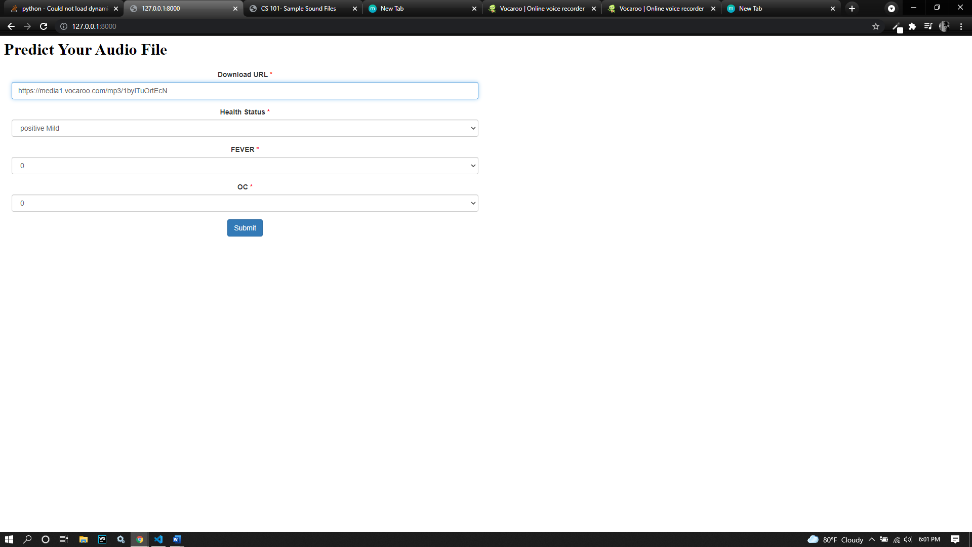

I tried to go with my explained approach where I commented the code and it generate this SSL Error to me

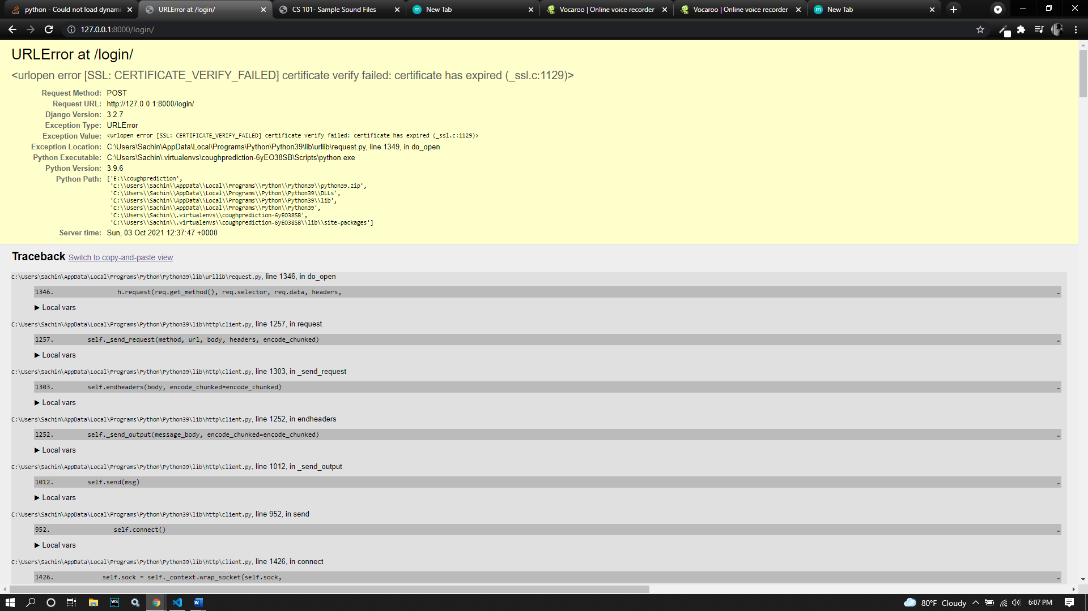

I searched for a solution for this and the solution mentioned on documentations and they as to to use “Certifi” library. I’ve installed it and still have this issue. So Please go through and share a solution if possible.

Thanks and regards,

Sachin