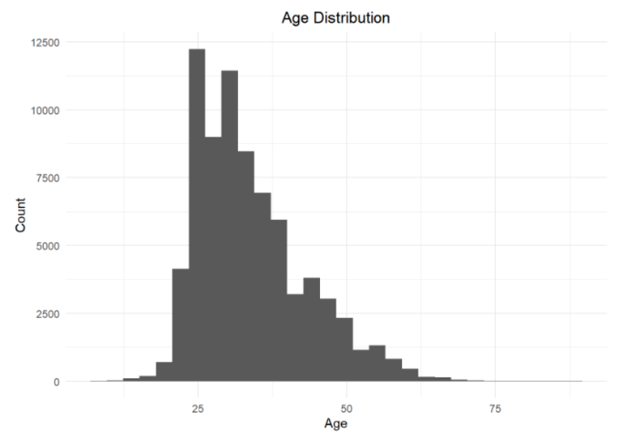**Participant’s Age**

**The race attracts young population**. Women’s age distribution is right skewed, see Fig. X1, which captures age from all the years. 75% population is aged 39 years and below.

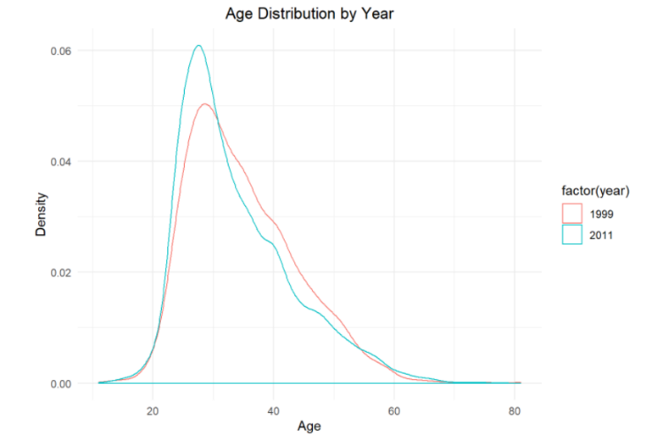**Clear shift to younger population in recent years is noted.** Looking at kernel density plots between 1999 and 2012, it is clear that there is shift towards younger age group, refer Fig X2.

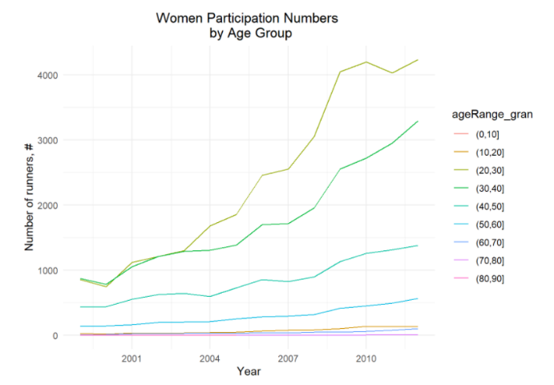Further, the women participation count over the years, for different age groups is shown in Fig X3. Younger age group, 20-30 and 30-40, not only dominate in count, but also have grown at maximum rate, as can also be seen from Fig X4.

*It is clear from Fig X2,3,4* ***that the age profile of runners has grown younger*** *in recent years.*

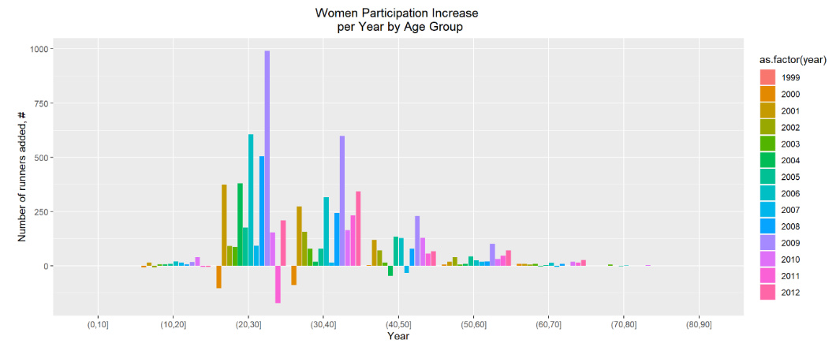

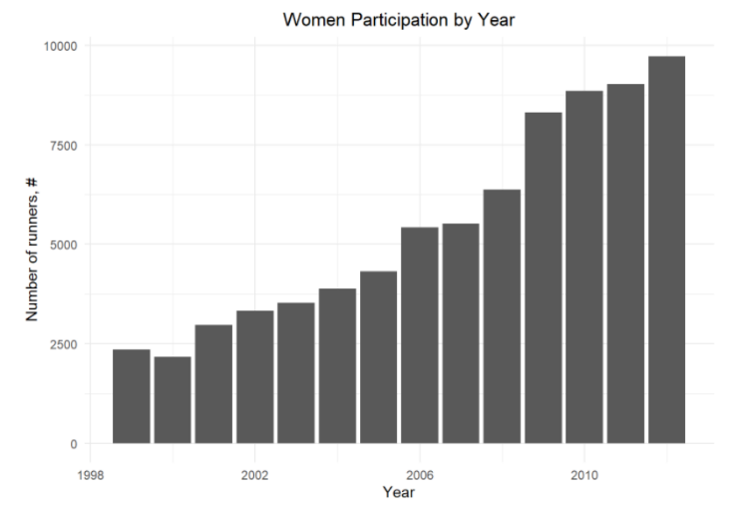**Participants Count**

The participants count has steadily increased from ~2500 to about ~10000, i.e. 4X over 14 years. Refer Fig. Y. 2009 saw the biggest jump. Clearly this race’s popularity has grown over the years.

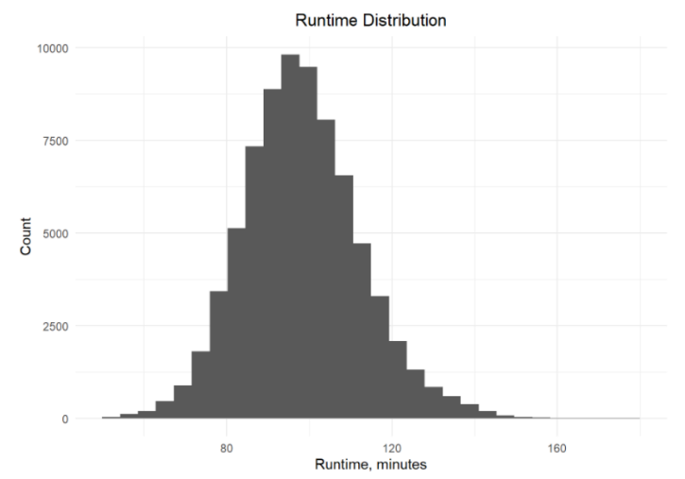

**Runtime Distribution**

Runtime, when considered over all the age groups, and overall the years, shows almost a normal distribution, with minor right skewness, refer Fig. Z1.

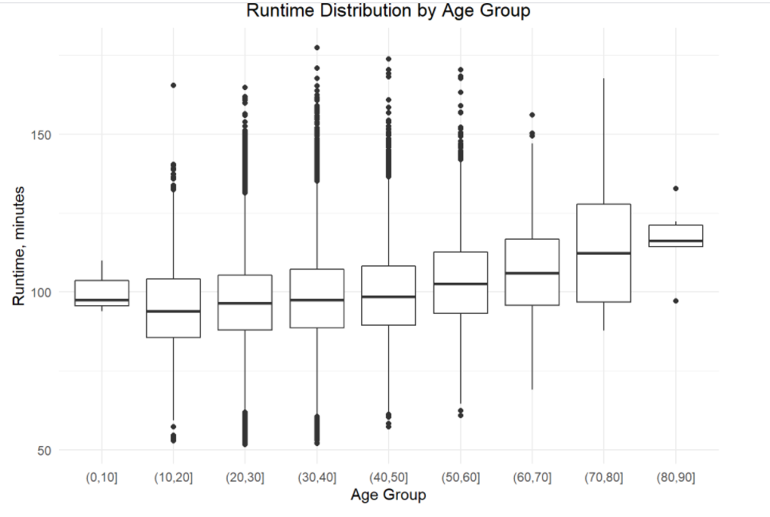Looking at distributions over different age groups, refer box plots in Fig Z2, it clear shows the expected trend that median runtime is larger for larger age - group.

It’s interesting that even the standard deviation of the runtimes is slightly increasing, 14.41 minutes to 20.34 minutes, going from age group 40-50 to 70-80. This is indicative of larger variation in fitness levels of participants at higher age group. 80-90 year age group shows a drop-in variation, presumably due to most people participating having similar fitness level, and capability. This is not unexpected.

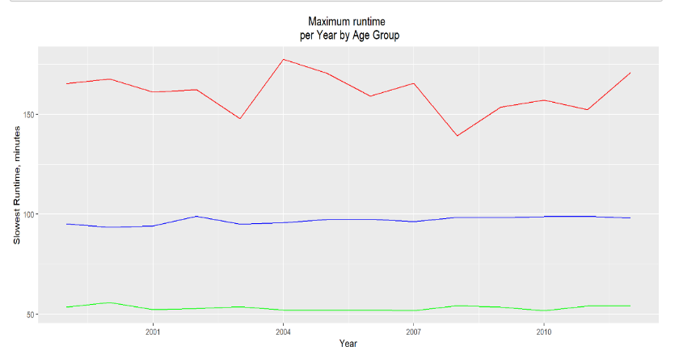Break up of race times by year, and **reviewing median, fastest and slowest runtime** provides **insight on over all race time trend through the years**. The median runtime and fastest runtime do not show as much variation as the slowest runtime. The standard deviation for different time metrics over the years is captured in Table X

|  |  |
| --- | --- |
| **Runtime Metric** | **Standard Deviation of Runtime over 14 years** |
| Min (fastest participant) | 1.22 minutes |
| Median (50th percentile) | 1.89 minutes |
| Max (slowest participant) | 10.18 minutes |

