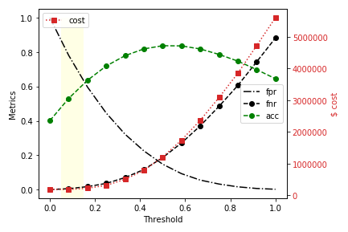

**Dollar Cost minimization & Recommendations**

**Requirement**

It is required that the dollar cost be minimized as part of model development, where cost associated for misclassification is defined as:

* False negative (FN) cost = $500
* False positive (FP) cost = $10
* True positive or true negative cost = $0

**Observations on requirement**

* FP misclassification error rate can be 50x FN, yet maintain the same $ cost.
* Above implies that FPR can be allowed to go high, as long as the cost is minimized.

**Summary on Cost Minimization for KNN model**

Threshold tuning for binary classification can provide us optimal model that minimizes $ cost.

* Optimal probability threshold that minimizes cost function = 0.083333
* Following is misclassification error rates, and accuracy for above threshold:
* FNR = 0.5%
* FPR = 78.1%
* Accuracy = 53.1%