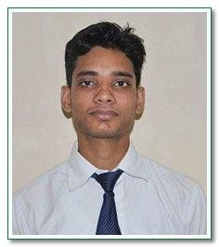SACHIN KUMAR

[mauryask5@gmail.com](mailto:mauryask5@gmail.com)

+919643580286

H.no. 50 Gali no.1, Ambedkar vistar colony,Abhaykhand 1,Indirapuram,Gzb, U.P(201014)

# Careerobjective:

To earn a job which provides me satisfaction, self development and help me to achieve personal as well as organizational goal by investing my technical knowledge and skills.I have ability to learn new technology.

# TechnicalCompetencies:

* CoreSubjects : Electrical Machine, Power electronics,Digital electronics
* Tools &Software : C-language,PLC SCADA

# Academicdetails:

|  |  |  |  |  |
| --- | --- | --- | --- | --- |
| **Course** | **School/college** | **Board/University** | **Year ofpassing** | **Percentage(%)** |
| B. Tech(EE) | G.L.A.University | UGC | 2017 | 70 |
| Intermediate | CENTRAL ACADEMY | CBSE | 2013 | 63.5 |
| Matriculation | CENTRAL ACADEMY | CBSE | 2011 | 74 |

**ProjectDetails:**

|  |  |
| --- | --- |
| **Projecttitle** | Underground cable fault detector. |
| **Description** | Detection of fault with the help of switches. And 16X2 display,shows the distance of the fault and type of fault. |

**SummerTraining:**

|  |  |  |
| --- | --- | --- |
| **Company** | **Title** | **Duration** |
| Bombardier Transportation Indialtd | TCMS,Passenger information system. | 4weeks |
| Cetpainfotech | PLC SCADA | 4weeks |

**Workshops /Seminars:**

* + Attended workshop on six sense technology conducted by i3 indiya.

# Achievements:

* + Coordinator in Srijan 2015.
  + Coordinator in Spandan and Maitree 2015.

# Personaldetails:

Father’sName : Mr. Raj Bahadur Maurya Gender :Male

Date of birth : April 04,1996 Languages known : Hindi,English

( Sachin Kumar)