Assignment-1

(1)UDP:

Application layer: iperf server(IP: 10.5.20.128,Default Port:5001)

Transport layer protocol:UDP

Network layer protocol:IPv4

TCP:Application layer protocol:HTTP

Transport layer protocol:TCP

Network layer protocol:IPv4

(2)(a)pic 1: 72 TCP packets consisting of length 66 and 1514.

pic 2: 17142 TCP packets consisting of length 66 and 1514.

pic 3: 633 TCP packets consisting of length 66 and 1514.

pic 4: 3955 TCP packets consisting of length 66 and 1514.

pic 5: 816 TCP packets consisting of length 66 and 1514.

- Yes,all UDP packets are of same size(length 1512).

- UDP throughput graph(bandwidth 28kbps)
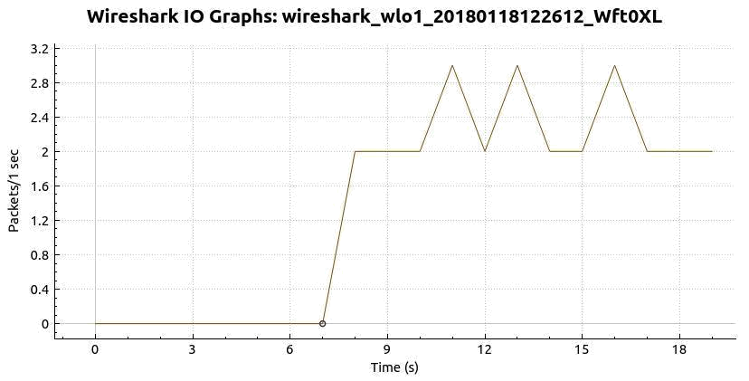

TCP throughput graph(pic 1)
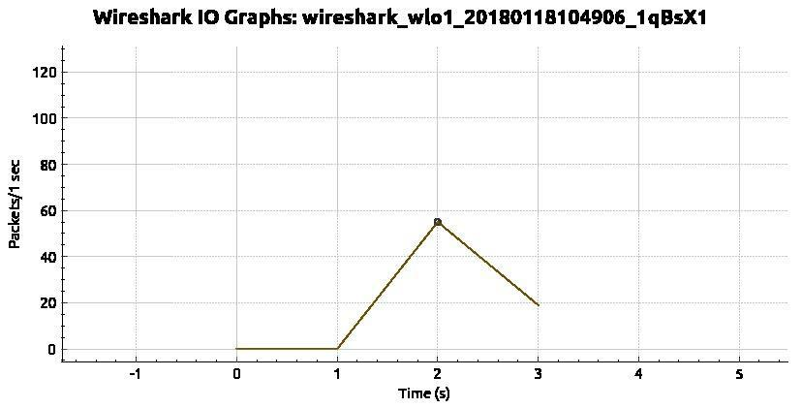

TCP throughput graph(pic 2)
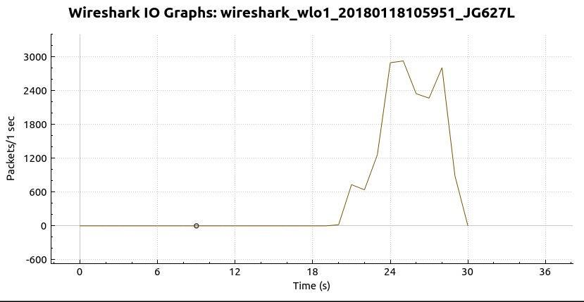

TCP throughput graph(pic 3)
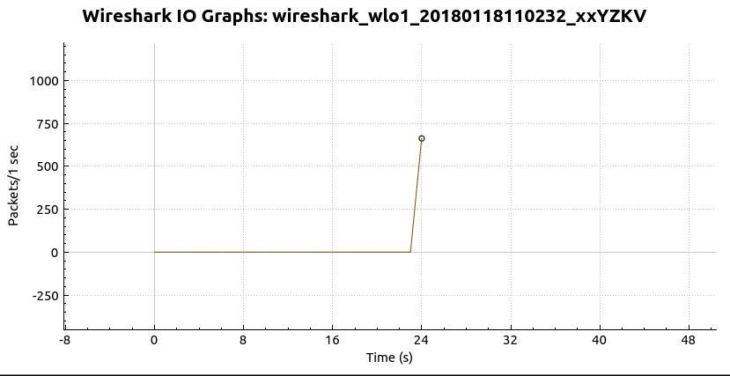

TCP throughput graph(pic 4)
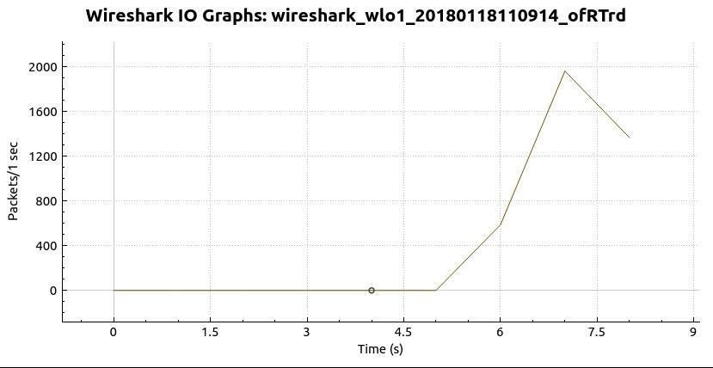

TCP throughput graph(pic 5)
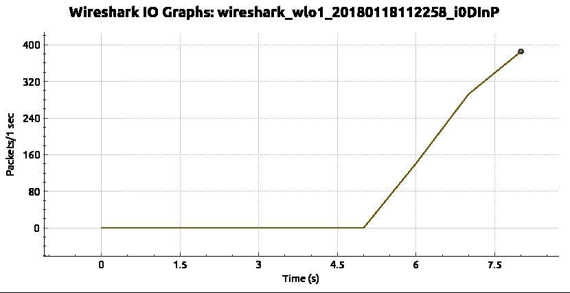

(d)(i)64 kbps
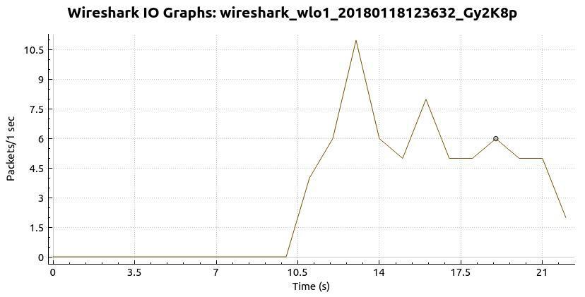

(ii)128 kbps
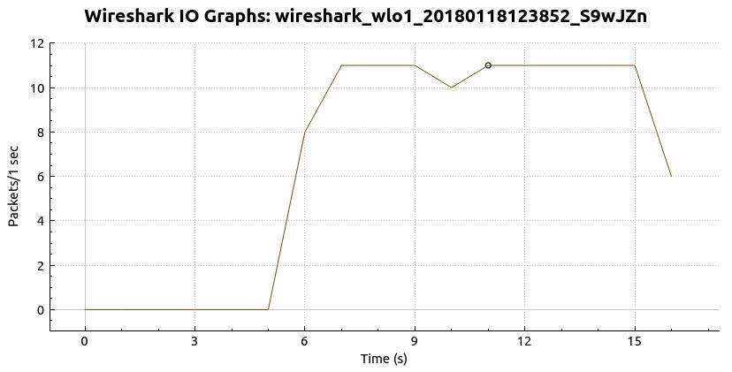

(iii)256 kbps
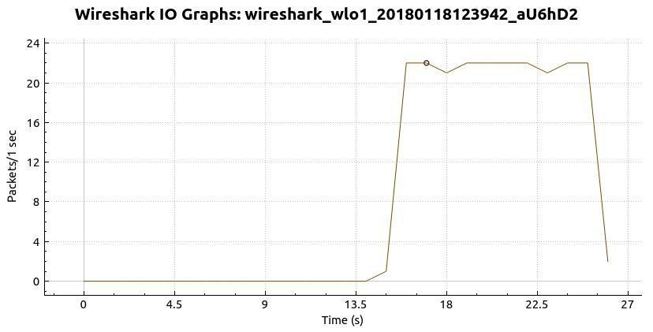

(iv)512kbps
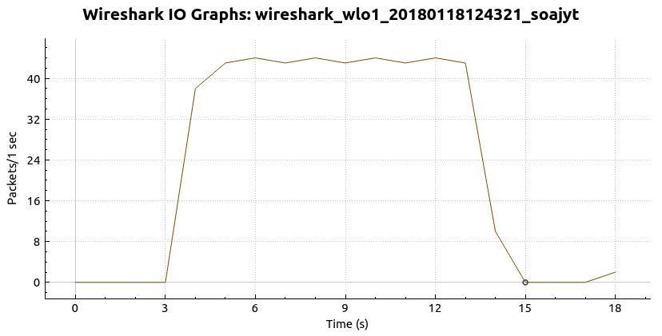

(v)1024 kbps
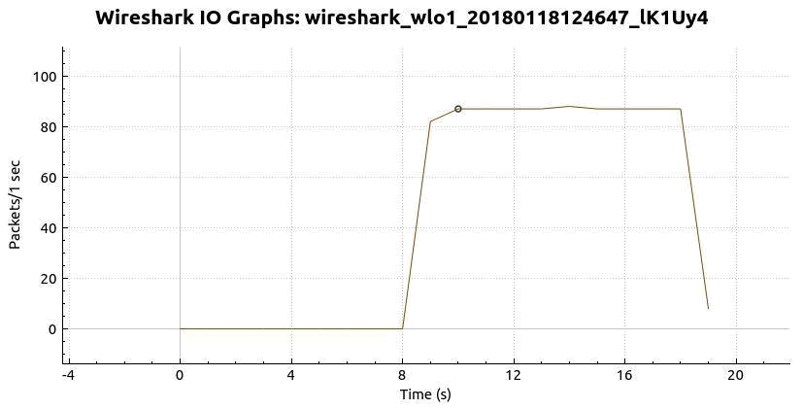

(vi)2048 kbps
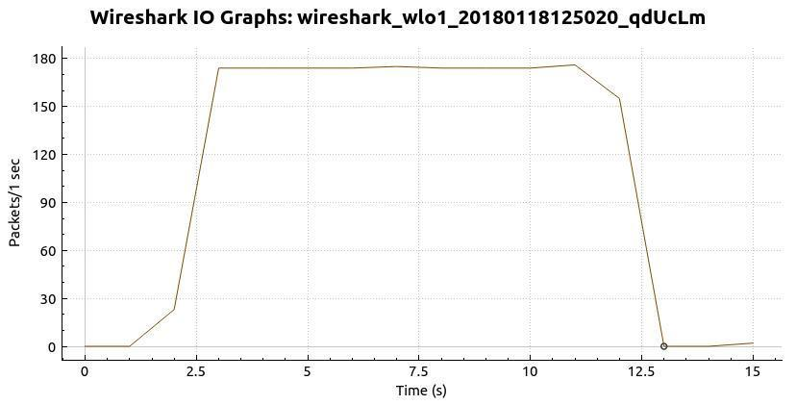

(3)No TCP packets were retransmitted from wireshark while running TCP

command to access images or while running UDP command to access

iperf server.

(4)1.UDP throughput with respect to the UDP bandwidth
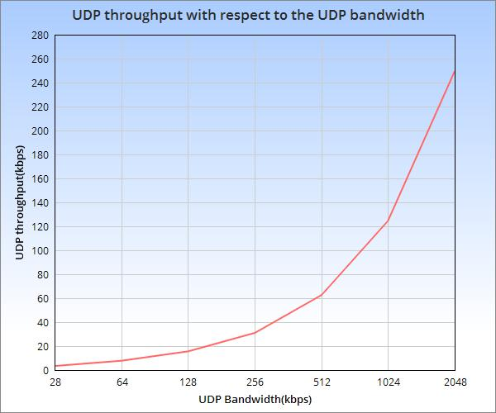

From the curve we can observe that UDP throughput is increasing with increase in UDP bandwidth.

(4)2.Number of UDP packets transmitted with respect to UDP bandwidth
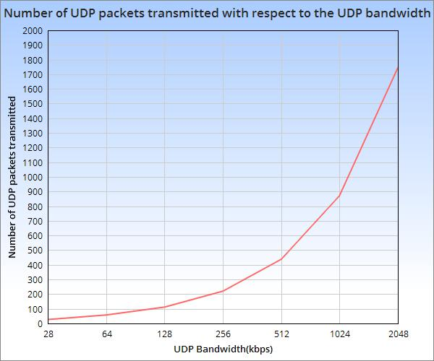

From the curve we can observe that Number of UDP packets transmitted is increasing with increase in UDP bandwidth.

