|  |  |
| --- | --- |
|  |  |
| ISCG 6420 Internet & Website Development | |
| **Name:** | Sachina Maharjan |
|  |  |
| **Class:** | ISCG- 6420 Internet and Website Development |
|  | |

**Deadline:** 5th June, 2024

|  |  |
| --- | --- |
|  |  |
| **Lecturers:** | Jesse Schollit |
|  |  |

**This submission is our own work, except where clearly referenced**.

Signature______Sachina_________

Date_____05/06/2024___________-

# Wireframes for Booking System.

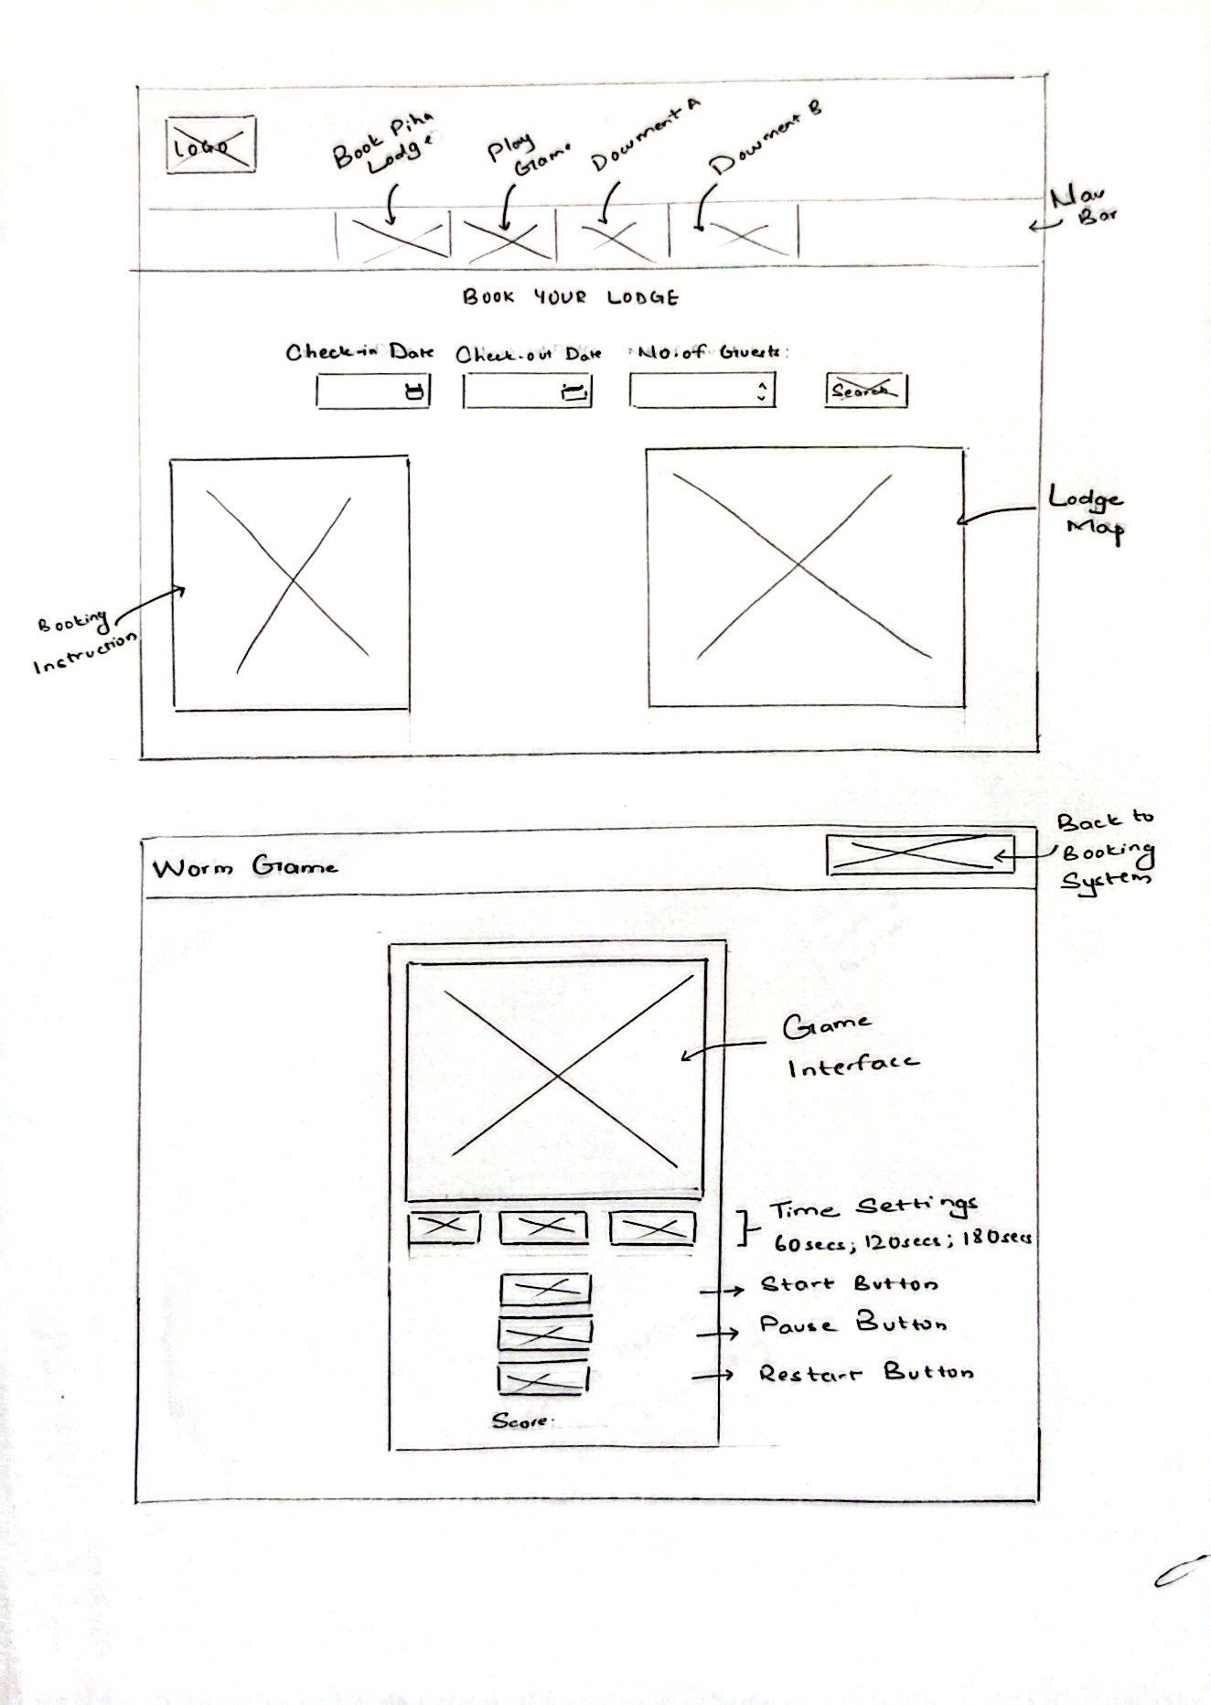

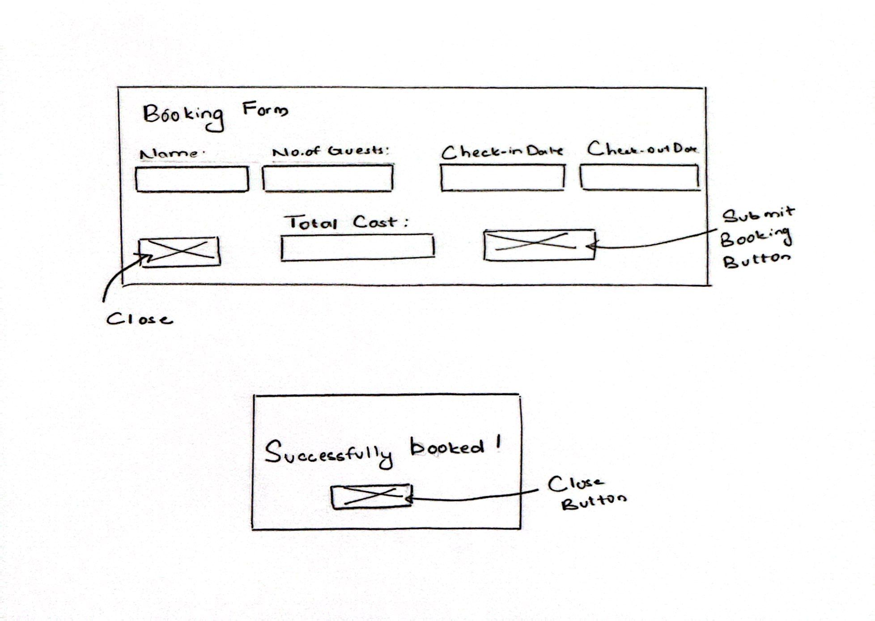

# Instruction to Book a Lodge

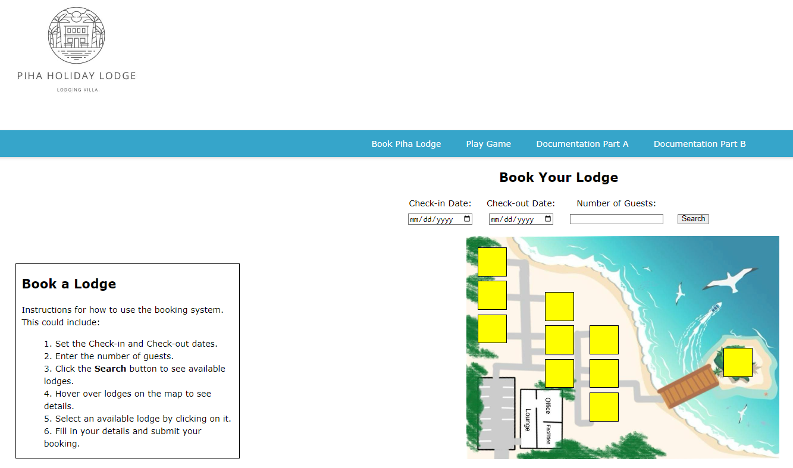

The home screen of the Piha Holiday Lodge looks like this. The instructions to book a lodge are given on the left side, and the right side shows the lodge map, displaying the lodge number, capacity, cost, status and images when hovering.

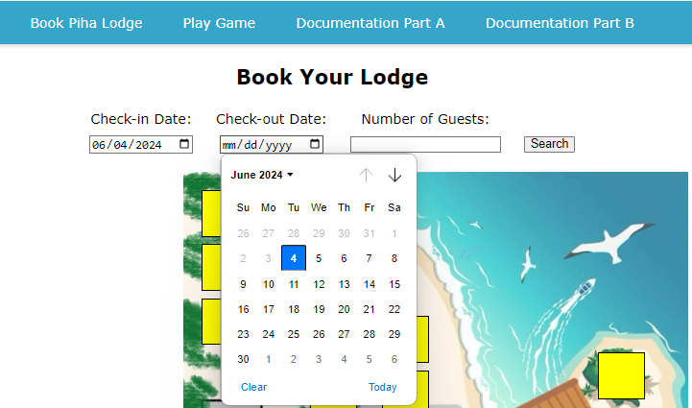

Fill out the fields with check-in, check-out and number of guests. Note that you cannot choose the check-out date earlier than the check-in date. After filling out these three fields, click the search button to look for the available lodges.

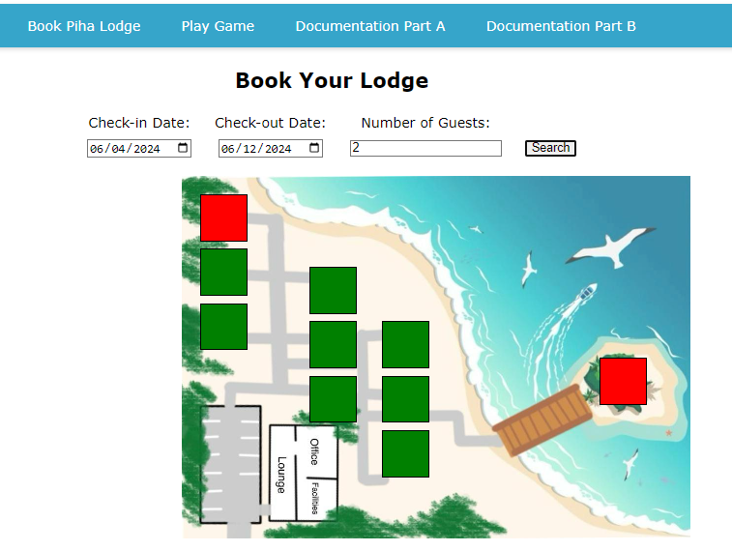

After clicking the search button, the map will show the available number of lodges in green as per the capacity of the guests. The red ones are always reserved or outside of your selected guest limit.

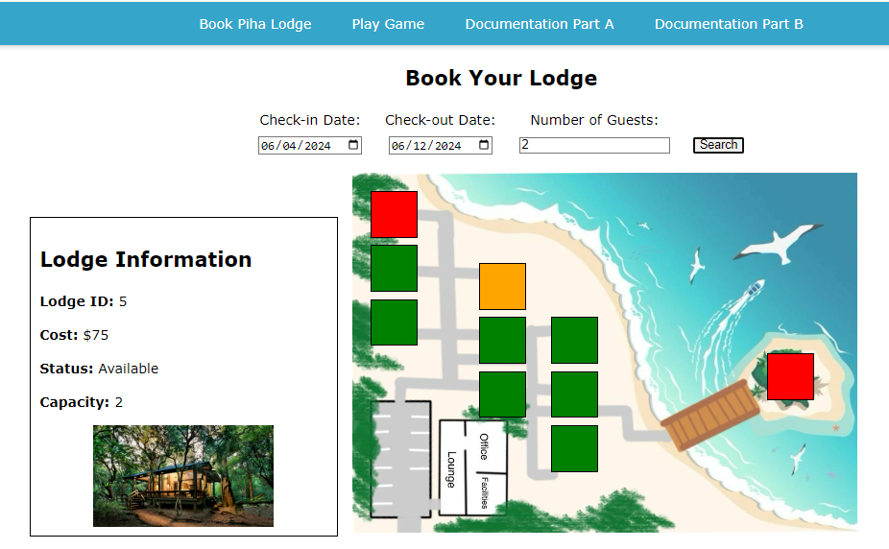

You can hover over the green lodges to see its information.

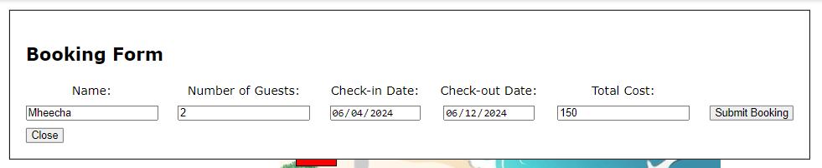

On clicking, a booking form will pop up, write your name, check other details and click submit booking.

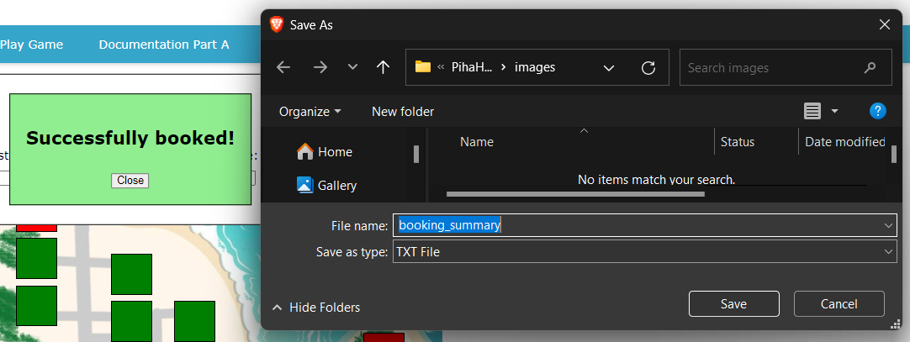

A text file will be downloaded to your system as your booking summary.