|  |  |
| --- | --- |
|  |  |
| ISCG 6420 Internet & Website Development | |
| **Name:** | Krijesh Karki (Student ID: 1568289) |
|  |  |
| **Class:** | ISCG- 6420 Internet and Website Development |
|  | |

**Deadline:** 5th June, 2024

|  |  |
| --- | --- |
|  |  |
| **Lecturers:** | Jesse Schollit |
|  |  |

**This submission is our own work, except where clearly referenced**.

Signature______Krijesh_________

Date_____05/06/2024___________-

# Wireframes for Worm Game.

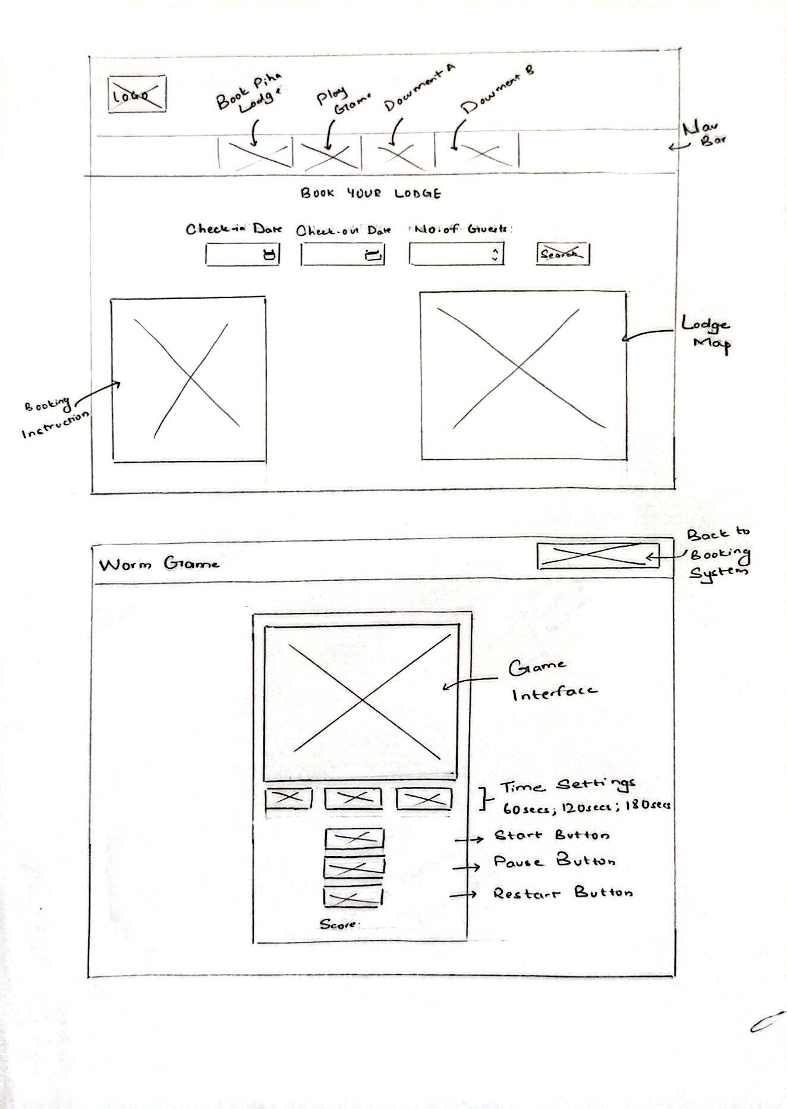

# Instructions for Worm Game

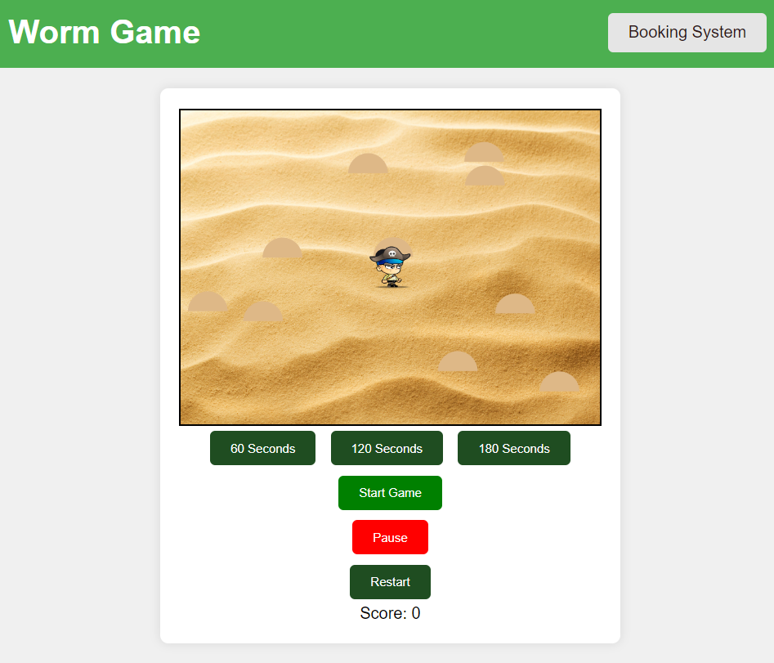

The game screen will load as shown. You can choose your preferred game duration: 60 seconds, 120 seconds, or 180 seconds. To begin the game, click the "Start Game" button.

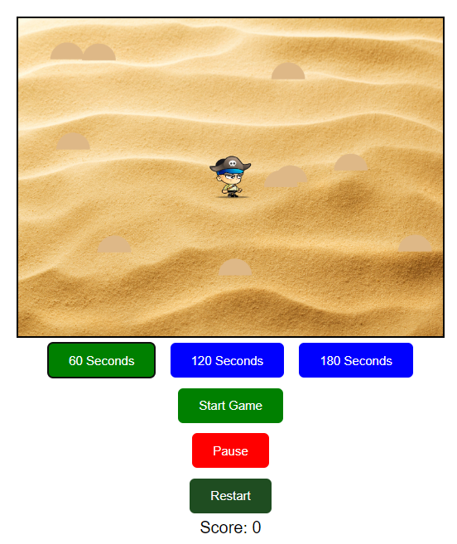

After clicking the start button, the game will begin. The key function for the character’s action is given in the table below:

|  |  |
| --- | --- |
| Action | Keys |
| Move Up | ‘W’ or Up Arrow Key |
| Move Down | ‘S’ or Down Arrow Key |
| Move Left | ‘A’ or Left Arrow Key |
| Move Right | ‘D’ or Right Arrow Key |
| Catch Worm | SpaceBar |

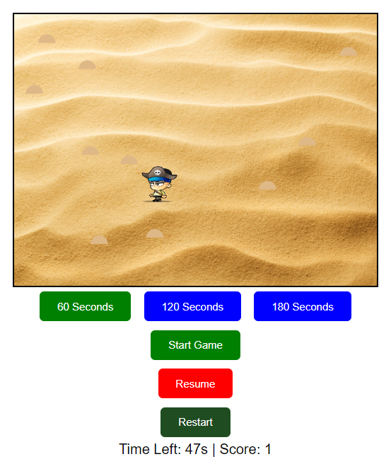

You can even pause the game by clicking the pause button, resume whenever you want, and restart the game using the restart button.