**Test Cases**

*Xiaowei An ( A )*

*Ambalkar Sachin ( A )*

*Ying ma (A20313747)*

1. Our shell can be invoked from the Ash shell provided with Minix.

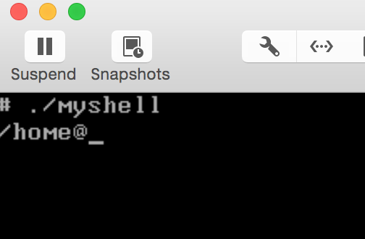

1. After execute the PROFILE file you can use the programs provided in /bin and /usr/bin. And will be in the HOME directory.



1. Our prompt shell display the current directory name.

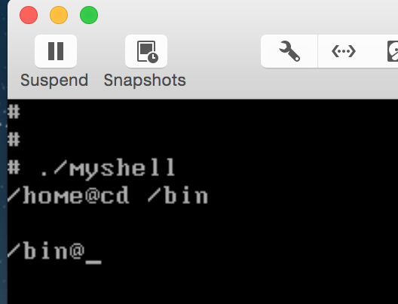

1. In the command line of our shell, I can exercise any executable programs including the utilities provided in /bin and /usr/bin.

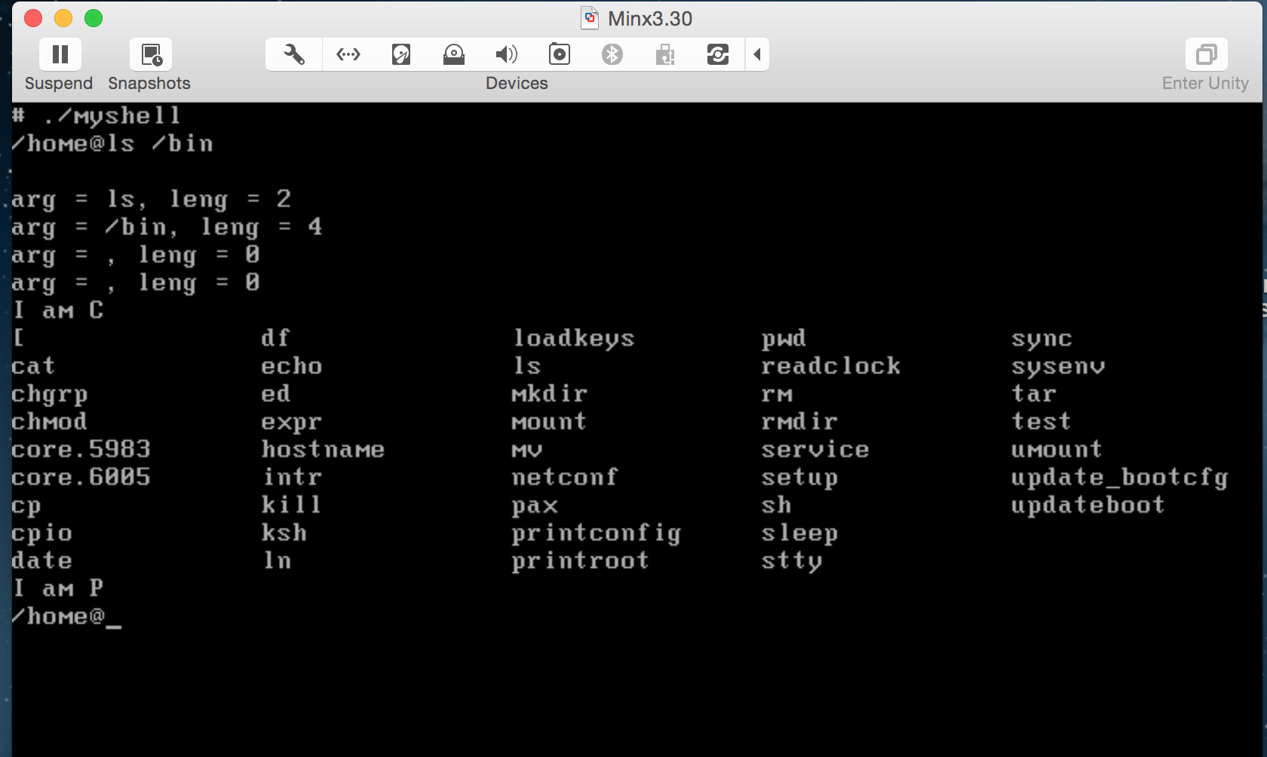

1. Our shell support the execution of list of commands asked by the requirements.

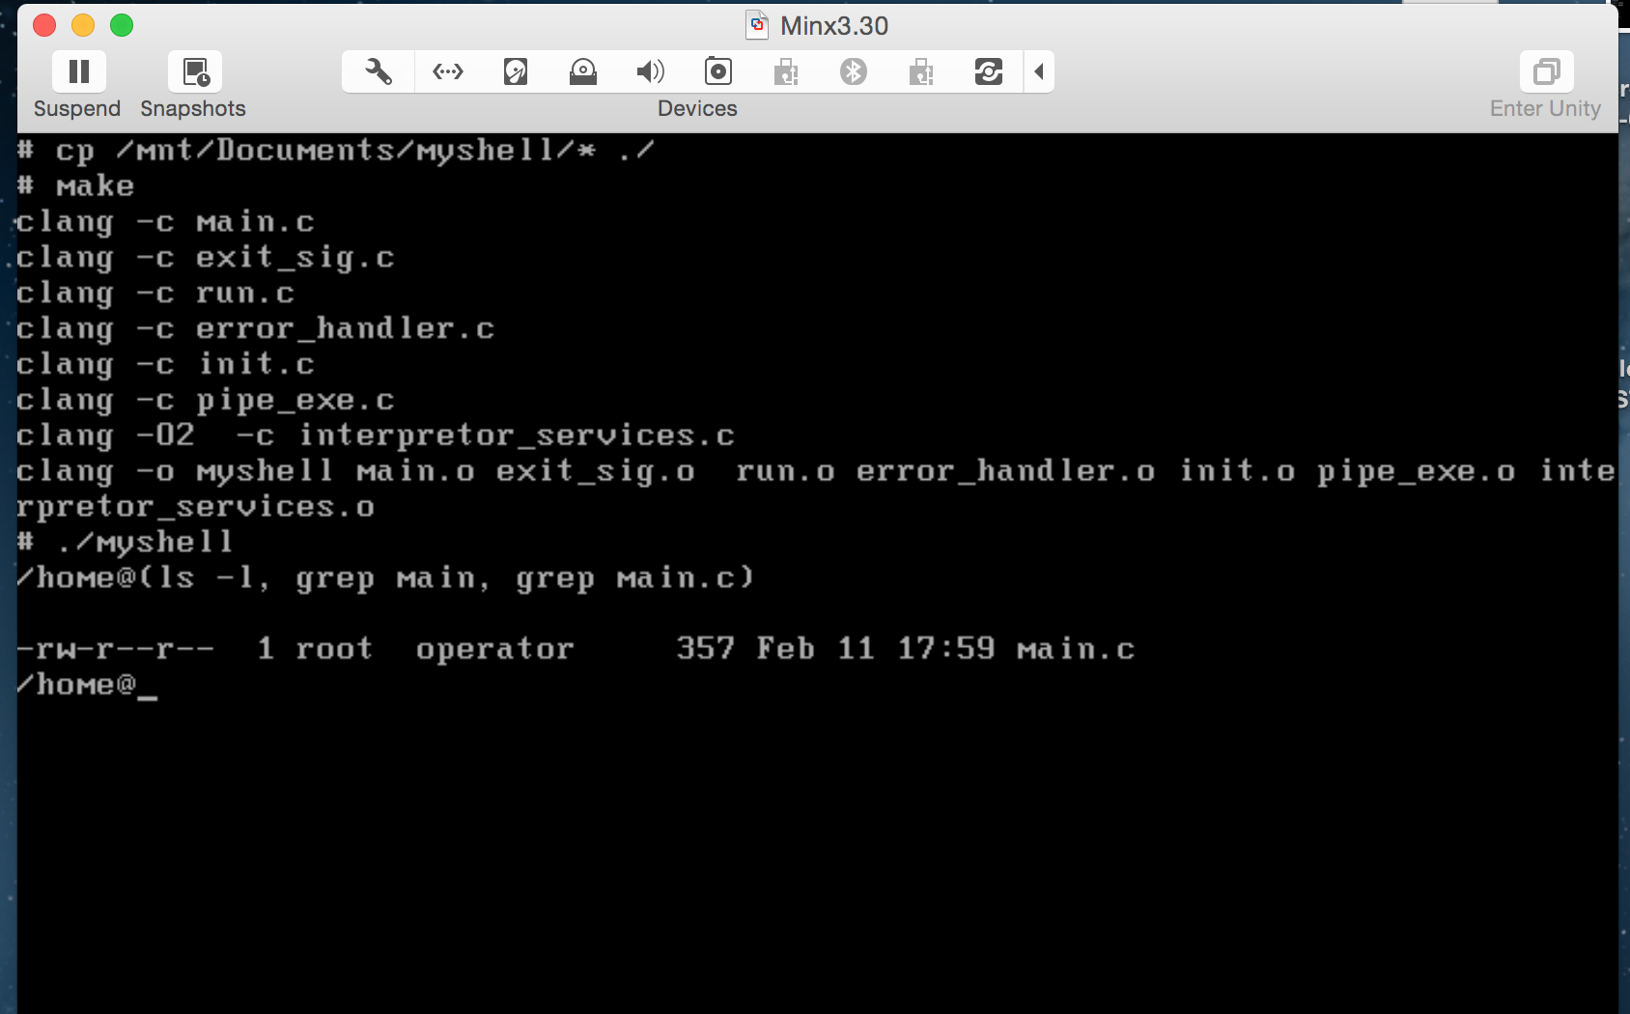

1. Our shell can only be terminated by exit and ctrl-c. If it is the latter, our shell will ask “Are you sure?” and exits after confirmation.

