1. First options is for inodewalker. It displays all inode numbers that are present in memory.

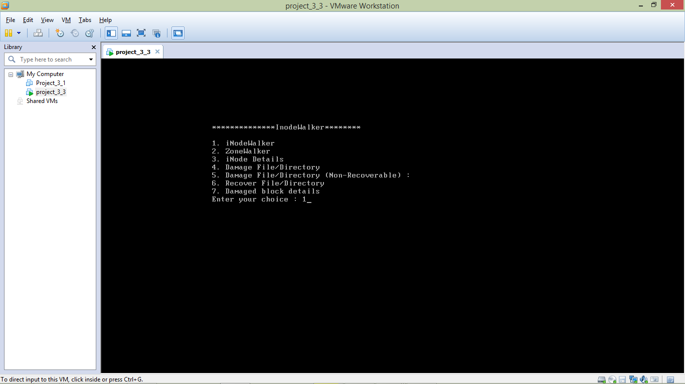

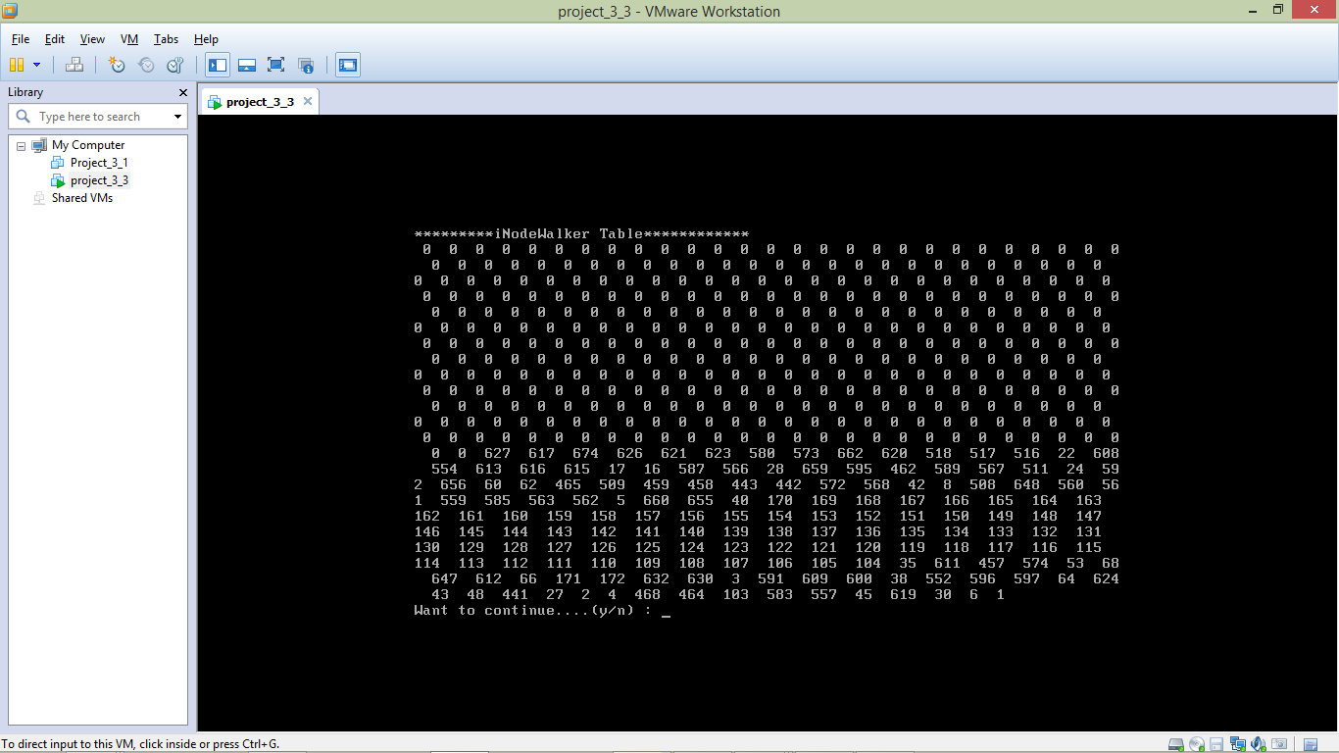

1. Second option is for Zonemapwalker. It displays all zones that are not free.

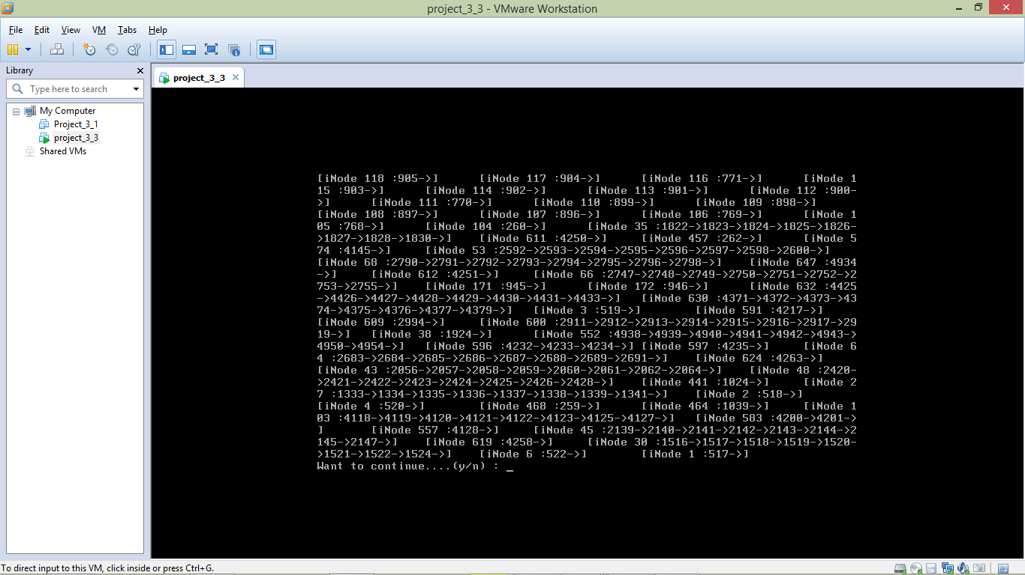

1. Option three gives particular inode details. Here we are displaying inode 637 details.

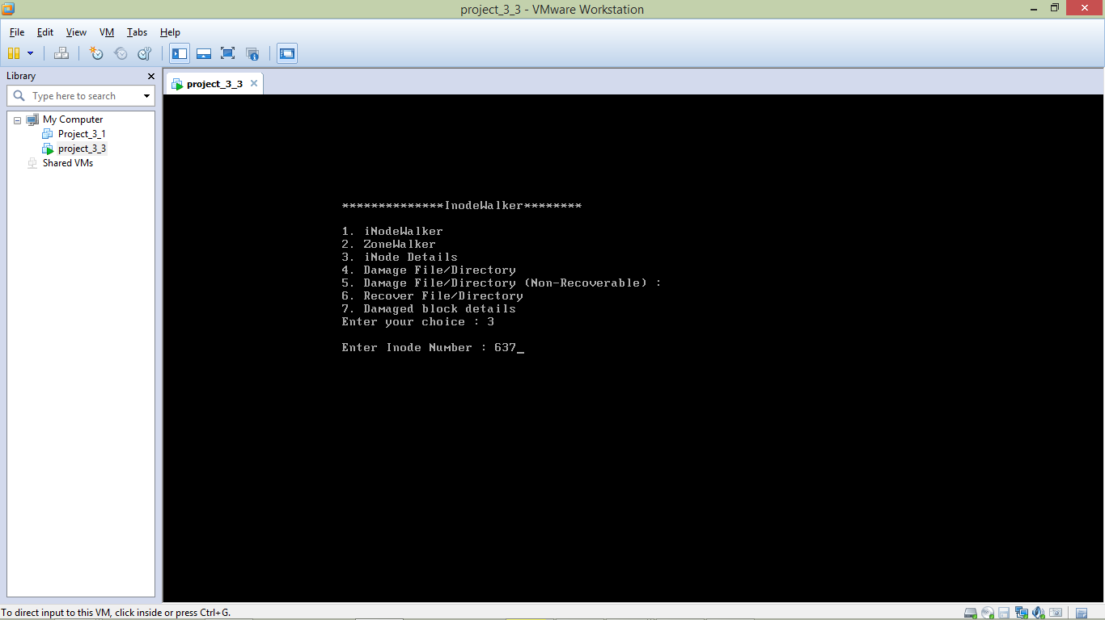

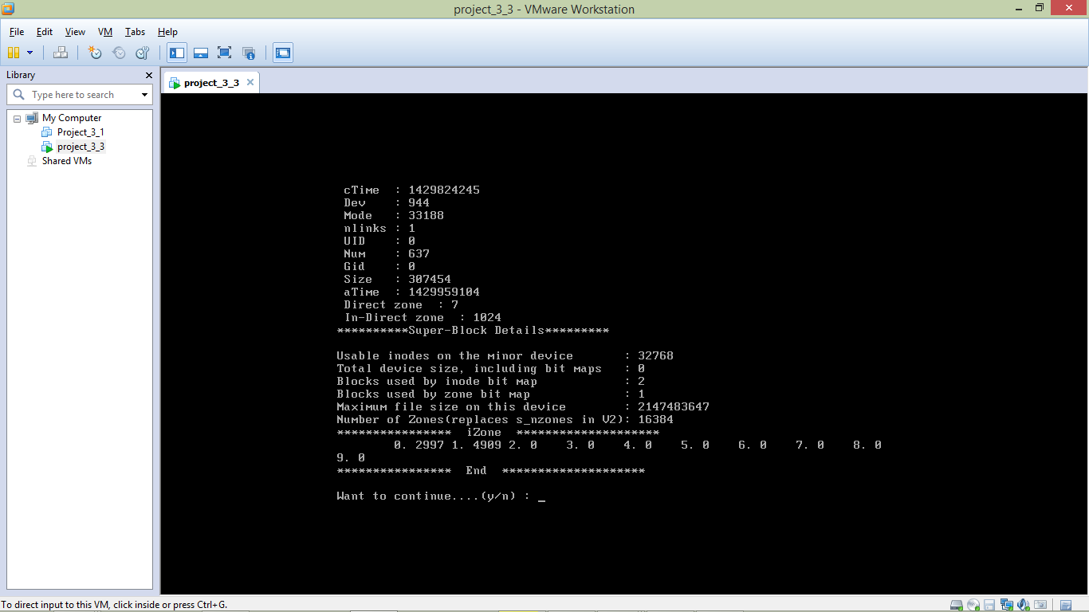

1. Option four is for damage file or directory. It will damage inode number entered by user.

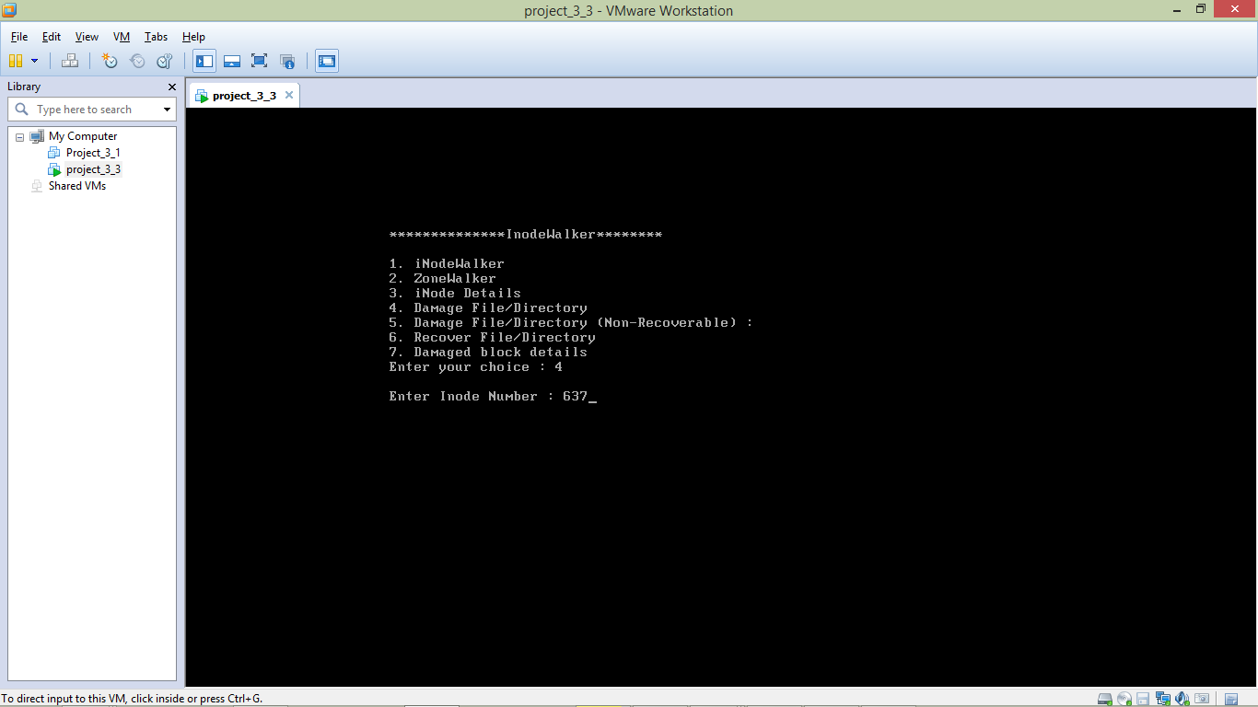

(For each iteration, it will damage one zone at a time. Here it damaged zone 4909. )

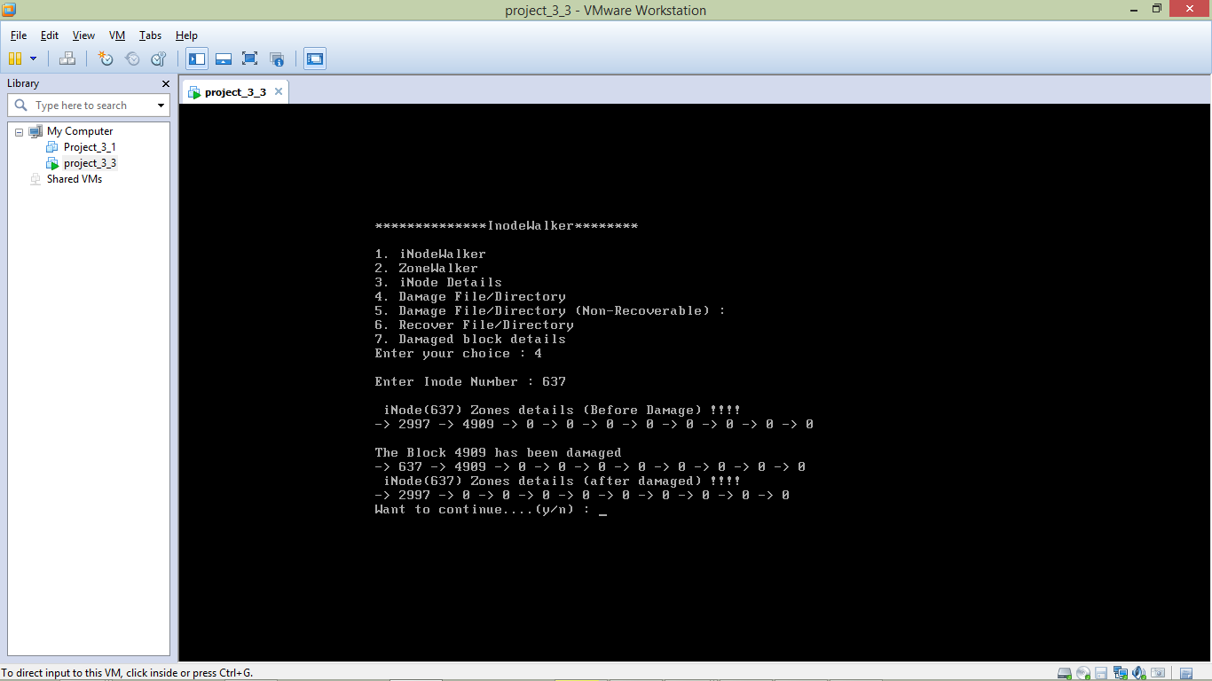

(In second iteration, it damaged zone 2997. )

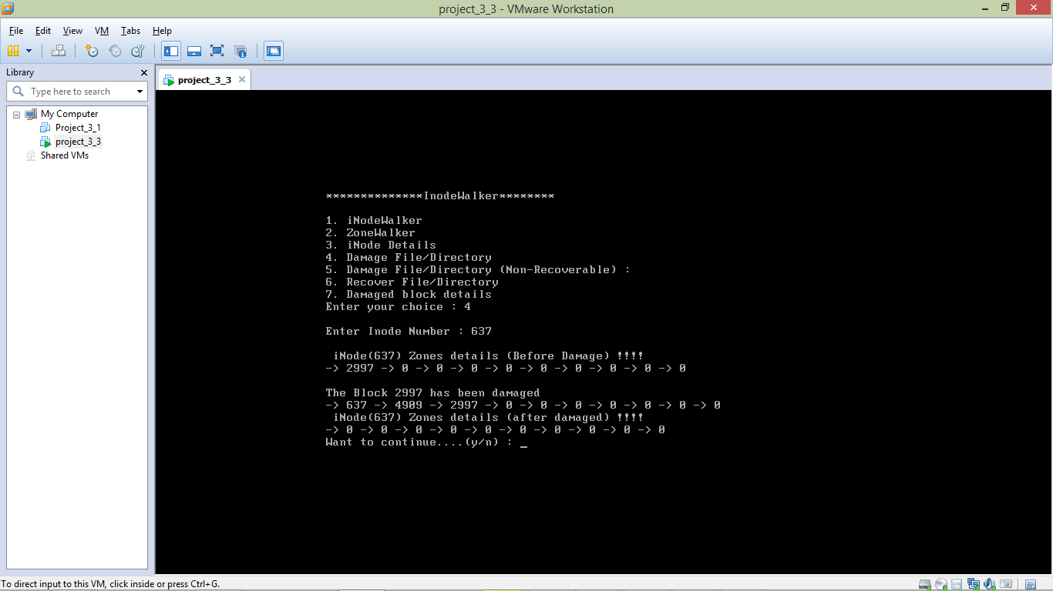

1. Option five is for damaged a particular file/directory permanently by inode.
2. In option 6, all damaged block for particular inode will be recovered.

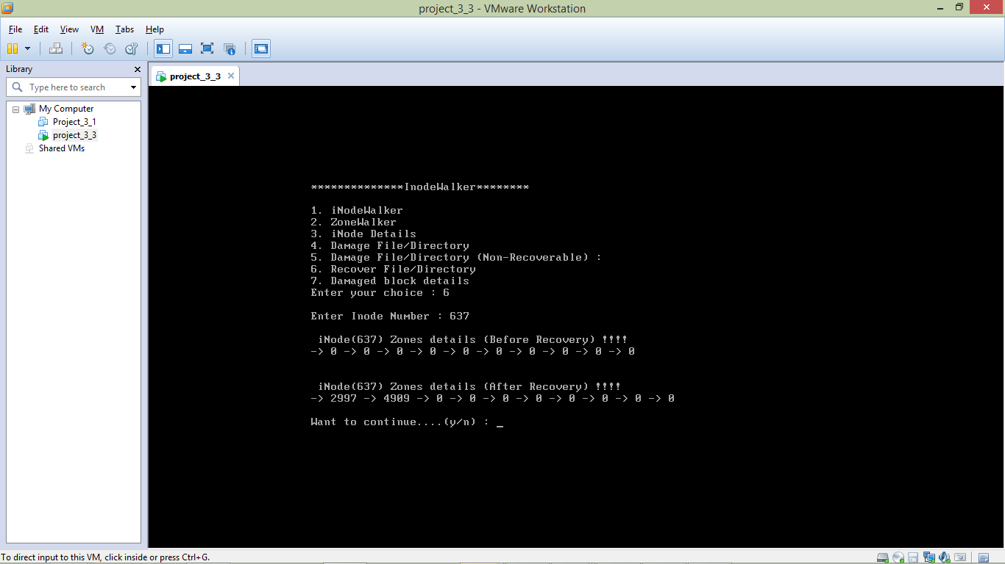

1. Option seven will give damaged block details.

