1.Explain Docker Architecture and its main components

Docker definition

Images , container, Docker file,

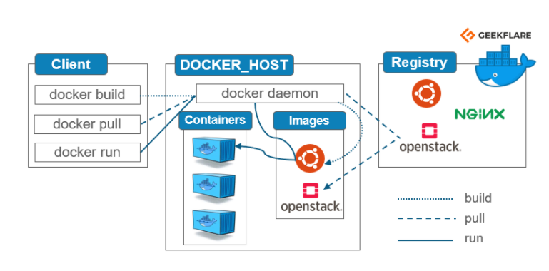

2.When a docker command is run, how docker reads the I/P and gives back the O/P? (eg: if I run command like docker ps, how it reads the I/P)

3.I’ve created a container from an image, executed it and installed some packages on the container. How to create new image from the running container with the new changes?

Docker commit running_containerid new_image:tag

4.Dockers default N/w type?

Defualt 0, it is a bridge n/w

5.What is bridge N/w?

6 Diff b/w Host and Bridge N/w.

7 How do you resolve memory issue on containers in Docker?

A)  how much memory you want to dedicate to that specific container. ?

For example, if you set --memory to **1 GB**, as in the example above, the amount of swap memory needs to be more than that. To run a container with an **additional** **1 GB** of swap memory, set the swap memory to **2 GB**.

sudo docker run -it --memory="1g" --memory-swap="2g" ubuntu

**A)**

syntax

sudo docker run -it --memory="[memory_limit]" [docker_image]

sudo docker run -it --memory="1g" ubuntu

https://phoenixnap.com/kb/docker-memory-and-cpu-limit

8 Explain Docker file. (steps in the file)

All instructions

Command to create container?

Docker run

9 How to access the application inside container from outside?

Using portmaping

10 How to access data in the container which got stopped or killed?

By Restarting the container

**OR**

1) **Editing file system on host directly**. This is somewhat dangerous and has a chance of completely breaking the container, possibly other data depending on what goes wrong.

2) **Changing the startup script** to something that never fails like starting a bash, doing the fixes/edits and then changing the startup program again to the desired one (like node or whatever it was before).

**More details:**

1) Using

docker ps

to find the running containers or

docker ps -a

to find all containers (including stopped ones) and

docker inspect (containername)

11 How do you configure volumes in Docker?

Docker volume volume_name image_name

docker run -p 8080:8080 -p 50000:50000 -d -v jenkins_home:/var/jenkins_home jenkins/jenkins:lts

12 Tell some docker commands which you use daily

13 What is name space

14 What is hypervisor

Hypervisor exposes CPU, RAM, network and disk resources to the VMs

Hypervisor also known as VM

It will divide CPU and Memory

15 Maven life cycle

* validate - validate the project is correct and all necessary information is available
* compile - compile the source code of the project
* test - test the compiled source code using a suitable unit testing framework. These tests should not require the code be packaged or deployed
* package - take the compiled code and package it in its distributable format, such as a JAR.
* verify - run any checks on results of integration tests to ensure quality criteria are met
* install - install the package into the local repository, for use as a dependency in other projects locally
* deploy - done in the build environment, copies the final package to the remote repository for sharing with other developers and projects.

Docker Image Size should be limited, what you do in Dockerfile

We will docker mulatistage build

maven life cycle

Where Are Docker Logs Stored By Default?

/var/lib/docker/containers/[container-id]/[container-id]-json.log.

The logging driver enables you to choose how and where to ship your data. The default logging driver as I mentioned above is a JSON file located on the local disk of your Docker host:

Webhooks config setup

Plugins installation