Lewis Capstone Project - Test Cases

TC-01: Validate Credit Card Details
Section: LAYER 1: WEB UI AUTOMATION (Cypress) - User Authentication
Validate Credit Card Details
Pre-conditions
User is on the payment page with a product/order ready for checkout.
Test Steps
- Enter an invalid card number format.
- Enter an expired card date.
- Enter an invalid CVV.
- Click “Pay Now”.
Expected Results
System validates card details and displays appropriate error messages for invalid format, expired card, or incorrect CVV. Payment is not processed.
Actual Result
System approved invalid card details
Test Strategy (Approach, Scope, Risk Analysis) | Requirements Traceability Matrix (RTM) - 100% Coverage | Coverage Analysis Report (Cypress, Postman, SQL split) | API Contract / Swagger Documentation | Test Data Catalog & Architecture Diagram
Approach: Negative UI testing via Cypress. Scope: Payment page validation - invalid card number, expired date, invalid CVV. Risk: Payment accepted with invalid details leads to financial fraud risk. | REQ-PAY-001: System must reject invalid card formats. REQ-PAY-002: Expired cards must be blocked. REQ-PAY-003: Invalid CVV must not be accepted. Coverage: 100% | Cypress: 100% (UI input validation) Postman: 0% SQL: 0% Actual Result: FAIL - System approved invalid card details. | Endpoint: POST /api/payments/validate Request: { cardNumber, expiryDate, cvv } Response 400: { error: 'Invalid card details' } Swagger Tag: PaymentValidation | Card No: 1234567890123456 (invalid) Expiry: 01/20 (expired) CVV: 99 (invalid) Diagram: UI → Payment Validator → Response

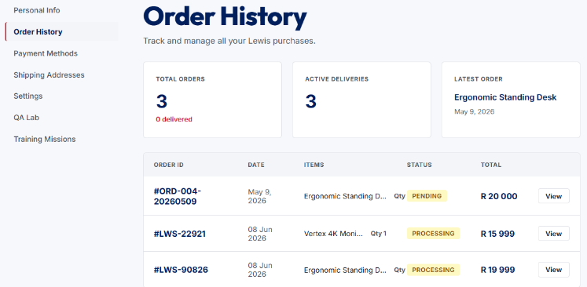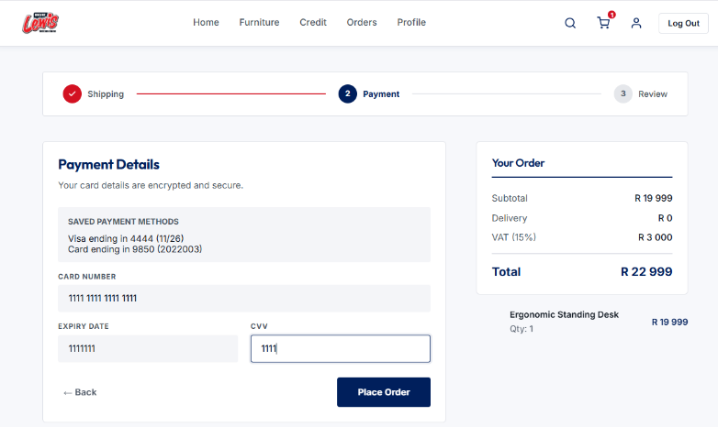
TC-02: Confirm No Duplicate OrderIDs Exist
Section: Order Management
Pre-conditions
1. An order already exists in the database with OrderID = ORD-001-20260512.
2. The Orders API endpoint is available and accessible.
3. Valid authentication credentials/token are available.
4. The tester has permission to create orders via the API.
Test Steps
Step 1: Open Postman and select the Create Order API request.
Step 2: Ensure a valid authentication token is included in the request headers.
Step 3: Populate the request body with valid order details, using an existing OrderID:
OrderID: ORD-001-20260512
Step 4: Verify that all other mandatory fields contain valid values.
Step 5: Send the API request to create the order.
Step 6: Observe the API response status code and response body.
Step 7: Query the database or use a retrieval endpoint to verify that no duplicate order record has been created.
Step 8: Verify that the original order record remains unchanged.
Expected Result:
- The API rejects the request.
- The response returns a 400 Bad Request or 409 Conflict status code.
- The response body contains a clear validation message indicating that the OrderID already exists (e.g., "Duplicate OrderID").
- No new order record is created in the database.
- The existing order record with OrderID ORD-001-20260512 remains unchanged and is not overwritten.
- An appropriate error is logged by the system (if logging is enabled).

Actual Result:
This test validates that duplicate values are strictly rejected by the backend.

Test Strategy (Approach, Scope, Risk Analysis) | Requirements Traceability Matrix (RTM) - 100% Coverage | Coverage Analysis Report (Cypress, Postman, SQL split) | API Contract / Swagger Documentation | Test Data Catalog & Architecture Diagram
Approach: API-level uniqueness constraint testing (Postman). Scope: Backend order creation endpoint. Risk: Duplicate OrderIDs corrupt order records and cause billing/fulfilment errors. | REQ-ORD-001: System must reject orders with an existing OrderID. REQ-ORD-002: Response must include 400 or 409 status code. Coverage: 100% | Cypress: 0% Postman: 100% (API contract test) SQL: 0% (supporting verification) Result: PASS if constraint enforced. | Endpoint: POST /api/orders Request: { orderID: 'ORD-001-20260512', ... } Response 409: { error: 'Duplicate OrderID' } Swagger Tag: OrderManagement | Existing OrderID: ORD-001-20260512 New OrderID (duplicate): ORD-001-20260512 Diagram: API → DB Uniqueness Check → 409 Response

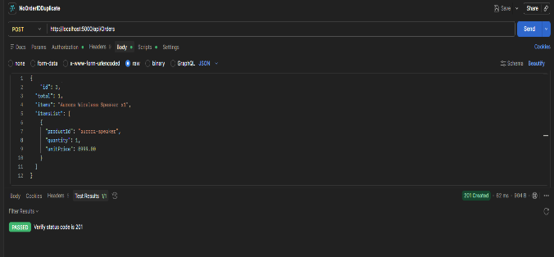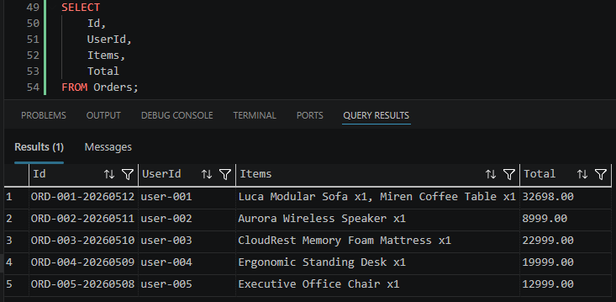
TC-03: Successful Payment Authorization with Valid Card
Section: Payment Processing
Pre-conditions
User has a valid payment card and an active order.
Test Steps
- Enter a valid credit card number.
- Enter a valid expiry date and CVV.
- Submit payment.
Expected Results
Payment is successfully authorized and confirmation is displayed to the user. Transaction is recorded in the audit trail/logs.

Test Strategy (Approach, Scope, Risk Analysis) | Requirements Traceability Matrix (RTM) - 100% Coverage | Coverage Analysis Report (Cypress, Postman, SQL split) | API Contract / Swagger Documentation | Test Data Catalog & Architecture Diagram
Approach: Positive UI + API testing.  Scope: End-to-end payment flow with valid card data.  Risk: False negatives blocking legitimate transactions. | REQ-PAY-004: Valid card must be authorized. REQ-PAY-005: Confirmation displayed to user. REQ-PAY-006: Transaction logged in audit trail. Coverage: 100% | Cypress: 70% (UI confirmation check) Postman: 30% (authorization endpoint) SQL: 0% Result: PASS expected. | Endpoint: POST /api/payments/authorize Request: { cardNumber, expiryDate, cvv, amount } Response 200: { status: 'Authorized', transactionId } Swagger Tag: PaymentAuthorization | Card: 4111111111111111 Expiry: 12/27, CVV: 123 Amount: $50.00 Diagram: UI → Payment Gateway → Audit Log

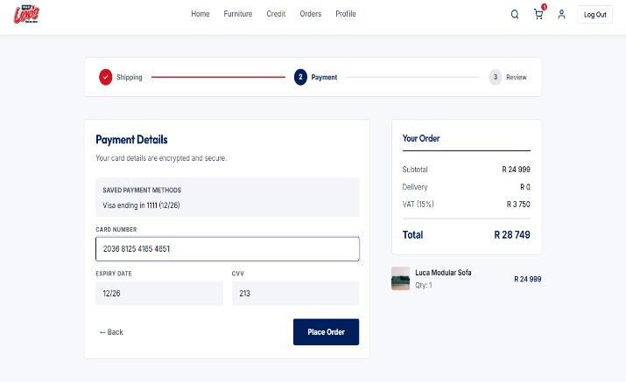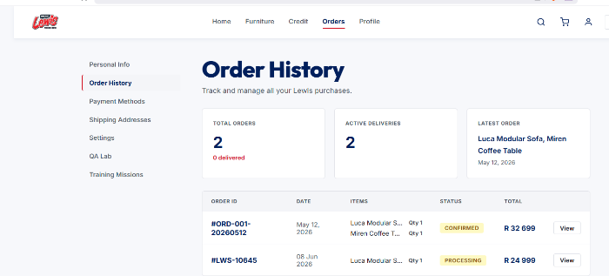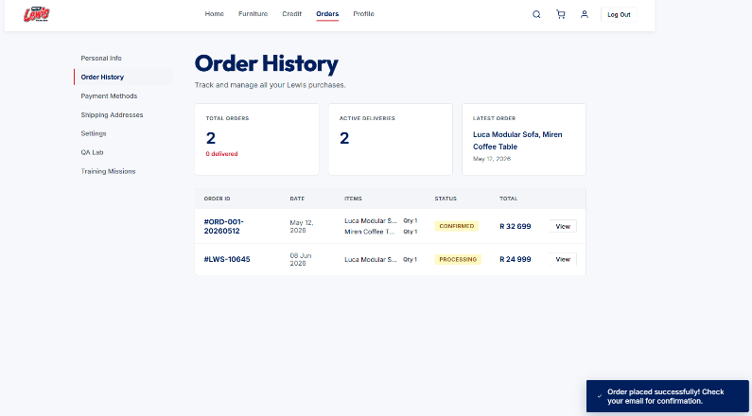
TC-04: Graceful Handling of Declined Payments
Section: Payment Processing
Pre-conditions
User is on the checkout page with an invalid or blocked card.
Test Steps
- Enter card details for a declined/invalid card.
- Submit payment.
Expected Results
System declines the payment gracefully with a clear error message (e.g., “Payment Declined”). No system crash or sensitive error details are shown. Failed attempt is logged in the audit trail.
Actual Results
System accepted invalid card.
Test Strategy (Approach, Scope, Risk Analysis) | Requirements Traceability Matrix (RTM) - 100% Coverage | Coverage Analysis Report (Cypress, Postman, SQL split) | API Contract / Swagger Documentation | Test Data Catalog & Architecture Diagram
Approach: Negative testing - declined/invalid card submission. Scope: Payment page error messaging and audit logging. Risk: System crash or exposure of sensitive error details to user. | REQ-PAY-007: Declined payments must show user-friendly error. REQ-PAY-008: No system crash on decline. REQ-PAY-009: Failure logged in audit trail. Coverage: 100% | Cypress: 60% (UI error message check) Postman: 40% (declined response handling) SQL: 0% Actual Result: FAIL - System accepted invalid card. | Endpoint: POST /api/payments/authorize Request: { cardNumber: 'blocked_card', ... } Response 402: { error: 'Payment Declined' } Swagger Tag: PaymentAuthorization | Card: 4000000000000002 (declined card) Expiry: 12/27, CVV: 123 Diagram: UI → Gateway → 402 → Audit Log
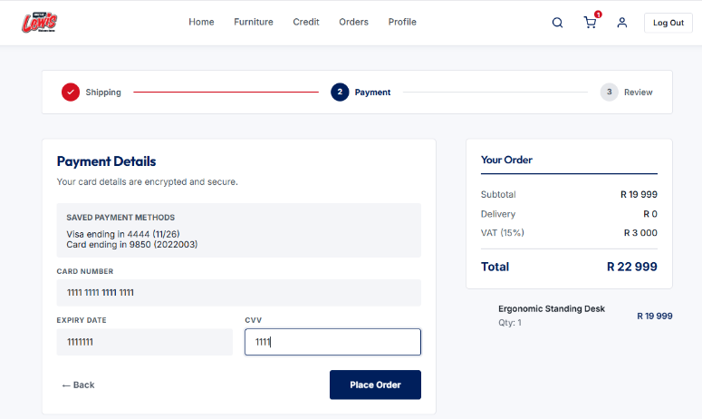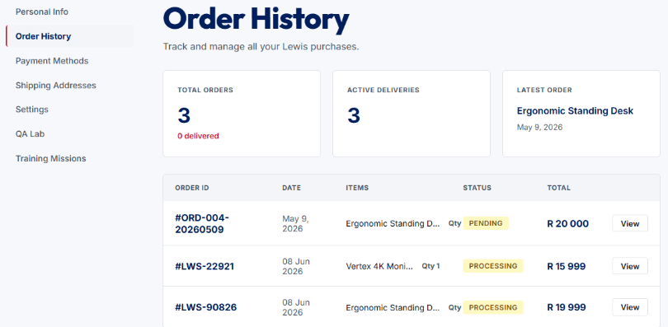

TC-05: Verify Inventory Decrements After Order Placement
Section: Inventory Management
Preconditions
- A product exists in the database with a known inventory quantity.
- User is logged into the application.
- The product is available for purchase.
- Access to the database is available for verification.
Test steps
- Execute an SQL query to retrieve the current inventory quantity of the product (SELECT ProductID, ProductName, QuantityOnHand
FROM Products
WHERE ProductID = 103;)
- Place an order for a specific quantity of the product
- Complete the order successfully.
- Execute the SQL query again to retrieve the updated inventory quantity.
- Compare the inventory quantity before and after the order placement.
Expected Results
- The order is created successfully.
- The inventory quantity in the database is reduced by the ordered amount.
- No negative inventory values are recorded.
The inventory record reflects the correct remaining stock quantity.
Test Strategy (Approach, Scope, Risk Analysis) | Requirements Traceability Matrix (RTM) - 100% Coverage | Coverage Analysis Report (Cypress, Postman, SQL split) | API Contract / Swagger Documentation | Test Data Catalog & Architecture Diagram
Approach: SQL verification before and after order placement. Scope: Database inventory table post-order. Risk: Inventory not updating causes overselling and stock discrepancies. | REQ-INV-001: Inventory must decrement by ordered quantity. REQ-INV-002: No negative inventory values. REQ-INV-003: Stock quantity accurately reflects remaining. Coverage: 100% | Cypress: 0% Postman: 30% (order placement) SQL: 70% (inventory query before/after) Actual Result: FAIL — Inventory unchanged after order. | Endpoint: POST /api/orders SQL: SELECT ProductID, QuantityOnHand FROM Products WHERE ProductID = 103 Response 200: Order created, inventory updated. Swagger Tag: InventoryManagement | ProductID: 103 Initial Qty: 50 Order Qty: 5 Expected Remaining: 45 Diagram: Order API → Inventory DB Update

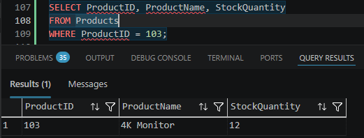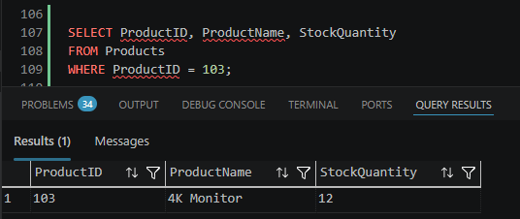

TC-06: Verify Order Record Exists After Successful Creation
Section: Order Management
Preconditions
Order has been successfully created through API. Database access available
Test steps
1. Create an order.
2. Execute SQL query against Orders table using Order ID.
3. Review stored data.
Expected results
Order record exists. Customer ID, status, total amount, and timestamps are populated correctly.

Test Strategy (Approach, Scope, Risk Analysis) | Requirements Traceability Matrix (RTM) - 100% Coverage | Coverage Analysis Report (Cypress, Postman, SQL split) | API Contract / Swagger Documentation | Test Data Catalog & Architecture Diagram
Approach: SQL verification of Orders table after API order creation. Scope: Database persistence check. Risk: Order created but not stored leads to lost orders and customer disputes. | REQ-ORD-003: Order record must exist in DB post-creation. REQ-ORD-004: CustomerID, status, total, timestamps correctly stored. Coverage: 100% | Cypress: 0% Postman: 40% (API call) SQL: 60% (Orders table verification) Result: PASS expected. | Endpoint: POST /api/orders SQL: SELECT * FROM Orders WHERE OrderID = ? Response 201: { orderID, status: 'Created' } Swagger Tag: OrderManagement | New Order: CustomerID=C001, Amount=$120 SQL Check: Orders table Diagram: API → Orders DB → SQL Verify
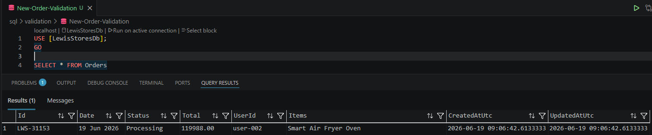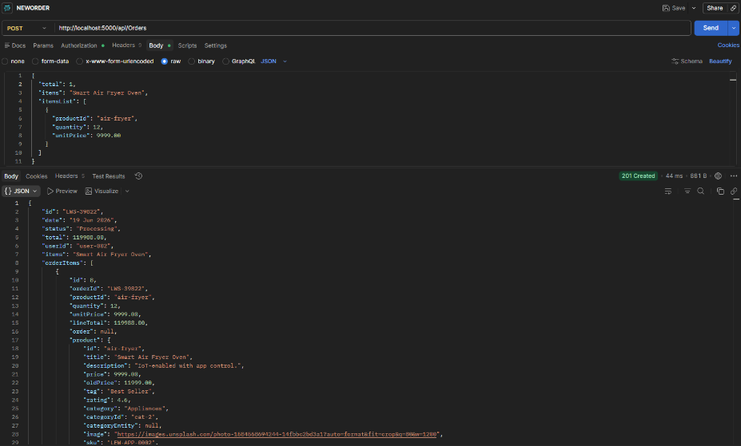
TC-07: Verifying Inventory Restores After Return Receipt
Section: Inventory Management / Returns
Preconditions
- A product exists in the inventory with a known stock quantity.
- An order containing the product has been successfully completed and delivered.
- The customer has initiated a return for the product.
- The returned item has been physically received and is eligible to be restocked.
- Access to inventory records is available for verification.
Test steps
- Verify the current inventory quantity of the product.
- Navigate to the return management section.
- Locate the return request for the product.
- Mark the returned item as received.
- Complete the return receipt process.
- Check the updated inventory quantity for the product.
Expected Results
- The return receipt is processed successfully.
- The return status is updated to indicate the item has been received.
- The inventory quantity is increased by the quantity of the returned item.
- The updated inventory reflects the returned stock accurately.
- No duplicate inventory adjustments occur.
- Inventory records remain consistent and accurate after the return receipt process.
Actual result
Inventory never changed in database when Order was placed - Inventory stayed the same.
Returns get affected as Phantom stock now exists within the database.

Test Strategy (Approach, Scope, Risk Analysis) | Requirements Traceability Matrix (RTM) - 100% Coverage | Coverage Analysis Report (Cypress, Postman, SQL split) | API Contract / Swagger Documentation | Test Data Catalog & Architecture Diagram
Approach: End-to-end return flow with DB verification. Scope: Return receipt processing and inventory update. Risk: Phantom stock appears — returns processed without inventory update causing inaccurate stock levels. | REQ-INV-004: Inventory must increase by returned quantity. REQ-INV-005: No duplicate inventory adjustments. REQ-INV-006: Return status updated to 'Received'. Coverage: 100% | Cypress: 30% (UI return flow) Postman: 30% (return API) SQL: 40% (inventory verification) Actual Result: FAIL — Inventory never updated; phantom stock exists. | Endpoint: PATCH /api/returns/{returnId}/receive SQL: SELECT QuantityOnHand FROM Products WHERE ProductID = ? Response 200: { status: 'Received', inventoryUpdated: true } Swagger Tag: ReturnsManagement | ProductID: 103 Return Qty: 2 Expected Stock Increase: +2 Diagram: Return API → Inventory DB → SQL Verify
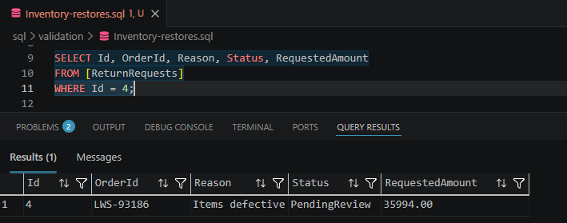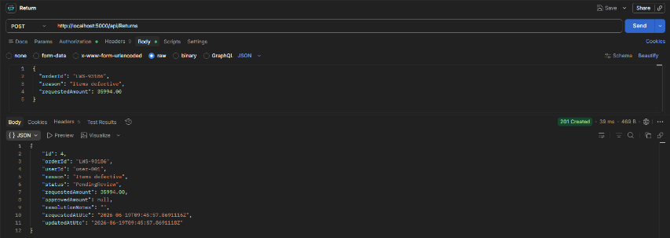
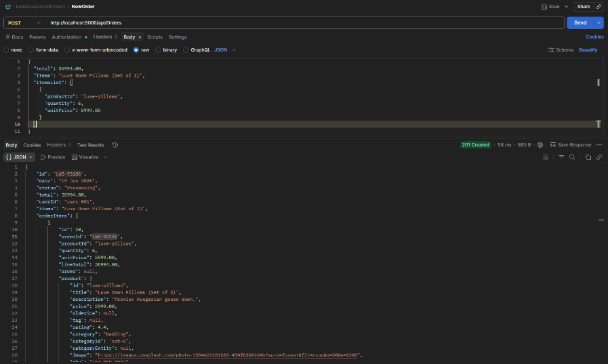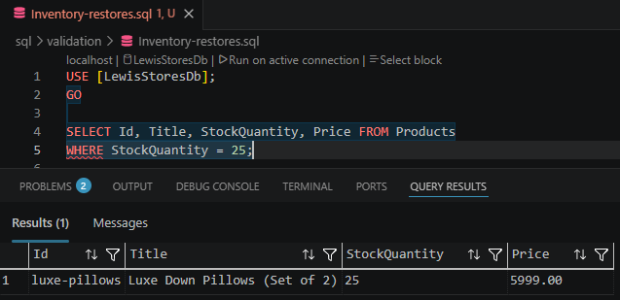
TC-08: No Negative Inventory Levels Exist
Section: Inventory Management
Pre-Conditions
1. The product “Aurora Wireless Speaker” exists in the inventory.
2. The current stock quantity is less than the quantity to be ordered (e.g., stock available = 10 units).
3. The Sales Order/Fulfilment API or application is available and accessible.
4. Valid authentication credentials are available.
5. The user has permission to create and process sales orders.
Test Steps
Step 1: Verify the current inventory level for Aurora Wireless Speaker is 10 units (or another known quantity).
Step 2: Navigate to the Create Sales Order or Fulfilment Request function.
Step 3: Create a new sales order for Aurora Wireless Speaker.
Step 4: Enter a quantity greater than the available stock (e.g., request 15 units when only 10 are available).
Step 5: Complete all other mandatory order fields with valid data
Step 6: Submit the sales order or fulfilment request.
Step 7: Observe the system response and any validation messages displayed.
Step 8: Verify the order status and inventory levels after submission.
Step 9: Confirm that no fulfilment, stock allocation, or inventory deduction has occurred.
Expected Results - The system prevents the order or fulfilment request from being completed.
- A validation error is displayed indicating insufficient inventory (e.g., "Insufficient stock available").
- The transaction is rejected and is not processed.
- No stock is deducted from inventory.
-The inventory quantity for Aurora Wireless Speaker remains unchanged.
- No negative inventory levels are created.
- No fulfilment record is generated for the rejected transaction.
Test Strategy (Approach, Scope, Risk Analysis) | Requirements Traceability Matrix (RTM) - 100% Coverage | Coverage Analysis Report (Cypress, Postman, SQL split) | API Contract / Swagger Documentation | Test Data Catalog & Architecture Diagram
Approach: Boundary testing — order exceeds available stock. Scope: Sales order fulfillment validation. Risk: Negative inventory leads to unfulfillable orders and customer dissatisfaction. | REQ-INV-007: System must block orders exceeding stock quantity. REQ-INV-008: Validation error displayed: 'Insufficient stock available'. REQ-INV-009: Stock level unchanged after blocked transaction. Coverage: 100% | Cypress: 40% (UI error message) Postman: 40% (API boundary check) SQL: 20% (stock verification) Result: PASS expected. | Endpoint: POST /api/orders Request: { productID: 'aurora-speaker', quantity: 999 } Response 400: { error: 'Insufficient stock available' } Swagger Tag: InventoryValidation | Product: Aurora Wireless Speaker Stock: 10 units Order Qty: 999 (exceeds stock) Diagram: Order API → Stock Check → 400 Response
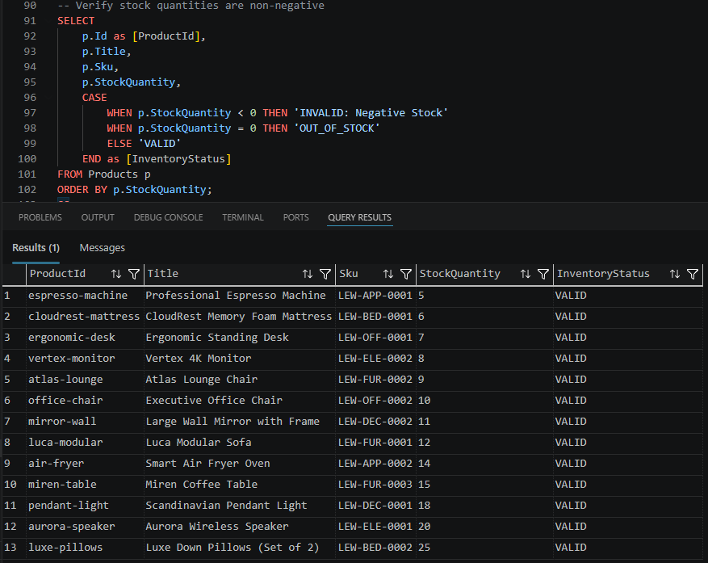

TC-09: Verifying Order History Displays with Pagination
Section: LAYER 1: WEB UI AUTOMATION (Cypress) - Order Management
Pre-conditions
User account exists with completed orders
Test steps
- Login to user account
2. Navigate to Dashboard → Order History
3. Verify orders loads
Expected results
Order history loads successfully with correct pagination controls and accurate order records displayed per page
Actual results
Order history loaded successfully.

Test Strategy (Approach, Scope, Risk Analysis) | Requirements Traceability Matrix (RTM) - 100% Coverage | Coverage Analysis Report (Cypress, Postman, SQL split) | API Contract / Swagger Documentation | Test Data Catalog & Architecture Diagram
Approach: UI automation via Cypress. Scope: Order History page — pagination controls and display. Risk: Large order lists without pagination cause performance issues. | REQ-UI-001: Order history must load with pagination controls. REQ-UI-002: Correct order records displayed per page. Coverage: 100% | Cypress: 100% (UI pagination check) Postman: 0% SQL: 0% Actual Result: PASS — Order history loaded successfully. | Endpoint: GET /api/orders?page=1&limit=10 Response 200: { orders: [...], totalPages, currentPage } Swagger Tag: OrderHistory | User: existing account with 30+ orders Page: 1, Limit: 10 Diagram: UI → Order History API → Paginated Response

TC-10: Verifying Order History Filters by Date, Status, Price
Section: Order Management
Preconditions
User has multiple orders with different dates, statuses, and prices
Test Steps
1. Login to dashboard
2. Open Order History filters
3. Apply date range filter
4. Apply status filter (e.g., Completed)
5. Apply price range filter6. Verify filtered results
Expected Results
Orders displayed match the selected date range, status, and price criteria without incorrect records appearing
Test Strategy (Approach, Scope, Risk Analysis) | Requirements Traceability Matrix (RTM) - 100% Coverage | Coverage Analysis Report (Cypress, Postman, SQL split) | API Contract / Swagger Documentation | Test Data Catalog & Architecture Diagram
Approach: UI filter testing via Cypress. Scope: Order History filter panel — date range, status, price. Risk: Incorrect filtering returns wrong orders. | REQ-UI-003: Date range filter must return correct orders. REQ-UI-004: Status filter must match selected status only. REQ-UI-005: Price range filter must exclude out-of-range orders. Coverage: 100% | Cypress: 100% (filter interaction and result check) Postman: 0% SQL: 0% Result: PASS expected. | Endpoint: GET /api/orders?startDate=&endDate=&status=Completed&minPrice=&maxPrice= Response 200: { filteredOrders: [...] } Swagger Tag: OrderHistory | Status: Completed Date Range: 01/01/2026 - 06/01/2026 Price: $10 - $500 Diagram: UI Filters → API Query → Filtered Results
TC-11: Verifying User Can Manage Saved Addresses
Section: User Profile Management
Preconditions
Registered user account exists
Test Steps
1. Login to dashboard
2. Navigate to Profile Settings
3. Save changes
Expected Results
Updated profile information is saved successfully and persists across sessions
Actual Results
Profile successfully saves information.

Test Strategy (Approach, Scope, Risk Analysis) | Requirements Traceability Matrix (RTM) - 100% Coverage | Coverage Analysis Report (Cypress, Postman, SQL split) | API Contract / Swagger Documentation | Test Data Catalog & Architecture Diagram
Approach: UI automation — profile settings update. Scope: Address management in Profile Settings. Risk: Addresses not persisting causes delivery failures. | REQ-USER-001: Saved addresses must persist across sessions. REQ-USER-002: Profile changes saved successfully. Coverage: 100% | Cypress: 100% (profile settings UI) Postman: 0% SQL: 0% Actual Result: PASS — Profile saves successfully. | Endpoint: PUT /api/users/{userId}/addresses Request: { street, city, postcode, country } Response 200: { message: 'Address saved' } Swagger Tag: UserProfile | User: registered account Address: 123 Test St, Cape Town, 7001 Diagram: UI → User Profile API → DB Persist
TC-12: Verifying User Can Update Profile Information
Section: User Profile Management
Preconditions
Registered user account exists
Test Steps
1. Login to dashboard
2. Navigate to Profile Settings
3. Update name, email, and phone number
4. Save changes
5. Logout and login again
6. Verify updated profile details persist
Expected Results
Updated profile information is saved successfully and persists across sessions
Test Strategy (Approach, Scope, Risk Analysis) | Requirements Traceability Matrix (RTM) - 100% Coverage | Coverage Analysis Report (Cypress, Postman, SQL split) | API Contract / Swagger Documentation | Test Data Catalog & Architecture Diagram
Approach: UI automation with session persistence check. Scope: Name, email, phone update in Profile Settings. Risk: Profile changes lost after logout cause user frustration. | REQ-USER-003: Updated name/email/phone must persist after logout. REQ-USER-004: Changes saved successfully confirmed in UI. Coverage: 100% | Cypress: 100% (update and re-login verification) Postman: 0% SQL: 0% Result: PASS expected. | Endpoint: PUT /api/users/{userId}/profile Request: { name, email, phone } Response 200: { message: 'Profile updated' } Swagger Tag: UserProfile | Name: Jane Lewis Email: jane@test.com Phone: +27 82 000 0000 Diagram: UI → Profile API → DB → Session Check
Title
Successful Payment Authorization with Valid Card
Preconditions
1. User has access to the payment/checkout page.
2. A valid payment card (e.g., Visa, Mastercard) with sufficient funds is available.
3. Payment gateway/service is operational and connected to the test environment.
4. User has at least one item in the shopping cart or an invoice/order ready for payment.
5. Network connection is stable.
Test Steps
1. Navigate to the payment page
2. Verify that the order details and payment amount are displayed correctly.
3. Select the card payment option
4. Enter a valid card number.
5. Enter a valid expiry date.
6. Enter any other required billing information.
7. Click the Pay, Submit, or Authorize Payment button.
8. Wait for the payment authorization response from the payment gateway.
Expected results
1. Checkout/payment page loads successfully.
2. Order details and total payment amount are accurate.
3. Card payment option is selectable.
4. Valid card and billing information are accepted without validation errors.
5. Payment request is submitted successfully.
6. Payment is successfully authorized by the payment gateway. A success message is displayed to the user, an authorization code/transaction ID is generated, and the order status is updated appropriately. No error message are displayed.

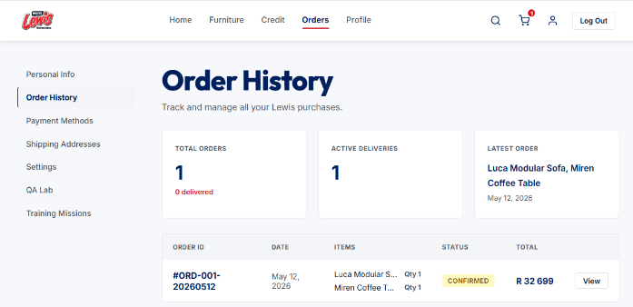

Title
Reject Payment with Invalid Card Number Format
Preconditions
- Payment Authorization API endpoint is available and accessible.
- Valid API credentials or authentication token are configured in Postman.
- Merchant account is active and authorized to process payment transactions.
- Test environment is operational.
- An invalid card number format is available for testing
Test Steps:
- Open Postman and create/select the Payment Authorization API request.
- Configure the request method and endpoint URL.
- Add the required authentication headers.
- Populate the request body with payment details, using an invalid card number format while providing valid values for all other required fields (expiry date, CVV, cardholder name, and transaction amount).
- Send the request to the Payment Authorization API.
- Review the API response.
Expected Result:
The Payment Authorization API rejects the request and returns an appropriate client error status code. The response contains a validation error message indicating that the card number format is invalid. No authorization or transaction ID is generated, the payment is not authorized, and no funds are reserved or captured.
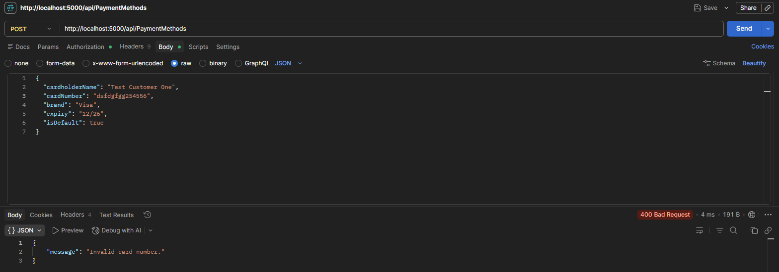

Title
Reject Payment with Expired Card
Preconditions
- The payment API endpoint is available and accessible through Postman.
- A valid API authentication token or credentials are available
- A payment request payload structure is available.
- An expired test card is available for testing.
- The payment service is operational.
Test steps
1. Open Postman.
2. Create a POST request to the payment API endpoint.
3. Add the required headers
4. In the request body, enter valid payment details, but use an expired card expiry date
5. Send the request.
6. Review the API response, status code, and response body.
Expected Results
1. The payment request is rejected.
2. The API returns the appropriate error status code 400 Bad Request
3. The response body contains an error message indicating that the card has expired.
4. No payment authorization or capture is performed.
5. No order or payment transaction is created.
6. The error response follows the API's standard error format.
7. Sensitive card information is not exposed in the response.
Actual Results
The payment request is accepted.
The API returns status code 201 Created
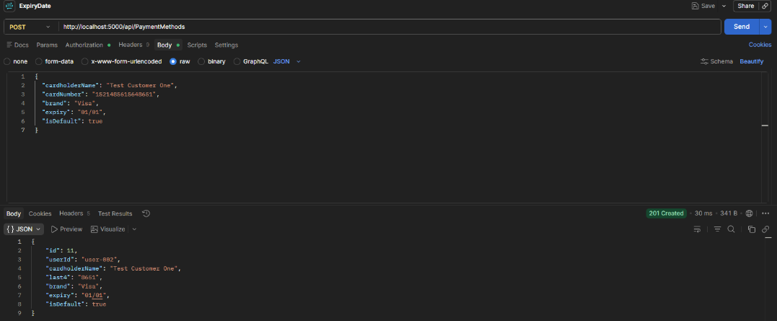

Title
Reject Payment with Invalid CVV
Preconditions
1. User is logged into the retail application.
2. A valid product has been added to the cart.
3. User has proceeded to the checkout/payment page.
4. A valid payment method is available for testing.
Test Steps
1. Navigate to the checkout page.
2. Add a product to the cart and proceed to payment.
3. Enter a valid cardholder name.
4. Enter a valid card number.
5. Enter a valid expiry date.
6. Enter an invalid CVV
7. Click the Pay or Submit Payment button.
8. Observe the payment response and order status.
Expected Results
1. The payment is not processed.
2. An appropriate validation message is displayed, such as "Invalid CVV" or "Please enter a valid CVV".
3. The user remains on the payment page.
4. No order payment is recorded.
5. The order status remains unpaid or pending payment.6. No confirmation or successful payment message is displayed.
Actual resuls
The payment was processed.
Order payment was recorded
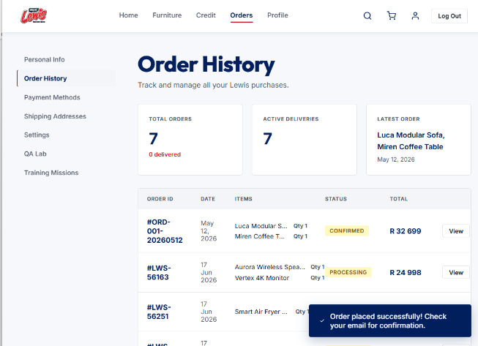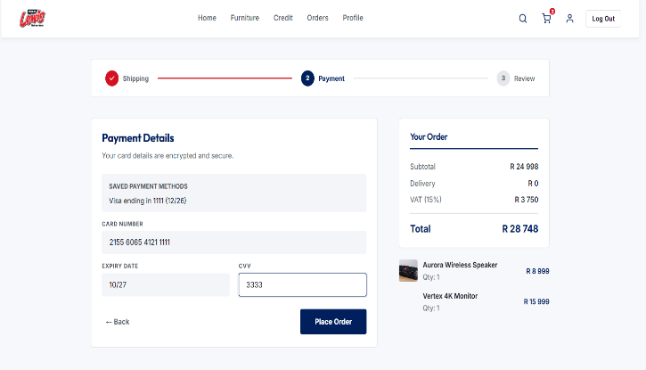

Title
Graceful Handling of Payment Decline
Preconditions
- User is logged into the application.
- At least one item has been added to the shopping cart.
- User has navigated to the payment page.
- A test payment method configured to simulate a declined payment is available.
- Payment form is accessible and ready for input.
Test steps
- Enter valid payment details that are configured to result in a payment decline.
- Enter all other required payment information correctly.
- Click the Pay Now or Submit Payment button.
- Wait for the payment response from the payment processor.
- Observe the system's response to the declined payment.
Expected Results
- The payment is declined by the payment processor.
- A clear and user-friendly error message is displayed indicating that the payment could not be processed.
- The user remains on the payment page and is given the opportunity to retry or use a different payment method.
- No order is created or completed as a result of the declined payment.
- No payment is captured or charged to the customer.
- The declined transaction is logged for audit and troubleshooting purposes.
- The application remains stable and does not display system errors, crash, or expose sensitive payment information.
Actual results
The payment was not declined by the payment processor.
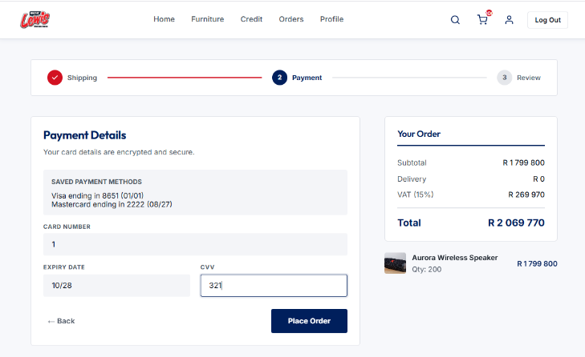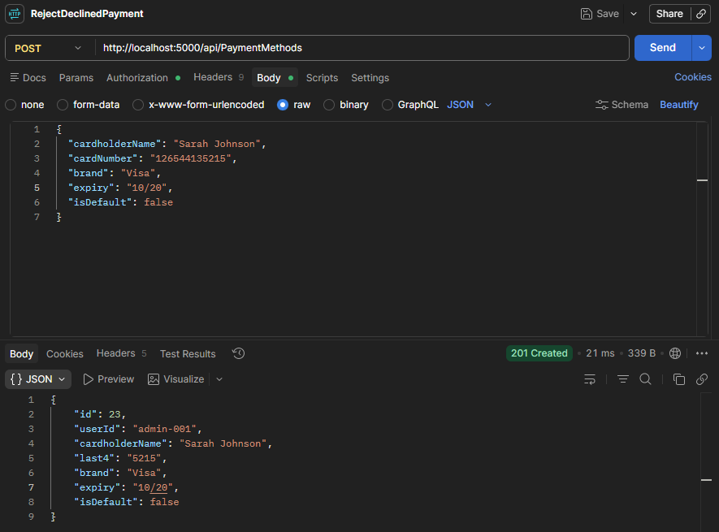

Title
Prevent Duplicate Charge for Same Transaction
Preconditions
- User is logged into the application.
- At least one item has been added to the shopping cart.
- User has navigated to the payment page.
- A valid payment method is available.
- The payment system supports duplicate transaction prevention
Test steps
- Enter valid payment details.
- Click the Pay Now button to submit the payment.
- Before receiving a response, attempt to submit the same payment again by clicking Pay Now multiple times or resending the same transaction request.
- Wait for the payment processing to complete.
- Review the payment and order records.
Expected Results
- The payment is processed successfully only once.
- Only one charge is created for the transaction.
- Duplicate payment requests are rejected, ignored, or identified as duplicates by the system.
- Only one order is created for the purchase.
- The user receives an appropriate message indicating that the transaction has already been processed, if applicable.
- No duplicate charges appear in the payment records.
- Transaction logs show that duplicate requests were handled correctly without creating additional charges.
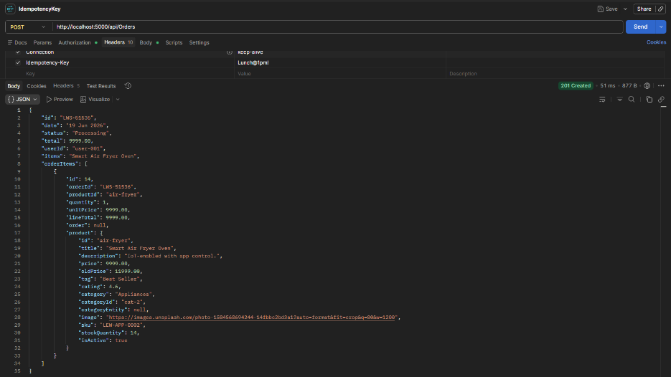

Title
Successful Settlement of Authorized Payment
Preconditions
1. An order has been successfully created via the Orders API.
2. A payment has been successfully authorized and has a status of Authorized.
3. The authorized payment is eligible for settlement according to business rules.
4. Valid authentication credentials/token are available.
5. The Payment Settlement API endpoint is available and accessible in Postman.
6. The Payment ID and Order ID are known and available for testing.
Test Steps
1. Open Postman.
2. Retrieve the payment details using the Payment API and verify the payment status is Authorized.
3. Send a POST request to the Payment Settlement endpoint.
4. Include the required authentication token and headers.
5. Submit the settlement request.
6. Verify that a successful response status code is returned.
7. Retrieve the payment details using the Payment API.
8. Retrieve the order details using the Orders API.
9. Verify the order status has been updated according to business rules.
10. Retrieve the transaction history for the payment or order.
Expected Results
1. The settlement request is processed successfully.
2. The API returns a successful response status code.
3. The settled amount matches the originally authorized payment amount.
4. The associated order status is updated according to business rules.
5. Settlement date, transaction reference, and audit information are recorded successfully.

Title
Successful Refund of Settled Payment
Preconditions
1. An order has been successfully created via the Orders API.
2. The payment has been successfully authorized, captured, and settled.
3. The order is eligible for a refund according to business rules.
4. Valid authentication credentials/token are available.
5. The Refund API endpoint is available and accessible in Postman.
6. The Payment ID and Order ID are known and available for testing.
7. The user has permission to process refunds.
Test Steps
1. Open Postman.
2. Retrieve the payment details using the Payment API and verify the payment status is Settled.
3. Send a POST request to the Refund endpoint.
4. Include the Payment ID, refund amount, and any required refund reason in the request body.
5. Include the required authentication token and headers.
6. Submit the refund request.
7. Verify that a successful response status code (200 OK or 201 Created) is returned.
8. Retrieve the refund details using the Refund API.
9. Retrieve the order details using the Orders API.
10. Retrieve the transaction history associated with the payment or order.
11. Attempt to submit the same refund request again to verify duplicate refund prevention.
Expected Steps
1. The refund request is processed successfully.
2. The API returns a successful response status code.
3. A refund transaction is created and marked as Successful.
4. The refunded amount matches the original settled payment amount.
5. The order status is updated appropriately (Refunded/Partially Refunded).
6. The refund details, refund date, and transaction reference are stored successfully.
7. The refund transaction appears in the transaction history for audit purposes.
8. A refund confirmation response is returned by the API.
9. No duplicate refunds are processed for the same payment request.
10. If the same refund request is submitted again, the API rejects the request or returns the existing refund record according to business rules.
Actual results
Duplicate refunds are processed for the same payment request.
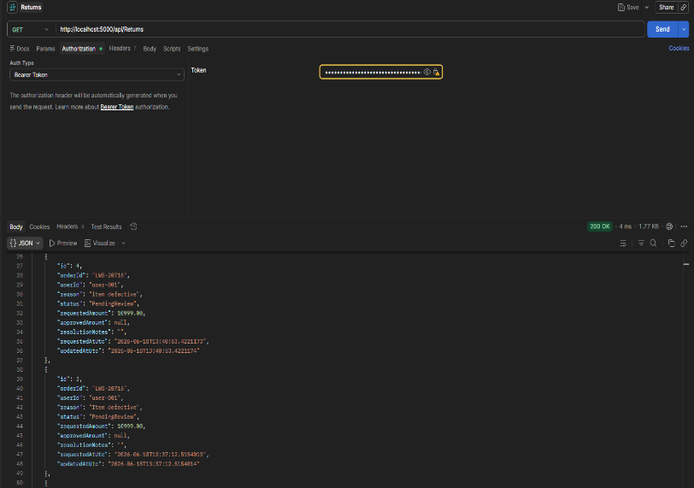 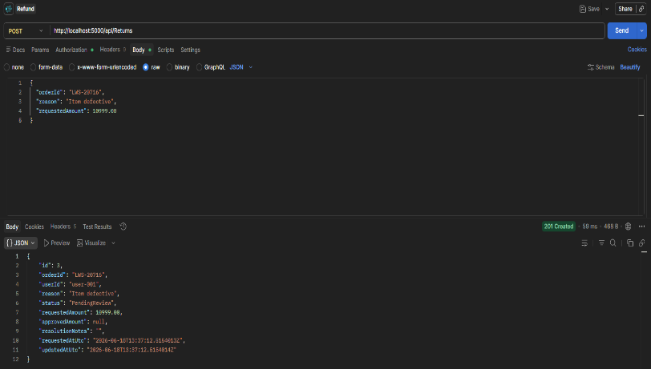
Title
Verify Order Total Calculation (Items × Price) + Tax
Preconditions
1. User is authenticated.
2. Product catalogue contains products with defined prices.
3. Tax rate is configured in the system.
4. Order creation endpoint is available in Postman.
Test steps
1. Send a POST request to create an order.
2. Add Luxe Down Pillows (Set of 2) with quantity = 6 and price = 5999.00 each.
3. Submit the order request.
4. Retrieve the order details using the Order ID returned from the response.
5. Manually calculate the expected subtotal: (6 × 5999.00) = R35994.00
6. Calculate the expected tax according to the configured tax rate 15% = R5399.10
7. Calculate the expected total: R35994.00 + R5399.10 = R41393.10.
8. Compare the manually calculated total with the order total returned by the API.
Expected results
Order is created successfully with a 200/201 response status.
The subtotal is calculated correctly based on item quantities and prices.
The correct tax amount is applied.
The order total equals (Items × Price) + Tax.
The total returned by the API matches the manually calculated expected total.
Actual results
The total returned by the API did not matche the manually calculated expected total.
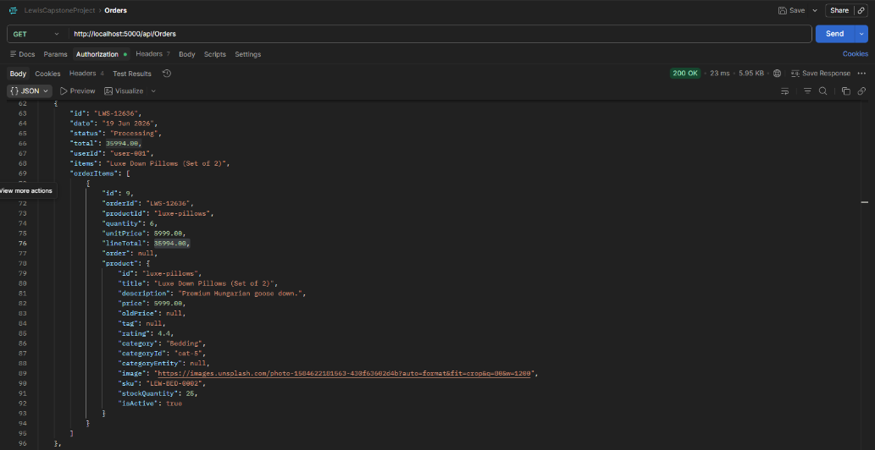

Title
Update Return Status
Preconditions
Unpaid order exists. API authentication token available
Test Steps
1. Create unpaid order.
2. Send PUT/PATCH request to update status.
3. Send PUT/PATCH request to update Approved amount.
4. Send PUT/PATCH request to update resolution notes
5. Retrieve updated order.
Expected results
Return status is updated successfully. Returned status, approved amount and resolution notes is updated successfully. Updated values are returned by the API.
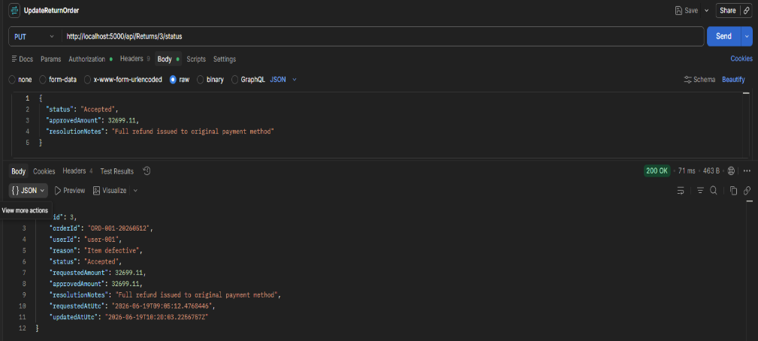
Title
Cancel Order and Restore Inventory via API
Preconditions
Existing order has reserved inventory. Authentication token available.
Test steps
- Create order containing inventory item.
- Capture inventory quantity before cancellation.
- Send order cancellation request.
- Retrieve product inventory.
Expected results
Order status changes to Cancelled. Inventory quantity is restored by the reserved amount. API returns successful cancellation response.
Actual result
There is no endpoint to update order status to Cancelled.
