Part 2 — Product Understanding
AbleSpace — Caseload → Take Data workflow

A note on how this was produced
I do not have a live AbleSpace account, so this walkthrough is built from the single Caseload screenshot provided in the assignment PDF (reproduced below), plus how a data-collection tool for special education/therapy caseloads (IEP/Eval due dates, service minutes, collaborators) conventionally behaves. Steps described as “this opens…” or “this likely lets you…” are my best inference from the UI, not something I clicked through myself — I've flagged those explicitly rather than presenting them as observed fact.

1. Screen overview
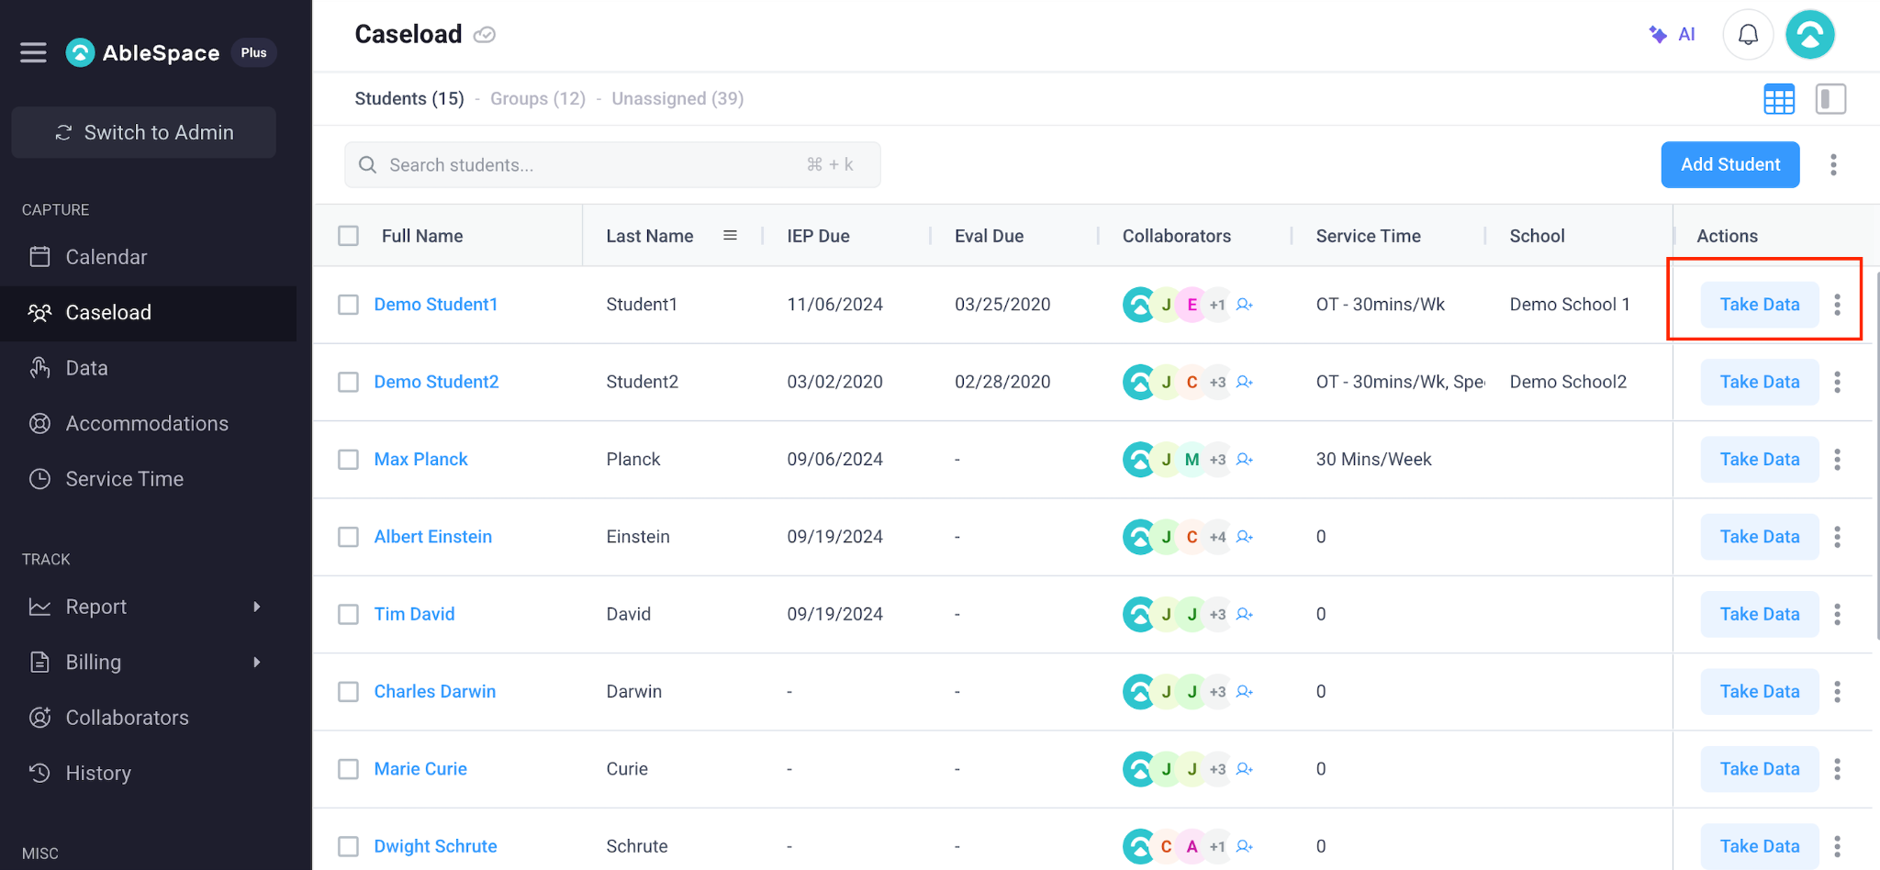
Caseload tab, "Students" sub-view — AbleSpace, as shown in the assignment PDF.
The screen sits under a left-hand "Capture" navigation group (Calendar, Caseload, Data, Accommodations, Service Time), which suggests Caseload is where a clinician starts their day: it's the list of students they're responsible for, before drilling into any one student's data.
The Caseload tab itself has three sub-counts as tabs: Students (15) · Groups (12) · Unassigned (39). The screenshot shows the Students view — a flat table, one row per student, with:
- Full Name / Last Name — the student identity, with Full Name as a clickable link (presumably into the student's profile).
- IEP Due / Eval Due — compliance dates; several rows show "-", implying no date has been set yet for that student.
- Collaborators — a stack of colored initials plus a "+N" overflow and a person-add icon, showing which staff are attached to that student's case.
- Service Time — a free-text-looking summary like "OT - 30mins/Wk" or "30 Mins/Week"; several rows just show "0", which reads as "no service time configured."
- School — which building/site the student belongs to (also frequently blank in this sample data).
- Actions — a primary "Take Data" button (highlighted in the assignment screenshot) plus a secondary "⋮" overflow menu per row.

2. The "Take Data" workflow, as I understand it
Based on the highlighted "Take Data" button and the product's category (a special-ed/therapy caseload + data-collection tool), the intended flow is:
- Clinician lands on Caseload → Students after logging in, seeing their full roster in one table.
- They scan IEP Due / Eval Due to spot anything time-sensitive, and Collaborators to see who else is on a given case.
- For the student they're about to see (in a session, therapy visit, or observation), they click "Take Data" on that row.
- (Inferred, not observed) This most likely opens a data-entry view scoped to that student — probably built around whatever goals/targets are already configured for them, letting the clinician log trial-by-trial or session-level data in the moment.
- (Inferred) Once saved, that session likely rolls up into the student's history/report, which is presumably what the "Report" and "History" items in the left nav surface later.
- The "⋮" overflow per row is presumably for actions that aren't the primary one — edit student, view profile, remove from caseload, etc. — kept out of the main row to avoid clutter.
I want to be clear that steps 4–6 are my inference from the button label and the product category, not something I clicked through — I'd verify this against the real product (or ask for a quick screen-share) before treating it as ground truth.

3. UX / functionality observations

What's working well
- Putting "Take Data" as the one solid-colored, primary-styled action in each row is a strong piece of information design — for a tool whose core job is "log data during a session," making that the visually loudest thing on the busiest screen is the right call.
- Surfacing Collaborators inline (not just on a detail page) lets a clinician see at a glance who else touches a case without an extra click — useful for a shared caseload.
- The Students / Groups / Unassigned counts as tabs give a quick sense of caseload shape (how many students have no group / no clinician yet) without navigating away.

Issues and suggested improvements
- Empty-state clarity — cells showing a bare "-" or "0" (IEP Due, Eval Due, Service Time) don't distinguish "not yet set" from "genuinely zero." A muted placeholder like "Not set" would remove that ambiguity and prompt the clinician to fill it in, rather than reading as a data gap they might not notice.
- Overdue/at-risk dates aren't flagged — IEP Due and Eval Due are compliance-critical dates in this domain; a plain date with no color coding for "due soon" or "overdue" undersells how important that column is. Even a simple color threshold (e.g. amber within 30 days, red if past due) would let a clinician triage their whole caseload in one glance.
- No visible sort/filter affordance on Service Time or School — with 15+ students (and presumably more at scale), being able to filter to "my school" or sort by "most overdue IEP" would matter more than it does at this sample size.
- Collaborators avatars have no visible names on hover/tooltip in the screenshot — initials-only avatars are compact but not self-explanatory to a new team member; a hover tooltip with the full name (and possibly role — OT, SLP, etc.) would help without adding permanent screen space.
- Bulk actions are implied but not obvious — there's a row-select checkbox column, but no visible toolbar for what a multi-select actually does (bulk reassign? bulk export?). If bulk actions exist, surfacing what becomes available on selection would make that checkbox column self-explanatory.
- "Take Data" as a button in every single row, every time, could get repetitive for a clinician working through their whole caseload in one sitting — a persistent "start session" flow (pick student inline, then go) or keyboard-driven quick actions could reduce the click-and-scan-and-click-again cycle for back-to-back sessions.

4. What I'd want to confirm with an actual walkthrough
- What the "Take Data" screen itself looks like, and whether it's goal-based, timer-based, or free-form.
- Whether the "⋮" menu duplicates or extends what's reachable from the student's own profile page.
- Why some students show "0" for Service Time while others show a real value — is that a data-entry gap on AbleSpace's demo data, or a genuine product state worth designing an empty state for.
- Whether Groups and Unassigned use the same table shape, or a different layout suited to their different job (e.g. Unassigned probably needs a "assign to me / assign to group" action that Students doesn't).

