Print Subsequence:

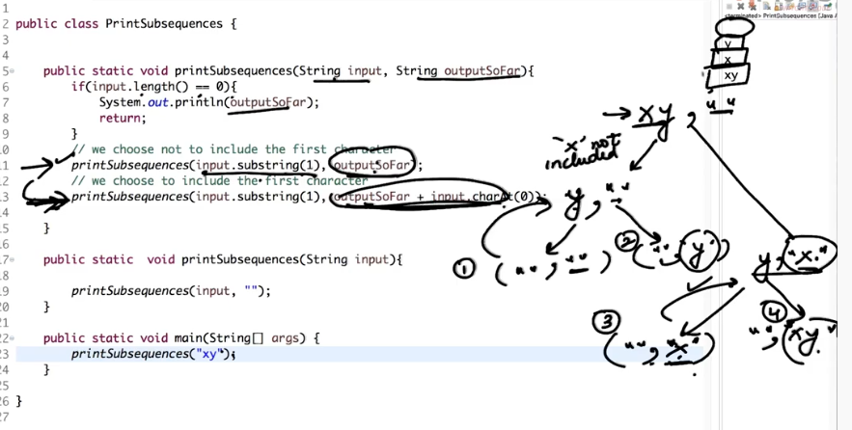**Return All Subsequences Of String:**

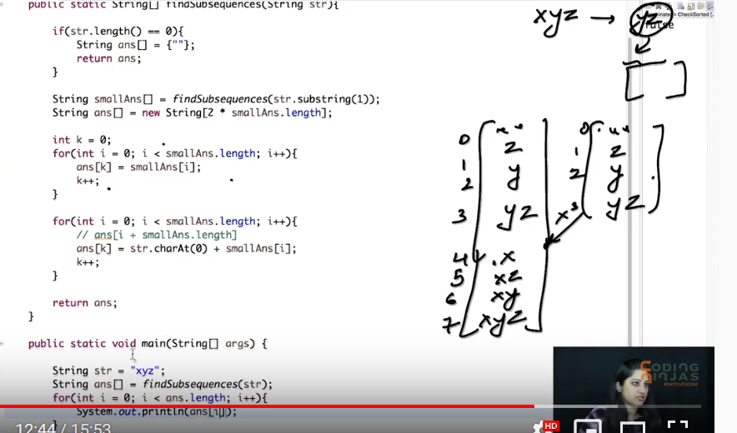

* Design random generation system without duplicate?

Hint: create array with n element and if random number generated is duplicate swap have with last value of array and decrement ‘j’ and set n = j then call Math.random(j).

* Function to return first kth occurrence element in array?
* Difference between RabbiteMQ and kafka?

1. Kafka is distributed messageing system

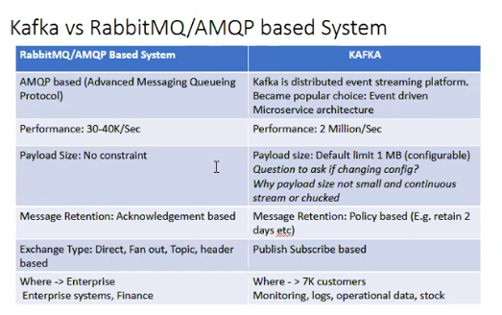

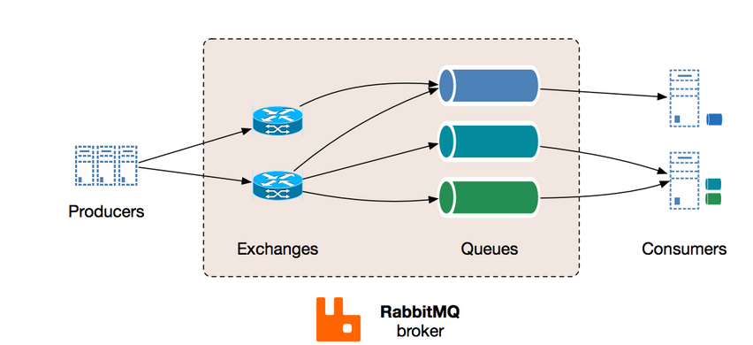

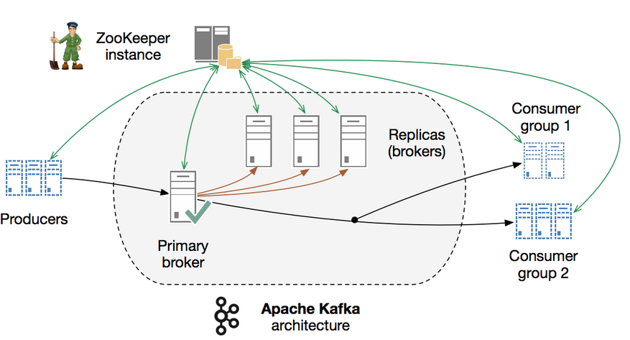

* Thread to increment and decrement problem?

**class** Count{

**private** AtomicInteger c= **new** AtomicInteger();

**public** **void** increment() {

c.getAndIncrement();

}

**public** **int** getvalue() {

**return** c.get();

}

**public** **void** decrement() {

c.getAndDecrement();

}

}

* Circular Queue implementation with insertion data?
* Difference between RestfulService and JSON over http?
* CI/CD
* Difference between images and container?
* Docker Architecture?
* What does images contain and how it is build?

Yodlee Infotech:

* Who application.properties maintained in Spring-Boot(Server.port)?
* How to run the spring-boot application and how to changes the properties of application while running?
* How embedded tomcat work in spring boot?
* String reverse “I am Indian” resulting must be “I ma naidni”
* What is use if equalTo() and hashcode() function in class?
* Difference between String s= “Sachin” and String s = new String(“Sachin”);

String obj = new String("Samuel");

String obj1 = new String("Samuel");

“When we created using new jvm will not look in string pool it will created new object. If we want jvm to look in to string pool. Use intern() method. This process is called interning.

String obj1 = new String("Samuel").intern();

== will compare the reference of object. “

//vs

String obj = "Samuel";

String obj1 = "Samuel";

in the first case obj==obj1 returns false

in the second case obj==obj1 returns true.

The reason for that is that in the first case you have two references to two different Objects. In the second case you have one object since Strings are immutable they are [interned](https://en.wikipedia.org/wiki/String_interning) and drawn from the same pool.

In computer science, **string interning** is a method of storing only one copy of each distinct [string](https://en.wikipedia.org/wiki/String_(computer_science)) value, which must be [immutable](https://en.wikipedia.org/wiki/Immutable_object).[[1]](https://en.wikipedia.org/wiki/String_interning#cite_note-1) Interning strings makes some string processing tasks more time- or space-efficient at the cost of requiring more time when the string is created or interned. The distinct values are stored in a **string intern pool**.

The single copy of each string is called its *intern* and is typically looked up by a method of the string class, for example String.intern()[[2]](https://en.wikipedia.org/wiki/String_interning#cite_note-2) in [Java](https://en.wikipedia.org/wiki/Java_(programming_language)). All compile-time constant strings in Java are automatically interned using this method.

* Hashset properties and how it will not available duplicate.
* How kafka will keep track of consumed messages.

Symphony:

* What are the coding standard and API standard maintained while designing?

<https://www.springboottutorial.com/rest-api-best-practices-with-java-and-spring>

* REST
* How to sort the collections?
* Difference between compare and comparable?
* How to track DB lock?
* API security?
* What is API transaction?
* What is sync and Async call?
* How the payment Gateway works?
* Socket Error?
* How to scale the Application?
* How API communicates in disturbed architecture?
* How @RequestBody map with POJO? Configuration file for the same?

Arben ladder:

* Different type of header parameters?
* Different type of http method?
* What is cross origin?
* Diff between SQL and NOSQL?

Walmart Labs:

* Check sum of two node is available in tree.
* Data structure for utilization of cab for day earing maximum profile for given time slot and price.
* How to handle request having more attribute.
* How to design the system which works in pull machine.
* How to design parking slot.
* Hotel booking array