Types of exception:

Default Exception:

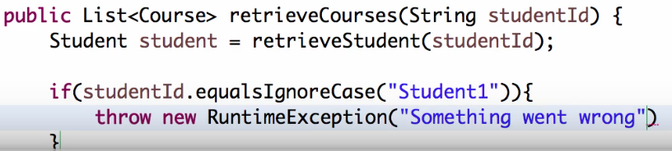

Default exception handling:

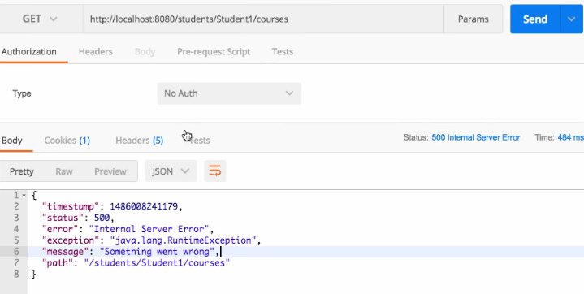

Custom Exception:

This is because we should never throw runtime exception with 500 status (Internal Error)

1. @ControllerAdvice
2. Create class which extends with ResponceEntityExceptionHandler
3. Create method with @ExceptionHandler(Exception.class) // Exception class is from java.lang package.
4. That method return ResponceEntity<CustomeClass>
5. Method except argument exception.
6. Create custom message class and set the values.
7. Then return ResponceEntity object.

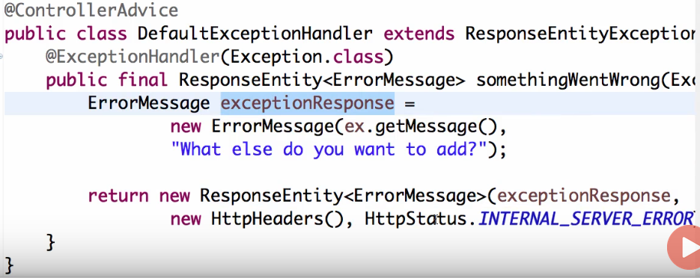

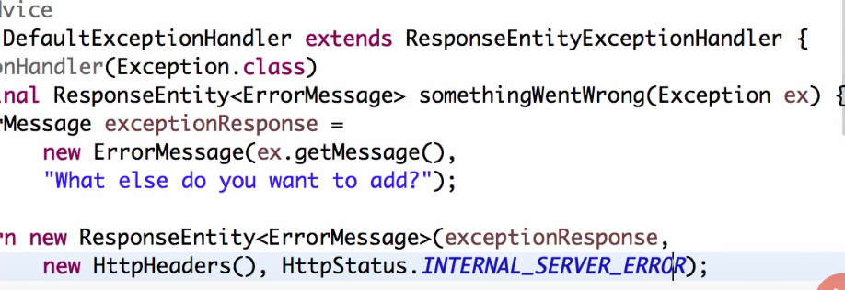

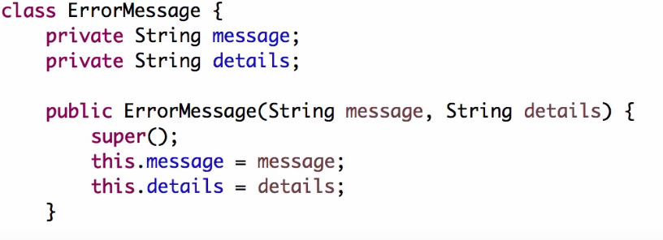

Details: <https://www.javainuse.com/spring/boot-exception-handling>

