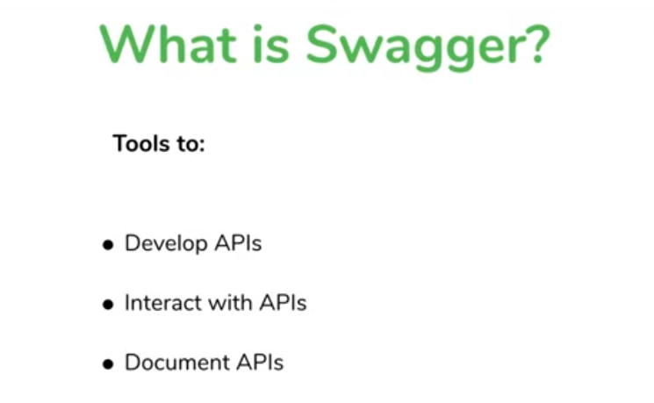

Problem with

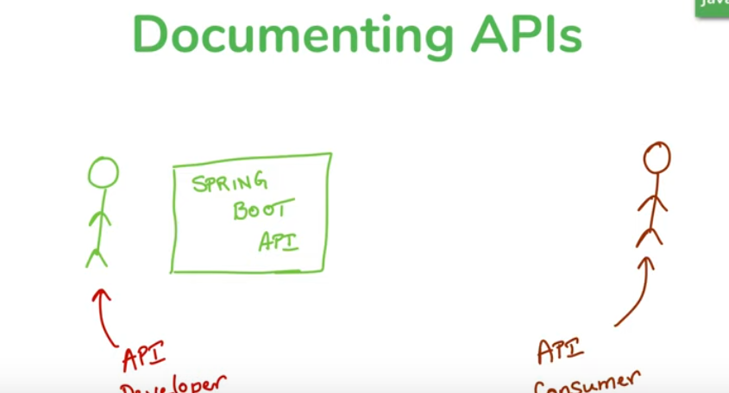

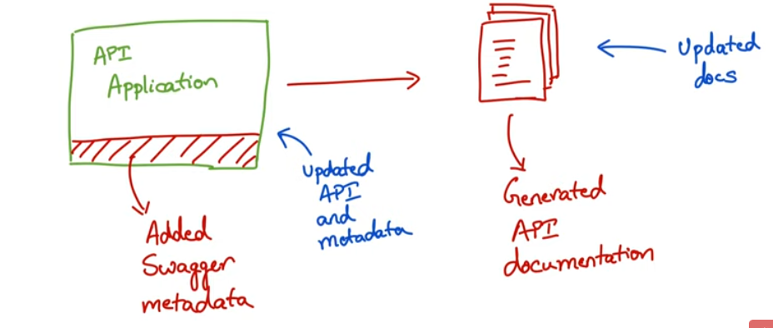

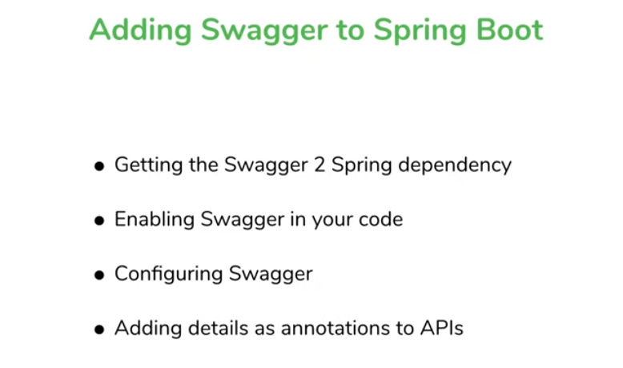

<dependency>

<groupId>io.springfox</groupId>

<artifactId>springfox-swagger2</artifactId>

<version>2.9.2</version>

</dependency>

<dependency>

<groupId>io.springfox</groupId>

<artifactId>springfox-swagger-ui</artifactId>

<version>2.9.2</version>

</dependency>

@EnableSwagger2

Docket is used to configure swagger.

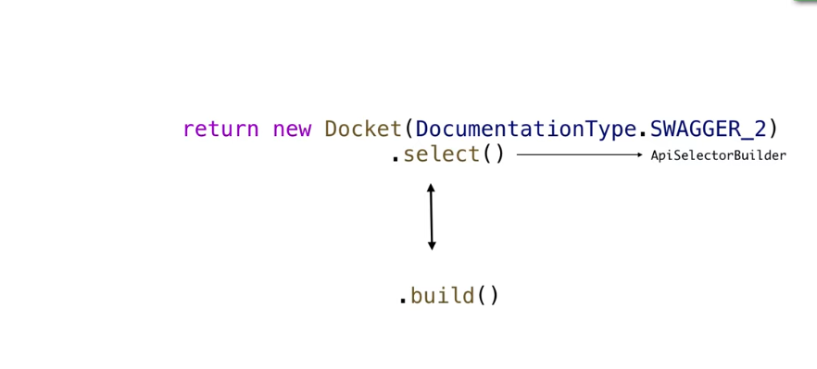

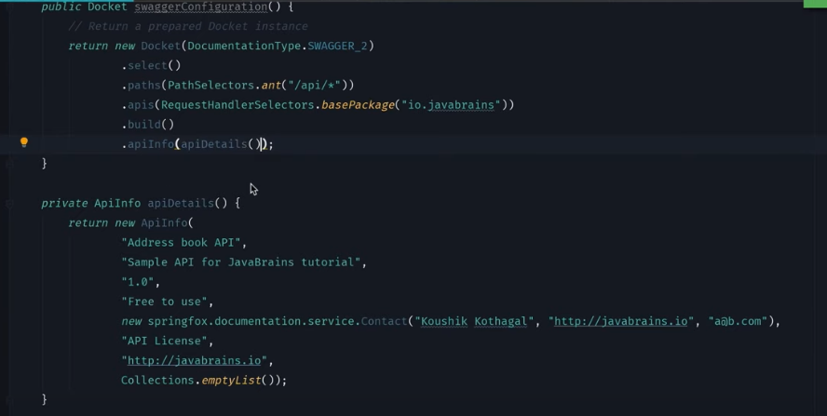

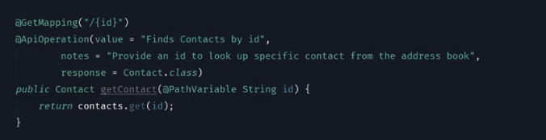

For request Param:

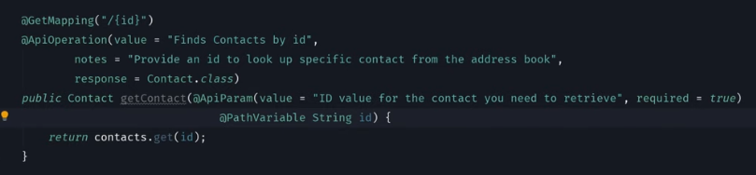

Model details:

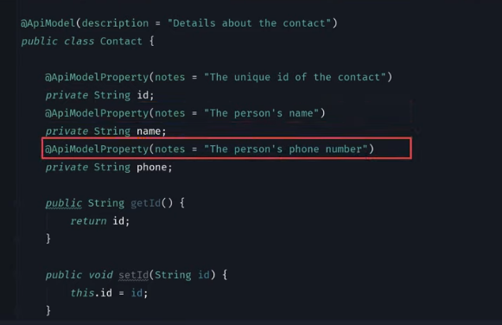

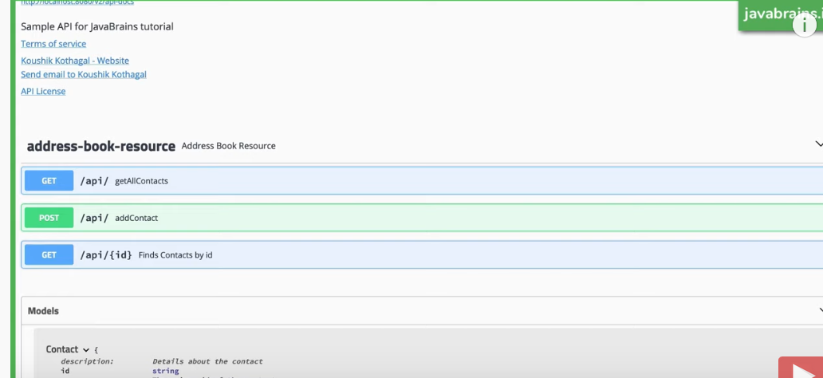

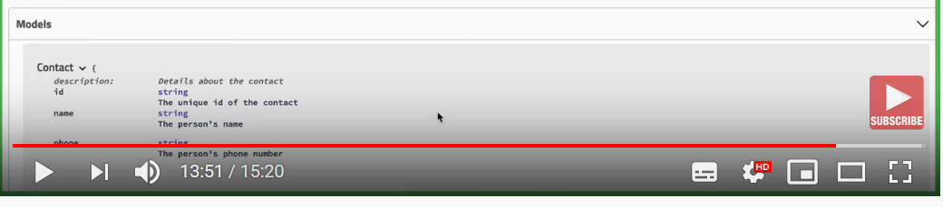

NEXT : Spring REST Docs