Architecture Specification
AI-Leveraged FDA Regulatory Submission Platform
Workflow, services, data, integration, security & deployment architecture
Joint venture: your technology company × Universal Regulatory
Version 0.2 (Draft) • Companion to the SRS • June 2026
CONFIDENTIAL

Contents

1. Introduction

1.1 Purpose & scope
This specification defines the technical architecture for the submission platform described in the SRS. It covers the logical service architecture, the submission workflow and state model, external integrations (notably FDA ESG NextGen), data and tenancy, the AI automation layer, and the security, compliance, and deployment architecture. It is the reference for build estimation, technology selection, and the computer-system-validation (CSV) plan.

1.2 Architectural decisions taken as input
- Tenancy: multi-tenant cloud platform with strict per-client isolation, plus an optional dedicated/private deployment for sensitive sponsors.
- Platform: a cloud-agnostic reference architecture expressed in portable component categories (containers, managed Postgres, object store, etc.) that map onto any major cloud.
- Boundaries: document generation is architecturally separated from gateway transport; final eCTD validation is gated by a licensed third-party engine; AI never finalizes a submission (human-in-the-loop).

1.3 Relationship to the SRS
Each architectural component traces to one or more SRS modules (A–I) and the non-functional requirements (NFR-*). Section 11 maps NFRs to the concrete mechanisms that satisfy them.

2. Architectural Drivers & Principles
The architecture is shaped primarily by regulatory and trust constraints rather than raw feature scope. The dominant drivers:

Driver | Architectural consequence
Regulatory correctness (eCTD) | Licensed validator as the final gate; versioned spec configuration; dual v3.2.2 / v4.0 output.
21 CFR Part 11 & CSV | Immutable audit trail, e-signature, RBAC, validated environments, controlled SDLC.
Data confidentiality & isolation | Per-tenant partitioning and keys; egress-controlled AI; private-deployment option.
FDA ESG NextGen as the transport | Dedicated submission service with API client, mTLS/cert management, ACK reconciliation.
AI leverage with accountability | AI services produce drafts/checks only; human review and sign-off are mandatory and audited.
Service-bureau economics | Multi-tenant, autoscaled, stateless services; automation as the margin engine.

Guiding principles: separation of concerns (generation vs. transport vs. validation); everything auditable (every state change is recorded immutably); least privilege and isolation by default; idempotent, replayable operations for safe resubmission; portability over cloud lock-in; and human-in-the-loop control at every point where AI touches a submission.

3. Logical Architecture
The platform is a layered set of stateless domain services behind an API gateway, supported by cross-cutting platform services and a partitioned data layer, integrating with FDA ESG NextGen, a licensed validator, private LLM endpoints, and the Word/PDF toolchain.
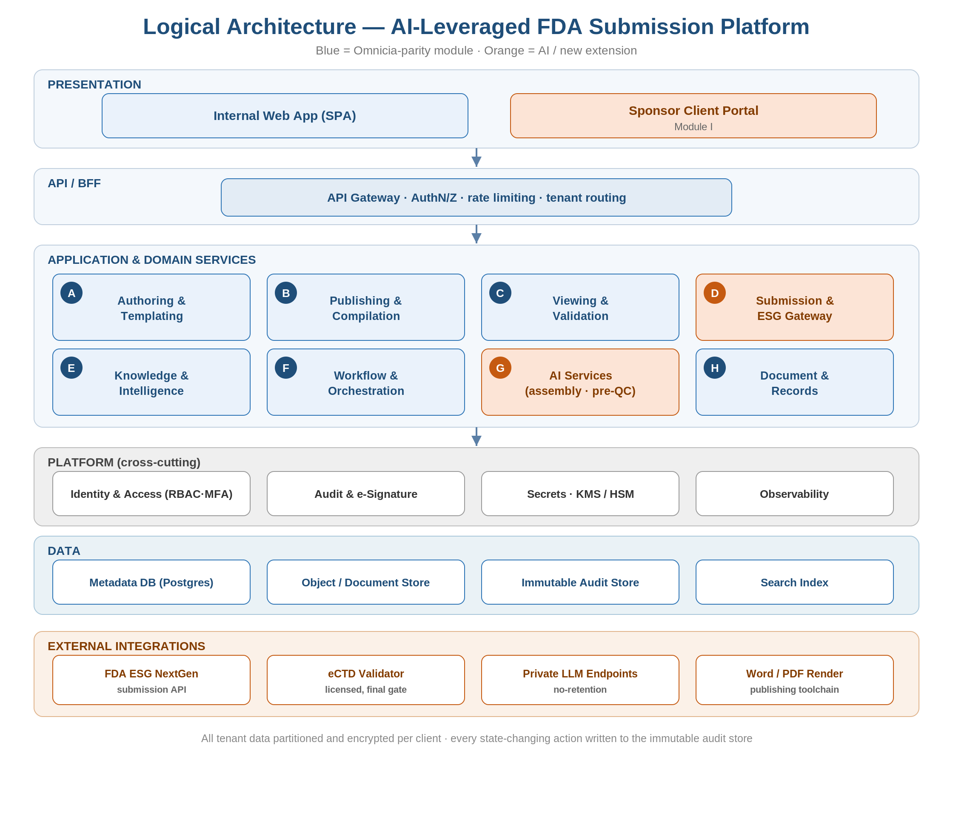
Figure 1 — Logical architecture. Blue = Omnicia-parity module; orange = AI / new extension.

3.1 Domain services (mapped to SRS modules)

Mod | Service | Core responsibility
A | Authoring & Templating | Word template engine, styles/macros, ICH file naming, document metadata.
B | Publishing & Compilation | Word→PDF, hyperlink resolution, eCTD backbone & lifecycle ops, STF, output packaging.
C | Viewing & Validation | Lifecycle viewer; orchestrates validation; adapter to the licensed validation engine.
D | Submission & ESG Gateway | ESG NextGen API client; submission state machine; ACK reconciliation; resubmission.
E | Knowledge & Intelligence | Specs, SOPs, prior submissions & correspondence; retrieval source for AI (RAG).
F | Workflow & Orchestration | Submission projects, tasks, QC workflow, sign-off routing, SLA/throughput.
G | AI Services | Document classification & assembly, metadata extraction, pre-QC, drafting — all human-reviewed.
H | Document & Records | Versioned controlled repository, retention policy, content integrity.
I | Client Portal & Collaboration | Sponsor upload/download, status visibility, scoped collaboration.

3.2 Language & runtime by module
Language strategy: TypeScript/Node is the default for I/O-bound services, and TypeScript/React for all web front-ends; Python is used for the AI and knowledge tier; Java (or Python) is used where mature PDF/eCTD libraries or the licensed validator SDK dictate. Services communicate through APIs and contracts, so this polyglot split is isolated and safe. Phase 0 is entirely TypeScript/Node (Mod D, F-core, H-core, and the shared foundations); Python and Java enter only as Phases 1–3 add AI and publishing.

Mod | Service | Language / runtime | Why
A | Authoring & Templating | TypeScript/Node | OOXML / template generation alongside the existing TS XML toolchain.
B | Publishing & eCTD Compilation | Java (or Python) | Most mature PDF / eCTD libraries; aligns with licensed publishing & validator SDKs.
C | Viewing & Validation | TypeScript viewer + validator-SDK language | Web viewer is JS-native; the validation adapter wraps the licensed engine (often Java).
D | Submission & ESG Gateway | TypeScript/Node | I/O-bound API client, XML payloads, state machine — Node's strength. Phase 0 core.
E | Knowledge & Intelligence | Python | RAG, embeddings, and vector search live in the Python AI ecosystem.
F | Workflow & Orchestration | TypeScript/Node | Orchestration and the operator-UI backend; optional workflow engine.
G | AI Services | Python | LLM / ML tooling, RAG, evaluation harnesses, and model SDKs.
H | Document & Records | TypeScript/Node | Persistence and audit; aligns with the core services.
I | Client Portal & Collaboration | TypeScript/React + Node | Web front-end with a scoped API.

4. Workflow & Process Architecture
The Workflow service (Mod F) orchestrates each submission as a long-running process; the Submission service (Mod D) owns the transmission and acknowledgement states. The lifecycle is modeled as an explicit state machine so that every transition is validated, auditable, and safely resumable.
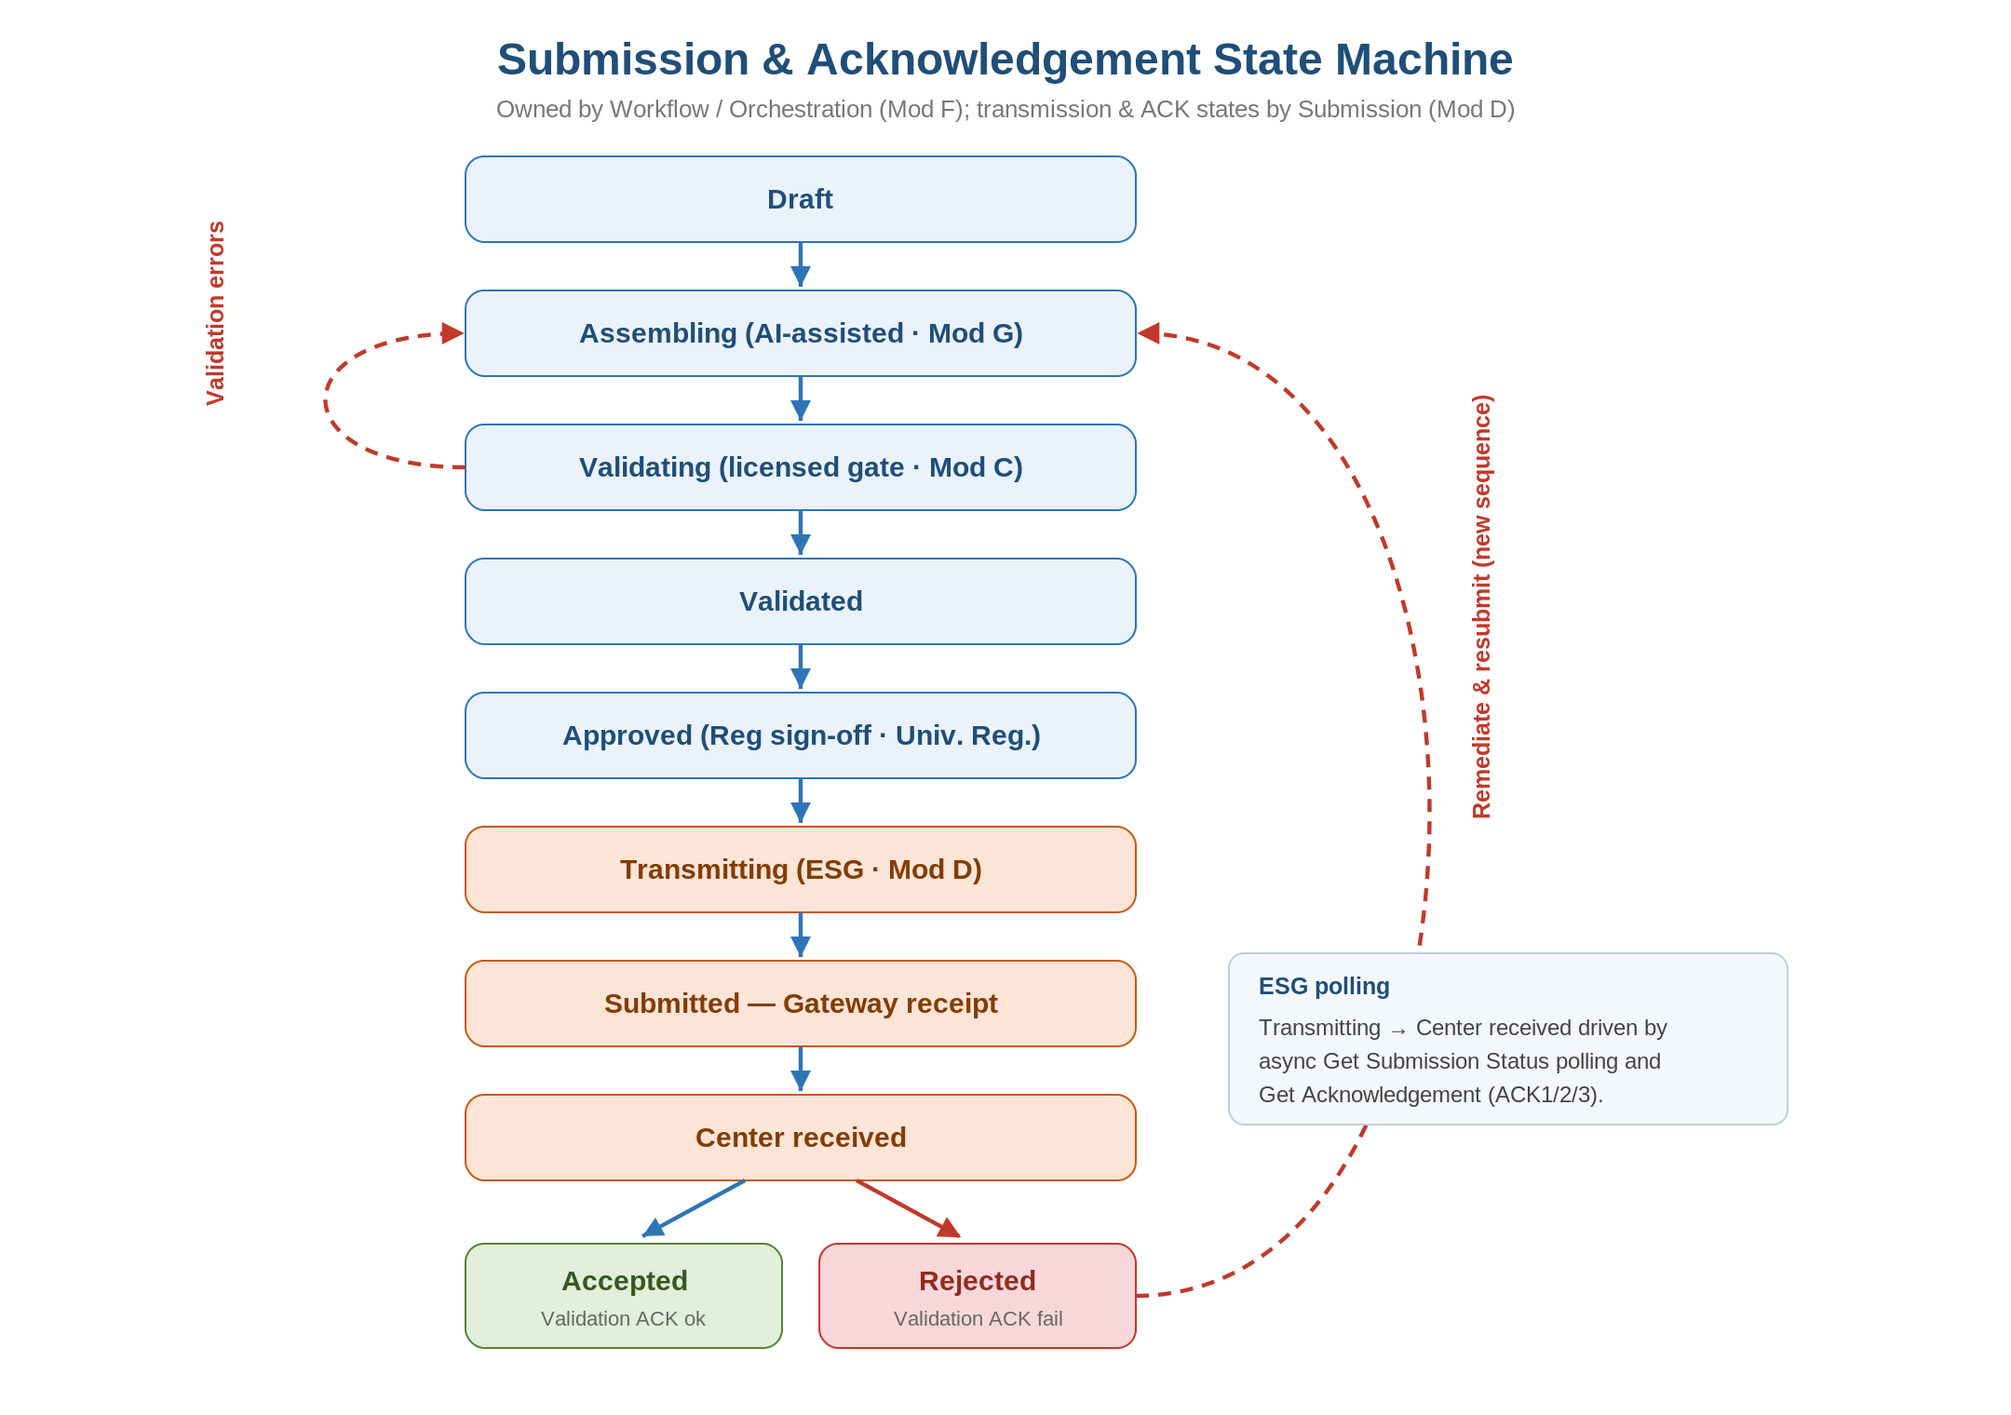
Figure 2 — Submission & acknowledgement state machine, with validation and remediation loops.
- Idempotency & replay: transitions are idempotent and event-sourced so a failed transmission or polling cycle can be safely retried without duplicate submissions.
- Remediation loops: validation failures return the submission to Assembling; a Rejected ACK triggers remediation and a new sequence rather than mutating the transmitted one.
- Human gates: the Approved state requires an e-signed sign-off by Universal Regulatory before transmission is possible — enforced, not advisory.
- Async execution: publishing, validation, and ESG polling run as queued jobs on async workers, decoupled from the request path.

5. Integration Architecture
The Submission service integrates with FDA ESG NextGen entirely through its published API: authenticate, upload, submit, poll status, and retrieve acknowledgements, all over mTLS with the non-repudiation certificate. Acknowledgements are reconciled back into the state machine and audit store.
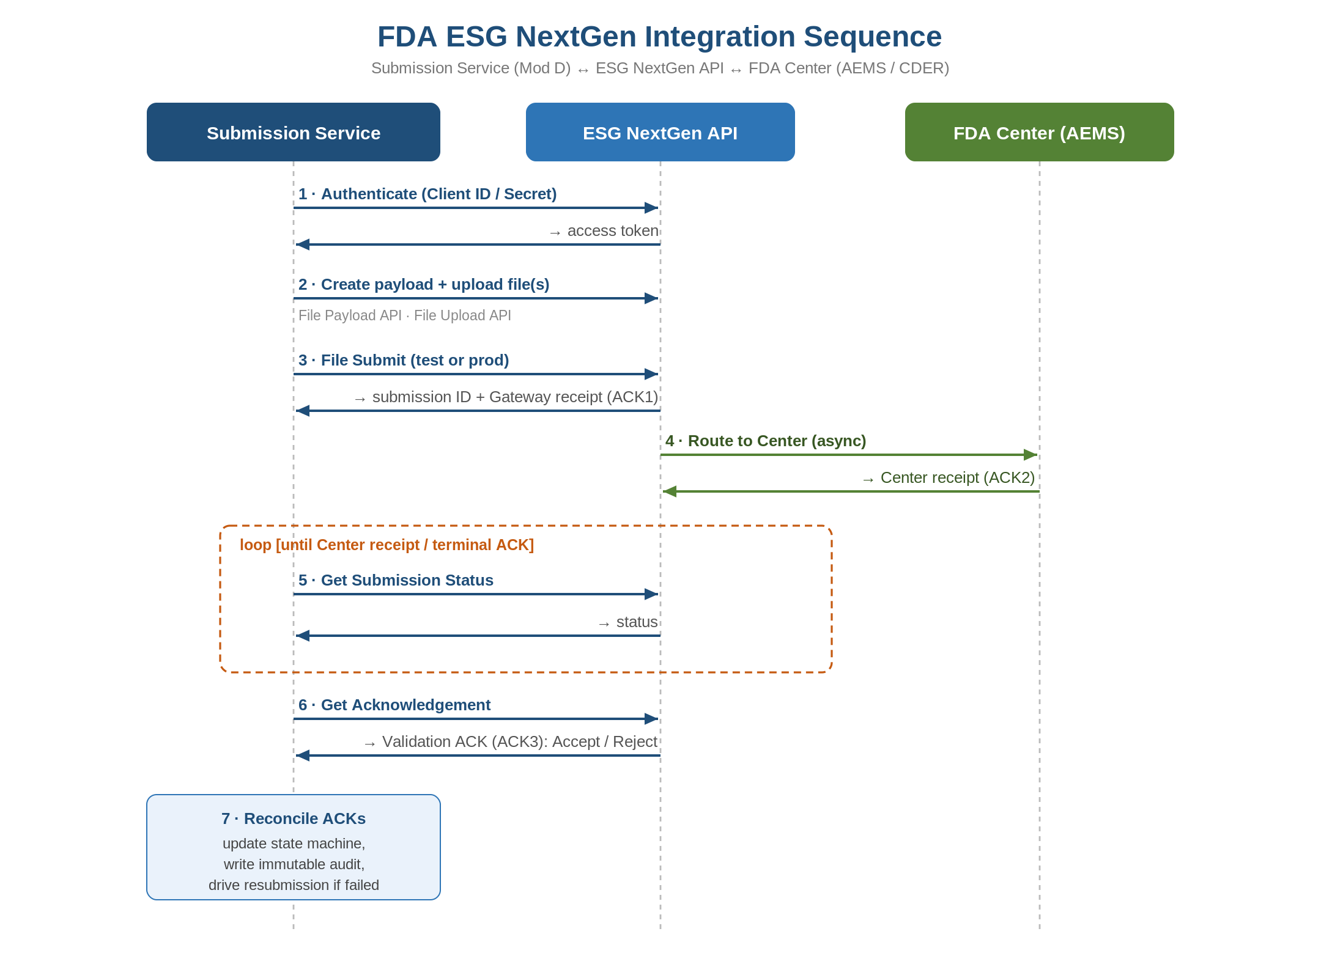
Figure 3 — FDA ESG NextGen integration sequence (submit → poll → acknowledge → reconcile).

5.1 Other integrations
- Licensed eCTD validator: invoked via an adapter as the authoritative final gate before sign-off; results recorded with the submission.
- Private LLM endpoints: called only through the AI service's abstraction layer, with no-retention terms and controlled egress; no sponsor content leaves the trust boundary for training.
- Word/PDF toolchain: headless rendering and PDF conformance run as isolated worker jobs.
- Test vs. production ESG: environment-scoped credentials and endpoints; production transmission is gated to the validated environment only.

6. Data Architecture
The data model is rooted at the Tenant, which is the unit of isolation. Submissions and their documents are the core lifecycle entities; acknowledgements and audit events provide the regulatory trail.

Entity | Key attributes | Notes
Tenant / Client | id, isolation keys, retention policy | Root of all isolation and access scoping.
Application | FDA app number, type (IND/NDA/BLA), center | Long-lived; many submissions over its life.
Submission / Sequence | sequence no, lifecycle op, status, checksums | Subject of the state machine.
Document / Leaf | CTD section, version, attributes, file ref | Granular eCTD leaf; lifecycle-managed.
Acknowledgement | type (ACK1/2/3), status, payload ref, timestamp | Reconciled to a submission.
Workflow Task | owner, role, status, due date | Drives QC and sign-off.
Audit Event | actor, action, before/after, signature, ts | Immutable / WORM; Part 11 trail.
User / Role | identity, tenant, role, permissions | RBAC; per-tenant scoping.

6.1 Tenancy & retention
- Isolation: tenant-scoped Postgres (schema or row-level security) and per-tenant object-store prefixes encrypted with per-tenant data keys; a tenant-context middleware enforces scope on every request.
- Classification: sponsor submission content is the highest classification; access is logged and least-privileged.
- Retention: configurable per-client retention honoring regulatory record-keeping; audit records are write-once and retained independently of operational data.

7. AI Automation Architecture
The AI layer (Mod G) is designed as an assistive, fully-audited tier that accelerates assembly and QC without ever holding final authority. It sits behind a model-abstraction layer so providers can be swapped and so all calls are governed uniformly.
- Model abstraction: a single internal interface fronts private LLM endpoints; no service calls a provider directly, enabling uniform logging, guardrails, and provider portability.
- Retrieval (RAG): AI grounds outputs in the Knowledge service (Mod E) — specs, SOPs, prior submissions — to reduce hallucination and keep guidance current.
- Core functions: document-to-CTD-section classification and assembly, metadata extraction, and pre-QC checks that run ahead of the licensed validator.
- Human-in-the-loop: every AI output is a proposal surfaced for human review; finalization and transmission require human action and e-signature (FR-G-03).
- Auditability: inputs, outputs, model and version, prompt, and reviewer identity are logged for each AI operation, doubling as CSV evidence.
- Confidentiality: no-retention/private endpoints and controlled egress guarantee sponsor content is never used for third-party training (NFR-SEC-04).

8. Security Architecture
- Identity & access: OIDC/SSO with MFA; role-based access scoped per tenant; least privilege enforced at API and data layers.
- Isolation: defense-in-depth — network segmentation, tenant-context middleware, row-level security, and per-tenant encryption keys.
- Encryption: TLS 1.2+ in transit; envelope encryption at rest via KMS; per-tenant data keys.
- Key & certificate management: KMS/HSM for keys; the FDA non-repudiation certificate is stored in the HSM-backed secret store with a documented rotation runbook.
- Egress control: outbound access restricted to FDA ESG, the licensed validator, and the private LLM endpoint.
- Assurance: security audit logging, breach detection, and a SOC 2 (or equivalent) attestation target (NFR-SEC-06/07).

9. Compliance & Validation Architecture
Part 11 controls are designed into the platform rather than bolted on, and the system is built and operated under a validated SDLC inside Universal Regulatory's quality system.

Part 11 / CSV control | Architectural mechanism
Access control | RBAC + MFA, least privilege, per-tenant scoping.
Audit trail | Immutable WORM audit store; before/after values; time-stamped, attributable.
Electronic signatures | Sign-off events cryptographically bound to identity and meaning; non-repudiable.
Record integrity | Content checksums, document versioning, encryption, retention policies.
Operational checks | State machine enforces ordering; production transmission gated to validated env.
System validation (CSV) | IQ/OQ/PQ; AI-generated conformance suites as OQ evidence; change control.

Environments are separated into Dev, Test, Validation (IQ/OQ/PQ), and Production, with promotion under documented change control. Identical container images flow through all environments to keep the validated state reproducible.

10. Deployment & Infrastructure Architecture
The platform runs as containerized, autoscaled services on a managed orchestration cluster in private subnets, with managed data services, HSM-backed secrets, and egress-controlled external connectivity. The same images deploy as an isolated single-tenant stack for sponsors who require it.
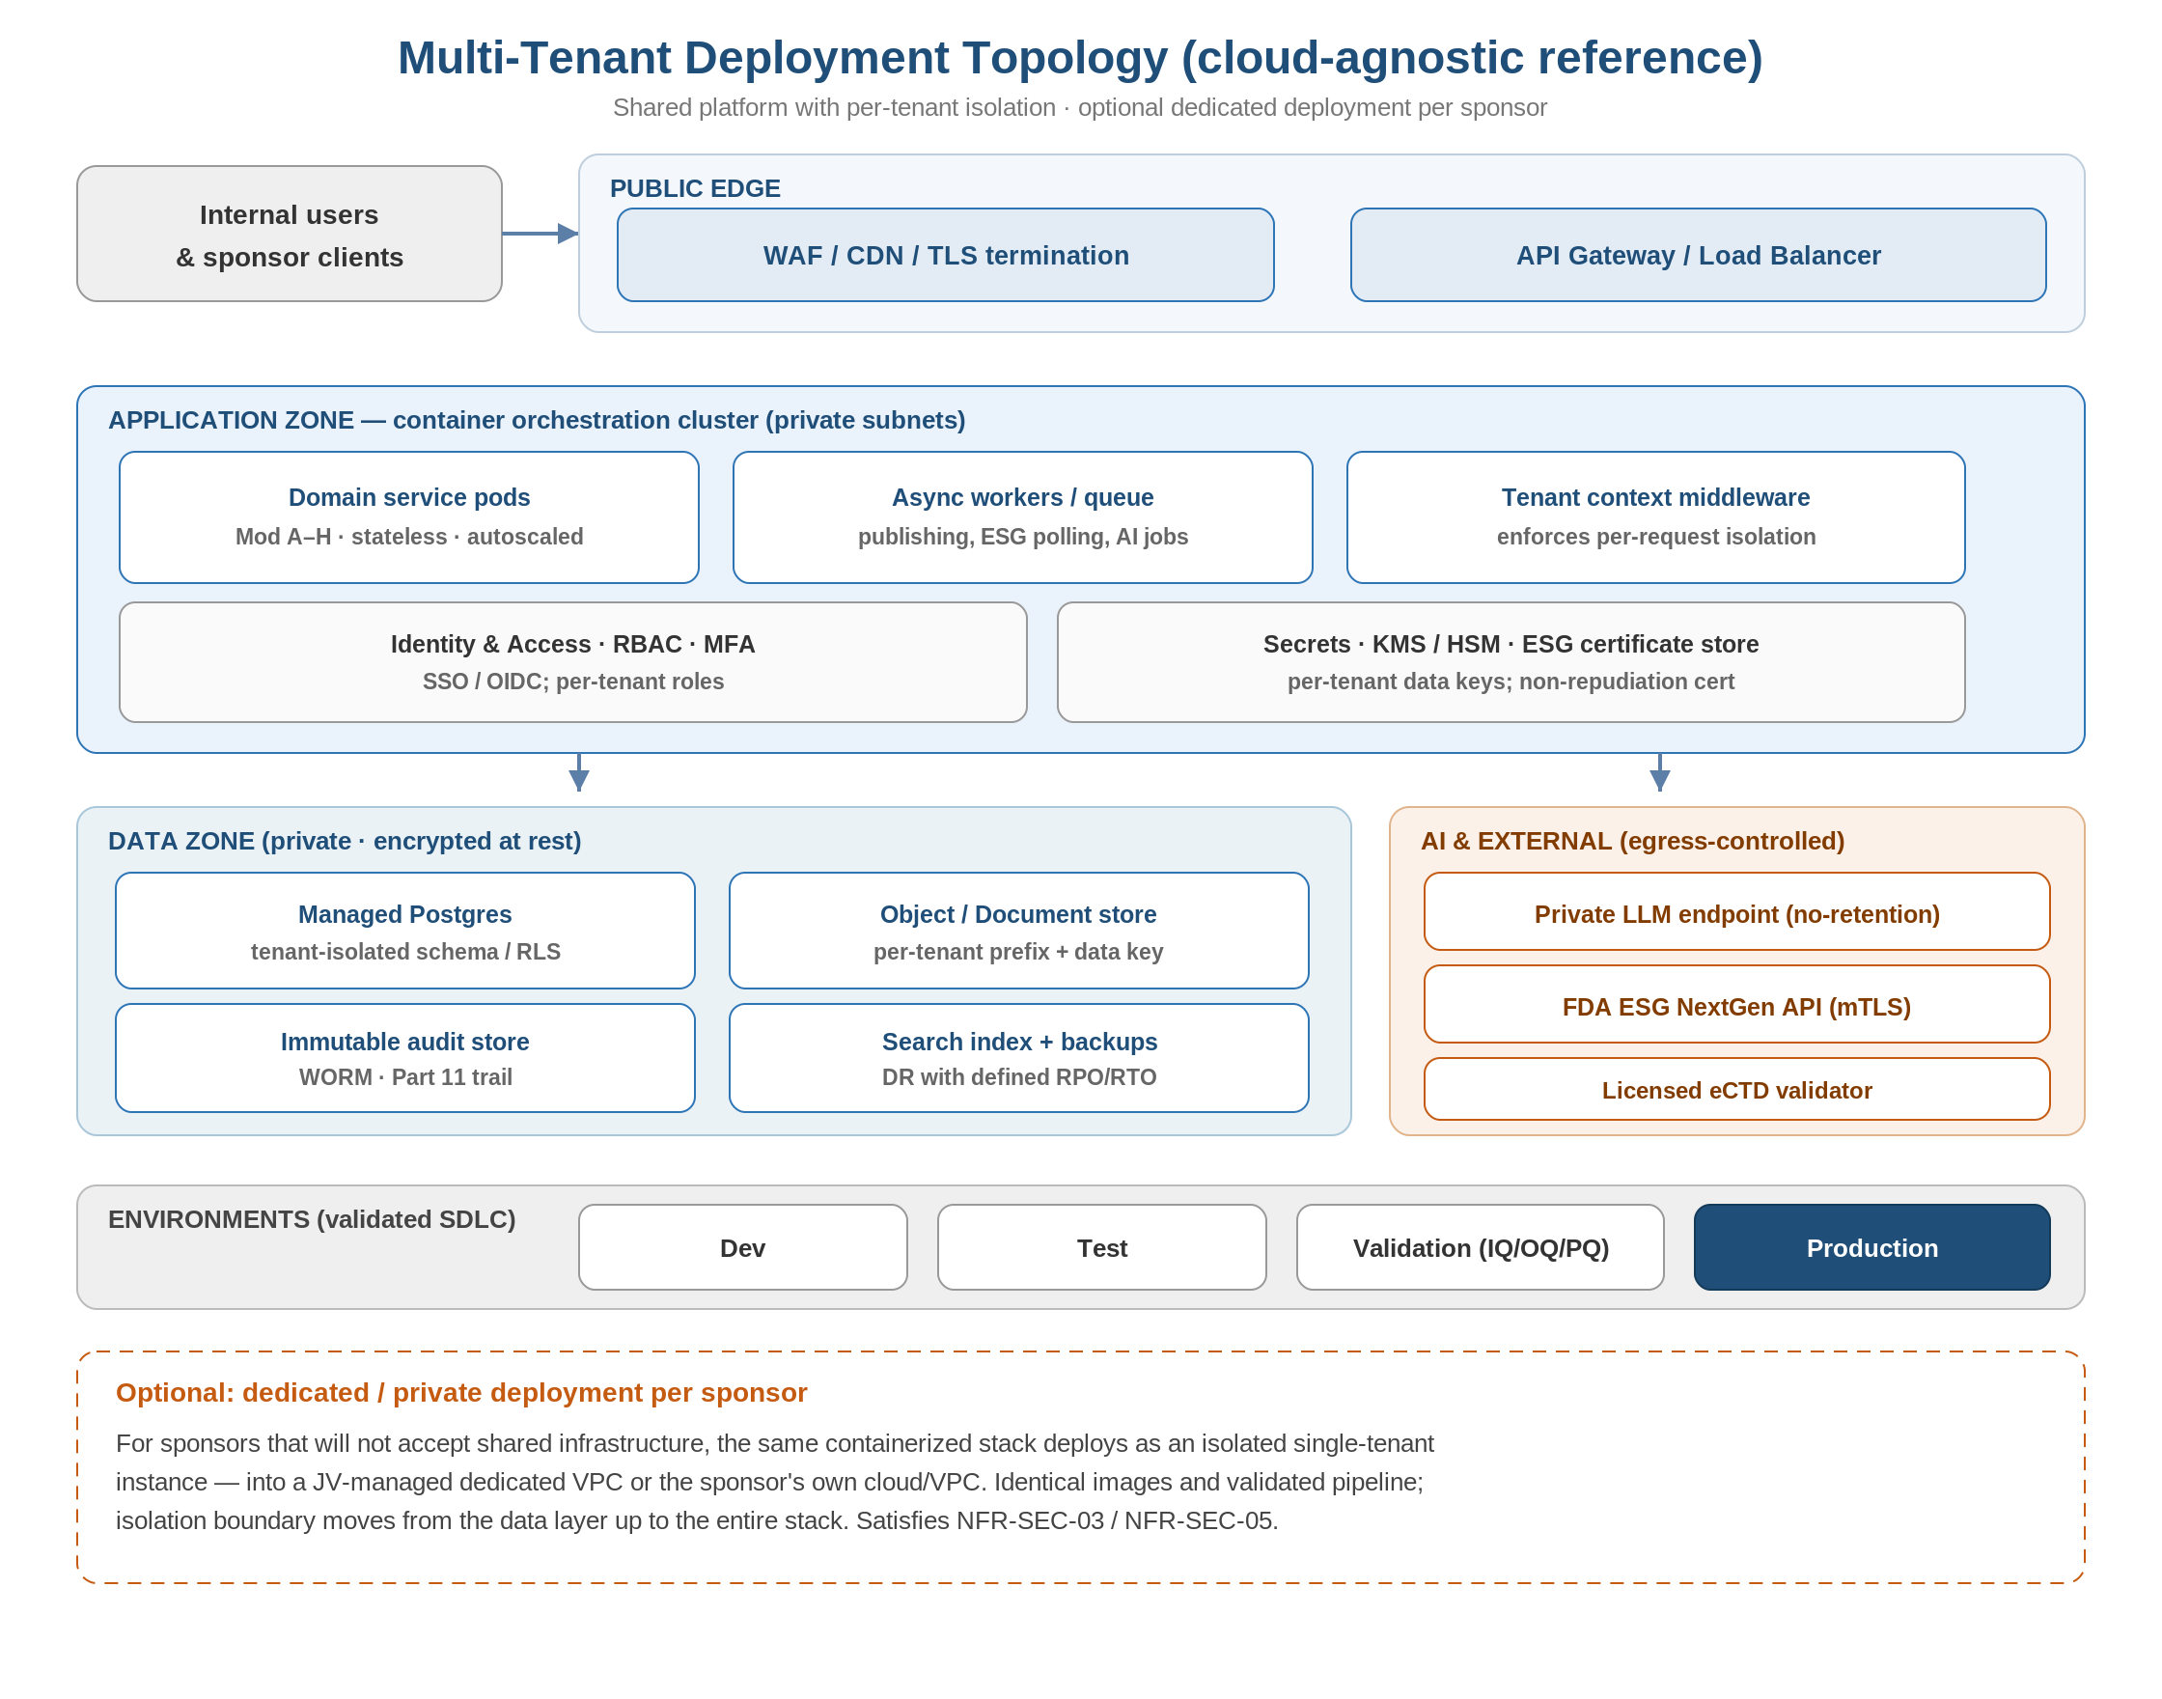
Figure 4 — Multi-tenant deployment topology with optional dedicated per-sponsor deployment.
- Resilience: multi-AZ managed data services; automated backups and disaster recovery with defined RPO/RTO (NFR-AVAIL-02).
- Scaling: stateless services scale horizontally; heavy publishing, validation, and ESG polling run on async worker pools.
- Private deployment: for sponsors rejecting shared infrastructure, the stack deploys into a dedicated VPC or the sponsor's own cloud — isolation boundary moves from the data layer to the whole stack.

11. Non-Functional Requirement Mapping
NFR | Architectural mechanism
NFR-COMP-01 (Part 11) | Immutable audit, e-signature, RBAC (§9).
NFR-COMP-02 (CSV) | Validated environments + controlled SDLC + conformance suites (§9, §10).
NFR-COMP-03 (eCTD specs) | Versioned spec config; dual v3.2.2 / v4.0 output (§5, Mod B).
NFR-SEC-01 (encryption) | TLS in transit; KMS envelope encryption at rest (§8).
NFR-SEC-03 (isolation) | Tenant middleware + RLS + per-tenant keys (§6, §8).
NFR-SEC-04 (no-training AI) | Private LLM endpoints + controlled egress (§7).
NFR-SEC-05 (private deploy) | Dedicated single-tenant deployment option (§10).
NFR-AVAIL-02 (DR) | Multi-AZ, backups, defined RPO/RTO (§10).
NFR-INT-01 (interoperability) | Standard eCTD output + licensed validator (§3, §5).
Performance / scale | Stateless autoscaled services + async workers (§4, §10).

12. Technology Reference Stack (cloud-agnostic)
Components are specified as portable categories. Example cloud mappings are illustrative, not a commitment.

Category | Reference | AWS | Azure | GCP
Orchestration | Kubernetes | EKS | AKS | GKE
Relational DB | Managed Postgres | RDS / Aurora | Azure DB Postgres | Cloud SQL
Object storage | S3-compatible | S3 | Blob | GCS
Secrets / keys | KMS + HSM | KMS / CloudHSM | Key Vault / MHSM | Cloud KMS / HSM
Identity | OIDC / SSO | Cognito | Entra ID | Identity Platform
Messaging / queue | Managed queue | SQS / SNS | Service Bus | Pub/Sub
Search / vector | Vector index | OpenSearch | AI Search | Vertex / AlloyDB
Observability | Logs/metrics/traces | CloudWatch + OTel | Monitor | Cloud Ops
Private LLM | No-retention endpoint | Bedrock | Azure OpenAI | Vertex AI

13. Key Architecture Decisions
Decision | Rationale | Alternative considered
Separate generation from transport | Isolates ESG/cert complexity; reused for both ICSR and eCTD tracks. | Single monolith
License the final validator | Trusted gate; lowers liability on pivotal submissions. | Build own validator
Multi-tenant + isolation | Service-bureau economics with strong isolation. | Single-tenant only
Human-in-the-loop AI | Part 11 accountability; AI cannot finalize. | Full automation
Immutable WORM audit | Part 11 record integrity. | Mutable application logs
Stateless services + async workers | Scales publishing/polling; resilient retries. | Synchronous monolith
Cloud-agnostic via containers | Portability; enables private deployment. | Cloud-native lock-in
Polyglot by tier | TS/Node for core & UI, Python for AI/knowledge, Java for publishing/validation. | Single language everywhere

14. Architecture Risks & Mitigations
Risk | Mitigation
ESG API or cert changes break transmission | Adapter abstraction; cert rotation runbook; contract tests against test gateway.
AI errors in assembly/QC | Human-in-the-loop sign-off + licensed validator as authoritative gate.
Cross-tenant data leakage | Defense-in-depth isolation; automated isolation tests; periodic audits.
eCTD spec drift (v3.2.2 → v4.0) | Versioned spec configuration; dual-format publishing built in.
CSV overhead slows delivery | Automated conformance suites double as OQ evidence.
Vendor/cloud lock-in | Cloud-agnostic component categories; containerized portability.

15. Architecture Build Roadmap
Architecture is delivered incrementally along the SRS phases, standing up the lowest-risk path (ESG transmission for ICSRs) before the full publishing stack.

Phase | Architectural focus
0 — Wedge | Submission service (D), ESG API client, ACK reconciliation, audit store, minimal UI — AEMS / E2B(R3).
1 — Lifecycle | Publishing (B) + Validation (C) with licensed gate, Workflow (F), Document & Records (H).
2 — Original INDs | Authoring (A), Knowledge (E), AI assembly & pre-QC (G), Client portal (I).
3 — NDA/BLA + v4.0 | Scale-out, full automation, eCTD v4.0 output, dedicated-deployment option.

Sources
FDA ESG NextGen (API, USP): https://www.fda.gov/industry/electronic-submissions-gateway-next-generation-esg-nextgen
FDA AEMS / E2B(R3) standards: https://www.fda.gov/drugs/fda-adverse-event-monitoring-system-aems/fda-adverse-event-monitoring-system-aems-e2br3-standards
FDA eCTD v4.0 submission standards: https://www.fda.gov/drugs/electronic-regulatory-submission-and-review/ectd-submission-standards-ectd-v40-and-regional-m1
Omnicia products (capability baseline): https://www.omniciainc.com/products

