Parallelization Map
What to build now, prototype, or hold — against Phase 0
Companion to the Architecture Specification and Phase 0 plan
Joint venture: your technology company × Universal Regulatory
Version 0.1 (Draft) • June 2026 • CONFIDENTIAL

1. Purpose
This map answers a single question: with Phase 0 underway, what may the team build in parallel, and what must wait? It classifies every architecture component into three tiers so engineering effort is spent where it compounds — and not where it risks building on unvalidated assumptions or unsettled JV terms.

2. How to read the three tiers
- Green-light now: shared foundations Phase 0 needs anyway; building them well now accelerates every later phase. Build under the gates.
- Prototype only: the highest-risk later capabilities. Spike them as throwaway research to retire technical risk and sharpen estimates — but do not productionize until Phase 0 validates the model.
- Gated on Phase 0: full production build is held until Phase 0 proves the hours-saved model and the gates clear; these then scale into Phases 1–3.

3. The Map
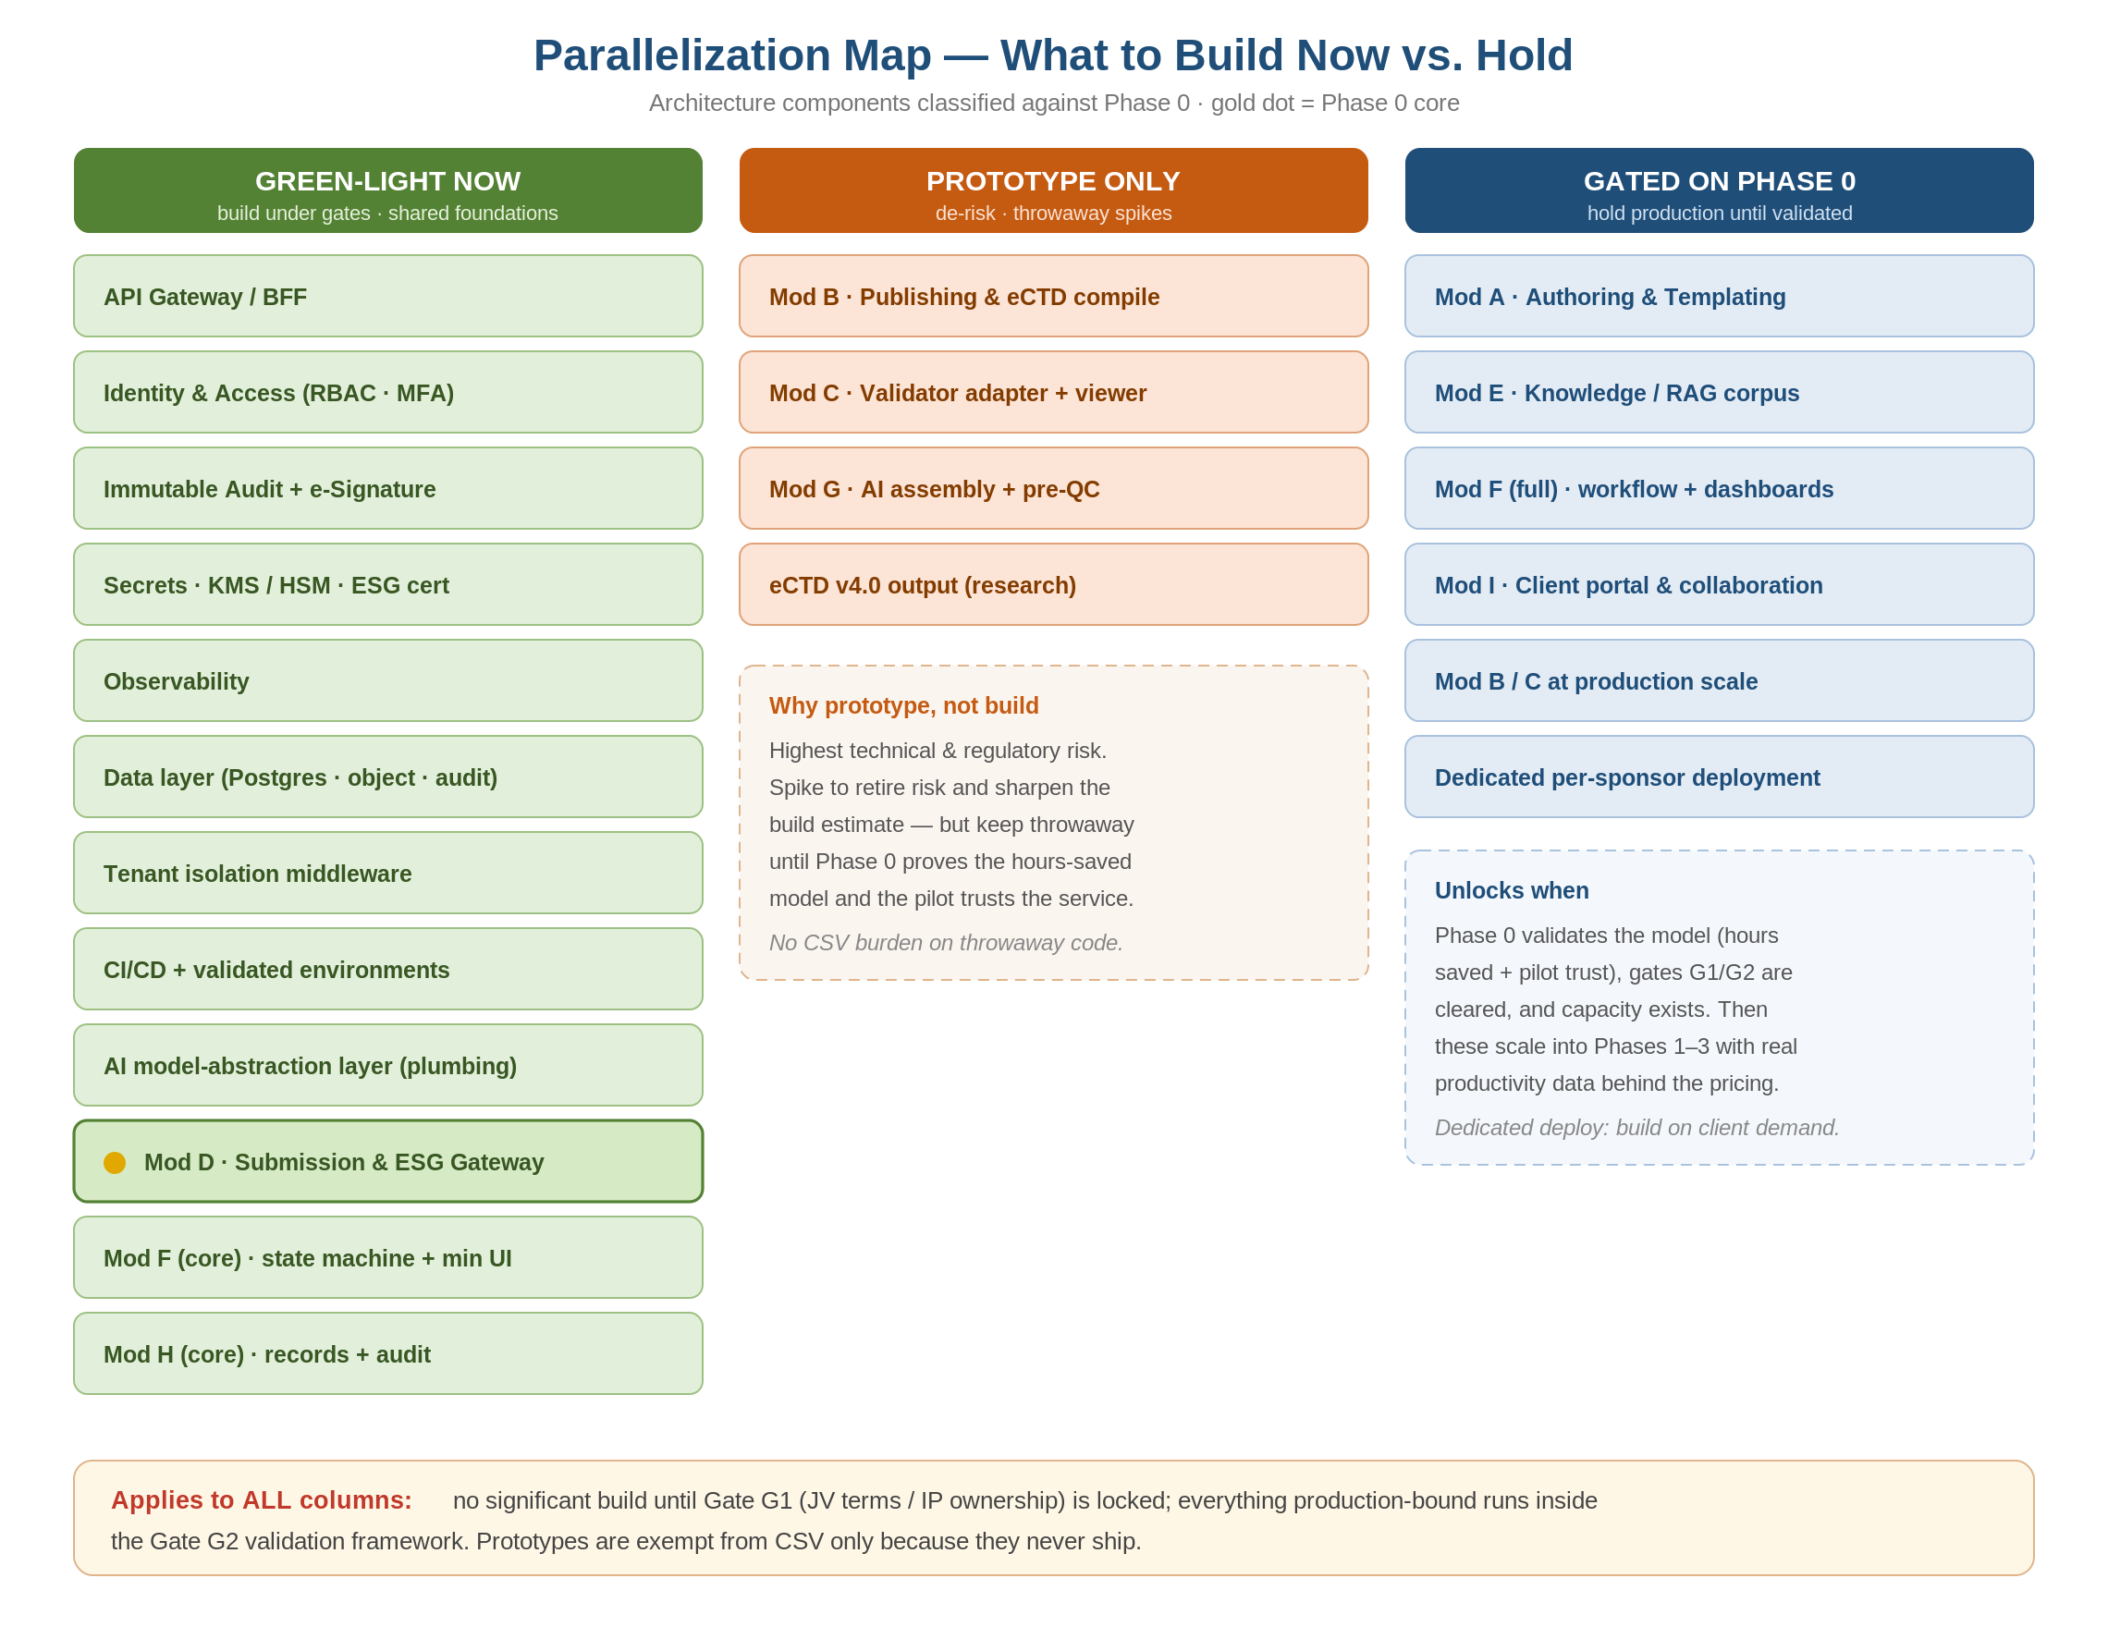
Figure 1 — Parallelization map. Gold dot marks the Phase 0 core (Mod D).

4. Tier 1 — Green-Light Now
These are foundational and largely required for Phase 0 itself; parallel investment is not waste, it is the platform. All of it still runs under Gates G1 (JV/IP) and G2 (validation).

Component | Why build now
API Gateway / BFF | Entry point and tenant routing for every service, including Phase 0.
Identity & Access (RBAC · MFA) | Required for Phase 0; foundational to all access control and Part 11.
Immutable Audit + e-Signature | Phase 0 core; the Part 11 backbone reused everywhere.
Secrets · KMS/HSM · ESG cert store | Phase 0 needs the non-repudiation certificate; foundational key management.
Observability | Operational visibility from day one; cheap to embed, costly to retrofit.
Data layer (Postgres · object · audit) | Phase 0 persistence; the shared data substrate.
Tenant isolation middleware | Isolation must be designed in, not added later (NFR-SEC-03).
CI/CD + validated environments | Phase 0 ships through these; enables the validated SDLC (WS4).
AI model-abstraction layer (plumbing) | The governed gateway for AI; build the plumbing now so features plug in later.
Mod D — Submission & ESG Gateway | This IS Phase 0 — the ESG client, state machine, and ACK reconciliation.
Mod F (core) — state machine + minimal UI | Operator UI and orchestration needed to run Phase 0.
Mod H (core) — records + audit | Records and audit trail for the Phase 0 submissions.

5. Tier 2 — Prototype Only
The hardest, highest-risk capabilities. Prototype them to learn and estimate — but keep them throwaway, with no validation burden, until Phase 0 earns the right to scale.

Component | Risk to retire via prototype
Mod B — Publishing & eCTD compilation | eCTD backbone, lifecycle ops, PDF conformance, hyperlinking — the deepest technical risk.
Mod C — Validator adapter + viewer | Integration pattern with the licensed validation engine; lifecycle rendering.
Mod G — AI assembly + pre-QC | Whether AI actually classifies/assembles reliably enough to save hours.
eCTD v4.0 output (research) | Forward-looking format; explore ahead of the mandatory cutover.

Guardrail: prototypes are exempt from CSV only because they never ship. The moment a prototype is destined for production, it re-enters the validation framework and is rebuilt to standard.

6. Tier 3 — Gated on Phase 0
Full production build is held until Phase 0 validates the model and the gates clear. Holding these protects focus on the deadline-critical wedge and avoids building extensively on unproven assumptions.

Component | Why gated / unlock condition
Mod A — Authoring & Templating | Needed from Phase 2; lower risk, so build (not prototype) once Phase 0 clears.
Mod E — Knowledge / RAG corpus | Full knowledge base and retrieval corpus; build with the AI features it serves.
Mod F (full) — workflow + dashboards | Project management, QC workflow, SLA dashboards; beyond the Phase 0 minimum.
Mod I — Client portal & collaboration | Sponsor-facing; valuable once there is a service to expose.
Mod B / C at production scale | Promote from prototype only after the eCTD risk is retired and the model is proven.
Dedicated per-sponsor deployment | Build when a specific client's security team requires it — demand-driven, not speculative.

7. Unlock Conditions
Two transitions move work rightward into production. Make them explicit so the team knows when the brakes come off.

Transition | Unlocks when
Prototype → Production | Phase 0 proves the hours-saved model AND the eCTD prototype has retired its technical risk AND the build re-enters the validation framework.
Gated → Build | Gate G1 (JV terms/IP) and G2 (validation framework) are cleared, Phase 0 is validated and live with the pilot, and capacity exists to scale into Phases 1–3.

8. Guardrails (apply to every tier)
- Gate G1 first: no significant build of any component before JV terms and IP ownership are locked — parallel work before G1 multiplies the wasted-effort and dispute risk.
- Gate G2 always: everything production-bound runs inside the validation framework; only throwaway prototypes are exempt, and only while they stay throwaway.
- Protect Phase 0 focus: the wedge has a hard deadline (Oct 2026) and first-pilot reputational stakes; parallel work must not starve it of the team's attention.
- Capture the flywheel early: even in prototypes, log AI inputs/outputs and human corrections so the later AI-native feedback loop has data to learn from.

Related documents
SRS (modules A–I) · Architecture Specification (components & figures) · Phase 0 Mobilization & Build Plan (gates G1/G2, workstreams).

