Phase 0 Mobilization & Build Plan
AI-Leveraged FDA Regulatory Submission Platform
The ESG / AEMS E2B(R3) wedge — gates, long-lead items, workstreams, and backlog
Joint venture: your technology company × Universal Regulatory
Version 0.1 (Draft) • June 2026
CONFIDENTIAL

Contents

1. Purpose & Objective
This plan turns the strategy, requirements, and architecture already defined (JV blueprint → SRS → architecture specification) into the first executable phase. It is deliberately narrow: stand up the lowest-risk, highest-learning slice of the platform and put a real submission through it.
Phase 0 objective: transmit E2B(R3) Individual Case Safety Reports to the FDA Adverse Event Monitoring System (AEMS, formerly FAERS) through the ESG NextGen API — automated submission, status polling, and acknowledgement reconciliation — validated and live with a pilot client.
This wedge is chosen because it exercises the hard external integration (the gateway and ACK handling) and the compliance backbone (audit, validation) without the weight of full eCTD publishing, and because the October 1, 2026 mandate making E2B(R3) compulsory for postmarketing ICSRs creates real, deadline-driven demand to anchor the pilot.

2. Readiness Gates (must clear before build)
Two gates must be cleared before significant build investment (workstream WS6). They are structural and regulatory, not technical — and skipping them is the classic way regulated, JV-based software wastes effort.

Gate | Criteria to clear | Owner
G1 — JV terms locked | Legal entity formed; IP ownership & platform license; value-based pricing & profit split; quality-system-of-record agreed. | JV principals + counsel
G2 — Validation approach | Validation Plan approved; SRS requirements traceability; platform mapped into Universal Regulatory's QMS; SDLC & change control defined. | Universal Regulatory QA + tech lead

Note: G1 is also a technical prerequisite — the FDA gateway account and the non-repudiation certificate must be registered to the JV legal entity, so build cannot ship under an undecided entity.

3. Long-Lead Items (start at Week 0)
These have external wait time and sit on the critical path. Start them immediately, in parallel with the gates.

Item | Why it is long-lead | Owner
ESG NextGen USP account + Client ID/Secret | FDA registration and approval lead time; gates all transmission. | Submission ops + JV entity
Non-repudiation certificate | Digital certificate procurement + letter; bound to the registered entity. | JV entity + IT security
ESG test environment access | Gated behind account approval; needed for first test submission. | Submission ops
Cloud account + LLM endpoint (BAA) | Procurement/security review; no-retention LLM agreement. | Tech lead

4. Cloud Target Selection Decision Point
The architecture is cloud-agnostic, so foundational and contract-first build needs no cloud commitment. But the target (AWS / Azure / GCP) must be decided early — it is a long-lead procurement item — and locked before the validated environments are provisioned.
- Decide by: ~Week 2–3 (mobilization). Procurement, security review, and the BAA have lead time.
- Hard deadline: before WS4 provisions the validated environments, and before the first hosted real ESG test submission (M4). Do not validate against one cloud and re-validate against another — IQ/OQ evidence is provider-specific.
- Not needed for: the local contract-first loop — foundations, Mod D vs mock, and unit/integration-vs-mock tests run on docker compose with no cloud.
- Forcing triggers: provisioning validated environments; wiring the first managed service (KMS/HSM for the certificate, managed Postgres, identity); the first hosted real ESG test submission.

4.1 Weighted selection criteria
Score each candidate cloud 1–5 per criterion, multiply by the weight, and total. AWS, Azure, and GCP all have credible GxP / validated-cloud stories, so the decision is driven more by trust and fit than by raw capability. Record the choice and rationale as an ADR.

Criterion | Weight | What to assess
Sponsor / UR cloud footprint & trust | 25% | Where target sponsors and Universal Regulatory's security teams already operate — eases vendor qualification.
Compliance & validated-cloud posture | 20% | GxP / HIPAA / SOC 2 attestations, BAA availability, qualification artifacts.
Required managed services | 15% | HSM for the certificate, managed Postgres, identity, no-retention LLM endpoint with BAA.
Team expertise & velocity | 15% | Fastest competency; fewer unknowns shorten Phase 0.
Security & isolation features | 10% | KMS/HSM, network isolation, per-tenant key support.
Cost & startup credits | 10% | Pricing and credit / startup programs.
Data residency / egress control | 5% | US data residency; controlled egress to FDA ESG.

5. Workstreams & Timeline
Six workstreams run largely in parallel. Build (WS6) is gated by G1, G2, and ESG test access; the gateway onboarding (WS3) is the critical-path dependency.

WS | Scope | Key output
WS1 — JV & commercial | Entity, IP/license, pricing, QMS-of-record. | Signed JV agreement
WS2 — Quality & validation | Validation Plan, traceability, SDLC, change control. | Approved VP; QMS integration
WS3 — ESG gateway (long-lead) | USP account, credentials, certificate, test env. | Working test transmission
WS4 — Platform & environments | Cloud selection; validated Dev/Test/Val/Prod; CI/CD; security baseline. | Provisioned validated envs
WS5 — Pilot client & baseline | Select pilot from UR base; capture manual hours baseline. | Pilot SoW; baseline metrics
WS6 — Phase 0 build | Submission svc (D), ESG client, ACK reconcile, audit (H), minimal UI. | Accepted submission → production
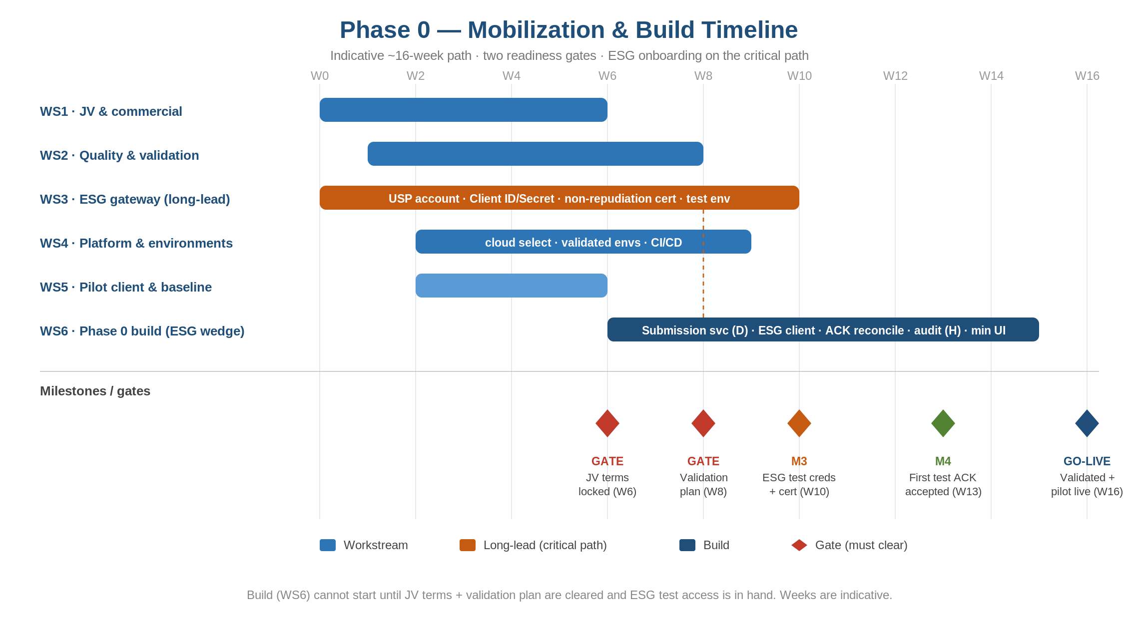
Figure 1 — Indicative Phase 0 timeline. Weeks are illustrative; gateway onboarding drives the critical path.

6. Phase 0 Scope

6.1 In scope
- E2B(R3) ICSR payload generation and transmission to AEMS via the ESG NextGen API.
- Status polling (Get Submission Status) and acknowledgement retrieval/parsing (ACK1/2/3).
- Submission state machine and ACK reconciliation with resubmission handling.
- Immutable audit trail of every transmission, payload hash, and acknowledgement (Part 11-aligned).
- Minimal operator UI to submit, monitor status, and review ACKs/errors.
- Test-then-production path within validated environments.

6.2 Out of scope (deferred to later phases)
- eCTD compilation/publishing (Mod B), authoring (A), viewer/validator (C), knowledge (E), AI assembly (G), client portal (I).
- eCTD v4.0 output and the licensed validation gate (these attach to the eCTD phases, not the ICSR wedge).

7. Phase 0 Build Backlog
Epic | Representative stories | Module
E1 Gateway connectivity | Authenticate (Client ID/Secret); test+prod config; mTLS / certificate handling. | D
E2 Payload & submit | Build E2B(R3) ICSR payload; File Payload/Upload; File Submit. | D
E3 Status & ACK | Poll Get Submission Status; Get Acknowledgement; parse ACK1/2/3. | D
E4 Reconciliation & state | Submission state machine; reconcile ACKs; trigger resubmission. | D / F
E5 Audit & records | Immutable audit of transmissions/ACKs; payload hashing; retention. | H
E6 Operator UI | Submit, monitor status, view ACKs and errors. | F (min UI)
E7 Validation evidence | Conformance tests as OQ evidence; IQ/OQ/PQ runbook. | WS2

8. Team & Roles
Role | Responsibility
JV principals + counsel | Clear Gate G1 (entity, IP, pricing, QMS-of-record).
Universal Regulatory QA | Clear Gate G2; own QMS integration and submission sign-off.
Tech lead / architect | Cloud selection, validated environments, architecture decisions.
Backend engineers (≈2) | Submission service, ESG client, ACK reconciliation, audit.
Submission operator | ESG account, certificate, test and production submissions.
Product / PM | Backlog, pilot coordination, hours-saved baseline.

9. Phase 0 Exit Criteria
Phase 0 is complete when all of the following hold:
- A first E2B(R3) test submission is accepted (test ACK3) and correctly reconciled.
- A real pilot ICSR is accepted in production AEMS via ESG NextGen.
- The system is validated (IQ/OQ/PQ) and operating under Universal Regulatory's QMS.
- An hours-saved baseline versus manual processing is captured (input to value-based pricing).
- The audit trail is complete and Part 11-aligned.

10. Risks & Dependencies
Risk / dependency | Mitigation
ESG onboarding slips | Start at Week 0; treat as the gating critical-path item; escalate early.
JV terms unresolved delays build | Hard gate — do not start WS6 until G1 clears.
Certificate/entity coupling | Resolve JV legal form first; it enables gateway registration and the cert.
Validation retrofitted late | Approve the Validation Plan before build; conformance tests double as OQ.
Oct 1, 2026 E2B(R3) mandate timing | Align go-live to capture deadline-driven pilot demand.

11. Immediate Next Actions (Weeks 0–2)
- Engage counsel to draft the JV agreement — entity, IP/license, and profit split.
- Open the ESG NextGen USP account and begin certificate procurement (long-lead).
- Convene Universal Regulatory QA to scope the Validation Plan and QMS integration.
- Shortlist and select the cloud target; set up the account and LLM BAA.
- Identify the Phase 0 pilot client from Universal Regulatory's base and define the baseline.

Sources
FDA ESG NextGen (API, USP, onboarding): https://www.fda.gov/industry/electronic-submissions-gateway-next-generation-esg-nextgen
FDA AEMS / E2B(R3) standards & Oct 2026 mandate: https://www.fda.gov/drugs/fda-adverse-event-monitoring-system-aems/fda-adverse-event-monitoring-system-aems-e2br3-standards

