Software Requirements Specification
AI-Leveraged FDA Regulatory Submission Platform
Capability parity with Omnicia, plus an AI-automation layer
Joint venture: your technology company × Universal Regulatory
Version 0.1 (Draft for review) • June 2026
CONFIDENTIAL

Document Control
Field | Value
Document | Software Requirements Specification (SRS)
Product | AI-Leveraged FDA Regulatory Submission Platform
Version / Status | 0.1 — Draft for partner review
Date | June 2026
Owner | JV product team (tech company × Universal Regulatory)
Priority scheme | M = Must (MVP) · S = Should · C = Could (MoSCoW)

Priority legend
- M (Must): required for a usable, compliant MVP; the platform cannot ship without it.
- S (Should): high value, targeted shortly after MVP; deferrable without breaking core service.
- C (Could): desirable; included when capacity allows or a client requires it.

Contents

1. Introduction

1.1 Purpose
This document specifies the requirements for a regulatory submission platform that matches the capabilities of Omnicia's product suite and professional-services workflow, and extends them with an AI-automation layer. It is the engineering and validation reference for the joint venture between the technology company and Universal Regulatory, and the basis for build/license decisions, test design, and vendor-qualification evidence.

1.2 Scope
The platform supports the end-to-end submission lifecycle for FDA (US) submissions — authoring, publishing/eCTD compilation, viewing/validation, gateway transmission, and records management — with parity support for EU and Canadian eCTD output. It serves the JV's internal service-delivery teams and, optionally, sponsor clients through a portal. It does not replace a sponsor's quality system; it operates as a controlled tool within Universal Regulatory's quality system.

1.3 Capability baseline — Omnicia parity map
Omnicia's published suite defines the parity baseline. Each product maps to a platform module; the JV adds an AI layer and native ESG NextGen transmission that Omnicia's core suite does not emphasize.

Omnicia product / service | Platform module | Parity vs. extension
omniTEMPLATE — granular authoring | Module A: Authoring & Templating | Parity + AI drafting
omniFILE — publishing / eCTD compilation | Module B: Publishing & Compilation | Parity + eCTD v4.0
omniVIEW — cloud viewer & validator | Module C: Viewing & Validation | Parity + licensed gate
omniASSIST — publishing services | Module F: Services & Workflow | Parity + automation
omniKB — knowledge base | Module E: Knowledge & Intelligence | Parity + AI query
Part 11 / records / FDA liaison services | Module H + NFRs | Parity
(not in core suite) | Module D: ESG NextGen Transmission | Extension
(not in core suite) | Module G: AI Automation Layer | Extension

1.4 Definitions and acronyms
- eCTD: electronic Common Technical Document — the structured format for regulatory applications (current v3.2.2; v4.0 emerging).
- ESG NextGen: FDA's modernized Electronic Submissions Gateway, exposing a submission API and the Unified Submission Portal (USP).
- ICSR / E2B(R3): Individual Case Safety Report and its HL7 data standard, mandatory for AEMS postmarketing reports from Oct 1, 2026.
- AEMS: FDA Adverse Event Monitoring System (formerly FAERS).
- STF: Study Tagging File, used to associate study documents in Module 4/5.
- Part 11 / CSV: 21 CFR Part 11 electronic records rules; Computer System Validation (IQ/OQ/PQ).

2. Overall Description

2.1 Users and roles
- Author: creates source documents using templates and authoring aids.
- Publisher: compiles, hyperlinks, and assembles eCTD sequences.
- QC reviewer: runs validation and quality checks before release.
- Regulatory lead (Universal Regulatory): owns final sign-off and the submission of record.
- Submission operator: transmits to FDA and manages acknowledgements.
- Client (sponsor): uploads content and tracks status via the portal.
- Administrator: manages users, roles, configuration, and audit.

2.2 Assumptions and constraints
- The platform operates inside Universal Regulatory's existing quality system and SOPs; it is not a standalone QMS.
- Final eCTD validation is gated by a recognized third-party validation engine (build/license decision from the JV blueprint).
- The system must be maintainable in a validated state (CSV) and support sponsor vendor-qualification audits.
- Study-data standards conversion (SDTM/ADaM/SEND) is out of initial scope and handled by partners (see Section 7).

2.3 Release phasing
Requirements are mapped to the blueprint's phased roadmap so the MVP targets the lowest-risk wedge first.

Phase | Capability focus | Primary modules
0 — Wedge | AEMS / E2B(R3) ICSR submission via ESG NextGen | D (ICSR), H
1 — Lifecycle | IND maintenance & minor sequences; core publishing | A, B, C, D, F
2 — Original INDs | Full eCTD compilation & validation end-to-end | A–H
3 — NDA / BLA | High-volume applications; v4.0; full automation | A–I, v4.0

2.4 Submission Workflow Overview
The diagram below shows the end-to-end Omnicia submission workflow the platform supports — from planning and authoring, through publishing and validation, to gateway transmission and acknowledgement handling. The dashed loop is the validation remediation cycle; the band beneath lists the capabilities applied across all stages.
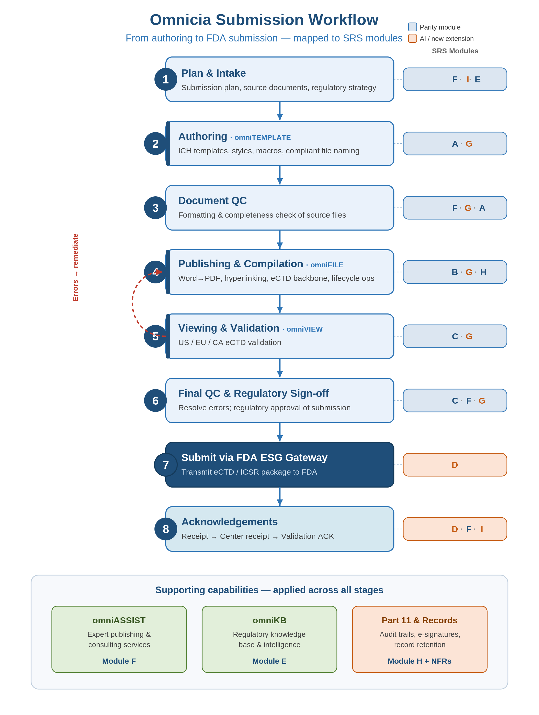

2.5 Workflow-to-Module Mapping
Each workflow stage in the diagram is delivered by one or more SRS modules. The mapping below ties stages to their owning modules and representative requirement IDs (full requirements in Section 3). In the diagram tags, blue denotes parity modules and orange denotes AI-automation or new extension modules (D, G, I).

Workflow stage | SRS modules | Representative requirements
1 — Plan & Intake | F – Workflow, I – Client portal, E – Knowledge | FR-F-01, FR-I-01, FR-E-01
2 — Authoring | A – Authoring/Templating, G – AI drafting | FR-A-01 to A-04, FR-G-06
3 — Document QC | F – QC workflow, G – AI pre-QC, A – Formatting | FR-F-02, FR-G-02, FR-A-03
4 — Publishing & Compilation | B – Publishing/eCTD, G – AI assembly, H – Records | FR-B-01 to B-09, FR-G-01, FR-H-01
5 — Viewing & Validation | C – Viewer/Validator, G – AI pre-QC | FR-C-01 to C-03, FR-G-02
6 — Final QC & Sign-off | C – Licensed gate, F – Sign-off, G – Human-in-loop | FR-C-04, FR-F-03, FR-G-03
7 — Submit via FDA ESG | D – ESG transmission | FR-D-01 to D-03, FR-D-06
8 — Acknowledgements | D – ACK reconcile, F – Dashboards, I – Client status | FR-D-04, FR-D-05, FR-F-04, FR-I-02
Remediation loop | C → B / A, driven by G and F | FR-C-03, FR-G-02, FR-B-06
Supporting band | F (omniASSIST), E (omniKB), H (Part 11/Records) | FR-F-*, FR-E-*, FR-H-*, NFR-COMP-01

3. Functional Requirements

3.1 Module A — Authoring & Templating (omniTEMPLATE parity)
ID | Requirement | Pri
FR-A-01 | Provide MS Word–based granular authoring with a guided document wizard that produces eCTD-ready documents. | M
FR-A-02 | Maintain a lean, ICH-compliant master template set (target ≤ 20 templates) covering all CTD document types for US, EU, and CA — not hundreds of per-document templates. | M
FR-A-03 | Apply standardized styles, a formatting toolbar, and macros that enforce agency formatting (fonts, margins, pagination, heading styles). | M
FR-A-04 | Auto-generate ICH-compliant file names and document metadata/attributes at creation. | M
FR-A-05 | Auto-populate customized headers and footers from document attributes. | S
FR-A-06 | Ensure authored Word files are optimized for downstream PDF publishing (styles map to bookmarks; no manual hyperlink rework). | M
FR-A-07 | Support reuse of existing Word source files and reusable content components across submissions. | S
FR-A-08 | Produce documents compatible with competitor publishing systems (interoperable output). | C

3.2 Module B — Publishing & eCTD Compilation (omniFILE parity)
ID | Requirement | Pri
FR-B-01 | Compile compliant eCTD submissions for US (FDA), EU, and Canada from source documents. | M
FR-B-02 | Generate the eCTD backbone (index.xml) and US regional XML per current FDA specifications (v3.2.2). | M
FR-B-03 | Support full eCTD lifecycle operations (new, replace, append, delete) and sequence numbering (0000, 0001, …) across an application's life. | M
FR-B-04 | Convert MS Word documents to FDA-compliant PDF (correct version, embedded fonts, no disallowed security, generated bookmarks). | M
FR-B-05 | Batch-insert internal and external hyperlinks in MS Word and convert absolute Word hyperlinks to relative PDF hyperlinks. | M
FR-B-06 | Re-publish without hyperlink rework when Word content changes (eliminate external PDF re-hyperlinking). | M
FR-B-07 | Support parallel build and revision of work-in-progress content during drug development. | S
FR-B-08 | Generate Study Tagging Files (STF) where required for Module 4/5 study documents. | S
FR-B-09 | Produce a submission-ready output package with correct folder structure and MD5 checksums. | M
FR-B-10 | Support eCTD v4.0 (HL7 RPS) output alongside v3.2.2 (dual-format publishing). | S

3.3 Module C — Viewing & Validation (omniVIEW parity)
ID | Requirement | Pri
FR-C-01 | Provide a cloud/browser-based eCTD lifecycle viewer rendering the full application across sequences, with current and cumulative views. | M
FR-C-02 | Validate submissions against US, EU, and Canadian eCTD specifications. | M
FR-C-03 | Run FDA technical validation criteria and report errors/warnings with severity and remediation guidance. | M
FR-C-04 | Gate final validation through a recognized third-party validation engine before release (per build/license decision). | M
FR-C-05 | Display document lifecycle history (operations applied across sequences). | S
FR-C-06 | Provide secure online storage of submissions; be platform independent. | M
FR-C-07 | Support eCTD v4.0 viewing and validation. | S

3.4 Module D — ESG NextGen Transmission & Acknowledgements (extension)
ID | Requirement | Pri
FR-D-01 | Submit completed submissions to FDA via the ESG NextGen submission API (File Submit), authenticated with Client ID and Secret Key from a USP account. | M
FR-D-02 | Support both test and production gateway endpoints and credentials. | M
FR-D-03 | Poll submission status (Get Submission Status) and surface real-time status through Center receipt. | M
FR-D-04 | Retrieve and parse acknowledgements (Get Acknowledgement): gateway receipt, Center receipt, and validation ACKs. | M
FR-D-05 | Reconcile acknowledgements to submissions via a per-submission state machine; flag failures and drive resubmission. | M
FR-D-06 | Submit E2B(R3) ICSRs to AEMS to satisfy the Oct 1, 2026 postmarketing mandate (covers the existing safety-reporting use case). | M
FR-D-07 | Immutably log all transmissions, payload hashes, and acknowledgements for audit. | M
FR-D-08 | Retain AS2 transmission as a fallback/legacy path. | C

3.5 Module E — Knowledge & Regulatory Intelligence (omniKB parity)
ID | Requirement | Pri
FR-E-01 | Provide a centralized knowledge base of regulatory requirements, agency specifications, templates, and SOPs. | M
FR-E-02 | Version and date-stamp guidance/spec content and track changes to eCTD specs and regional requirements. | S
FR-E-03 | Provide a searchable repository of prior submissions, FDA correspondence, and lessons learned. | S
FR-E-04 | Maintain agency requirement matrices for US, EU, and CA. | C

3.6 Module F — Services Enablement & Workflow (omniASSIST parity)
ID | Requirement | Pri
FR-F-01 | Provide project/workflow management for submission engagements (tasks, milestones, owners, deadlines). | M
FR-F-02 | Provide a source-file QC checklist workflow ensuring files meet eCTD requirements before publishing. | M
FR-F-03 | Support role-based task assignment and handoffs between authors, publishers, QC, and regulatory sign-off. | M
FR-F-04 | Provide capacity/throughput dashboards (submissions in flight, status, SLA tracking). | S
FR-F-05 | Capture productivity metrics (hours per submission, AI-assist rate) to support value-based pricing and the JV economic split. | S

3.7 Module G — AI Automation Layer (differentiator)
ID | Requirement | Pri
FR-G-01 | AI-assisted assembly: classify and map source documents to the correct CTD sections and propose document granularity. | M
FR-G-02 | AI pre-QC: detect formatting, hyperlink, bookmark, naming, and completeness issues before the licensed validation gate. | M
FR-G-03 | Human-in-the-loop control: every AI output is reviewable, attributable, and requires human sign-off; AI never finalizes or transmits a submission. | M
FR-G-04 | Log all AI operations with inputs, outputs, model and version, and reviewer identity for audit and validation evidence. | M
FR-G-05 | Auto-generate conformance test artifacts from specifications to serve as operational-qualification evidence. | S
FR-G-06 | AI-assisted authoring/drafting from templates and prior approved content (human-reviewed). | S
FR-G-07 | AI extraction of metadata to auto-populate eCTD leaf attributes. | S
FR-G-08 | Conversational assistant over the knowledge base and (with isolation guarantees) submission content. | C

3.8 Module H — Document & Records Management
ID | Requirement | Pri
FR-H-01 | Provide a controlled document repository with versioning, check-in/out, and metadata. | M
FR-H-02 | Enforce configurable record-retention policies meeting regulatory requirements. | M
FR-H-03 | Maintain a full audit trail of document actions (who, what, when, before/after). | M
FR-H-04 | Segregate documents and submissions per client. | M

3.9 Module I — Client Portal & Collaboration
ID | Requirement | Pri
FR-I-01 | Provide a secure client portal for upload of source content and download of deliverables and acknowledgements. | S
FR-I-02 | Give clients real-time submission status visibility. | S
FR-I-03 | Support in-app comments/collaboration on documents and submissions. | C

4. Non-Functional Requirements

4.1 Compliance & validation
ID | Requirement | Pri
NFR-COMP-01 | Be 21 CFR Part 11 compliant: secure audit trails, electronic signatures, access controls, and record integrity. | M
NFR-COMP-02 | Be developed and maintained under Computer System Validation (IQ/OQ/PQ) and kept in a validated state. | M
NFR-COMP-03 | Conform to current FDA eCTD technical specifications and regional M1; support v3.2.2 now and v4.0 as it matures. | M
NFR-COMP-04 | Operate under documented, reproducible SDLC and GxP change control; AI-generated code is human-reviewed and traceable. | M
NFR-COMP-05 | Maintain an evidence package supporting sponsor vendor-qualification audits. | S

4.2 Security & data governance
ID | Requirement | Pri
NFR-SEC-01 | Encrypt data in transit (TLS 1.2+) and at rest. | M
NFR-SEC-02 | Enforce role-based access control with least privilege and multi-factor authentication. | M
NFR-SEC-03 | Provide per-client data isolation/segregation. | M
NFR-SEC-04 | Guarantee sponsor content is never used to train third-party models; use no-retention model endpoints. | M
NFR-SEC-05 | Offer a private/in-tenant processing option for clients who require it. | S
NFR-SEC-06 | Provide comprehensive security audit logging and breach detection/notification. | M
NFR-SEC-07 | Target SOC 2 (or equivalent) attestation. | S

4.3 Performance, availability & usability
ID | Requirement | Pri
NFR-PERF-01 | Publish a typical sequence and complete validation within agreed performance targets; support concurrent multi-client publishing. | S
NFR-AVAIL-01 | Meet a 99.5%+ uptime target for cloud services. | S
NFR-AVAIL-02 | Provide backup and disaster recovery with defined RPO/RTO. | M
NFR-USE-01 | Offer a simple learning curve with minimal IT support (Omnicia parity claim); be browser-based and platform independent. | S
NFR-INT-01 | Produce output compatible with third-party eCTD viewers/publishers and integrate with the MS Word / Adobe PDF toolchain. | M
NFR-INT-02 | Expose an API for integration with sponsor systems. | S

5. Data & Integration Requirements
- eCTD standards: v3.2.2 backbone and US regional M1 (mandatory); v4.0 (HL7 RPS) as a forward-compatible output.
- FDA ESG NextGen API: File Submit, Get Submission Status, Get Acknowledgement, and credential APIs; Client ID/Secret via USP; test and production environments.
- E2B(R3): ICSR generation and transmission to AEMS per the October 2026 mandate.
- Document toolchain: MS Word (authoring) and Adobe PDF (publishing) interoperability; PDF must meet FDA PDF specifications.
- Study data (deferred): SDTM/ADaM/SEND and define.xml handled by partners initially; integration points reserved for a later phase.

6. Acceptance & Validation Approach
Each Must requirement has a corresponding acceptance test; AI-generated conformance suites (FR-G-05) serve as OQ evidence. Final acceptance of any submission output requires a pass from the licensed third-party validator (FR-C-04) and human regulatory sign-off (FR-G-03, owned by Universal Regulatory). The system is released into use only after IQ/OQ/PQ under the partner's quality system (NFR-COMP-02).

7. Out of Scope (Initial Releases)
- Study-data standardization and conversion (SDTM/ADaM/SEND, define.xml) — partner-provided initially.
- Acting as the sponsor's quality management system — the platform is a controlled tool within Universal Regulatory's QMS.
- Non-US/EU/CA regional submission formats beyond eCTD parity scope.
- Replacing the licensed final-validation engine with an in-house validator (revisit once a track record exists).

Sources
Omnicia products (omniTEMPLATE / omniFILE / omniVIEW / omniASSIST / omniKB): https://www.omniciainc.com/products
FDA ESG NextGen: https://www.fda.gov/industry/electronic-submissions-gateway-next-generation-esg-nextgen
FDA AEMS / E2B(R3) standards: https://www.fda.gov/drugs/fda-adverse-event-monitoring-system-aems/fda-adverse-event-monitoring-system-aems-e2br3-standards
FDA eCTD v4.0 submission standards: https://www.fda.gov/drugs/electronic-regulatory-submission-and-review/ectd-submission-standards-ectd-v40-and-regional-m1

