Page Review: Tunbridge Wells Airport Transfers
Page I checked: https://langtoncars.com/tunbridge-wells-airport-transfers/
Checked on: 29 October 2026, live page on desktop and mobile
Hi, I went through the new page properly on desktop and mobile, looked at the code behind it and checked how Google will read it. Overall the new design is a big step up. It is clean, the green and dark colours suit the brand, the prices are right there and the page loads fast. There are a few things holding it back though, mostly on the SEO and trust side. I have kept everything short and put my suggestions under each point.
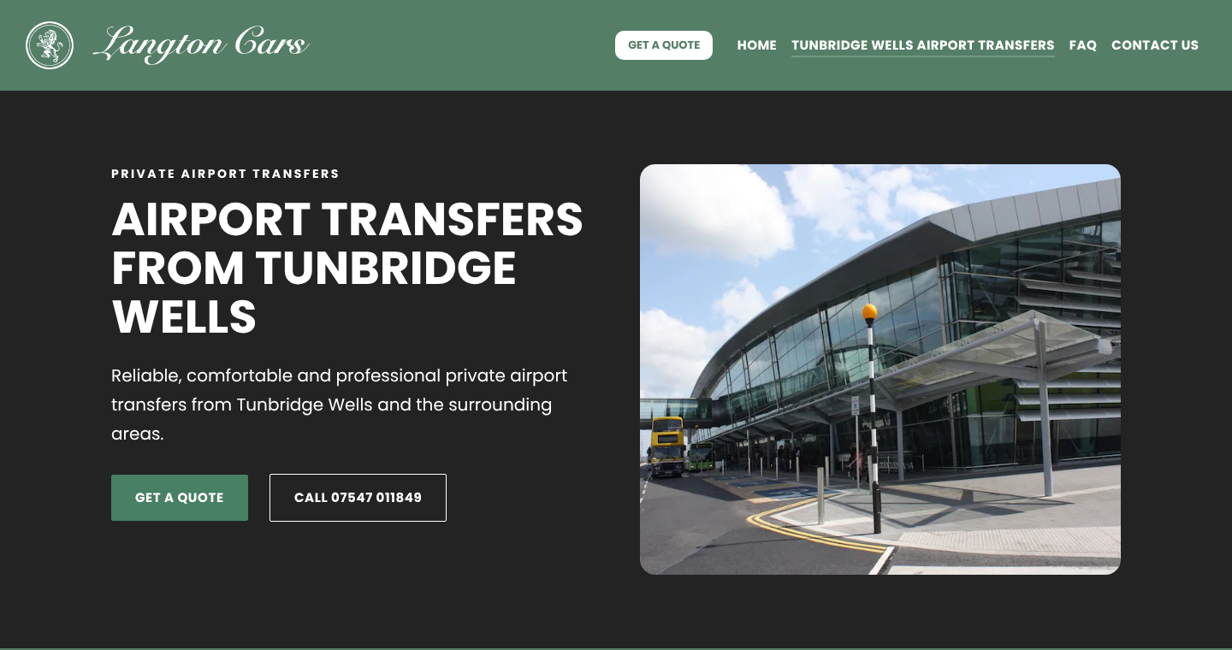
Desktop hero section

What is already working well
- Clear H1 "Airport Transfers From Tunbridge Wells" which matches what people search for.
- Prices are visible upfront. Customers love this and it builds confidence straight away.
- Fast page. In my test the main image loaded in about 1.3 seconds on mobile and the layout barely moves while loading.
- HTTPS is set, http and www versions redirect properly, and the canonical tag points to the right URL.
- Phone and WhatsApp links are clickable, and the "How your transfer works" steps are easy to follow.

1. Page title and keyword clash
The page title currently shows "Tunbridge Wells Airport Transfers" twice. This happens because the site name itself in WordPress includes that phrase, so every page gets it added on the end.
The bigger issue is the homepage. Its title is also built around "Reliable Airport Transfers in Tunbridge Wells", so the homepage and this page are fighting for the same search. Google usually picks one and the other gets ignored.
My recommendation: change the site title in WordPress settings to just "Langton Cars", then set this page title to something like "Tunbridge Wells Airport Transfers | Gatwick from £80 | Langton Cars". Let the homepage target the wider brand and services (executive, wedding and airport travel) and link down to this page.

2. Meta description
There is no written meta description. WordPress is pulling the first lines of the page, so Google sees "PRIVATE AIRPORT TRANSFERS AIRPORT TRANSFERS FROM TUNBRIDGE WELLS..." in capitals. That looks messy in search results and wastes the chance to get the click.
Suggested: "Private airport transfers from Tunbridge Wells to Gatwick, Heathrow, Stansted and London City. Fixed fares from £80, local licensed drivers. Get a quote today."

3. Schema markup
The only structured data on the page is a breadcrumb. For a local taxi business this is a missed opportunity.
- LocalBusiness or TaxiService schema with the name, address, phone, opening hours and the areas served.
- Service schema with the four airport prices as offers.
- FAQPage schema for the five FAQs already on the page.
This helps Google understand the business and connects the page with the Google Business Profile.

4. Images
None of the airport images have alt text, so Google and screen readers get nothing from them. Also the hero image does not look like any of the four airports listed, it reads as a generic stock photo of a terminal.
My recommendation: add simple alt text like "Gatwick Airport terminal" and "Langton Cars airport transfer from Tunbridge Wells". For the hero, I would use a real photo of your car, ideally with the driver at a terminal. That alone builds more trust than any stock image.

5. Design and UX on desktop
The layout is good, but a few small things look unfinished.
- In the "Why travel with Langton Cars" section, the word COMFORTABLE breaks into "COMFORTABL E TRAVEL". A smaller font size on these card headings will fix it.
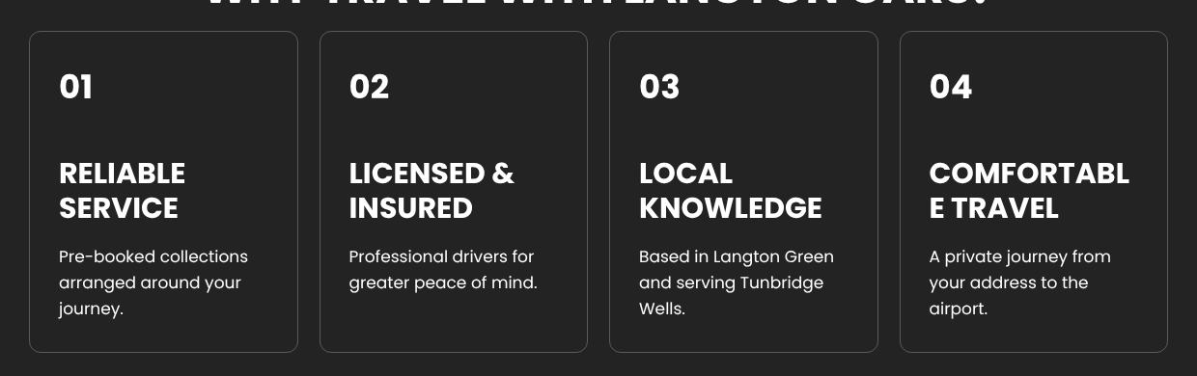
Heading breaking onto two lines
- The "Get a quote" button sits before Home in the menu. I would move it to the far right and show the phone number next to it, as that is where people look for it.
- The menu label "Tunbridge Wells Airport Transfers" is long. "Airport Transfers" is enough in the nav.
- The airport cards have no button. Someone reading about Gatwick has to scroll down to find a quote button. A small "Book Gatwick transfer" button under each fare would help conversions.
- The FAQ section has a lot of empty space between closed questions. Tightening that up will make it feel neater.
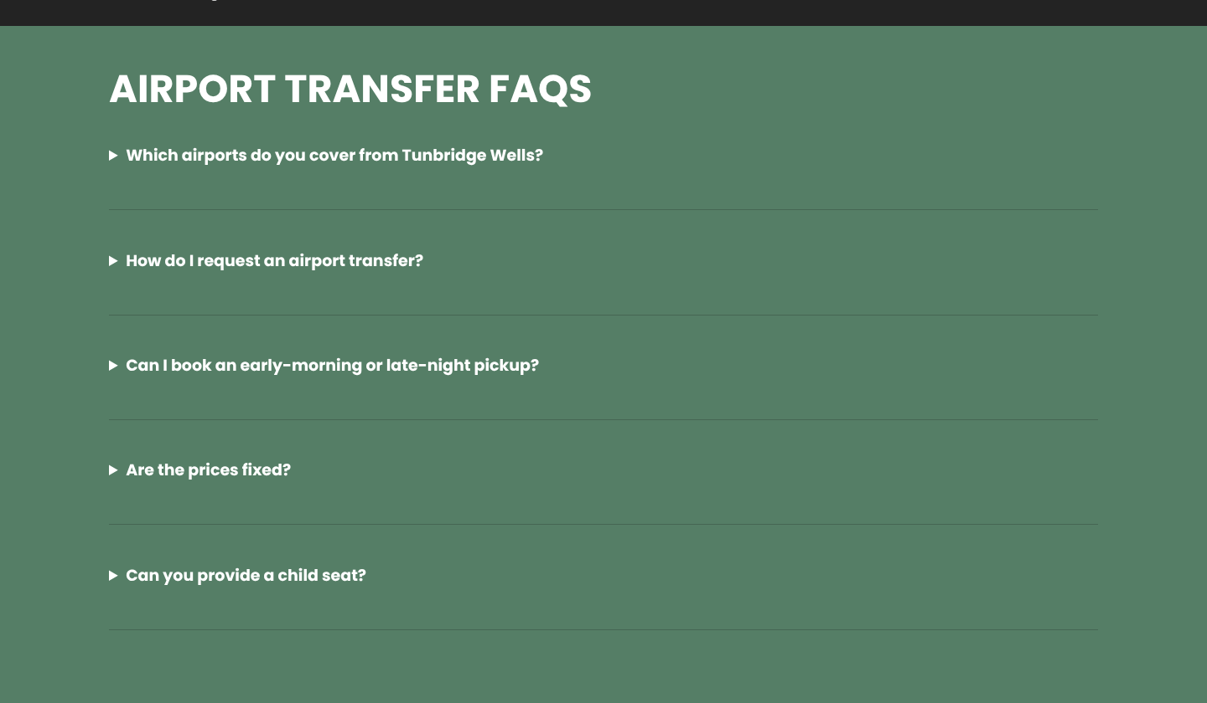
FAQ section with large gaps
- Almost every heading is in capitals. It looks bold but it gets tiring to read. I would keep capitals for the small labels only.

6. Mobile experience
Most of the bookings for this kind of service come from phones, so this matters a lot.
- The menu icon is squeezed right up against "Cars" in the logo and it is very small to tap (around 18 pixels, Google suggests at least 44).
- There is no Get a quote or Call button in the mobile header. Once someone scrolls past the hero there is no quick way to call.

Mobile header, menu icon touching the logo
My recommendation: make the logo a bit smaller on mobile, give the menu icon more space, and add a sticky bar at the bottom with three buttons: Call, WhatsApp and Get a Quote. This is the single biggest conversion win on this page in my opinion.
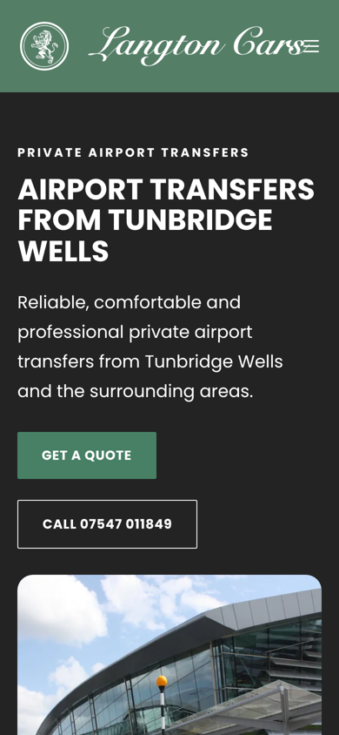
Mobile first screen

7. Content and trust
The page has around 600 words, which is light for a money page in a competitive local search. More importantly, there is nothing that proves the business is real and trusted yet.
- Add Google reviews or a few customer testimonials.
- Mention the council licence (for example licensed by Tunbridge Wells Borough Council) and the vehicle type, passenger and luggage capacity.
- Add the useful details people actually search for: flight monitoring, waiting time, meet and greet, return journeys, and whether the price is per car or per person.
- The email is a Gmail address. A domain email like bookings@langtoncars.com looks much more professional.
- Make sure the address and phone here match the Google Business Profile exactly.

8. Internal linking
This is quite weak right now. Apart from the menu, the page only links to the quote page, phone, email and WhatsApp.
- Create a page for each airport, for example https://langtoncars.com/gatwick-airport-transfers/ and link each airport card to it.
- Link "quote form" in the FAQ answer to https://langtoncars.com/get-a-quote/
- Add a link to https://langtoncars.com/faq/ under the FAQ section for more questions.
- The village list (Pembury, Speldhurst, Groombridge and so on) is plain text. Later on, the strongest villages can get their own short pages and be linked from here.
- From the homepage, link to this page with clear anchor text like "airport transfers from Tunbridge Wells".

9. Footer
The footer has the basics, phone, email, address and WhatsApp, but it is doing very little for the customer or for SEO. It also feels a bit empty with a lot of dark space.
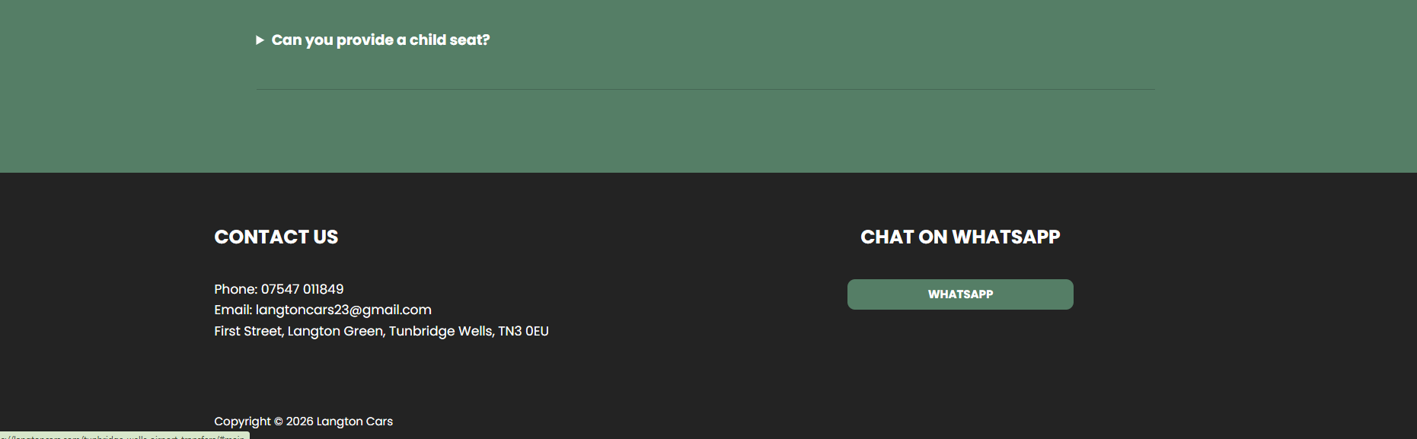
Current footer
- Add a quick links column with Home, Airport Transfers, FAQ, Contact Us and Get a Quote. Once the airport pages are live, add Gatwick, Heathrow, Stansted and London City links here too. This spreads internal links across the whole site.
- Add a Privacy Policy link. The site collects personal details through the quote form, so this is needed for UK GDPR, and a Terms or Booking Conditions page is good to have as well.
- Show opening or booking hours, for example "Available 24 hours, pre booking required". People booking early flights want to see this.
- Link the address to Google Maps and use the exact same name, address and phone as the Google Business Profile. A small Google reviews badge or star rating here would add a lot of trust.
- Add the private hire licence details from the council. It reassures customers and almost every competitor shows it.
- The WhatsApp block says "Chat on WhatsApp" and then the button just says "WHATSAPP". I would merge it into one clear button like "Message us on WhatsApp" with the WhatsApp icon, and place it next to a "Call now" button.
- Switch the Gmail address to a domain email like bookings@langtoncars.com.
- In the code the heading is typed as "CONTACt Us". It shows fine on screen because of the capitals style, but worth correcting.

10. Technical bits
- The page language is set to "en" and the social sharing locale is en_US. For a UK business I would set both to en GB.
- Comments are switched on for this page (the code loads a comment form). On a service page I would turn comments off.
- During my check, the server returned a 403 error once for an iPhone browser and then started blocking my requests with "429 Too Many Requests" after only a handful of page loads. Please ask the host to review the firewall or rate limit settings so real visitors and Googlebot never get blocked. I could not open the robots.txt and sitemap because of this, so those are worth checking in Search Console.

Priority list
Priority | What I would do
High | Fix the page title and the homepage clash for the same keyword
High | Write a proper meta description
High | Add LocalBusiness, Service and FAQ schema
High | Add reviews, a real car photo and licence details for trust
High | Fix the mobile header and add a sticky Call / WhatsApp / Quote bar
Medium | Add alt text to all images and swap the hero image
Medium | Build airport pages and link them from the cards
Medium | Grow the content with useful journey details
Medium | Rebuild the footer with quick links, privacy policy, hours and licence details
Low | Fix the broken card heading, nav order, en GB locale and turn off comments

Happy to go through any of this on a call. Once the title, schema, mobile header and trust bits are sorted, I think this page will be in a really strong position for Tunbridge Wells airport searches.

