

**Post 1: Switch Statement In Java**

**Date: 2nd July 2023**

**Switch Statement**

Here is brief explanation about switch statement & how to use it.

Later we will learn the new switch expression which was introduced in java 14 & and it became a standard feature starting from it.

Why we use swich statement?

By using the switch statement, we can improve code readability by replacing multiple nested if-else conditions.

Here is an example of if-else condition:

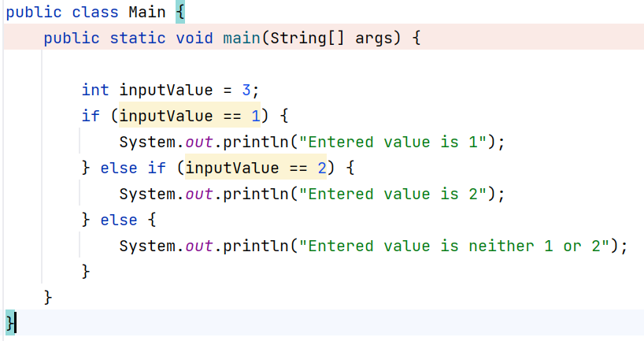

Lets use another mechanism that java provides called “Switch” statement and test if variable matches

Lets use another mechanism that java provides called “Switch” statement and test if variable matches

We evaluate the age provided in the switch argument against multiple other case values. In the event that none of the case values matches the argument, the code block associated with the default label is executed.

Use of Break Statement:

The break statement is used to exit from a switch statement. We expected that only one of the case blocks will be executed in a switch statement. If we miss to include a break statement, it will result in the execution of the subsequent blocks.

We need to be very alert to add the break statement at the end of the each statement unless if there is any required use case.

The switch statement has seen quite a few updates through the years. Lets explore some of the new features of the switch statement.

|  |  |
| --- | --- |
| **Traditional Switch Statement in a method returning Values** | **Enhanced Switch expression** |
|  | ­­­ |

when the statement is used as an expression then default keyword is mandatory to use otherwise compiler will throw the exception “, "the switch expression does not cover all possible input values