Bare International Assignment Test For Full Stack Developer

**Frontend Desing Screen**

Main Page where the user types English letter and clicks on the search button to get translated into Hungarian

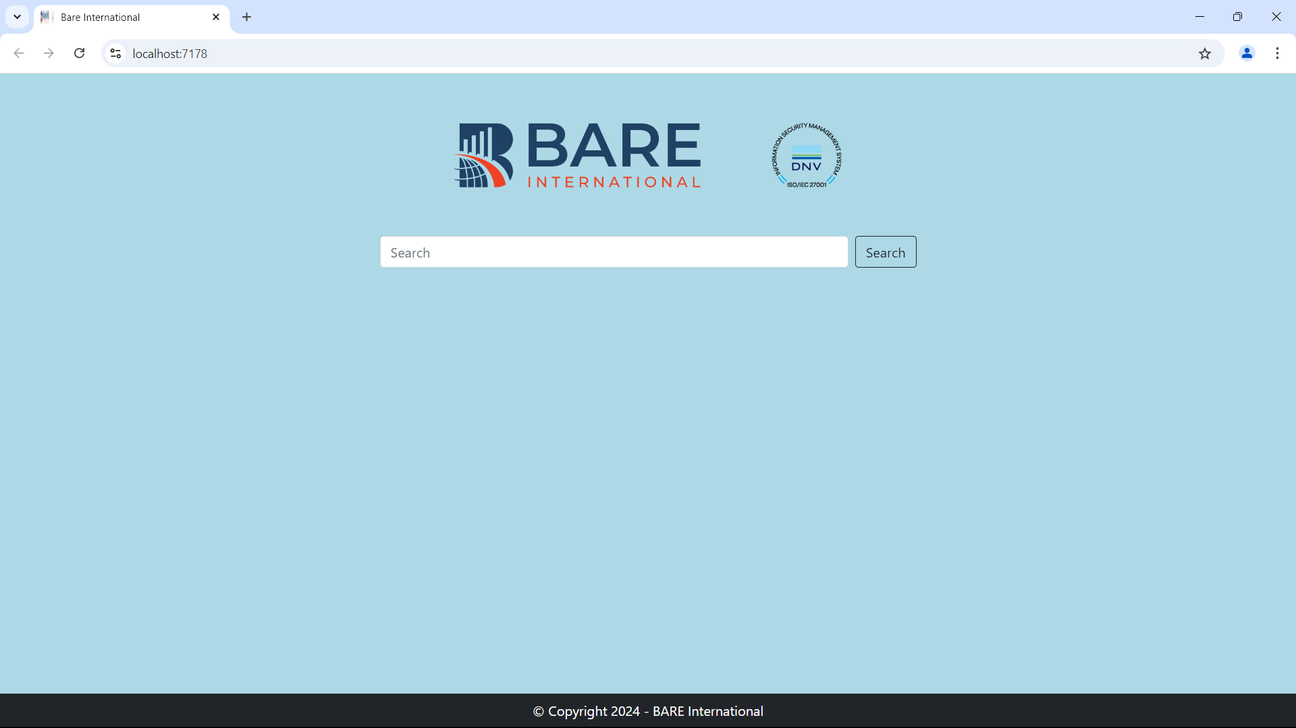

Focus On the Search Box when a user types the alphabet on the input type

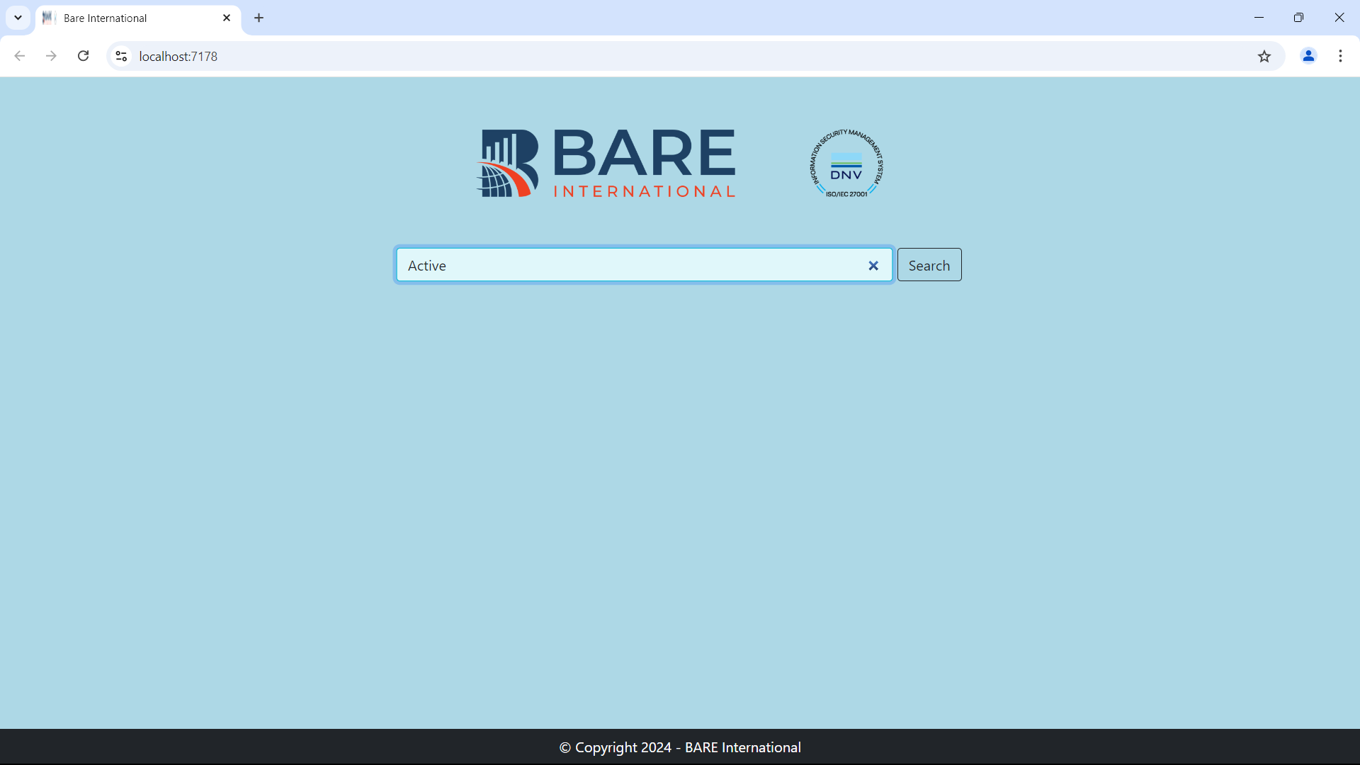

Onclick of search button

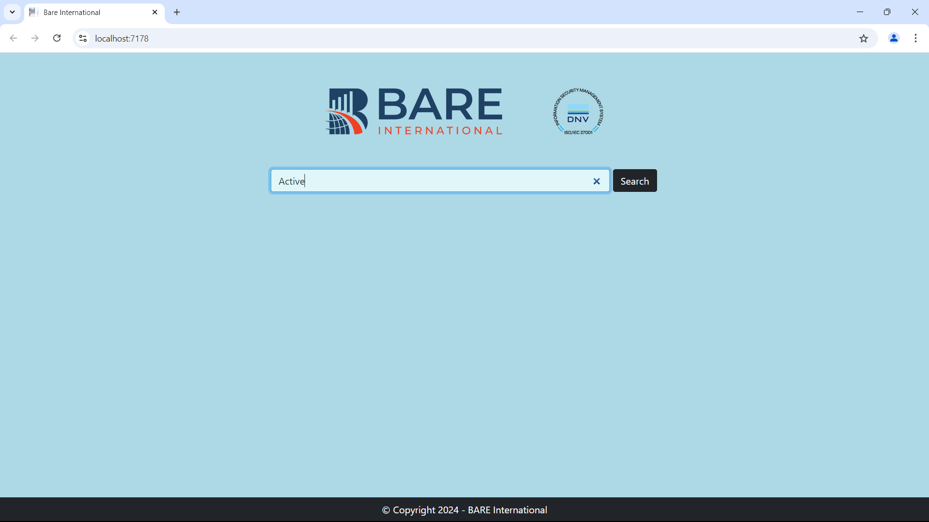

Popup which contains translated message into Hungarian from English

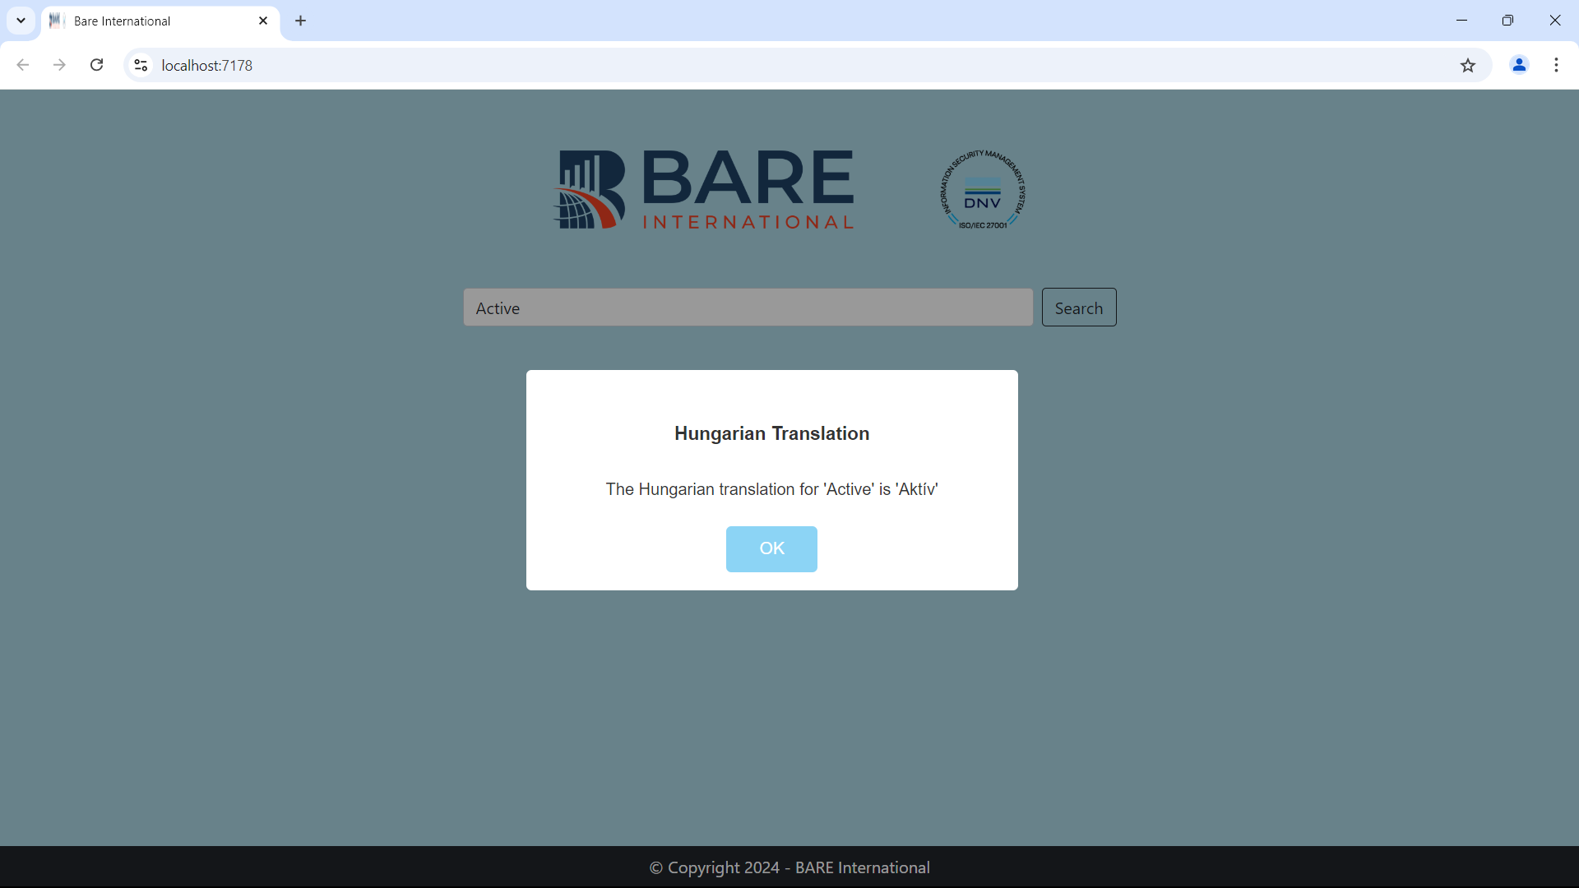

If the user doesn’t type in the search box(empty) and click on the search button

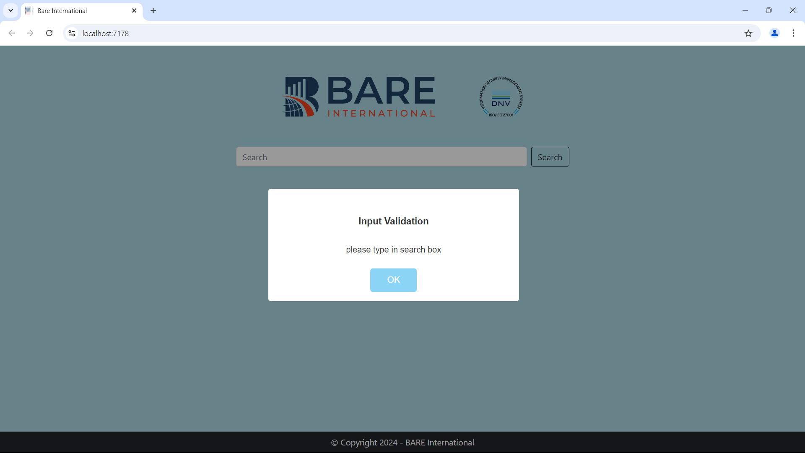

If the User types any English alphabet and that data is not present in the Database then the below screen will appear

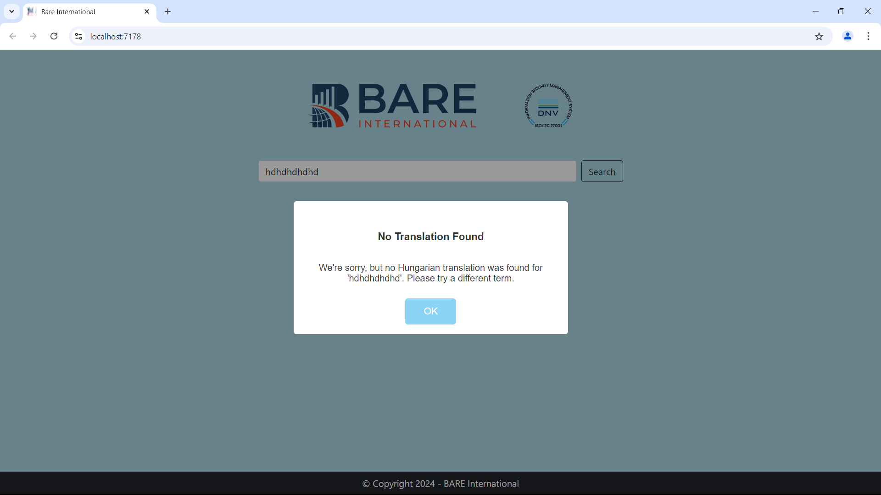

If the website backend server is down or API is down or any database-related exception occurs when the user click on the search button below the screen

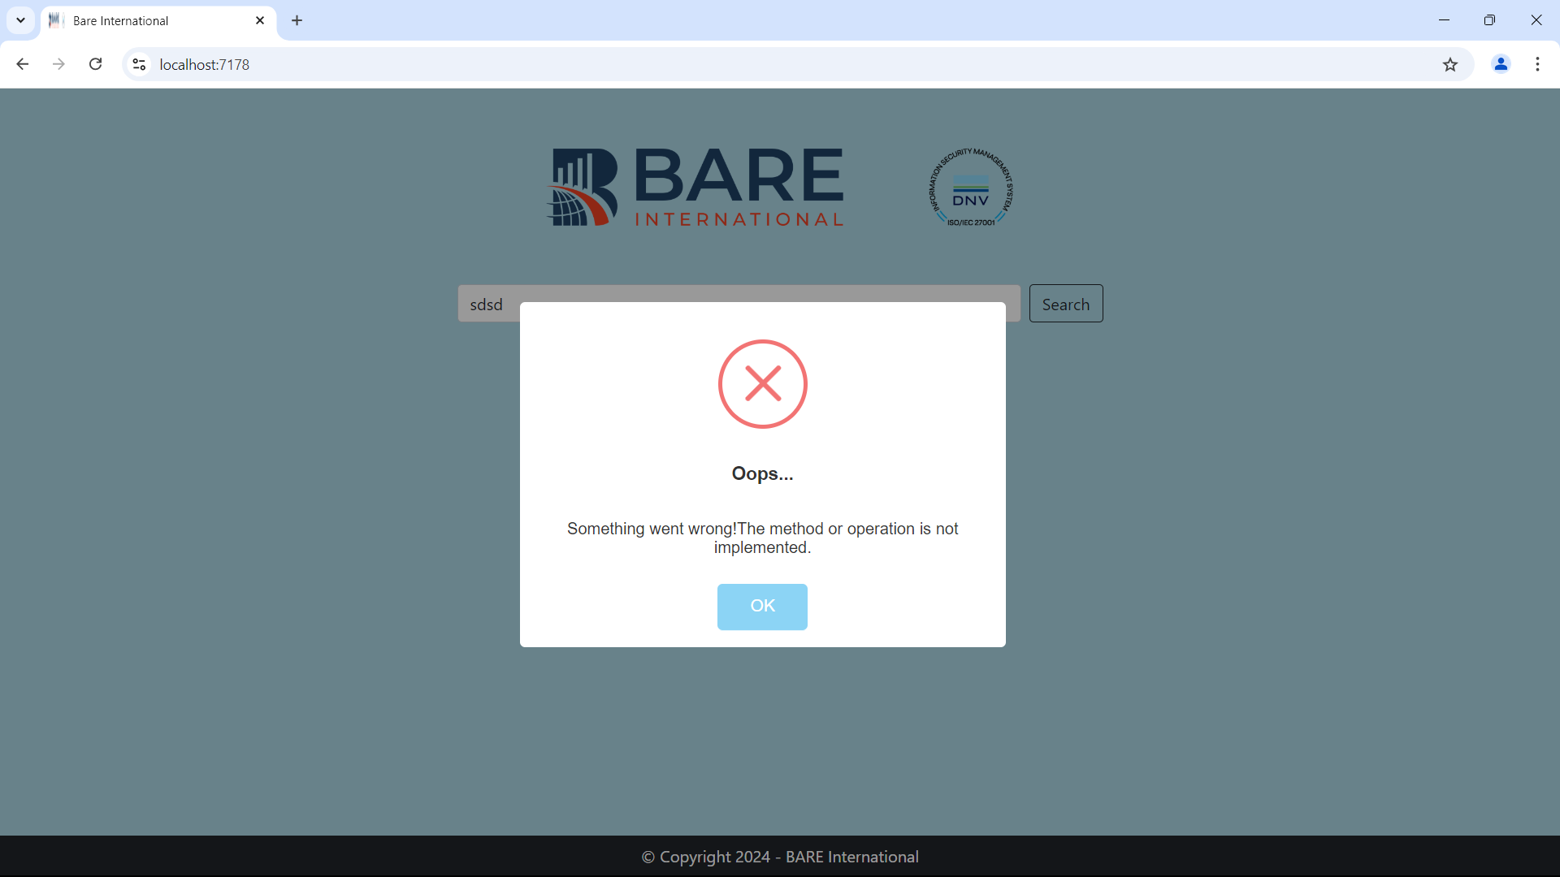

**Backend Project Structure**

I have used **N-Tier Architecture**

1. DL(Data Layer) : Database operation perform here
2. BL(Business Layer): business logic are written here
3. Model: all class objects are here
4. Main Project: where view and API are written here

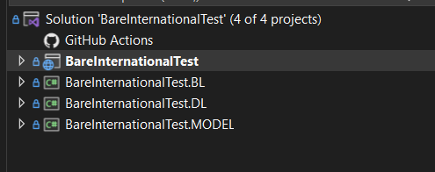

**Technical Skills That I have used in the project**

**Frontend**: HTML, CSS, Bootstrap 5, Jquery, AJAX, Javascript, external Library for alert box

**Backend**: Dot Net Core MVC, Dot Net Core Web API

**Database**: Microsoft SQL Server (MSSQL)

**Additional Feature**

To get the exception or why we failing issue on the website Nlog is used here every click of the user is stored in the database and file

For info level log only file is maintained and for error level log file and database both are maintain with stack trace

File Path for Log File

PATH : BareInternationalTest\BareInternationalTest\NlogFile\

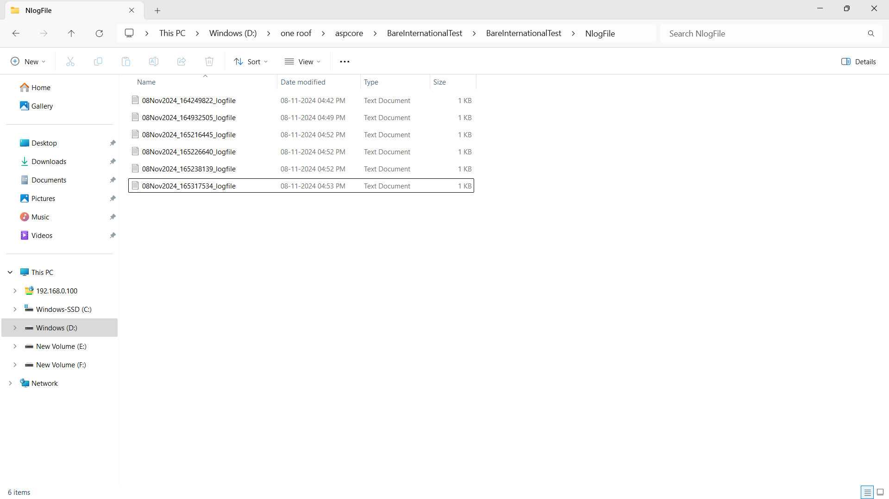

Error Log File db Maintain

