An explainable AI knowledge-based model for predicting startup success using multi-source entrepreneurial data
Short Communication
Sachin Gujjalwar
gujjalwarsachin199@gmail.com,

Abstract
Accurate startup-success predictors are black boxes that can contradict entrepreneurship knowledge, which limits their use in investment and innovation decisions. We propose KG-XAI, a knowledge-guided explainable model that couples nine theory-grounded rules with gradient-boosted trees learned from multi-source entrepreneurial data. The rules enter the learner as features and monotone constraints, an in-fold refinement step releases any rule the training data contradict, and exact TreeSHAP explains each prediction by data source and by rule. In a leakage-safe study of 7,455 startups built from four linked Crunchbase tables and tested on later cohorts, KG-XAI matches the best black box (AUC 0.837 vs 0.840, p = 0.15), outperforms an interpretable boosted additive model (0.825) and reduces theory-violating what-if responses from 19.3% to 0.0%; a 922-firm benchmark confirms the pattern. When up to three rules are given the wrong direction, refinement releases all of them and keeps accuracy flat, whereas naive knowledge injection degrades. Code and data are openly available.
Keywords: explainable artificial intelligence; knowledge-based systems; informed machine learning; startup success prediction; entrepreneurship; digital transformation; innovation

1. Introduction
Digital transformation has turned venture assessment into a data problem [1,2]. Investors, accelerators and innovation agencies increasingly screen startups with artificial intelligence (AI) built on platform data such as Crunchbase [3–5], and machine-learning studies predict acquisition, exit or failure from the funding, network and legitimacy signals that venture capitalists themselves weigh [6–11]. Three problems limit their use. The most accurate predictors are black boxes [12–16]. They learn only from data, so their what-if responses can contradict entrepreneurship theory, whereas informed machine learning argues that prior knowledge should shape the learner itself [17,18]. And lifetime snapshot features partly encode how long a firm survived, a target leakage that inflates reported accuracy [19,20].
Existing remedies treat these problems separately. Post-hoc explainers such as SHAP describe a trained black box [21–23] but cannot stop it from contradicting theory; monotonic classification [24] and theory-guided data science [18] impose knowledge but assume that it is correct. Entrepreneurship knowledge, however, is contested and context dependent, and to our knowledge no startup-prediction study validates its prior knowledge before imposing it or audits whether the trained model's what-if behaviour respects it. This short communication proposes KG-XAI and contributes (i) a nine-rule knowledge base encoded as features and monotone constraints, (ii) in-fold refinement that releases knowledge the training data contradict, (iii) explanations by data source and by rule with a directional violation rate (DVR) audit, and (iv) a leakage-safe multi-table evaluation with an out-of-time test and a wrong-knowledge stress test, reproducible with one command.

2. Proposed KG-XAI Framework
KG-XAI combines multi-source data views, a knowledge base, in-fold refinement and a knowledge-guided learner with exact explanations (Figure 1).
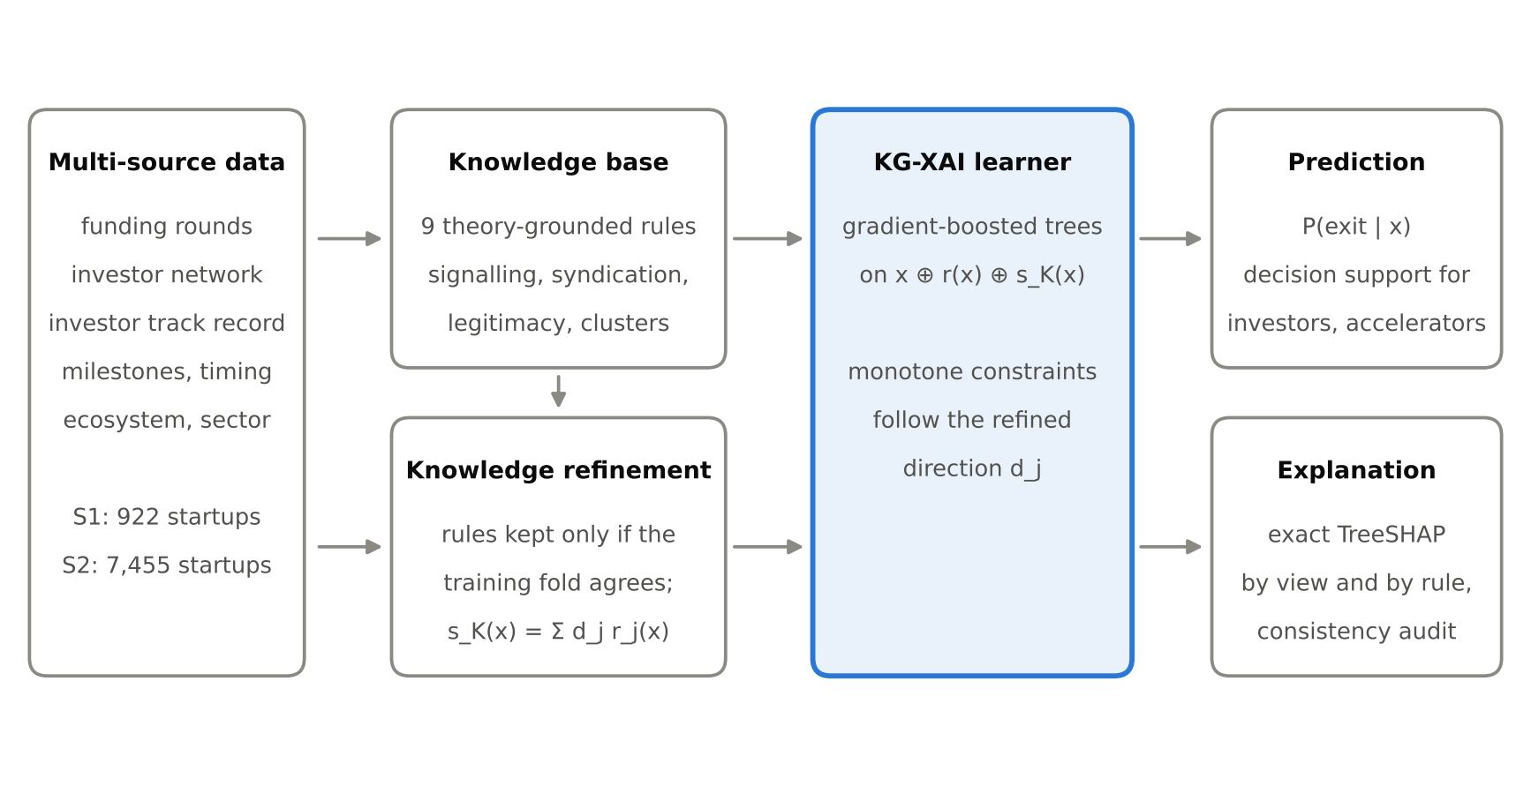
Figure 1. The KG-XAI framework. Rules are validated on each training fold, then enter a gradient-boosted learner as features and monotone constraints; TreeSHAP explains predictions by source view and by rule.

2.1 Knowledge base and refinement
The knowledge base K = {(c_{j}, d_{j}, L_{j})}, j = 1, …, 9, pairs each rule condition c_{j} with an expected direction d_{j} ∈ {+1, −1} and the raw features L_{j} whose direction the same theory fixes. The rules operationalise signalling and venture-capital (VC) certification [25,26], staged financing [27], the resource-based view [28], syndication [29], endorsement [30], legitimacy [31], clusters [32] and the liability of newness [33] (Supplementary Table S1). Rule activations r_{j}(x) = 1[c_{j}(x)] form the knowledge score
s_{K}(x) = Σ⁹_{j=1} d̂_{j} r_{j}(x)(1)
Because stated knowledge can be wrong for a population, each direction is validated on the training fold only and released (d̂_{j} = 0) when the data disagree:
d̂_{j} = d_{j} · 1[sign(Pr(y = 1 | r_{j} = 1) − Pr(y = 1 | r_{j} = 0)) = d_{j}](2)
Linked features are checked by the sign of their Spearman correlation with success; released items are reported for expert review.

2.2 Learner and consistency audit
A LightGBM ensemble [34], the strongest model family for tabular business data [35], is trained on z = [x, r(x), s_{K}(x)] with a monotone constraint on every input whose validated direction d̂_{k} ≠ 0:
d̂_{k} · (f(z + δe_{k}) − f(z)) ≥ 0, for all δ > 0(3)
Exact TreeSHAP [22] attributions φ_{k}(x) are aggregated per source view, Φ_{v}(x) = Σ_{k∈v} |φ_{k}(x)|, and per fired rule. To audit consistency, each startup receives a theory-consistent improvement δ_{k} on each linked feature (a flag set to 1, a count raised by one, or a continuous value raised by one standard deviation, with rules recomputed); DVR is the share of probes P in which the predicted probability falls:
DVR = (1/|P|) Σ_{(i,k)∈P} 1[p̂(x_{i} ⊕ δ_{k}) < p̂(x_{i}) − ε](4)

3. Experimental Design
Study 1 is the public Startup Success Prediction benchmark [36]: 922 U.S. startups (596 acquired, 326 closed) with 32 lifetime snapshot features in six views. Study 2 joins four tables of the open Crunchbase snapshot of December 2015 [37] (companies, rounds, investments, acquisitions) for startups first funded in 2005–2012 with a known outcome (success: acquisition or IPO; failure: closure). Predictions are made at t₀ = first funding + 2 years, every feature uses only information dated before t₀, firms acquired before t₀ are excluded and undisclosed amounts are treated as missing. It has 7,455 startups (49.2% success) and 36 features in six views: funding, network, investor track record, temporal, ecosystem and sector (Supplementary Table S4).
Baselines are logistic regression, random forest, histogram gradient boosting, LightGBM and a boosted additive model with one feature per tree, the principle of the Explainable Boosting Machine [38,39], plus a knowledge-only rule scorer and three ablations of KG-XAI (without refinement, constraints or rule features). All hyperparameters are tuned by nested 3-fold grid search [40] (Supplementary Table S3). We use 5×5 repeated stratified cross-validation with the corrected resampled t-test [41] and, in Study 2, train on the 2005–2009 cohorts (n = 4,539) and test on 2010–2012 (n = 2,916) with a paired bootstrap. Metrics are AUC, Brier score, precision in the top 10% (P@10%), DVR and SHAP rank stability. The stress test gives k = 1–3 confirmed rules and their linked features the wrong direction (up to ten draws per k) and compares KG-XAI with naive knowledge injection. Experiments use Python, scikit-learn [42] and LightGBM 4.6.

4. Results and Discussion
KG-XAI matches the best black box while nearly eliminating theory violations (Table 1). In Study 2 it reaches an AUC of 0.814 against 0.815 for LightGBM (p = 0.32), and 0.837 against 0.840 on the later cohorts (p = 0.15; 95% CI of the difference −0.006 to 0.001). It significantly outperforms logistic regression, histogram boosting and the interpretable additive model (0.825 out of time, p < 0.001), while the knowledge base alone reaches only 0.765; Study 1 shows the same pattern (0.827 vs 0.834, p = 0.35).
Table 1. Accuracy, calibration and knowledge consistency of all compared models.
Model | S1 AUC | S1 DVR (%) | S2 AUC (CV) | S2 P@10% | S2 Brier | S2 DVR (%) | S2 AUC 2010–12 | S2 SHAP stability (ρ)
Logistic regression | 0.795 ± 0.041‡ | 9.5 | 0.807 ± 0.009‡ | 0.872 | 0.179 | 20.6 | 0.827‡ | –
Random forest | 0.824 ± 0.039 | 36.3 | 0.811 ± 0.009 | 0.863 | 0.177 | 26.9 | 0.834 | –
Hist. gradient boosting | 0.816 ± 0.037 | 37.8 | 0.809 ± 0.009† | 0.879 | 0.179 | 22.1 | 0.826‡ | –
LightGBM | 0.834 ± 0.037 | 33.9 | 0.815 ± 0.009 | 0.883 | 0.175 | 15.6 | 0.840 | 0.944
Boosted GAM (EBM-style) | 0.831 ± 0.040 | 29.5 | 0.806 ± 0.009‡ | 0.864 | 0.180 | 17.4 | 0.825‡ | 0.942
Knowledge base only | 0.778 ± 0.042‡ | 6.8 | 0.765 ± 0.009‡ | 0.832 | 0.196 | 0.8 | 0.796‡ | –
KG-XAI w/o refinement | 0.826 ± 0.038 | 0.0 | 0.814 ± 0.008 | 0.881 | 0.176 | 0.1 | 0.837 | 0.943
KG-XAI w/o constraints | 0.834 ± 0.037 | 34.2 | 0.815 ± 0.008 | 0.880 | 0.176 | 16.1 | 0.840 | 0.935
KG-XAI w/o rule features | 0.827 ± 0.040 | 7.0 | 0.815 ± 0.008 | 0.882 | 0.175 | 0.0 | 0.840 | 0.945
KG-XAI (proposed) | 0.827 ± 0.037 | 6.8 | 0.814 ± 0.008 | 0.881 | 0.176 | 0.1 | 0.837 | 0.943
Mean ± SD over 25 folds of 5×5 repeated cross-validation with nested tuning; the 2010–12 column trains on the 2005–2009 cohorts only. P@10% = precision in the top 10% of ranked startups; DVR = directional violation rate. † p < 0.05, ‡ p < 0.01 for the AUC difference from KG-XAI (corrected resampled t-test; paired bootstrap for the time split).
Data-only models violate theory in 15.6–26.9% of what-if probes in Study 2 (19.3% for LightGBM out of time) and in 29.5–37.8% for the tree ensembles in Study 1. KG-XAI reduces this to 0.1%, 0.0% and 6.8%; the Study 1 residual stems from VC backing, the one item refinement released there. Removing the monotone constraints keeps accuracy but restores DVR (16.1% and 34.2%), so the constraints deliver consistency, while attribution stability stays on par with LightGBM (ρ = 0.943 vs 0.944). Dropping Study 1's three lifetime features lowers AUC by about 0.01, confirming mild leakage that Study 2 avoids by design.
Why does knowledge cost so little accuracy? Refinement keeps only directions that the training data support, so the retained constraints mainly rule out non-monotone patterns rather than true effects; the ablation without rule features (0.815 in Study 2) indicates that the constraints, not the added features, carry this behaviour. A cost would arise only where stated knowledge is wrong, which is precisely what refinement detects.
Under deliberately wrong knowledge (Table 2), refinement released 100% of the wrong rules and none of the correct ones in both studies. Its accuracy stays flat (0.813 at every k in Study 2), whereas naive injection degrades (0.813 to 0.793 in Study 1; Figure 2b). Released rules become unconstrained, so violations of the true theory still grow with k, less than under naive injection in Study 2 (12.2% vs 17.6% at k = 3; Figure 2c): refinement protects accuracy and flags wrong knowledge, while correcting it stays a human decision. Scaling all rule thresholds by ×0.5–×1.5 changes AUC by at most 0.003 (Supplementary Table S2).
Table 2. Wrong-knowledge stress test.
Study | Wrong rules (k) | Draws | AUC refined | AUC naive | DVR refined (%) | DVR naive (%) | Wrong knowledge released (%) | Correct knowledge released (%)
S1 | 0 | 1 | 0.816 | 0.813 | 6.1 | 0.0 | – | 0.0
S1 | 1 | 5 | 0.819 | 0.809 | 13.8 | 10.8 | 100 | 0.0
S1 | 2 | 10 | 0.821 | 0.802 | 20.5 | 19.8 | 100 | 0.0
S1 | 3 | 10 | 0.823 | 0.793 | 26.8 | 26.3 | 100 | 0.0
S2 | 0 | 1 | 0.813 | 0.813 | 0.2 | 0.2 | – | 0.0
S2 | 1 | 6 | 0.813 | 0.812 | 4.6 | 6.9 | 100 | 0.0
S2 | 2 | 10 | 0.813 | 0.811 | 8.2 | 12.0 | 100 | 0.0
S2 | 3 | 10 | 0.813 | 0.809 | 12.2 | 17.6 | 100 | 0.0
k confirmed rules and their linked features are given the wrong direction (up to 10 random draws per k, 5-fold cross-validation). Refined = KG-XAI; naive = knowledge imposed as stated. DVR is measured against the true theory.
All nine rules hold in Study 2, whereas VC certification is contradicted in Study 1 (60.7% vs 66.6% success) but strongly confirmed in Study 2 (60.8% vs 29.6%): refinement lets one knowledge base serve populations it was not written for. Funding evidence carries the most attribution (0.71 log-odds per startup), followed by temporal evidence (0.51), sector and the knowledge rules (0.39 each) (Figure 2a). For decision makers, the top 10% of startups ranked by KG-XAI exited 88.1% of the time against a 49.2% base rate, and the DVR audit and refinement log give AI-assisted screening a measurable, reviewable link to stated theory and policy.
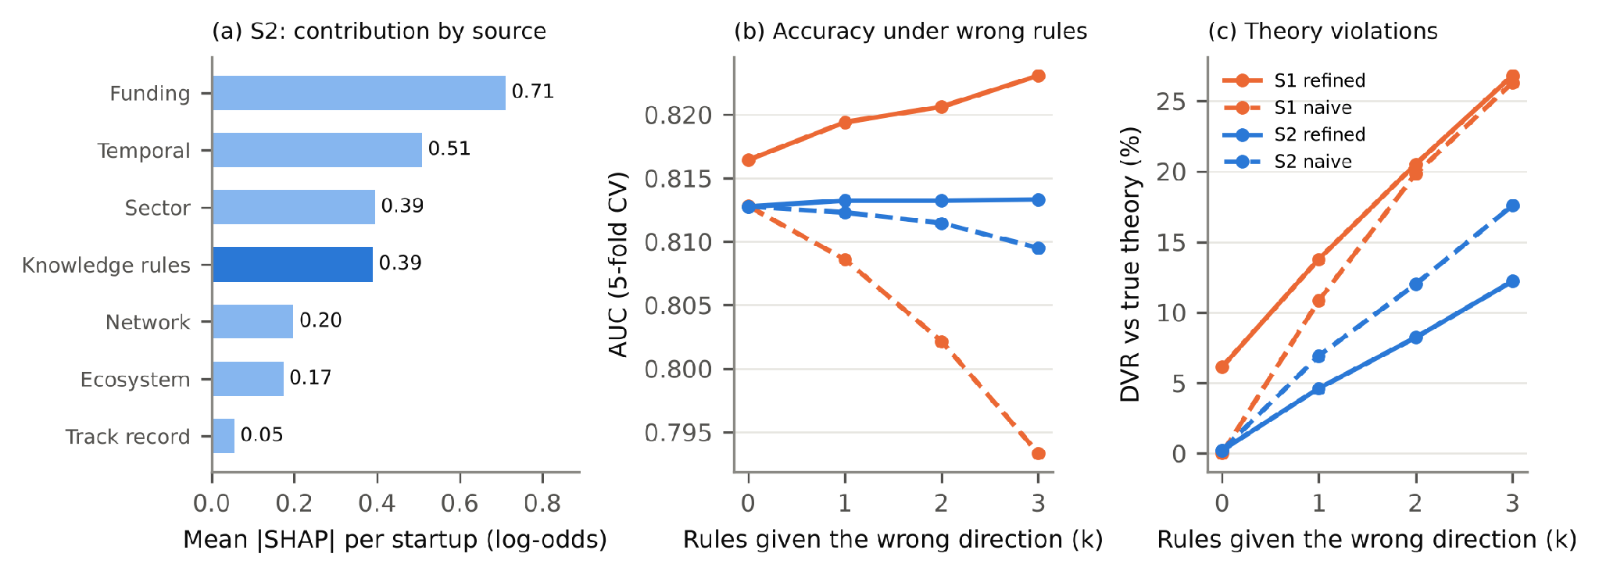
Figure 2. (a) Out-of-fold TreeSHAP contribution of each source view in Study 2. (b) AUC and (c) directional violation rate against the true theory when k confirmed rules are given the wrong direction: refined KG-XAI (solid) versus naive knowledge injection (dashed).

5. Limitations
This study has five limitations. First, Crunchbase over-represents U.S. and well-funded firms. Second, closures and IPOs are undated, so a firm that closed inside the two-year window cannot be excluded. Third, success is defined as acquisition or IPO, which leaves out firms that are still operating. Fourth, the rule thresholds were set from theory by the author, although results are stable under ±50% changes (Supplementary Table S2). Fifth, refinement checks only the direction of a rule and releases rather than repairs it.

6. Conclusion
KG-XAI shows that a small, theory-grounded knowledge base can be built into a data-driven startup predictor without losing accuracy, while making its behaviour auditable and its knowledge testable. Future work will elicit rules from investors and language models, add text sources, model exit timing and study expert-in-the-loop repair.
For knowledge-based systems, the approach turns a knowledge base from a fixed input into a testable component: each rule is validated, used, audited and, when the evidence rejects it, reported back to the expert.

Data Availability
All code, data, results, tables and figures are openly available at https://github.com/saching1302/KG-XAI-Startup-Success. Running python kgxai.py reproduces Tables 1–2, Figures 1–2, the graphical abstract and the supplementary material. Study 1 uses the public Kaggle Startup Success Prediction dataset; Study 2 uses features derived from the open Crunchbase export (CC BY-NC 4.0), rebuilt automatically from the raw tables.

Declaration of Competing Interest
The author declares that there are no known competing financial interests or personal relationships that could have appeared to influence the work reported in this manuscript.

Declaration of Generative AI and AI-Assisted Technologies
During the preparation of this work the author used Claude (Anthropic) to assist with experimental design, code development, data analysis and language editing. After using this tool, the author reviewed and edited the content as needed and takes full responsibility for the content of the manuscript. All experimental results, tables and figures were generated by executable code from the public datasets.

Funding
This research received no specific grant from any funding agency in the public, commercial, or not-for-profit sectors.

CRediT Authorship Contribution Statement
[Author Full Name]: Conceptualization, Methodology, Software, Validation, Formal analysis, Investigation, Data curation, Writing - original draft, Writing - review and editing, Visualization.

References
[1] Vial, G. (2019). Understanding digital transformation: A review and a research agenda. Journal of Strategic Information Systems, 28(2), 118–144.
[2] Verhoef, P. C., Broekhuizen, T., Bart, Y., et al. (2021). Digital transformation: A multidisciplinary reflection and research agenda. Journal of Business Research, 122, 889–901. https://doi.org/10.1016/j.jbusres.2019.09.022
[3] Obschonka, M., & Audretsch, D. B. (2020). Artificial intelligence and big data in entrepreneurship: A new era has begun. Small Business Economics, 55(3), 529–539. https://doi.org/10.1007/s11187-019-00202-4
[4] Nambisan, S. (2017). Digital entrepreneurship: Toward a digital technology perspective of entrepreneurship. Entrepreneurship Theory and Practice, 41(6), 1029–1055. https://doi.org/10.1111/etap.12254
[5] Dwivedi, Y. K., Hughes, L., Ismagilova, E., et al. (2021). Artificial intelligence (AI): Multidisciplinary perspectives on emerging challenges, opportunities, and agenda for research, practice and policy. International Journal of Information Management, 57, 101994. https://doi.org/10.1016/j.ijinfomgt.2019.08.002
[6] Gompers, P. A., Gornall, W., Kaplan, S. N., et al. (2020). How do venture capitalists make decisions? Journal of Financial Economics, 135(1), 169–190. https://doi.org/10.1016/j.jfineco.2019.06.011
[7] Arroyo, J., Corea, F., Jimenez-Diaz, G., et al. (2019). Assessment of machine learning performance for decision support in venture capital investments. IEEE Access, 7, 124233–124243.
[8] Żbikowski, K., & Antosiuk, P. (2021). A machine learning, bias-free approach for predicting business success using Crunchbase data. Information Processing & Management, 58(4), 102555. https://doi.org/10.1016/j.ipm.2021.102555
[9] Ross, G., Das, S., Sciro, D., et al. (2021). CapitalVX: A machine learning model for startup selection and exit prediction. Journal of Finance and Data Science, 7, 94–114.
[10] Kim, J., Kim, H., & Geum, Y. (2023). How to succeed in the market? Predicting startup success using a machine learning approach. Technological Forecasting and Social Change, 193, 122614. https://doi.org/10.1016/j.techfore.2023.122614
[11] Antretter, T., Blohm, I., Grichnik, D., et al. (2019). Predicting new venture survival: A Twitter-based machine learning approach to measuring online legitimacy. Journal of Business Venturing Insights, 11, e00109. https://doi.org/10.1016/j.jbvi.2018.e00109
[12] Rudin, C. (2019). Stop explaining black box machine learning models for high stakes decisions and use interpretable models instead. Nature Machine Intelligence, 1, 206–215.
[13] Barredo Arrieta, A., Díaz-Rodríguez, N., Del Ser, J., et al. (2020). Explainable artificial intelligence (XAI): Concepts, taxonomies, opportunities and challenges toward responsible AI. Information Fusion, 58, 82–115.
[14] Adadi, A., & Berrada, M. (2018). Peeking inside the black-box: A survey on explainable artificial intelligence (XAI). IEEE Access, 6, 52138–52160. https://doi.org/10.1109/ACCESS.2018.2870052
[15] Saeed, W., & Omlin, C. (2023). Explainable AI (XAI): A systematic meta-survey of current challenges and future opportunities. Knowledge-Based Systems, 263, 110273. https://doi.org/10.1016/j.knosys.2023.110273
[16] Ali, S., Abuhmed, T., El-Sappagh, S., et al. (2023). Explainable artificial intelligence (XAI): What we know and what is left to attain trustworthy artificial intelligence. Information Fusion, 99, 101805. https://doi.org/10.1016/j.inffus.2023.101805
[17] von Rueden, L., Mayer, S., Beckh, K., et al. (2023). Informed machine learning – A taxonomy and survey of integrating prior knowledge into learning systems. IEEE Transactions on Knowledge and Data Engineering, 35(1), 614–633.
[18] Karpatne, A., Atluri, G., Faghmous, J. H., et al. (2017). Theory-guided data science: A new paradigm for scientific discovery from data. IEEE Transactions on Knowledge and Data Engineering, 29(10), 2318–2331. https://doi.org/10.1109/TKDE.2017.2720168
[19] Kaufman, S., Rosset, S., Perlich, C., et al. (2012). Leakage in data mining: Formulation, detection, and avoidance. ACM Transactions on Knowledge Discovery from Data, 6(4), 15. https://doi.org/10.1145/2382577.2382579
[20] Kapoor, S., & Narayanan, A. (2023). Leakage and the reproducibility crisis in machine-learning-based science. Patterns, 4(9), 100804. https://doi.org/10.1016/j.patter.2023.100804
[21] Lundberg, S. M., & Lee, S.-I. (2017). A unified approach to interpreting model predictions. Advances in Neural Information Processing Systems, 30, 4765–4774.
[22] Lundberg, S. M., Erion, G., Chen, H., et al. (2020). From local explanations to global understanding with explainable AI for trees. Nature Machine Intelligence, 2, 56–67.
[23] Gregoriades, A., & Themistocleous, C. (2025). Improving crowdfunding decisions using explainable artificial intelligence. Sustainability, 17(4), 1361. https://doi.org/10.3390/su17041361
[24] Cano, J.-R., Gutiérrez, P. A., Krawczyk, B., et al. (2019). Monotonic classification: An overview on algorithms, performance measures and data sets. Neurocomputing, 341, 168–182. https://doi.org/10.1016/j.neucom.2019.02.024
[25] Spence, M. (1973). Job market signaling. Quarterly Journal of Economics, 87(3), 355–374.
[26] Hsu, D. H. (2004). What do entrepreneurs pay for venture capital affiliation? Journal of Finance, 59(4), 1805–1844.
[27] Gompers, P. A. (1995). Optimal investment, monitoring, and the staging of venture capital. Journal of Finance, 50(5), 1461–1489.
[28] Barney, J. (1991). Firm resources and sustained competitive advantage. Journal of Management, 17(1), 99–120.
[29] Lerner, J. (1994). The syndication of venture capital investments. Financial Management, 23(3), 16–27.
[30] Stuart, T. E., Hoang, H., & Hybels, R. C. (1999). Interorganizational endorsements and the performance of entrepreneurial ventures. Administrative Science Quarterly, 44(2), 315–349.
[31] Zimmerman, M. A., & Zeitz, G. J. (2002). Beyond survival: Achieving new venture growth by building legitimacy. Academy of Management Review, 27(3), 414–431.
[32] Delgado, M., Porter, M. E., & Stern, S. (2010). Clusters and entrepreneurship. Journal of Economic Geography, 10(4), 495–518.
[33] Stinchcombe, A. L. (1965). Social structure and organizations. In J. G. March (Ed.), Handbook of Organizations (pp. 142–193). Rand McNally.
[34] Ke, G., Meng, Q., Finley, T., et al. (2017). LightGBM: A highly efficient gradient boosting decision tree. Advances in Neural Information Processing Systems, 30, 3146–3154.
[35] Shwartz-Ziv, R., & Armon, A. (2022). Tabular data: Deep learning is not all you need. Information Fusion, 81, 84–90. https://doi.org/10.1016/j.inffus.2021.11.011
[36] KC, M. (n.d.). Startup success prediction [Data set]. Kaggle. Retrieved October 23, 2026, from https://www.kaggle.com/datasets/manishkc06/startup-success-prediction
[37] Crunchbase Inc. (2015). Crunchbase open data export, December 2015 snapshot [Data set, CC BY-NC 4.0]. Retrieved October 23, 2026, from https://github.com/notpeter/crunchbase-data
[38] Lou, Y., Caruana, R., Gehrke, J., et al. (2013). Accurate intelligible models with pairwise interactions. Proceedings of the 19th ACM SIGKDD International Conference on Knowledge Discovery and Data Mining, 623–631.
[39] Nori, H., Jenkins, S., Koch, P., et al. (2019). InterpretML: A unified framework for machine learning interpretability. arXiv:1909.09223.
[40] Lessmann, S., Baesens, B., Seow, H.-V., et al. (2015). Benchmarking state-of-the-art classification algorithms for credit scoring: An update of research. European Journal of Operational Research, 247(1), 124–136. https://doi.org/10.1016/j.ejor.2015.05.030
[41] Nadeau, C., & Bengio, Y. (2003). Inference for the generalization error. Machine Learning, 52(3), 239–281.

