Makeup Examination-July-2024

V SEMESTER DIPLOMA EXAMINATION
SCHEME OF VALUATION
CYBER SECURITY
SUB CODE : 20CS54I
Q. no |  | DESCRIPTION |  |  |  |  |  |  | Marks distribution | Total marks
SECTION I
1 | a | Defence in depth need for security + example |  |  |  |  |  |  | 8+2 | 10
1 | b | Explanation(Minimum 5 methods) |  |  |  |  |  |  | 5*2 | 10
OR
2 | a | Explanation of any 5 |  |  |  |  |  |  | 5*2 | 10
2 | b | Brief explanation of any 10 |  |  |  |  |  |  | 10*1 | 10
SECTION II
3 | a | Calculating secret key + Algorithm steps |  |  |  |  |  |  | 10+4 | 14
3 | b | Euler Totient of each |  |  |  |  |  |  | 3+3 | 6
OR
4 | a | RSA Algorithm + Finding decryption Key |  |  |  |  |  |  | 4+10 | 14
4 | b | Asymmetric cryptography + Hashing |  |  |  |  |  |  | 3+3 | 6
SECTION III
5 | a | Importance of threat modeling + Example |  |  |  |  |  |  | 5+5 | 10
5 | b | List cloud models + Explain any 3 |  |  |  |  |  |  | 1+3*3 | 10
OR
6 | a | Explanation threat modelling + Diagram |  |  |  |  |  |  | 2+8 | 10
6 | b | Diagram of SDLC + List + explain 5 stages |  |  |  |  |  |  | 4+1+5 | 10
SECTION IV
7 | a | Types + Benefits |  |  |  |  |  |  | 5+5 | 10
7 | b | In secured data storage + in secured cryptography |  |  |  |  |  |  | 5+5 | 10
OR
8 | a | Need of static code + compare any 3 |  |  |  |  |  |  | 4+2*3 | 10
8 | b | List HTTP methods + explain any 8 |  |  |  |  |  |  | 2+8 | 10
SECTION V
9 | a | Life cycle 5 stages Explanation |  |  |  |  |  |  | 5*2 | 10
9 | b | Types of hackers(any 2) + 3 Teams |  |  |  |  |  |  | 4+6 | 10
OR
10 | a | List phases + explain any 4 |  |  |  |  |  |  | 2+8 | 10
10 | b | List tools + explanation |  |  |  |  |  |  | 2+8 | 10

Makeup Examination - JULY 2024

V semester Diploma Examination
CYBER SECURITY 20CS54I
Model answers
NOTE: All model answers are general specific to subject, if any answers are relevant
please give marks.

SECTION-I

1 a.What is the need of defense in depth for a network? Illustrate with an example 10M

The concept of defense in depth is a critical aspect of network security and refers to the use of multiple layers of security measures to protect against potential threats.

• The idea is to create a series of barriers that must be overcome in order to successfully penetrate the network, making it much more difficult for an attacker to achieve their goals.
• The need for defense in depth arises because no single security measure can provide complete protection against all potential threats.
• By implementing multiple layers of security, an organization can reduce the risk of a successful attack and minimize the damage that might occur in the event of a breach.

Some of the benefits of defense in depth include:

Redundancy: By using multiple layers of security, an organization can ensure that even if one Layer is bypassed, there are still other layers in place to prevent a breach.

Improved security: Each layer of security provides an additional barrier that must be Overcome by an attacker, making it more difficult to penetrate the network.

Increased resilience: Defense in depth provides an organization with the ability to with stand Multiple types of attacks and to continue to operate even if one layer of security is Compromised.

Better risk management: By implementing multiple layers of security, an organization can better manage risk and ensure that it is prepared to respond to potential security threats.
Examples include
Antivirus software, firewalls, intrusion detection systems, multifactor authentication, data encryption and incident response

1b.From the perspective of a hacker, mention the methods of infiltration rules to be applied to capture the confidential information. 10M

Cybercriminals are constantly finding new and innovative ways to infiltrate company networks and steal sensitive data.

Social engineering: Social engineering refers to the manipulation of individuals to steal sensitive information or perform actions that compromise a company's security.

Pretexting. This is when an attacker calls an individual and lies to them in an attempt to gain access to privileged data. For example, pretending to need a person ‘s personal or financial data in order to confirm their identity.
Tailgating This is when an attacker quickly follows an authorized person into a secure, physical location. Where an attacker follows an unaware user to gain access to an area without authorization.
Denial-of-Service Denial-of-Service (DoS) attacks are a type of network attack that is relatively simple to carry out, even by an unskilled attacker. A DoS attack results in some sort of interruption of network service to users, devices or applications.
Distributed DoSA Distributed DoS (DDoS) attack is similar to a DoS attack but originates from multiple, coordinated sources
Man in The Middle: A MitM attack happens when a cybercriminal takes control of a device without the user‘s knowledge. With this level of access, an attacker can intercept and capture user information before it is sent to its intended destination. These types of attacks are often used to steal financial information. There are many types of malware that possess MitM attack capabilities.
Password attacks: Weak passwords are a common vulnerability exploited by hackers.
Entering a username and password is one of the most popular forms of authenticating to a web site. Therefore, uncovering your password is an easy way for cybercriminals to gain access to your most valuable information. Some of the common password security attacks:

Password Spraying: This technique attempts to gain access to a system by spraying‘ a few commonly used passwords across a large number of accounts.
Dictionary Attacks: A hacker systematically tries every word in a dictionary or a list of commonly used words as a password in an attempt to break into a passwordprotected account.
Brute Force Attacks: The simplest and most commonly used way of gaining access to a password-protected site, brute-force attacks see an attacker using all possible combinations of letters, numbers and symbols in the password space until they get it right.
Software vulnerabilities: Hackers can exploit vulnerabilities in software and applications to gain unauthorized access to a system or to install malware.
Physical attacks: Physical attacks refer to the hacking of company systems through physical means like stealing a laptop or connecting to a network port
Phishing attacks: Phishing attacks are a common tactic used by hackers to gain access to an organization's network. They usually send emails or messages that appear to come from a trusted source, like a bank, to trick employees into revealing sensitive information.
OR
2 a. How do you provide two step verification for your login account, considering the vulnerabilities present in web applications? 10M

Multi Factor Authentication:
Multi-factor Authentication (MFA) is an authentication method that requires the user to provide two or more verification factors to gain access to a resource such as an application, online account, or a VPN.

MFA is a core component of a strong identity and access management (IAM) policy.
Rather than just asking for a username and password, MFA requires one or more additional verification factors, which decreases the likelihood of a successful cyber attack.

Three Main Types of MFA Authentication Methods
Most MFA authentication methodology is based on one of three types of additional information:
- Things you know (knowledge), such as a password or PIN
- Things you have (possession), such as a badge or smart phone
- Things you are (inherence), such as a biometric like fingerprints or voice recognition.

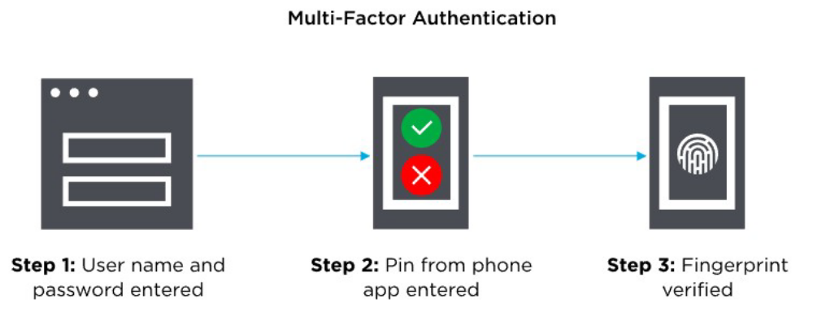

2b. You are creating a new password for your online banking, how will you strengthen your password elaborate. 10M
Passwords are a set of strings provided by users at the authentication prompts of web accounts. Although passwords still remain as one of the most secure methods of authentication available to date, they are subjected to a number of security threats when mishandled. The role of password management comes in handy there.
Password management is a set of principles and best practices to be followed by users while storing and managing passwords in an efficient manner to secure passwords as much as they can to prevent unauthorized access.
Traditional methods of password management
• Writing down passwords on sticky notes, post-its, etc.
• Sharing them via spreadsheets, email, telephone, etc.
• Using simple and easy to guess passwords
• Reusing them for all web applications
• Often forgetting passwords and seeking the help of 'Forgot Password' option
While hackers are equipped with advanced tools and attacks, it is important to manage passwords
• Use strong and unique passwords for all websites and applications
• Reset passwords at regular intervals
• Configure two-factor authentication for all accounts
• Securely share passwords with friends, family, and colleagues
• Store all enterprise passwords in one place and enforce secure password policies within the business environment
• Periodically review the violations and take necessary actions.

SECTION-II

3a. Let p=23 and q=5 Alice picks x=4 and Bob picks y=3, Compute the shared secret between Alice and Bob using Diffie-Hellman key exchange protocol. 14M

Formulas used in Diffie-Hellman key exchange protocol:
1. Key = (YA)XBmod p -> this is the same as calculated by B
2. Global Public Elements
p: p is a prime number. here in our example p=23
α: α < pand α is the primitive root of p. here in our example α =5
3. Key generation for user A
● Select a Private key XA Here, XA <p
Now, Calculation of Public key YA YA = aXA mod p
4. Key generation for user B
● Select a Private key XB Here, XB <q
● Now, Calculation of Public key YB YB = aXb mod q
5. Calculation of Secret Key by A
● key =(YB)XA mod p
6. Calculation of Secret Key by B
● key =(YA)XB mod p

Example
1. Alice and Bob both use public numbers P = 23, q = 5
2. Alice selected private key a = 4, and Bob selected b = 3 as the private key
3. Both Alice and bob now calculate the value of x and y as follows:
● Alice: x = (54 mod 23) = 4
● Bob: y = (53 mod 23) = 10
4. Now, both Alice and Bob exchange public numbers with each other.
5. Alice and Bob now calculate the symmetric keys
● Alice: ka = ya mod p = 104 mod 23 = 18
● Bob: kb = xb mod p = 43 mod 23 = 18
18 is the shared secret key.

3b. Find Euler totient function : φ(255),φ(256) 6M

φ(255)
255=5*3*17
Here p1=5, p2=3, p3=17
φ(255)=φ(255)*((1-1)/p1) ((1-1)/p2) ((1-1)/p3))
φ(255)=255*(((1-1)/5) ((1-1)/3) ((1-1)/17) )
=255*((4/5)*(2/3)*(16/17))
=128
φ(256)
256=28
Here p1=2
φ(256)=φ(256)*((1-1)/p1))
φ(256)=256*(((1-1)/2))
=256*(1/2)
=128
OR

4a. List the steps in RSA algorithm. Given an implementation of RSA algorithm
that uses primes p=17, q=11, encryption key e=7. What is the decryption key(d). 14M

Steps of RSA algorithm
1. Select two prime numbers p and q
2. Calculate n=p*q
3. Calculate φ(n)=(p-1)(q-1)
4. Select e such that GCD(φ(n),e))=1
5. Select d such that d * e mod φ(n) = 1
6. Public key Pu={e,n} anf private key Pr ={d, n}
7. Encryption: C= pow(M,e) mod n
8. Decryption: M=pow(C,d) mod n

Solution to the problem
1. Given p=17 and q=11
2. Calculate n=p*q,
n=17*11=187
3. Calculate φ(n)=(p-1)(q-1)
φ(n)=(17-1)(11-1)
φ(n)=16*10
φ(n)=160
4. Encryption key e=7
5. Find d, such that d*e mod n(φ)=1
Substitute the value k till get whole number for d from k=1,2,3…….etc
d=((φ(n)*k)+1)/e at k=1 we got whole number
d=((192*1)+1)/7
d=23
6. Hence the decryption key(d) is=23.

4b. In relation with cryptography explain the following 6M
- Asymmetric cryptography
- Hashing
Digital signatures rely on asymmetric cryptography, also known as public key cryptography. An asymmetric key consists of a public/private key pair.The private key is used to create a signature, and the corresponding public key is used to verify the signature.
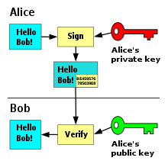

Hashing

Verifies the integrity of data: Hashing is used to check if data has been tampered with or not. A hash function produces a unique output for a specific input, so if even a single character in the input is changed, the hash value will also be different.
• Ensures secure password storage: Hashing is used to store passwords securely. Instead of storing the actual password, the hash value of the password is stored, which makes it more secure.
•Efficient data comparison: Hashing is used to compare data efficiently. Two inputs can be compared by comparing their hash values, which is much faster than comparing the entire inputs.
SECTION III

5a. Assuming you are working as software security professional for a company as
designer define threat modeling. Why do you consider it as important? llustrate with an example. 10M
Threat modeling is the process of identifying, analyzing and prioritizing potential threats and vulnerabilities in a system, application, or organization, in order to improve its security. Its importance is as follows
•Detect problems early in the software development life cycle (SDLC) even before coding begins
•Spot design flaws that traditional testing methods and code reviews can overlook
•Evaluate new forms of attack that you might not otherwise consider
•Maximize testing budgets by helping target testing and code review
•Identify security requirements

•Remediate problems before software release and prevent costly recoding after deployment
•Think about threats beyond standard attacks to the security issues unique to your application

EXAMPLE
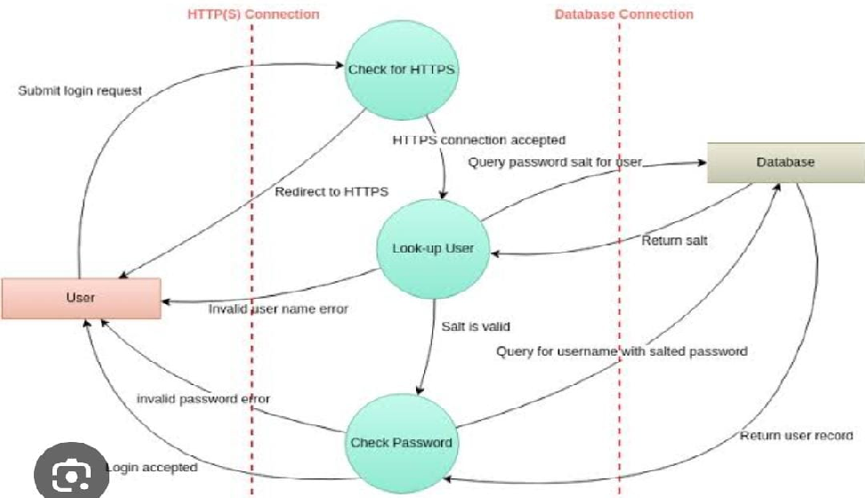

5 b. Explain various cloud service models 10M
Software as a Service (SaaS) : Also known as a 'Software on Demand' and the most common option for private users. SaaS is hosted by the vendor or service provider where applications are made available to users over the internet. Traditionally, software applications are bought upfront before installing on the computer. With SaaS, instead of purchasing the software, users can subscribe and pay monthly via the internet.If you are a small company that requires collaboration between teams and needs applications that is accessible via web and mobile, SaaS might be a good option for you. This is also recommended for businesses who don't want to get involved with servers or hardware issues.
Examples of Saas :
Google Workspace (formerly Suite) , Drop box, Salesforces , Cisco WebEx
Infrastructure as a Service (laS) The most common type of Cloud service where users can rent their entire IT Infrastructure from a service provider and pay corresponding to their use. This includes servers, storage, networks, and operating systems. Some reasons that small businesses or firms prefer laas are that it is faster, easier, and cost-efficient lessening the responsibility of the organizations to maintain their infrastructure. This service model is recommended for businesses that require increased security and need control over the infrastructure. Popular examples of laaS include:
* DigitalOcean, Linode, Rackspace, Amazon Web Services (AWS), Cisco Metacloud, Microsoft Azure, Google Compute Engine (GCE)
Platform as a Service (PaaS)
This service provides a facility for users to publish and customize software applications in a hosted environment. PaaS allows developers to create applications faster without the need to configure the infrastructure. The service provider has its hardware and software freeing the user from installing it to implement a new application. One benefit of PaaS is its lower cost and the user only pays for essential things. If your business is planning to create a customized app and multiple developers are working on the same project, PaaS is a good option.
Functions as a Service (FaaS)
Before we understand Functions as a Service, it is important to understand the most popular tech term associated with Faas - serverless computing. Serverless computing is a cloud computing model that takes away low-level infrastructure decisions and server management from the developers. The application architect need not deal with the allocation of resources as it is managed by the cloud service provider.
FaaS is a brand-new and very young cloud computing service acting as a game-changer for many businesses. It is a serverless computing concept that lets software developers develop applications and deploy an individual "function", piece of business logic, or an action without their infrastructure. Examples include Microsoft azure function, webtask.io, open whisk, AWS Lambda

OR
6a. Create a threat model for secure online banking application. 10M
A systematic process designed to identify and evaluate the potential threats and vulnerabilities within the system using threat model.
It is a tool that enables engineers to understand and predict possible attack factors and enhance security measures.
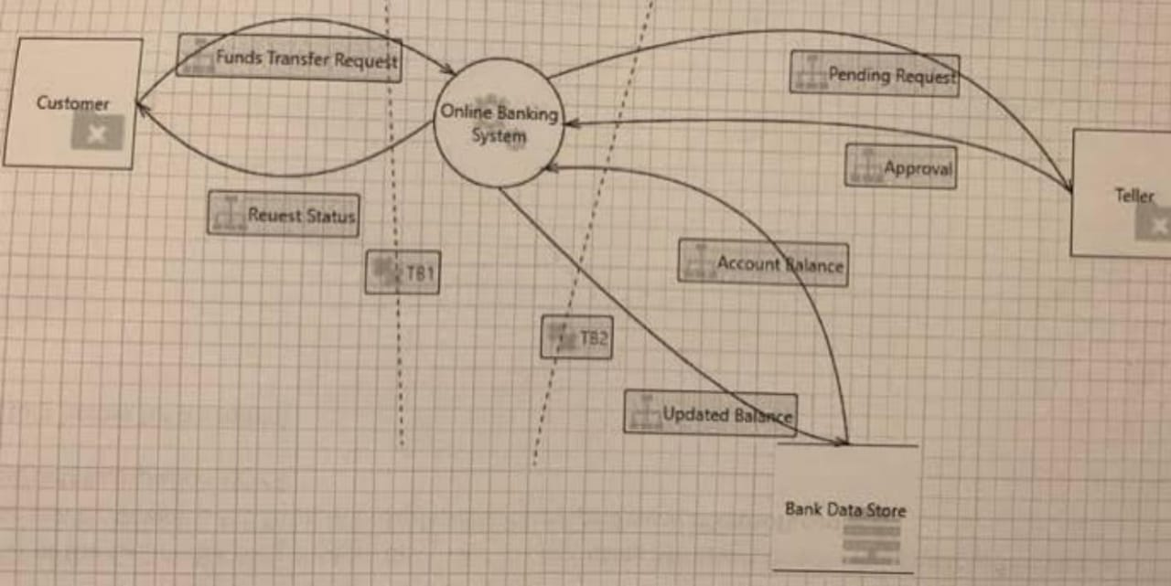

6b. Explain the Software Development Life Cycle. (SDLC) with neat diagram 10M
SDLC is the acronym for software development life cycle. It is also called the software development process. All the tasks required for developing and maintaining software. It consists of a plan describing how to develop, maintain, replace and alter the specific software. It is a process for planning, creating, testing, and information system. It is a framework of describes the activity performed at each stage of software development. It is a process used by a system analyst to develop an information system including requirements, validation, training, and ownership
. 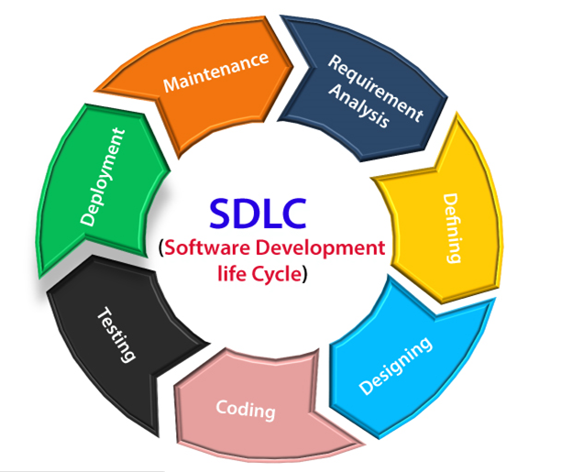
Stage-1: Requirement gathering
The feasibility report is positive towards the project and next phase start with gathering requirement from the user. Engineer communicates with the client and end-users to know their Idea and which features they want to software to include.
Stage-2: Software design
It is a process to transform user requirements into a suitable form. It helps programmers in software coding. There is a need for more specific and detailed requirements in software. The output of the process can directly be used in implementation in a programming language. There are three design levels as follows.
- Architectural design
It is the highest abstract version of the system. In a software system, many components interact with each other.
- High-level design
It focuses on how the system along with all its components and its can be implemented in form of modules.
- Detailed design
It defines the logical structure of each module and its interface to communicate with each module.
Stage-3: Developing Product
In this phase of SDLC, you will see how the product will be developed. It is one of the crucial parts of SDLC, It is also called the Implementation phase.
Stage-4: Product Testing and Integration
In this phase, we will integrate the modules and will test the overall product by using different testing techniques.
Stage-5 Deployment maintenance
Linux hardening refers to the process of securing a Linux operating system and reducing its potential attack surface. This is achieved by implementing various security measures, such as updating and patching the system, configuring secure permissions and users, disabling unnecessary services, using firewalls and intrusion detection systems, and more. The goal of Linux hardening is to minimize the risk of unauthorized access, theft of data, or other security.
In this phase, the actual deployment of the product, or you can say the final product will be deployed, and also we will do maintenance of product for any future update and release of new features.
SECTION IV
7a. Explain types and benefits of penetration testing. 10M
Types of penetration testing:
• Internal network penetration testing
An internal network pen test is used to determine what an attacker could do with initial
Network access. Insider threats, such as personnel acting maliciously, whether purposefully or
Accidentally, can be mirrored by an internal network pen test.
External network penetration testing
An external network pen test is used to evaluate the efficiency of perimeter security policies
In preventing and detecting attacks, as well as to find flaws in internet-facing assets like web,
Mail, and FTP servers.
Online application penetration testing
This testing entails a set of processes aimed at acquiring information about the target system, Identifying flawsor vulnerabilities, and researching exploits that will attack such flaws or
Mobile app penetration testing
This testing identifies flaws in a mobile application’s cyber security posture. The safety and
Security of iOS and Android applications are the ones that get the most assessed.
Penetration testing for mobile applications helps protect apps and reduces the chance of
Fraud, virus or malware infections, data leaks, and other security breaches.
API Penetration Testing.
APIs have ushered ina new digital transformation era in the cloud, loT, and mobile and web Apps. Every day, the average individual interacts with many APIs without even realizing it, Especially on mobile. APIs are the connective tissue that allows data to flow from one system toanother, both internally and externally.
Cloud Penetration testing
An authorized simulated cyber-attack against a system housed on a Cloud provider, such as Amazon’s AWS or Microsoft’s Azure, is known as Cloud Penetration Testing. A cloud Penetration test’s primary purpose is to identify a system’s flaws and strengths so that its Security posture may be appropriately appraised.
Benefits of Penetration testing
- Reveal vulnerabilities
- Show real risks
- Test your cyber-defence capability
- Ensure business continuity
- Have a third party expert opinion
- Maintain trust
7 b.Assuming the following scenarios explain how mobile security exploitation occurs in
I. Insecure data storage 5+5=10M
II Insecure cryptographic implementations
Mobile Device Security refers to the measures designed to protect sensitive information stored on and transmitted by laptops, Smartphone, tablets, wearable, and other portal devices. At the root of Mobile device Security is the goal of keeping unauthorized users from accessing the enterprise network.
Insecure Data storage: Insecure Data Storage vulnerabilities occur when develop teams assume that users or malware will not have access to a mobile device's file system and subsequent sensitive information in data-stores on the device.
Following are some measures to protect our Data Storage:
1. Encrypt Data: Secure Data Storage and Password-Protected Files
2. Check Cloud for Security Features
3. Account Authentication
4. Develop Better Policies for Secure Data Storage
5. Backups and Updates Are Key for Secure Data Storage
Insecure cryptographic implementation: Insecure Cryptographic Storage is a common vulnerability that occurs when sensitive data is not stored securely. Insecure Cryptographic Storage isn't a single vulnerability, but a collection of vulnerabilities.
Important data is encrypted when it needs to be. This includes:
Making sure you are encrypting the correct data.
Making sure you have proper key Storage and management
Making sure thät you are not using known bad algorithms.
OR
8. a. What is the need for static code analysis? Compare static code analysis with dynamic code analysis 10M

Need for static code analysis
- It can evaluate all the code in an application, increasing code quality.
- It provides speed in using automated tools compared to manual code review
- Paired with normal testing methods, static testing allows for more depth into debugging code.
- Automated tools are less prone to human error.
- It will increase the likelihood of finding vulnerabilities in the code, increasing web or application security.
- It can be done in an offline development environment.

Static Code Analysis | Dynamic Code Analysis
Whitebox security testing  The tester has access to the underlying framework,design,and implementation.The application is tested from the inside out. This type of testing representsthedeveloper approach. | Black box security testing  The tester has no knowledge of the technologies orframeworks that the application is built on. Theapplication is tested from the outside in. This type oftestingrepresentsthe hackerapproach.
Requires source code  SASTdoesn’trequireadeployedapplication.Itanalyzes the sources code or binary withoutexecutingthe application. | Requires a running application  DASTdoesn’trequiresourcecodeorbinaries.Itanalyzesbyexecutingthe application.
FindsvulnerabilitiesearlierintheSDLC  Thescan can beexecutedassoonas codeisdeemedfeature-complete. | Finds vulnerabilities toward the end of the SDLCVulnerabilities can be discovered after thedevelopment cycleiscomplete.
Less expensive to fix vulnerabilities  Since vulnerabilities are found earlier in the SDLC,it’s easier and faster to remediate them. | More expensive to fix vulnerabilities  SincevulnerabilitiesarefoundtowardtheendoftheSDLC, remediation often gets pushed into the nextcycle. Critical vulnerabilities may be fixed as an emergency release.
Can’t discover run-time and environment-relatedissues  Since the tool scans static code, it can’t discover run-time vulnerabilities. | Can discover run-time and environment-relatedissues  Since the tool uses dynamic analysis on an application,it is able to find run-time vulnerabilities.
Typically supports all kinds of software Examples include web applications, web services,and thick clients. | Typically scans only apps like web applicationsandwebservices  DAST is not useful for other types of software.

OR
8 b. List and explain HTTP methods. 10M

HTTP methods: The HTTP method indicates what action to be performed by the Server. These method names are case sensitive and they must be used in uppercase.
The various HTTP methods on:

• GET Method
• HEAD Method
• POST Method
• PUT Method
• DELETE Method
• CONNECT Method
• OPTION Method
•TRACE Method

GET Method:
A GET request retrieves data from a web server by specifying parameters in the URL portion of the request. This is the main method used for document retrieval.

HEAD Method:
TheHEADmethodisfunctionallysimilartoGET,exceptthattheserverreplieswithare status line and Header section only.
POST Method:
The POST method is used when you want to send some data to the server, for example, file update, form data, etc using HTML forms.
PUT Method:
The PUT method is used to request the server to store the included entity-body at a location specified by the given URL.
DELETE Method:
The DELETE method is used to request the server to delete a file at a location specified by the given URL.
CONNECT Method:
The CONNECT method is used by the client to establish a network connection to a web server over HTTP.
OPTIONS Method:
The OPTIONS method is used by the client to find out the HTTP methods and other options supported by a web server. The client can specify a URL for the OPTIONS method, or an asterisk (*) to refer to theentire server.
TRACE Method:
The TRACE method is used to echo the contents of an HTTP Request back to the requester which can be used for debugging purpose at the time of development.

SECTION V
9 a. Illustrate the life cycle of security incident management.
Incident management is a process that describes the necessary actions taken by an organization to analyze, identify, and correct problems while taking actions that can prevent future incidents. The 5 stages or steps to be followed in an incident management lifecycle:

1. Incident identification & logging
2. Incident categorization
3. Incident prioritization
4. Incident response
5. Incident resolution and closure

1. Incident identification
Once identified as an incident, the service desk logs the incident as a ticket. The ticket should include information, such as the user’s name and contact information, the incident description, and the date and time of the incident report (for SLA adherence). Sources of incident reporting include walk-ups, self-service, phone calls, emails, support chats, and automated notices.

2. Incident categorization
Incidents can be categorized and sub-categorized based on the area of IT or business that the incident causes a disruption in like network, hardware etc.

3. Incident prioritization
The priority of an incident can be determined as a function of its impact and urgency using a priority matrix.
The urgency of an incident indicates the time within which the incident should be resolved.
a) Critical b) High c) Medium d) Low
4. Incident response
Once the incident has been identified, categorised and prioritised, it can then be assigned to the right person, also known as the incident owner, who typically has to respond to the issue.

5. Incident resolution and closure
An incident is considered resolved when the technician has come up with a temporary workaround or a permanent solution for the issue. An incident can be closed once the issue is resolved and the user acknowledges the resolution and is satisfied with it.
.
9 b. Explain the different kinds of hackers? what do you mean by blue ,red and purple teams 10M
A Hacker is a person who is intensely interested in the mysterious workings of any computer operating system. Hackers are most often programmers.
The Three Main Types of Hackers
White Hat Hackers
White hat hackers are the one who is authorized or certified hackers who work for the government and organizations by performing penetration testing and identifying loopholes in their cyber security. They also ensure the protection from the malicious cyber crimes. They work under the rules and regulations provided by the government, that’s why they are called Ethical hackers or Cyber security experts.
Black Hat Hackers
They are often called Crackers. Black Hat Hackers can gain unauthorized access to your system and destroy your vital data. The method of attack they use common hacking practices they have learned earlier. They are considered to be criminals and can be easily identified because of their malicious actions.
Gray Hat Hackers
Gray hat hackers fall somewhere in the category between white hat and black hat hackers. They are not legally authorized hackers. They work with both good and bad intentions, they can use their skills for personal gain. It all depends upon the hacker. If a gray hat hacker uses his skill for his personal gains, he/she is considered as black hat hackers.
Red Team
A red team is “a collection of personnel authorized and organized to simulate a prospective adversary’s attack or exploitation capabilities against an enterprise’s security posture,” according to the National Institute of Standards and Technology (NIST). To find weaknesses in a system, the red team assumes the role of the attacker or rival.
Blue Team
“The group responsible for protecting an enterprise’s usage of information systems by maintaining its security posture against a set of mock attackers,” according to NIST, is what a blue team is. When an organization’s essential assets are being protected, the blue team is playing defense while the red team is on offense.
Purple Team
Purple teaming is used in a controlled environment to simulate real-world cyberattacks and security problems, hence improving an organization’s security. Penetration testing in cyber security is a colorful experience. A purple team falls somewhere in the middle, often filling both roles. Purple teams can also be inserted into red/blue testing engagements to help assess the testing process and ensure that red and blue teams communicate and coordinate effectively.
OR

10 a. Discuss phases of Devops with a diagram and illustrate how security is integrated in it. 10M
DevOps security (DevSecOps) is an approach to cybersecurity that focuses on application development and development operations(DevOps).It combines three phrases:
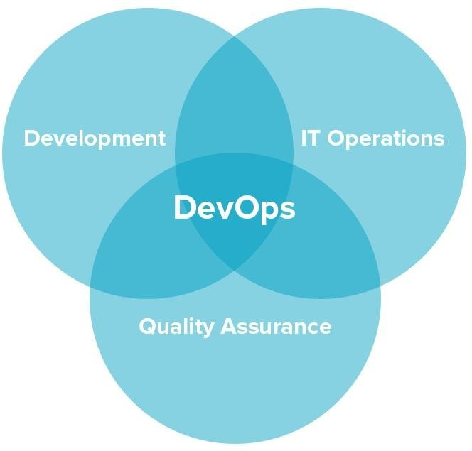
  - Development2.Operations 3.Security
The goal of DevOps security isto remove barriers between an organization’s software development andits IT operations. Namely, it calls for speed and intense, fast communication and collaboration.
The goal of DevOps security is to remove barriers between an organization’s software development and its IT operations. Namely, it calls for speed and intense, fast communication and collaboration.
Core of the DevOps security philosophy is continuous deployment. Development and IT teams work closely and rapidly to add to and fix software. This means ,for example, adding new features and troubleshooting bugs so that they can be continuously released in fast cycles without causing disruptions. Security is integrated in DevOps as follows,
• Configuration management: ensuring the consistency and security of configurations across multiple environments, from development to production.
• Continuous Integration and Continuous Deployment (CI/CD): securing the pipeline and ensuring that only authorized changes are deployed to production.
• Infrastructure as Code (IaC): managing the security of infrastructure components defined as code, such as cloud resources or containerized applications.
• Container security: securing the lifecycle of containers, from build to deployment and runtime.
• Secrets management: securely storing and managing sensitive information, such as passwords and access keys, in the DevOps environment.
• Compliance: ensuring that DevOps practices align with regulations and industry standards, such as those related to data privacy and security.
10 b. List incident management tools and their features
Some of the most common incident management tools are
- Monitoring tools
- Service desks
- AIOps platform
- Vdocumentation

Monitoring tools: Help identify outages, trigger alerts, and diagnose incidents. Monitoring tools also reduce costs by freeing DevOps teams to better manage the software lifecycle.
Service desks: A place for users to submit tickets, chat with the service desk team, monitor progress of their tickets and perform some self-service tasks. Typically, the service desk is run through a management system that enables key incident management tasks, such as prioritization and categorization.
AlOps platforms: Using logs and historic data, AIOps can provide context for better decision-making, smarter resource allocation and faster incident response. Companies that use AIOps for incident management have reported reducing IT costs and MTTR by 50%.
V Documentation: Scripts that automatically document changes to an environment, making it easy to record incidents for post mortem analysis. For example, teams can set up the PowerCLI scripts to run on a monthly schedule to record incidents for deeper analysis.

CERTIFICATE
This is to certify that all the model answers prepared by me for subject CYBER SECURITY (20CS54I ) are as per the syllabus.

SHAHEEN BANU
SENIOR LECTURER
COMPUTER SCIENCE AND ENGINEERING
GOVERNMENT POLYTECHNIC
HARIHARA-170

