NAME: SACHIN HANSDA
ROLL NO.: 111601019

DBMS LAB
MID-SEM

QUESTION PAPER SET B

Q1:
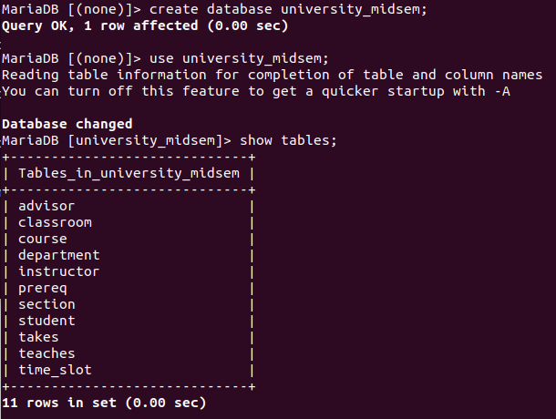

.

Q2:
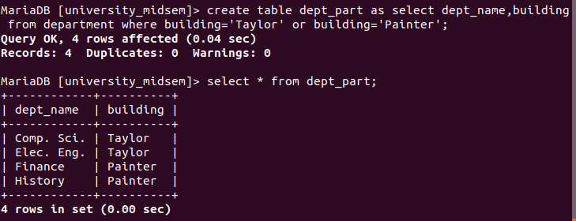

Q3:

SQL Code:

drop trigger if exists bdg_const;
DELIMITER $$
create trigger bdg_const
after update on dept_part
for each row
begin
declare cnt int;
select count(*) into cnt from department where building=new.building;
if cnt = 0 then
signal sqlstate'45000'
set message_text='insertion failed due to invalid entry for building';
else
update department
set building=new.building
where dept_name=new.dept_name;
end if;
end;$$
DELIMITER ;

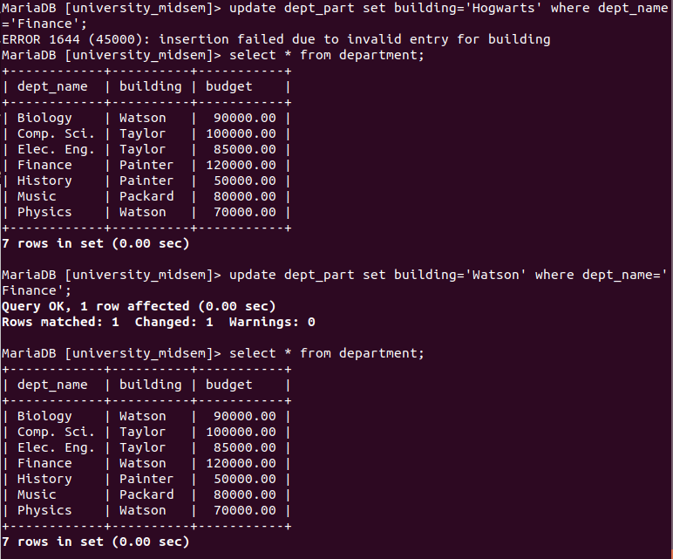

Q4:
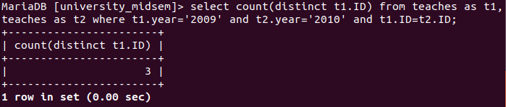

Q5:
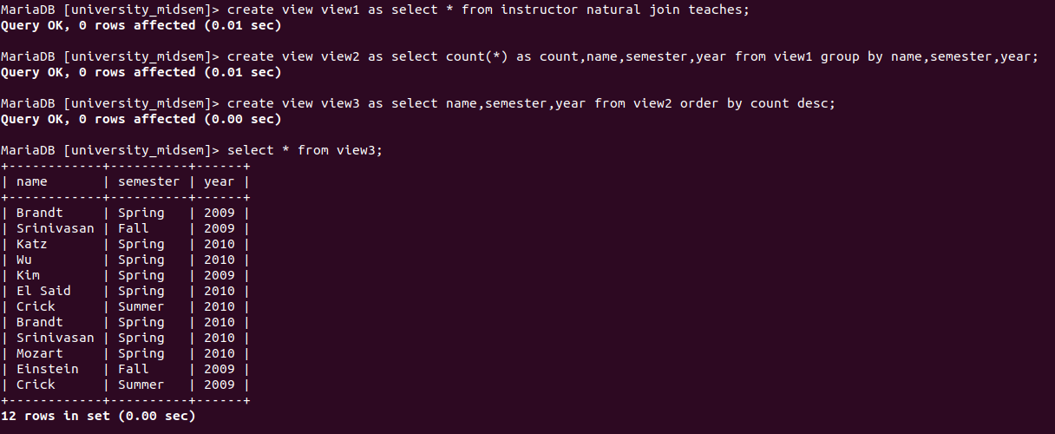

Q6.a:
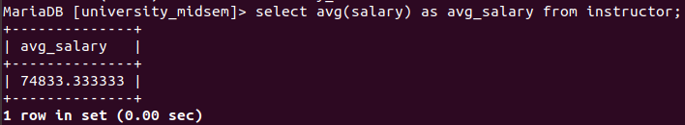

Q6.b:
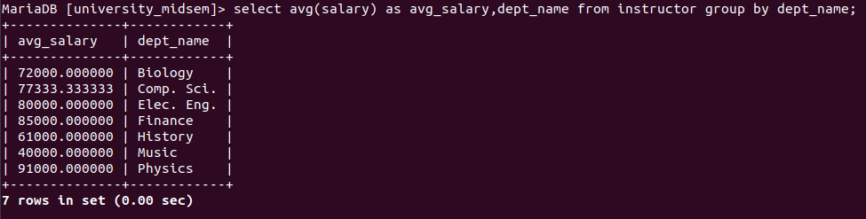

Q6.c:
