

Sri Lanka Institute of Information Technology

OZONE GYM MANAGEMENT SYSTEM

Project Proposal

Information Technology Project (IT2080)

2020

ITP-2020-S2-MATARA-04

Submitted by:

1. IT19101620 – Salika Madhushanka W.J
2. IT19049496 – Deshistha Thilindra H.B
3. IT19055954 – Sandun Harshana S.G
4. IT19101248 – Sachini Sumeera A.L.G
5. IT19151298 – Seliya Mindula K
6. IT19046808 – G Janira Jayaprabha
7. IT19129136 – S.Y.S Pallawala
8. IT19062570 – Kavindu Maduhansa G.L

Submitted to:

Chamari De Silva

……………………

(Supervisor’s signature)

24 July 2020

**Table of Contents Page No.**

1. Introduction
   1. Client Background 3
   2. Problems Faced by Client and Corresponding Solutions 3-5
2. Benefits of the system 6
3. System Overview Diagram 7
4. System Functionalities
   1. Customer Management 8
   2. Employee Management 8 - 9
   3. Schedule Management 9

4.4 Payment Management…………………………………………………………... 10

4.5 Diet Plan Management…………………………………………………….......... 10

4.6 Online Shopping Store Management 11

4.7 Additional Expenses & Booking Management ……………………................... 11

4.8 Stock Control Management 11

1. Tools and Technologies 12
2. Gantt Chart… 12
3. Task Distribution 13

# INTRODUCTION

## 

## Client Background

Ozone Gym fitness is located in Matara which was established in the year 2014. They currently have 723 registered members at their gym, out of which roughly 40% are active members. Ozone Gym has a variety of workout schedules sub-divided in few categories based on different requirements for each schedule they have a trainer in charge. All the trainers who are employed at Ozone Gym are part time workers and currently they have 8 professional trainers working with them.

Ozone Gym is equipped with highly sophisticated equipment and they hold an items count of 450 which includes weights, benches, dumbbells, kettlebells, gym balls and fitness equipment and etc.

* 1. **PROBLEMS & SOLUTIONS**

**1. Handling customers and trainers**

**Problem**

Ozone gym has handwritten documents on members and employee’s information. All the member payments and employee salaries are documented in books. As a result, there were several instances where they had misunderstandings between employees and members. In addition, they have misplaced some of the past records. Handling information of customers and employees are the most challenging task that Ozone gym facing.

**Solution**

Employee management will help to store all employee and member information and retrieve them whenever needed. As a result, Ozone gym will be able to manage the gym efficiently and more effectively. This also improve the member’s experience more favorable and it improves the management of the gym.

**2. Marketing the Business**

**Problem**

The client uses posters and leaflets on their marketing and promotion purposes. Currently, gym spending money from their profit on making these posters and leaflets.

**Solution**

The online gym site will make it easy to customer and the client in marketing. So, the client does not need to waste their money on designing and printing posters and leaflets regularly. The online web application has the all the capabilities on displaying and describe the facilities and the services of the gym. In the customer point of view, they will also have a better idea on the gym, and it is easy to check the services and facilities of the gym rather by visiting it.

**3. Diet Plans for Customers**

**Problem**

Most of thecurrent members do not follow a diet plan. Although the customers asked for diet plans for their workout plans. But the trainers suggest random diet plan suggestions which members did not like.

**Solution**

Depending on the members Body Mass Index (BMI) our diet plan management will suggest number of diet plans. If the members do not like the suggested diet plan by the system, they have the freedom to select their own dietary plan.

**4. SCHEDULES**

**Problem**

Current members of the Ozone gym do not have a way to track their progress in their workout sessions and schedules. Mostly the new members are the victims of it.

**Solution**

Schedule management in our system helps the members to keep track on their process and their schedules. There are several schedules based on the gender of the member and several types of work out plans to select on.

1. **STOCK CONTROL MANAGEMENT**

**Problem**

Purchase of store equipment, products and their payments are manually recorded, they are not maintained properly, client request a solution to check the overall monthly stock. And also they have had some incidents where their equipment such as dumbbells and bars were stolen/ misplaced. So they did not realize it for a long time and were too late when the realized it.

**Solution**

Online stock manages the availability of products and equipment. And also it handles the payments and keep records of each transaction and update stocks when products and equipment are out of stock.

1. **Booking a personal trainer**

**Problem**

Though the members request a personal trainer booking, currently there is not any method for the members to book a specific trainer for their work out plan.

**Solution**

By introducing booking management, the members could book a specific trainer for their workout plans and schedules. They can book a trainer for a period of time in a specific day.

1. **Payment**

**Problem**

The payments done by customers are handled by manually and they did not have proper knowledge about payment packages. They didn’t have a proper way to inform due to customer.

**Solution**

In the payment management, it provides proper payment packages and way to notify due to the customer. If a customer didn’t pay, there is way to block the access of a customer to the system.

1. **BENEFITS OF THE SYSTEM**

Our Online gym store system has numerous benefits for OZONE gym center. In expansion to the arrangements given to the issues the gym center has key benefits when considering the gym center as an entire. The foremost critical advantage is that the administrator has less work and the gym center can be kept up and controlled more proficiently.

In addition, less data surplus and easier to do every task, cost saving, data can be easily updated and retrieved, payment details can be entered, member data can be stored securely, exercise equipment can be easily obtained using the online store.

Furthermore, the system maintains a proper record of all aspects of the organization and enables the generation of reports. This allows them to review their performance, identify opportunities for improvement, and deliver better performance results in terms of standards and profitability.

1. **SYSTEM OVERVIEW**

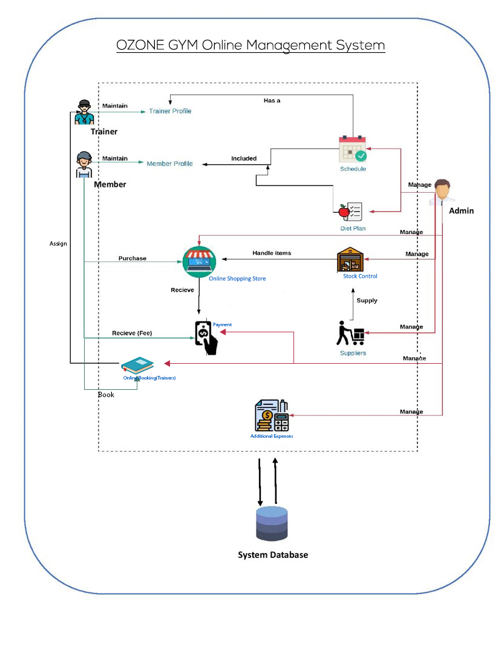

1. **FUNCTIONALITIES**

There are 8 main functions in the system. The functionalities can be access by 3 different personas to operate. Administrator, Trainers and customers are those 3 personas that could handle the functionalities. There can be one or two personals that assign to a function.

* 1. **CUSTOMER MANAGEMENT SYSTEM**

**Customer Side**

A customer can easily signup to the system and make an account by entering the required details. But only administration could activate the account. So, a customer must pay a payment to the gym in order to be activate the account and become a member.

When the member logins to their account, they will be able to view their personal information and the options that provide as mention in below.

* Attendance marking
* Current schedule viewing
* Update personal information in the profile

For a new member the system assign “Beginner’s schedule”, as the attendance mark by the member the schedule will be increase day by day. After finishing a certain schedule, a member could continue the same schedule, or the system will assign a new schedule.

**Administrator Side**

Add a customer account to the system, update members account and delete members account are the authorized activities done by the administration side. By the search option, administrator can search for a member through a name or a membership id. So, administrator also make monthly reports on a member in the gym.

* 1. **EMPLOYEE MANAGEMENT**

**Trainer's Side**

Trainers can update limited information such as personal information in the profile and password. Trainers also can view their current schedule that they are responsible for that assign by the system for the members.

**Administrator Side**

The employees in the system could be update and delete by the administrator as well as add a new employee. The employee attendance will mark by the administrator and could search for an employee by their employee id or the schedule that they are currently handling on.

All the employee’s salary is calculating in addition with the overtime earnings, by the administration. There is an employee hierarchy for their specializations so, the allowances, overtime earnings and bonuses are differed from the specialization. Add, update, delete and view the employee hierarchy is done by the administration.

Administration also can generate individual employee salary reports but, only overall report will be stored, and others will use for reference purposes.

* 1. **SCHEDULE MANAGEMENT**

**Customer Side**

This function allows the members to select their own schedule in the system as their physique, preferences and requirements. Members could select only one schedule level at a time. Following are the schedule levels that member could choose.

1. Beginner  
2. Intermediate  
3. Advance  
4. Professional

After selecting their preferred schedule level, they must select one or more workout categories, in every schedule there are 4 categories to select. Following are the workout categories that system will display.

1. Weight loss  
2. Muscle building  
3. Cardio  
4. Calisthenics

Above categories content is change according to member’s gender. Once a member completes a schedule, they can work on the same schedule or move on to a new schedule. For the comfortability of the members, all the schedule details are stored in PDF format.

**Administrator Side**

Administrator can add, update and delete a schedule in the system with full authority and search a schedule by its name. But, if a member currently using a schedule, that schedule can not be delete. Administrator also could change the names of the schedule at any time. Administration could make reports on schedules based on the gender and the specific schedule.

Finally, administrator have to assign specific trainers to specific workout category by looking at their specializations.

* 1. **PAYMENT MANAGEMENT**

**Customer Side**

Customer can choose one of payment plans. If a customer chooses a wrong payment package, he/she can request to change the package. The customer can view the payments due.

**Administrator Side**

When a member registered to the gym they will have to select a payment scheme. Following are 3 payment methods currently available at OZONE Gym:

1. Monthly Basis
2. Six Months
3. Annual Basis

The administrator has the ability add new schemes and update or remove the existing schemes. Administrator also has to keep track of the payments of the members. In case a member has a due administrator can notify him/her about the due. If a member has not made their payments for more than 3 months, then they access to the system will be block until they pay the due.

The administrator should be able to search the customer’s payments history/details by typing the customer id.

Finally, the administrator can generate reports of payments made.

* 1. **DIET PLAN MANAGEMENT**

**Customer Side**

Member could choose a diet plan on their motivation and their preferences. But, by default the system will suggest a custom diet plan for the member on their own Body Mass Index (BMI). However, members are free to select their own diet plan on their preferences though system suggest them a plan.

**Administration Side**

The administration can add, update and delete the diet plans, which are stored in Database. Following are the diets plans, which introduce by the gym.

1. Weight Loss  
2. Muscle Building  
3. Athlete  
4. Cardio / Calisthenics

Any diet plan could be search by the administration by their names or by their identification number. Finally, administrator can generate reports about diet plans.

* 1. **ONLINE SHOPPING STORE MANAGEMENT**

**Admin Side**

* Update /Delete bill Details

In this function Admin can update/delete details of bills.

Finally generate customer order reports using customer purchase.

**Customer Side**

* Shopping Cart
* Search Items
* Add to favorites
* View their bill

User can purchase gym equipment using shopping cart and increase or decrease the quantity of items.

If he or she wish to remove item they can remove.

They can add to their favorites.

User can check out the items to purchase.

* 1. **ADDITIONAL EXPENSES & BOOKING MANAGEMAENT**

**Customer Side**

A member can book a personal trainer for their work out plan from a list of trainers. They can add update or delete a booking. Member must give the date and the time period that they willing to book a personal trainer.

**Administration Side**

Additional expenses function allows the admin to add update or delete data on monthly rental, electricity bill, water bill and repairs. At the end admin could take monthly reports on additional expenses.

Booking management function allows the administrator to add, update or delete the available trainers for booking. When a trainer is book by a member.

* 1. **STOCK CONTROL MANAGEMENT**

**Administrator Side**

Stock management keeps track of all the products and equipment in the gym by a specific code for each equipment. Admin can add/update and delete any item from the system. In addition, the system will alert administrator about product equipment for maintenance after a certain period. The time period is varying from equipment to equipment. So then administrator could request for a maintenance.

1. **TOOLS AND TECHNOLOGIES**

* C# - Asp.Net

* MySQL

1. **GANTT CHART**

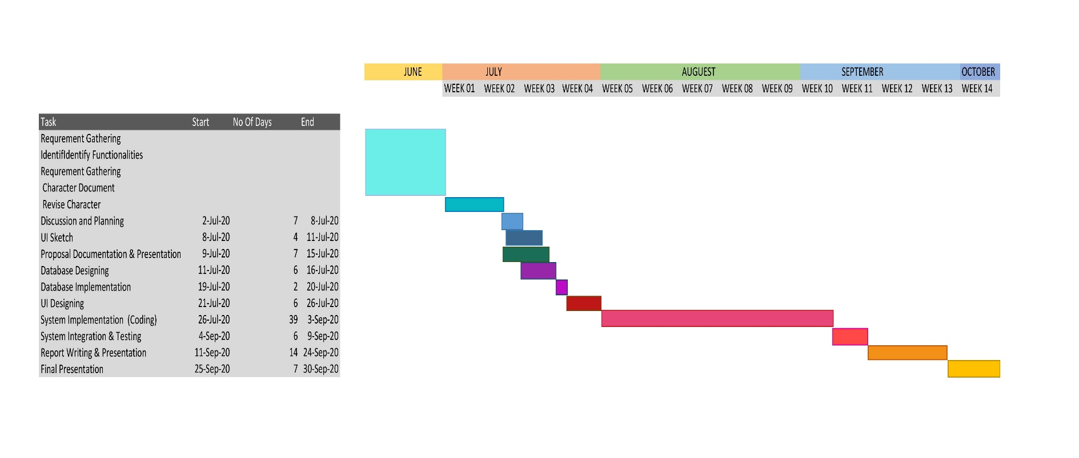

1. **TASK DISTRIBUTION**

|  |  |
| --- | --- |
| **Name with Initials** | **Brief Description of the Function** |
| Salika Madhushanka W.J | Employee Management   * Add/Update/Delete Employees * Mark attendance(add/update/delete) * Calculate salary for instructors * Search employee details |
| Deshitha Thilindra H.B | Customer Management   * Create customer profiles * Customer can add/delete/update his/her profile * Mark attendance * Search members by Admin |
| Sandun Harshana S.G | Stock Control Management   * Add/Update/Delete Gym equipment * Add/Update/Delete Products * Search available items of Gym |
| Sachini Sumeera A.L.G | Online Shopping Store Management   * Add/Update/Delete products from stores * Buy gym equipment using shopping cart * Manage store payments * Can search item |
| Seliya Mindula K | Schedule Management   * Add/Update/Delete Schedules * Search each schedules * Can download his schedule |
| G Janira Jayaprabha | Diet Plan   * Add/Delete/Update/ diet plan * Customer can see diet plans * Customer can find suitable diet plan |
| S.Y.S Pallawala | Payment Management   * Add/Update/Delete payment package * Customer can select payment package * Customer can see due |
| Kavindu Maduhansa G.L | Additional Expenses and Booking Management   * Add/Delete/Update/ additional expenses data * Generate a monthly report * Add/Delete/Update booking |