|  |  |
| --- | --- |
|  | **Sri Lanka Institute of Information Technology**  TMP-22-109 |

Project Topic Assessment – 2022 (Regular)

Topic

Mobile Application to Analyzing fisheries Market, Shrimp Farming and Identifying Fish Species using

Image Processing

Abstract (200 Words Max):

Abstract (200 Words Max):

There is much qualitative information regarding the fish species in the country but the quantitative information of fishes in Sri Lanka is clearing wanting. Sri Lanka has been earning a large income from the fishing industry from ancient times to the present. This study aims to examine the price behavior of several key types of fish consumed by Sri Lanka. Both the fishing community and the consumer are affected by certain issues.

In those days image processing technology has been used various field such as science, and technology. The use of image processing technique is improving the manual approach process to achieve accurate result. This activity is as important not only for the Market customers, shrimp Farmers and Fisherman, but it is also important for the education purpose.

In the society how many problems arise in the fishing industry are very few seek solutions. Professional shrimp farmers are particularly vulnerable to certain diseases when they infect their prawn cages. What we need to do here is take a large amount of data, train it and pay close attention to the diseases that infect those fishes or shrimp so that solutions can be found for what may happen in the future. This is a very important issue for the society today as well as for the future. It is a problem that many people have not sought a solution for this. The consumer who goes to buy fish for his daily needs is greatly inconvenienced as he does not know the reasonable prices of the fish.

Research Group/Area: Select the area by referring to the document uploaded to the Course Web

Knowledge Inspired Computing (KIC)

**ICT for Development (ICTD)**

**Supervisor should fill this part**

Continuation of Previous Year Project?

Supervisor and Co-Supervisor endorse the proposed project, and hence, guide the students to acquire required knowledge skills pertaining to above sub domains of their specializations.

Supervisor: **Select Supervisor**

If yes, state the Project ID

and year

Signature

Co-Supervisor: **Select Co-Supervisor**

External Supervisor

Name

Team Members:

|  |  |  |
| --- | --- | --- |
| Student Name | Student ID | Specialization |
| Leader: A.L.G Sachini Sumeera | IT19101248 | IT |
| Member 2: Nipun Pesala H.R | IT19033860 | IT |
| Member 3: Maleesha Thilani M.A | IT19191584 | IT |
| Member 4: Perera M.G.S | IT19517766 | IT |

Research Problem:

* When buying fish from the market, it is sometimes difficult for customers to identify the fish with their names. There, the seller is often able to deceive the customer
* One of the major problems faced by university studies is that it takes a long time to identify species referring a books.in this situation student or researcher need to compare images this is a difficult task.
* Sri Lanka has a large number of endemic fish species. Most of these species are endangered. Due to the ignorance, these species are in great danger.
* Market fish prices are not always constant. Fish prices fluctuate from time to time depending on the fish harvest. In such cases, the customer and fish sellers does not have a correct idea about the price of the new fish, so some times we have to pay more to buy the fish.
* Foreigners are greatly embarrassed by the inability to find reasonable prices for local fish in Sri Lanka.
* Another major problem for shrimp farmers is the fungal infection and another disease. If these diseases are not correctly identified at an early stage the entire shrimp pond will be destroyed.it is very important to identify these diseases
* And also important for shrimp growers to know if shrimp have grown to the right size to reap the harvest.
* One of the major problems for the ornamental fish frames is the transmission of various diseases to these ornamental fish. Another problem is that ornamental fish farmers have no idea about the disease and what medicines use to treat it. This can be a huge loss to the economically for ornamental fish farmers.

**MUST: Add three main references in IEEE format**

1]<https://www.hindawi.com/journals/vmi/2010/679130/>

2] <https://iopscience.iop.org/article/10.1088/1742-6596/1529/5/052031/pdf>

3] <https://www.science.gov/topicpages/s/shrimp+farming+industry>

4]<https://www.cfc.gov.lk/web/index.php?option=com_fishprice&view=price&location_id=2&Itemid=155&lang=en>

5] <https://www.spiedigitallibrary.org/conference-proceedings-of-spie/11442/1144218/The-use-of-machine-learning-algorithms-for-image-recognition/10.1117/12.2565546.full?SSO=1>

6] <https://towardsdatascience.com/image-recognition-with-machine-learning-on-python-image-processing-3abe6b158e9a>

7] <https://iopscience.iop.org/article/10.1088/1742-6596/1529/5/052031/pdf>

8] Wijegoonawardena, P.K.M., and P.P.G.S.N. Siriwardena, 1996. Shrimp farming in Sri Lanka: health management and environmental considerations. *In* Health Management in Asian Aquaculture. Proceedings of the Regional Expert Consultation on Aquaculture Health Management in Asia and the Pacific. R.P. Subasinghe, J.R. Arthur & M. Shariff (eds.), p. 127–139. FAO Fisheries Technical Paper No. 360, Rome, FAO. 142p.

9] [Faculty of Fisheries and Food Science, Universiti Malaysia Terengganu (UMT),  
21030 Kuala Nerus, Terengganu, Malaysia](file:///C:\Users\Acer.LAPTOP-CAE6OQA2\Downloads\Faculty%20of%20Fisheries%20and%20Food%20Science,%20Universiti%20Malaysia%20Terengganu%20(UMT),)  
  
10][Faculty of Ocean Engineering Technology and Informatics, Universiti Malaysia  
Terengganu (UMT), 21030, Kuala Nerus, Terengganu, Malaysia.](file:///C:\Users\Acer.LAPTOP-CAE6OQA2\Downloads\Faculty%20of%20Ocean%20Engineering%20Technology%20and%20Informatics,%20Universiti%20Malaysia)

Solution proposed:

The solution we are proposing is to create a new fish recognition system that will overcome the various shortcomings of current fish recognition systems. One of the major weaknesses of the existing systems is the lack of accurate output for Sri Lankan species. This system will enhance the problems of students, researchers and farmers (Shrimp and ornamental fish).

• Also system will be able to identify endangered and endemic fish species in Sri Lanka. This this facilitates university academic activities. This system quotes fish prices so that people, who are unfamiliar with the market price of the fish, especially the young generation, can buy fish at the right and fair price without being fooled by fraudsters. They can buy fish without any hassle by comparing the two prices. At reasonable Price so you can get an idea of the changes in fish prices during the season buying and selling can be done. Data on past fish prices are available year-on-year and can provide an idea about future prices of fish supply in market.

• This system has the ability to determine Shrimp age. Then a shrimp grower can find the harvest in the shrimp box even before the harvest season. You can also decide when, in what month and on what day the harvest will take place. The grower can find out what the disease is that has spread to the shrimp box. If diseases infect the shrimp box, we can determine the profit and loss before selling it.

• The system also has the ability to detect diseases of ornamental fish. Also System provide a chatbot to diagnose medicine for particular diseases. This will allow users to accurately diagnose diseases and determine the appropriate medications.

• As explained, it is expected to consolidate all the above-mentioned

functionalities under a single platform and to present an effective

solution that is equipped to address difficulties.

System Overview Diagram for the solution proposed. Recommended to draw using [draw.io.](https://app.diagrams.net/) Note: This is not an activity/flow (UML) diagram

1. **Man components including the data sources, stakeholders, interaction among the stakeholders, etc.**
2. **Interconnection among the components**
3. **Major SW and HW components**

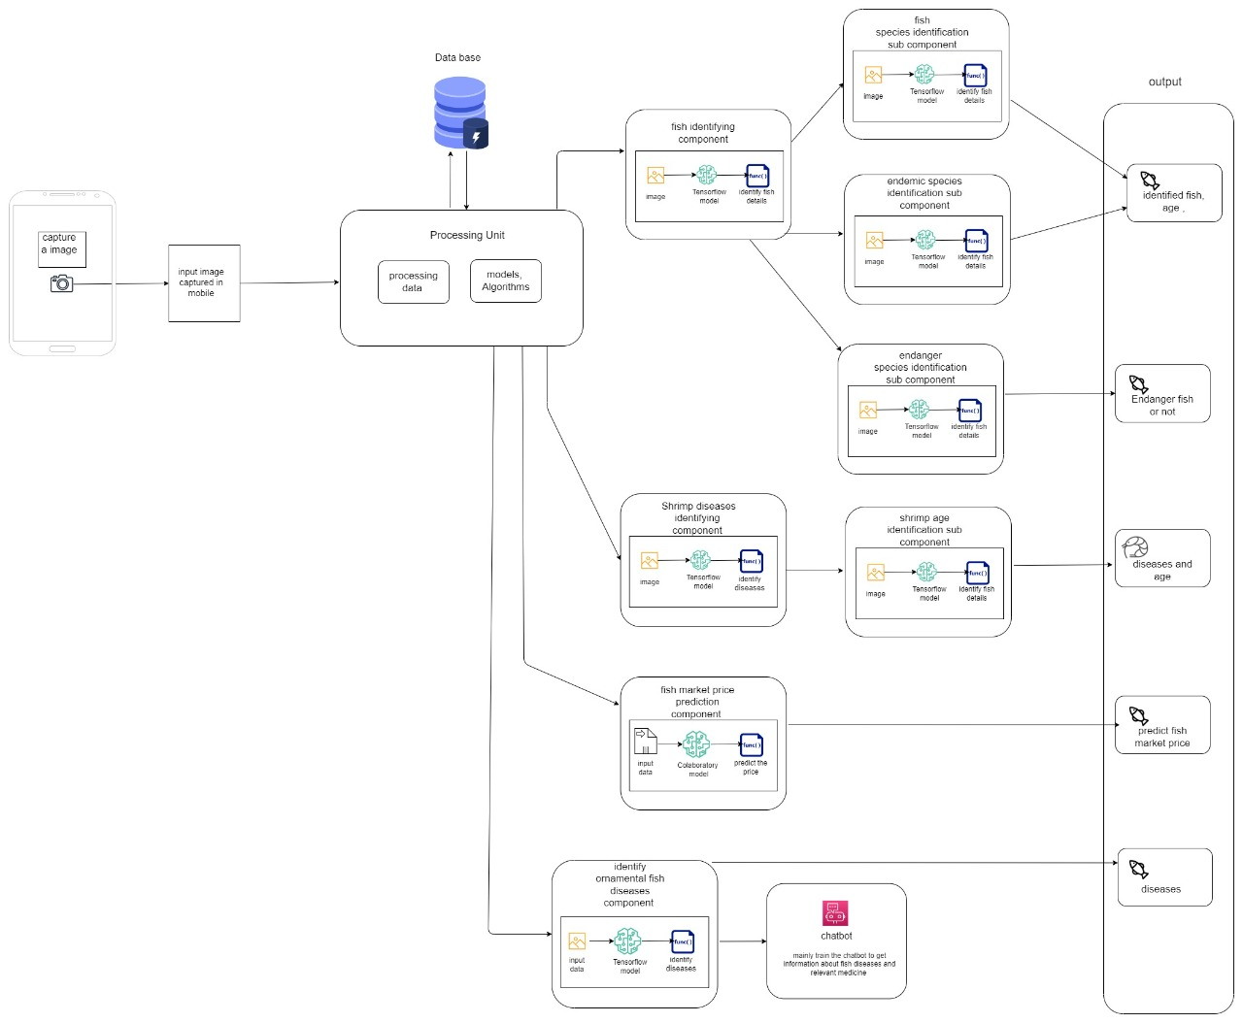

Objectives (1 main objective and 4 sub objectives):

**Main Objective:**

Create a system for fish and fish disease, shrimp disease identification application to help academic and avoiding problems for everyone in the fishing industry.

To achieve the main objective, the sub objective can be segregated as mentioned below:

* Identify fish species according to the given input image.
* Identify the shrimp disease facing shrimp farmers.
* Predict the fish market prices in silence.
* Identify the ornamental fish disease aquarium fish farmers.

**Sub Objective 1:** Age perdition for the farmed fish for food

Identify endanger fish species

**Sub Objective 2:** Identify shrimp age

Predict the maximum number of shrimp in the particular aria (pond).

**Sub Objective 3:** Predict the fish prices are increase or decrease.

Predict the annual fish yield increase or decrease

**Sub Objective 4:** Create chat bot to ask question directly.

Task Divided Among the Members:

Member 1

1) Create a model for Predict to market prices and annual fish yield.

* Collect prices of market fish species in previous year.

               2) Analyse the data and predict the prices are increase or decrease for particular fish.

* Using machine learning can predict the fish market price for given fish. Estimate increase or decrease of price before they happen.

3) Analyse the data and predict the annual fish yield increase or decrease for particular fish.

Member 2

* 1. Create a model for fish species usinng tensorflow
* Collect all images and all details for particular fish species and create a model and training the model.
  1. Identify fishspecies using image processing.
     + Object detection algorithm can be trained for fish detection.
     + Generates the small segments in the input
     + Predict whether the rectangle contains a valid object.
     + Finally Identify the relevant class or the object.([***YOLO algorithm***](https://www.mygreatlearning.com/blog/yolo-object-detection-using-opencv/))
  2. Identify endemic species in Sri Lanka.
* This will Cleary identify whether the fish are endemic or not.
  1. Identify endangered fish species
* This will Cleary identify whether the fish are endanger or not.

Member 3

1) Create a model for shrimp disease using tensorflow

* Collect all images and all details for particular fish species and create a model and training the model.

       2) Identify the shrimp disease facing shrimp farmers.

* Collect the images of infected shrimp.
* Classify the images according to the type of diseases.
* After trained model identify the shrimp disease.

        3) Shrimp age estimation

* Identify the shrimp length.
* According to the length calculate the shrimp in month.

4) Predict the amount of shrimp particular pond or area.

Member 4

1) Create a model for ornamental fish disease using tensorflow

* Collect all images and all details for particular fish species and create a model and training the model.

             2) Identify ornamental fish diseases in Sri Lanka

3) Create chatbot to get details about the ornamental fish diseases and relevant medicine for    particular diseases

* Based on the relevant fish diseases AI- based chatbot can answer to the question related to the ornamental fish diseases and medicines for the diseases. Using(NLP, machine learning and AI).

Technologies to be used:

* Artificial Intelligence
* Open CV
* Computer vision
* Machine Learning
* Neural Networks
* Google Cloud Provider

If supervisor States that this year is a continuation of previous work, state the further work the students should do compared to the previous years.

(NOTE: This part has to be filled by the supervisor)

**This part will be filled by the Topic Screening Panel members**

Acceptable: Mark/select as necessary

|  |  |  |
| --- | --- | --- |
| Acceptance/  Rejection | Correction State | |
| Minor Correction | Major Corrections |
| Accepted |  |  |
| Resubmit |  |  |
| Rejected |  | |

Corrections (if necessary)

|  |
| --- |
| Rephrase the title since it is not complete. For part of each member, mention the techniques that will be used in the component. |

Major changes proposed: ____________________________________________________________________________________________________________________________________________________________________________________________________________________________________________________________________________________________________________

Any other Comments: _________________________________________________________________________________________________________________________________________________________________________________________________________________________________

Approved by the review panel:

|  |  |
| --- | --- |
| **Member’s Name** | **Signature** |
| Dr. Anuradha Karunnasena |  |
| Ms. Sanjeevi Chandrasiri |  |
| Ms. Lokesha Weerasinghe |  |
| Ms. Thamali Dassanayake |  |

**Important**:

1. According to the comments given by the panel, do the necessary modifications and get the approval by the **same panel**.
2. If the project topic is rejected, find out a new topic and inform the CDAP Group for a new topic pre-assessment.
3. A form approved by the panel must be attached to the **Project Charter Form**.

**Appendix**

Appendix 1: Reply mail from the Supervisor

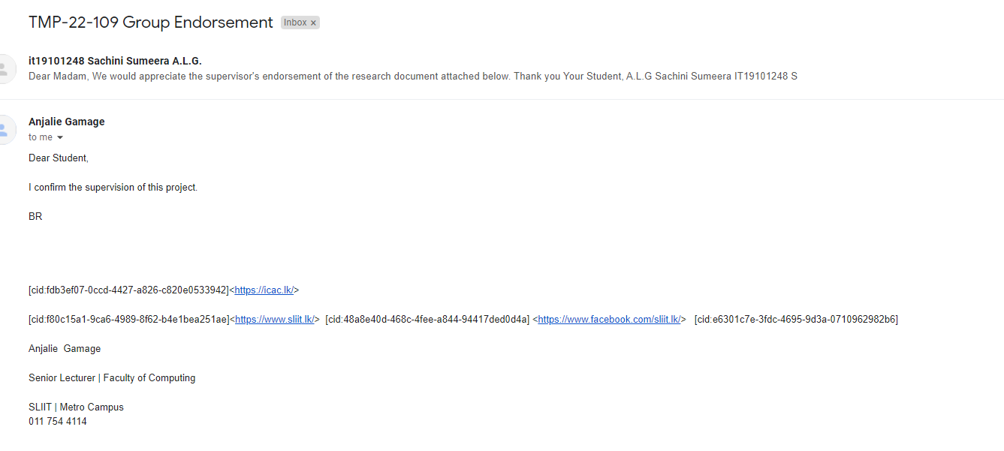

Appendix 2: Reply mail from the Co-Supervisor

