Examining Factors Influencing Loan Approval: A Statistical Approach

Introduction
Loan approval is a critical process in the financial and banking sector, as it directly impacts both financial institutions and applicants. Accurately evaluating a customer’s eligibility helps reduce financial risk while efficient credit distribution. The Loan Approval Classification Dataset provides valuable insights into how personal, financial, and credit-related factors influence loan approval decisions.
This dataset includes key variables such as applicant income, applicant’s income, loan amount, loan term, credit history, education level and employment status. These attributes accepted for a comprehensive analysis of applicant profiles and their likelihood of loan approval. By analyzing this dataset, researchers and analysts can identify patterns and relationships between applicant characteristics and loan approval outcomes. Statistical analysis can be applied to predict loan approval status, assess credit risk, and improve decision-making processes in financial institutions. Ultimately, insights derived from this dataset can support the development of automated loan approval systems, promote transparency, and enhance financial inclusion by enabling faster and more accurate lending decisions.

The Objective of the Study
The main objective of this study is to predict how demographic, financial, and credit-related factors such as income, loan amount, credit history and age influence loan approval decisions. The study also analyzes the impact of applicants’ socio-economic and employment characteristics on the likelihood of loan approval using statistical and classification techniques. The findings aim to support data-driven decision-making for improving loan approval processes, reducing financial risk, and promoting fair lending practices.

Description of the Data
The Loan Approval Classification Dataset contains several attributes related to applicant personal, financial, and credit information, providing an integrated picture of factors influencing loan approval. This study uses secondary data collected from the Kaggle website.
This dataset contains 500 user records analyzing applicant income, loan amount, credit history, and other personal details in relation to loan approval. (After clearing data set ,data set have only 477) .The study considers a total of 12 columns, including continuous variables such as applicant income, co-applicant income, and loan amount, as well as categorical variables such as education level, employment type, and property area. The target variable indicates the loan score.
By analyzing these data points, researchers can identify patterns, find factors that increase or decrease the chance of loan approval, and build predictive models to support accurate and fair lending decisions.

Statistical Methods
The collected data set was verified for correctness and completeness before analysis. Minitab Software Windows version of 16 was utilized to carry out the analysis of data. Various visualization techniques were used so that relationships among variables could be explored.
Graphical representations such as pie charts and scatter plots were used to visualize the relationships between variables. The basic information about variables and potential relationships were estimated using Descriptive statistics and correlation. Multiple Linear Regression (MLR) technique was used to find the relationship between the users’ popularity with other variables. All the assumptions were tested to obtain a better outcome.

Results and Discussion

A total of 500 users were included for the study. The users are distributed in the several categorical factors as shown in Figure 1. Most of the users haven’t taken loan before(73.4%)and showed the higher loan intent level performance in education users (21.4%).
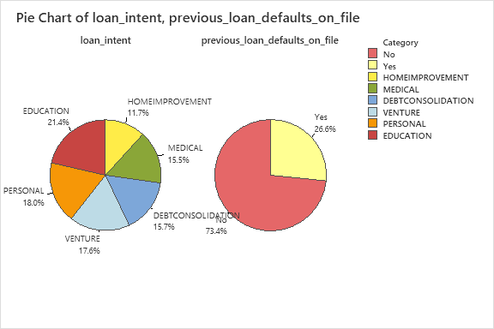

Figure 1;Pie Charts for loan status, Type of loan intent

Correlations
Correlations
 | stloanamount | stin
stin | 0.493
stcr | 0.149 | 0.029
Figure 2-correlations
Here, Figure 2 shows that loan amount and income are positively correlated, and credit score and loan amount are also positively correlated, but not strongly. The original dataset does not follow the normality assumption; therefore, before analysis, we applied a square root transformation to the data.
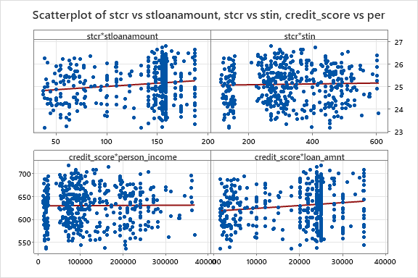
Figure 3 scatter plot
Figure 3 shows the relationship between the predictor variable and the explanatory variables. The figure indicates that income and credit score have a positive relationship. Similarly, loan amount and credit score also show a positive relationship. The top-level and lower-level graphs provide an idea of each variable’s relationship and behavior before and after transformation. No of strong outliers are observed in these graphs.The graphs also suggest a positive linear relationship; however, the data is loosely clustered, indicating a moderate linear relationship. The bottom-left and bottom-right graphs show that there is no strong relationship between income and loan amount in the data received from users, but there is high variation around the regression line.

Statistics
Table 1-Descriptive Statistic
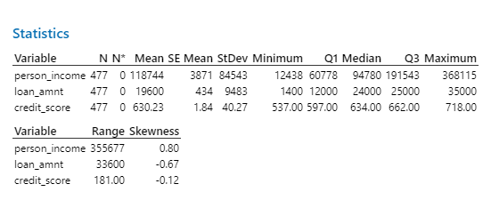

The descriptive analysis focused on variables in the dataset to gain a comprehensive understanding of the characteristics and trends within the data. By analyzing these descriptive statistics for each variable, we can gain insights into the central tendencies, variability, and distributions of the data. This helps us identify patterns, trends, and potential outliers within the dataset. Table 1 shows the descriptive statistics of the continuous variables.
The mean number of credits score received in 630.23, indicating their average popularity based on the data. The standard deviation of 40.27 suggests a variability in the credit score. The minimum and maximum values of 537 and 718 , respectively, demonstrate the range of score among the users. This negatively skewed (-.12)suggests a moderate level of variability in the wickets taken.

Coefficients
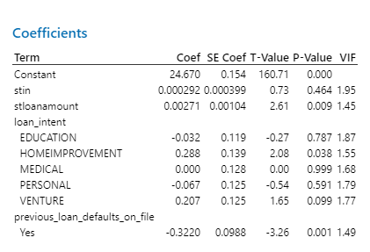Table 2 coefficients
Table 2 shows the coefficients of the final MLR model. From the table, we can see that education, personal information, and previous loan status have negative coefficients, which means that higher values in these factors are linked to a lower credit score. The other variables have positive coefficients, so higher values in these increase a person’s credit score. But since the p-value is greater than 0.05, it shows that the data still has some outliers. This is also supported by the ANOVA results from the regression.

Analysis of Variance
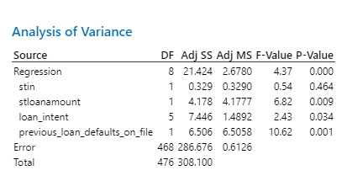

Conclusion

From the analysis, it can be seen that applicant income, applicant income, and credit history have a strong positive effect on loan approval. On the other hand, factors like education, marital status, and previous loan status have a negative effect, meaning higher values in these make loan approval less likely.
The regression results show that income, credit history, and loan amount are the most important factors in deciding loan approval, while other variables like gender, employment type, and property area have smaller effects. Overall, the study highlights that financial stability and credit history are key for predicting loan approval, and understanding these factors can help banks make fair and accurate lending decisions.

Screenshot/ image or part of the dataset

